A Report on Industrial Visit West Kallada Floating Solar Power Plant

Submitted by

Noufiya N
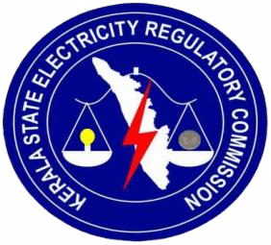
INTERN

Kerala State Electricity Regulatory Commission Thiruvananthapuram
Kerala
December 2025

Chapter 1
Introduction

As part of my internship programme, I had the opportunity to learn about the West Kallada Floating Solar Project in Kerala through an informative session conducted by the NHPC team. The session helped me understand the overall concept, planning, and functioning of a large-scale floating solar power plant.
I learned that the project is a grid-connected solar PV plant developed over a leased water area and is designed to supply power to KSEB under a long-term power purchase agreement . The plant is expected to generate a significant amount of clean energy annually, contributing to the growth of renewable energy in the state .
During the session, I was introduced to the basic working of the floating solar system, including how solar panels generate DC power, how inverters convert it into AC power, and how transformers increase the voltage before transmitting the electricity to the grid . I also gained an understanding of the general layout of the project and the process involved in power evacuation and grid connection.

Chapter 2
The West Kallada Floating Solar Project
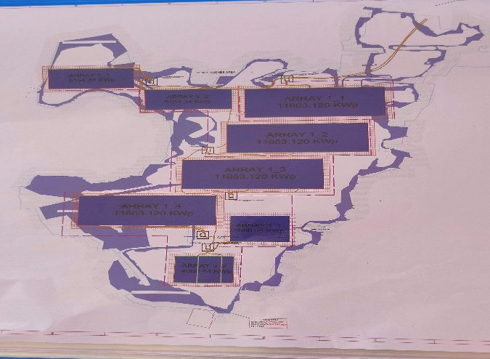

The West Kallada Floating Solar Project is a large-scale renewable energy project developed in Kerala. It is a grid-connected floating solar photovoltaic power plant constructed on a water body, where solar panels are installed on specially designed floating platforms. This method helps utilize water surfaces effectively and reduces the need for large areas of land, making it an environmentally friendly solution for power generation.
The plant has an installed capacity of 50 MW, with a DC capacity of 65 MW, and is expected to generate nearly 100 million units of electricity annually in its first year . The electricity produced is supplied to KSEB under a long-term power purchase agreement, supporting the state’s growing energy demands.
The project consists of a large number of high-capacity solar modules mounted on floating structures. The generated DC power is converted into AC power using inverters, then stepped up through transformers before being transmitted to the grid through a dedicated evacuation system .A 110 kV switchyard is also part of the system to ensure smooth and reliable power transmission .
Overall, the West Kallada Floating Solar Project is an example of advanced solar technology and sustainable energy planning. It highlights the effective use of innovative floating solar systems to promote clean energy generation and reduce environmental impact.

Chapter 3
Project Overview
The West Kallada Floating Solar Project is a flagship 50 MW grid-connected Solar PV installation located in Kerala. This utility-scale project represents a strategic collaboration in which West Kallada Non-Conventional Energy Promoters Private Limited (WKNCEPPL) provides the leased water area for development, while the generated power is supplied to the Kerala State Electricity Board, the designated off-taker under a long-term agreement.
Developed as a floating solar power plant, the project makes use of specially engineered floating platforms that support high-capacity photovoltaic modules on a water surface. This innovative approach enhances energy density per unit area and effectively addresses common challenges related to large-scale land acquisition. In addition, floating solar systems can help reduce water evaporation and improve panel efficiency due to the cooling effect of water.
As a grid-connected installation, the project is integrated into the state’s power network through a dedicated transmission system, ensuring reliable evacuation of the generated electricity. The plant plays a vital role in strengthening Kerala’s renewable energy portfolio and reducing dependence on conventional fossil fuel-based generation.
Project Administrative Specifications

Parameter | Value
Project cost | Rs. 249.42 crores
Commercial Operation Date (COD) | 04.02.2026
Power Purchase Agreement | Rs. 3.04 / kWh for a 25-year tenure
Land Details | 291.68 acres (3% revenue sharing in lieu of lease rental)

Plant Capacity
- DC Capacity: 65 MW peak (MWp)
- AC Capacity: 50 MW
- Net Anticipated Annual Energy (Year 1): 99.909 million units (MU)
- Capacity Utilization Factor (CUF): 22.79%
Technical Specifications
Solar Modules | Quantity: 1.10 lakh modules
Solar Modules | Rating: 590-Watt peak (Wp) per module
Inverters | 4.4 MVA Units: 10 Nos.
Inverters | 3.3 MVA Units: 2 Nos.
Inverter Duty Transformers | 5 units of 8.8 MVA
Inverter Duty Transformers | 1 unit of 6.6 MVA
Power Transformers | 2 units of 31.5 MVA
Power Transformers | Voltage Rating: 33/110 KV

Grid Interconnection and Power Evacuation
Power evacuation is facilitated through a strong 110 kV transmission infrastructure, ensuring reliable integration with the local grid and improved system stability.
Evacuation Infrastructure: The project incorporates a 1.2 km Line-In-Line-Out (LILO) arrangement on the existing 110 kV Kundara–Chavara transmission line. The scheme requires the erection of 7 transmission towers, with the LILO tapping point located approximately 1.1 km from the plant switchyard.
Grid Impact: The injection of 50 MW into the grid substantially relieves loading on nearby 220 kV substations at Kayamkulam, Sasthamkotta, and Kundara, contributing to better load balancing and operational reliability.
Economic and Technical Benefits: In addition to delivering its installed capacity, the project achieves an estimated system power loss reduction of about 1.33 MW. This reduction in transmission losses translates into tangible economic benefits for the state utility and effectively enhances the project’s overall net contribution to the power system.

Chapter 4
Funding and Tariff Structure
The Central Financial Assistance (CFA) provided by the MNRE is a capital subsidy aimed at reducing the initial investment requirement for renewable energy projects. The assistance is capped at ₹20 lakh per MW or 30% of the eligible solar park cost, whichever is lower. For the proposed 50 MW project, the per-MW ceiling translates to a maximum eligibility of ₹10 crore. However, since 30% of the approved park cost amounts to ₹7.63 crore, the CFA is restricted to this lower value. This financial support enhances project viability by lowering upfront capital expenditure and easing the overall investment burden.
The State Viability Gap Funding extended by the Government of Kerala is a capital grant intended to bridge financial gaps in projects where certain critical components do not yield direct revenue. For this project, a VGF of ₹11.83 crore has been sanctioned specifically for power evacuation infrastructure, including substations, transmission lines, and grid interconnection facilities. This support significantly reduces the developer’s capital requirement, strengthens project bankability, and contributes to maintaining a competitive end-user tariff.
As per the PPA executed with Kerala State Electricity Board Ltd,the project will supply electricity at a fixed levelized tariff of ₹3.04 per kWh for a period of 25 years, ensuring predictable and stable long-term revenue.

Chapter 5
Opportunities Constraints and Scalability
Environmental and Operational Benefits
- Thermal Regulation and Efficiency Improvement:
The water body acts as a natural cooling medium, resulting in reduced photovoltaic module temperatures, improved voltage stability, and enhanced energy conversion efficiency.
- Reduction in Evaporation Losses:
Partial shading of the Mundakapadam basin by floating solar arrays limits direct solar exposure, thereby reducing water evaporation and supporting water resource conservation.
- Efficient Dual Utilization of Resources:
The project enables simultaneous renewable energy generation and preservation of waterlogged polders, optimizing the use of land–water interfaces without competing land requirements.
Key Implementation Constraints
- Operational and Maintenance Challenges:
Floating solar installations require marine-grade operation and maintenance systems, corrosion-resistant components, and purpose-built access pathways to ensure safe and efficient servicing.
- Higher Initial Capital Investment:
Additional upfront costs are incurred for specialized mooring and anchoring systems, along with moisture-protected electrical and grid-integration infrastructure.
- Environmental Sensitivity of Aquatic Systems:
Continuous ecological monitoring is necessary to ensure that reduced light penetration does not adversely impact aquatic biodiversity and water quality
Scope for Replication and Scalability
The West Kallada floating solar initiative can act as a reference model for deployment across similar hydro-geographical settings in Kerala:
- Kuttanad Region:
Well suited for polder-based floating solar systems due to extensive low-lying and water-covered terrain.
- Chalakudy River Basin:
Presents strong potential for flood-resilient renewable energy installations integrated with river systems.
- Vembanad Lake Periphery:
Areas such as Vaikom and Cherthala are suitable for modular and phased floating solar clusters.
- Irrigation Reservoirs:
Moderate-scale replication is feasible at reservoirs like Malampuzha and Meenkara, enabling decentralized renewable energy generation.

Chapter 5
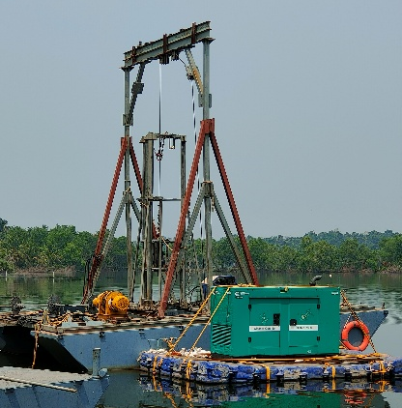
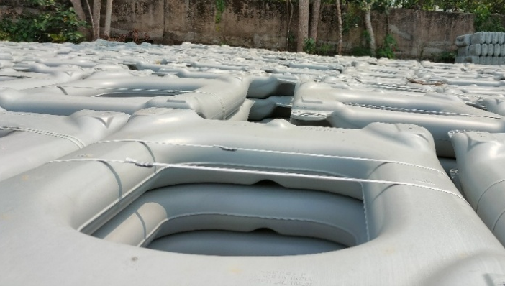
Current Site Execution Works

At the West Kallada Floating Solar Project in West Kallada, the ongoing site activities primarily include installation of the mooring system, anchoring operations, and levelling of the floating platform base. The mooring system is being deployed to maintain positional stability of the floating photovoltaic array under varying wind loads, water currents, and reservoir level fluctuations. High-strength mooring lines are connected between the floating structure and anchor points, designed based on hydrodynamic and wind load calculations to ensure controlled movement and prevent lateral drift. Anchoring works are simultaneously carried out using suitable anchoring mechanisms such as deadweight concrete blocks or pile anchors, depending on reservoir bed conditions. Anchor capacity is determined considering uplift forces, drag forces, and total structural load, ensuring long-term stability during extreme weather conditions.
In addition, base levelling is being performed to achieve uniform buoyancy distribution and proper alignment of the floating platform. This includes interlocking of modular floats, adjustment of connectors, verification of tilt angle for optimal solar irradiation, and load balancing prior to PV module installation. Proper levelling ensures structural integrity, prevents uneven stress concentration, and facilitates accurate mounting of photovoltaic panels and associated electrical components. These activities form a critical foundation for subsequent works such as module installation, DC cabling, inverter placement, and grid integration.

Chapter 6
Construction Challenges Impacting Project Timeline

One of the major challenges observed at the West Kallada Floating Solar Project in West Kallada is the construction of the switchyard in a marshy terrain selected due to land availability constraints. The geotechnical conditions of the identified site indicate low soil bearing capacity, high moisture content, which significantly complicate foundation design and structural stability.
The switchyard requires heavy electrical equipment such as power transformers, control panels, and high-voltage structures, which demand a firm and stable foundation. However, due to the marshy nature of the soil, conventional shallow foundations are unsuitable. Deep foundation solutions involving pile foundations of approximately 20 meters depth are required to transfer structural loads to deeper, relatively stable strata. Even with deep piling, achieving a strong and reliable base is challenging because of soft soil layers and potential differential settlement. However, due to technical and economic constraints, efforts are being made to identify an alternative location with better soil conditions for switchyard development.
Another critical project challenge is the schedule dependency between floating platform installation and switchyard completion. While the modular floating pontoons and platform structures can be assembled and deployed within approximately six months, grid connectivity and power evacuation cannot be established until the switchyard construction is completed. Since switchyard development in weak soil conditions involves extended piling works, soil stabilization, and structural curing periods, it significantly increases the overall project timeline. This creates a bottleneck in commissioning and power export, making switchyard construction the key limiting factor in project completion.

Chapter 7
Conclusion
The West Kallada Floating Solar Project in West Kallada represents a technically advanced implementation of utility-scale floating photovoltaic (FPV) technology integrated into the state power grid. With a DC capacity of 65 MWp and an AC export capacity of 50 MW, the project demonstrates optimized DC–AC ratio design, efficient energy conversion, and robust transmission planning through a 110 kV evacuation system.
From a technical perspective, the project highlights the complexity involved in floating solar deployment, including hydrodynamic stability analysis, mooring and anchoring system design, buoyancy balancing of HDPE pontoons, and structural load distribution across interconnected floating arrays. Proper base levelling and tilt alignment ensure uniform stress distribution and optimal solar irradiance capture, directly influencing plant performance ratio and long-term reliability.
The switchyard construction presented significant geotechnical challenges due to low soil bearing capacity and marshy terrain conditions. The requirement of deep pile foundations (approximately 20 m depth) to achieve adequate load transfer illustrates the importance of detailed soil investigation, foundation engineering, and settlement control in heavy electrical infrastructure development. The dependency of grid synchronization on switchyard completion further emphasizes the critical role of transmission infrastructure in determining overall project commissioning timelines.

