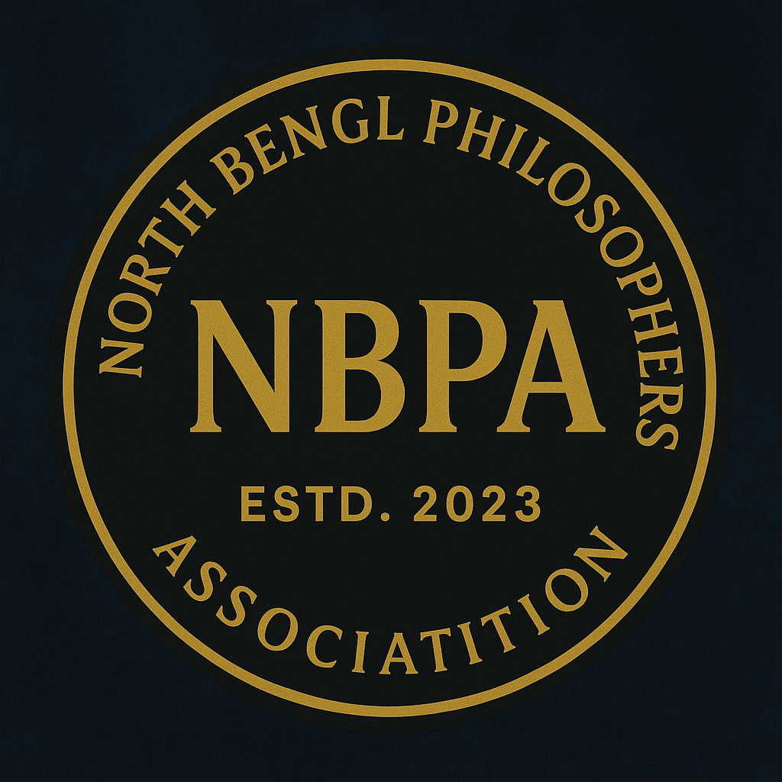
LIFE MEMBERSHIP APPLICATION FORM
North Bengal Philosophers Association (NBPA)
ESTD: 2023 Govt. REG. No. S0056397
(Circular Road, Newtown Para, Jalpaiguri, Pin- 735101)

Personal Details
Photo
Full Name (in Block Letters): ______________________________________
Date of Birth: ________________________________
Gender: Male / Female / Other

Contact Information
Postal Address:
________________________________________________________________________
________________________________________________________________________
Mobile Number (WhatsApp): ________________________________
Email ID: ________________________________

Professional / Academic Details
Designation / Occupation: _____________________________________________
Institution / Organization: _____________________________________________

Membership Details
Account Name: North Bengal Philosophers Association
A/C no. 44604699754
IFSC: SBIN0006829
Branch Code: 6829
Branch Name: Champasari, Siliguri
Type of Membership: Life Membership
Life Membership Fee: ₹ 5000/-
Mode of Payment: Cash / Bank Transfer / UPI / Cheque / DD
Transaction / Reference No.: ________________________________
Date of Payment: ________________________________

Declaration
I hereby apply for Life Membership of the North Bengal Philosophers Association (NBPA). I declare that the information provided above is true and correct to the best of my knowledge. I agree to abide by the rules and regulations of the Association.
Place: ________________________________
Date: ________________________________
Signature of the Applicant: ________________________________

_________________________________________________________________________________________________

Office Use Only
Membership No.: ________________________________
Date of Approval: ________________________________
Receipt No.: ________________________________
Authorized Signature: ________________________________
Seal of the Organisation

