Mail COMPLETED
Application, and Check to
Bay Area Radio Control Society
Bruce Rumrey
12721 County Road 55
Foley, AL 36535

2025 MEMBERSHIP RATES
Open & Senior …………...$100.00
Physically Unable to Mow..$60.00
Mower Team……………..$50.00
Snowbird………………….$50.00
Junior …….…………....….$20.00*
Junior Anyone younger than 18 years
*Note: Junior Memberships are FREE with a paid Open or senior Membership.
Dues are due by January 31st.
For new members’ After July 1st dues can prorated at $10.00 a month for what is left of a year.

2025 B.A.R.C.S. Club Officers
President...Albert Whitney……...251-591-7351
VP……….Andy Woerner……....858-837-2427
Secretary...Michael Conlon..........713-907-4252
Treasurer...Bruce Rumrey........…763-381-2271
Safety …...Bill Azok…..…..…….251-422-5612
Mowing Coord Fred Christensen...251-458-4560

* * * FOR OFFICIAL USE ONLY * * *

Initials Date

2025 Dues Paid _________ _________

AMA Verified _________ _________

Card Issued __________ _________

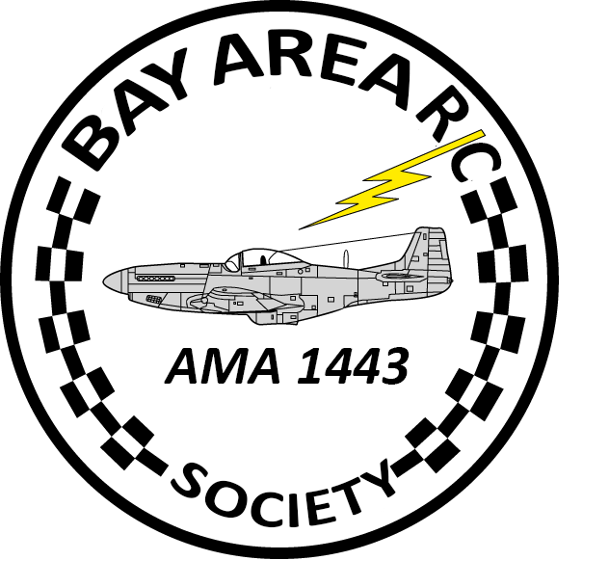

Bay Area Radio Control Society

Summerdale, Alabama
2025 Application / Renewal Form
Date _________________

(AMA Membership is required to fly at the B.A.R.C.S. Flying field)
Please Print Legibly (First, MI, Last)

Name_____________________________________________________________________

Street or P.O. Box________________________________________________

City, State, Zip_____________________________________________________________

Telephone (____________________________Cell Phone(______)__________________________________

Email Address ______________________________________AMA Number_________________________

