Bodiam Concert Band

Robertsbridge 800: 21 June 2025 Joining Instructions

Location: The Clappers Recreation Ground, ROBERTSBRIDGE, TN32 5AA

Website: <https://rbr800.fun>

Band scheduled to play 2 sessions: 12:00 – 13:00

13:45 – 14:15

Programme: flexible within current playlist. We’re aiming to link to the events that are happening around us, as far as that is possible.

Access and parking: The site will be open from early morning and I have permission for 2 vehicles to drive to the arena and park in the venue (percussionists). Other than that parking in the immediate vicinity is going to be “difficult”.

Recommended parking is in Pelham Walk. Turn in by the “New Spice”, High Street, Robertsbridge. I live at number 1. My 4 neighbours have agreed that the band can use our shared area for the day. We may end up double parking – so, if you intend to leave once we’ve finished our slot, let me know and we’ll try to allow for that. It’s a 5 minute walk to the arena - and festival trolley is available for heavier instruments. Satnav: TN32 5BP

Please take extra care, especially when leaving, as there will be lots of pedestrians around.

We’re opening the event at 12:00. There is lots to see and plentiful food and drink on site. Chairs are provided, but we will be in the open air – pegs at the ready.

TV, radio and dignitaries invited - but that will depend on what else is news that day.

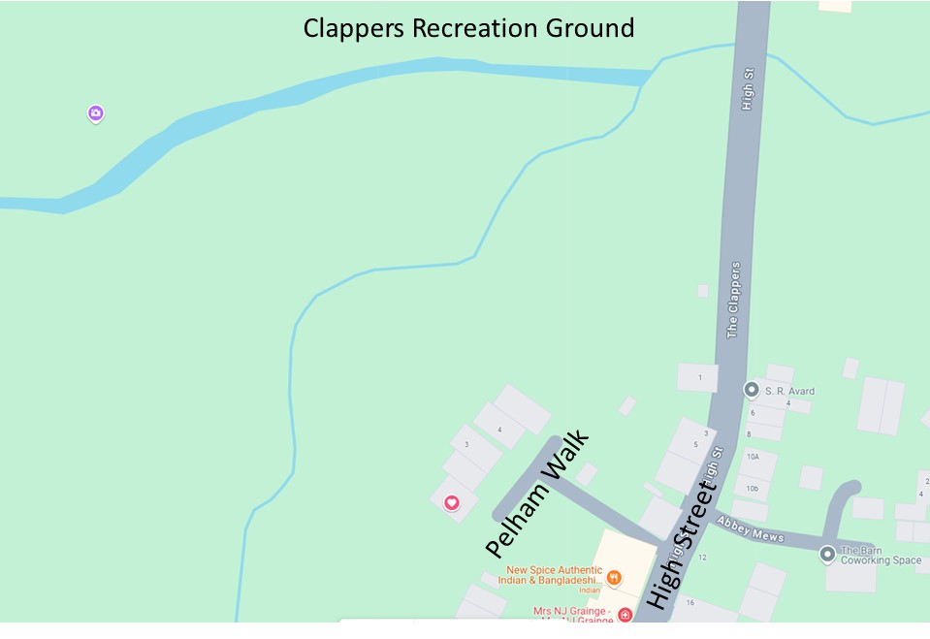

If you have any questions, please let me know. John S.