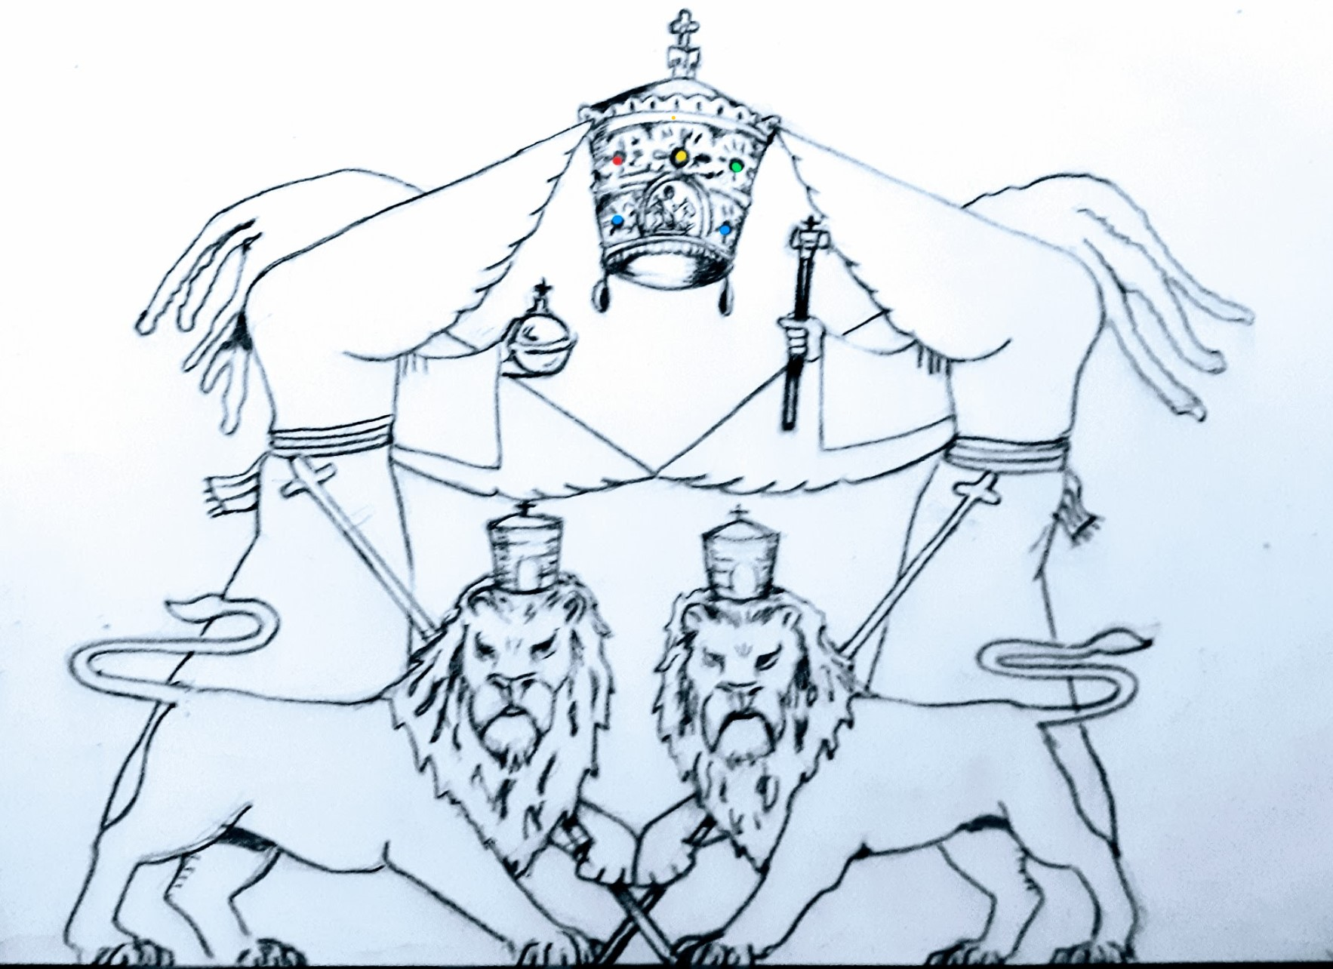
2344 Kemper Ln.
Suite 6892
Cincinnati Ohio 45206
Ethiopian African Church Triumphant Inc.

Wedding Feast Nov 2
In the **Book of Revelation**, the "Bride" symbolizes **spiritual Israel**, often understood as the collective faithful who are spiritually united with God. This is seen in Revelation 19:7-8, where the **Bride of Christ** (symbolizing the Church or Israel) is adorned in **white garments**, representing **righteousness, purity, and holiness**.

The **12 tribes of Israel** are considered the chosen people (RastafarI), spiritually reflecting God’s covenant. Their role as a "bride" signifies their spiritual commitment and relationship with the Messiah, embodying purity, faithfulness, and divine union (ONE NESS/ UNITY) in the context of the new Jerusalem, described in Revelation 21.

The **wearing of white** is significant, reflecting their purity, righteousness, and readiness for this union (TRUTHS AND RIGHTS). The imagery speaks to the collective responsibility of the faithful to uphold their covenant with God (STAND FIRM). In RastafarI and other spiritual traditions, this concept resonates deeply with the understanding of divine election and the spiritual journey towards redemption.
In Rasta livity, the concept of the "Bride" in the Book of Revelation holds deep meaning. The Bride represents Zion, the spiritual people of Jah, specifically Israel in its spiritual form. Jah people are pure, represented by the WHITE ROBES, symbolizing righteousness, as Rastafari seek to live in unity and purity with Jah.
The 12 Tribes of Israel are symbolic of the fullness of Jah's people, called to live in righteousness and oneness with the Creator, like a bride is one with her husband. The Bride of Christ is that ultimate union of Jah’s chosen ones, those who live in I righteousness, receiving Jah blessings and walking in the ways of Haile Selassie I, the Lion of Judah.
Why we were White Garments
The white robes symbolize the purity of mind, body, and soul, as the Bride is washed clean by truth and knowledge. Jah people are preparing themselves, just like a bride, to meet their Divine King in that eternal union. The marriage is a covenant of faith, loyalty, and love, showing that Zion is Jah's chosen people, ready to reign with the Most High.
This aligns with Rasta teachings of living clean, following righteousness, and maintaining a strong spiritual connection with Jah.
Coronation
On November 2, 1930, a day etched in the hearts of Rastafari and many others around the world, Ras Tafari Makonnen ascended to the throne as Emperor Haile Selassie I in Addis Ababa. This was not just a political event; it was a divine moment (Revelation of Christ in his Kingly Character as told in the book of Revelations), a fulfillment of prophecy that resonated far beyond the borders of Ethiopia.
The coronation of Haile Selassie I was a grand affair, attended by representatives from 72 nations, signaling Ethiopia’s growing influence on the global stage. But for us, the true significance lay in the spiritual power of the event. The ceremony was steeped in the sacred traditions of the Ethiopian Orthodox Tewahedo Church, a powerful reminder of the deep connection between the divine and the monarchy. It was here that Ras TafarI took the Throne name of “Haile Selassie First,” meaning “Might & Power of the Trinity,” a name that symbolizes his role not just as a ruler, but as a spiritual guide and protector of the faith.
As the anointed Emperor King of Kings Conquering Lion of Judah (seat of King David and Solomon and the Queen of Sheba) , Haile Selassie I was invested with the imperial regalia—crown, orb, scepter, and sword—each a symbol of his divine right and sacred duty to lead Ethiopia under
the watchful eye of the Trinity. This was not merely a ritual; it was a declaration of his divine mandate to rule and guide his people with wisdom and strength.
Empress Menen Asfaw, the beloved consort of Haile Selassie, was crowned alongside him, receiving the title “Queen of Queens.” Her presence at the coronation was a powerful symbol of balance, unity, and strength. Together, they embodied the “Full Balance” of life, a concept deeply revered in Rastafari philosophy. Empress Menen’s coronation was more than just ceremonial—it was a recognition of her vital role in the leadership of Ethiopia and a testament to the sacred partnership between man and woman in the divine order.
For the RastafarI community, the coronation of Haile Selassie I and Empress Menen was not just a moment in Ethiopian history; it was a pivotal event in the spiritual journey of Ethiopian African descendants worldwide. It affirmed Haile Selassie I’s status as the rightful ruler and messianic figure, fulfilling the prophecies of old and igniting a movement that would spread across the globe, carrying with it the messages of peace, unity, and the divine right of African people to self-determination.

