**TAPER CHART**

| **WEEK** | **Current Dose(g/day)** | **Reduction(%)** | **New Dose(g/day)** | **Notes/symptoms** |
| --- | --- | --- | --- | --- |
| 1 | 56 | 10 |  |  |
| 2 |  |  |  |  |
| 3 |  |  |  |  |
| 4 |  |  |  |  |
| 5 |  |  |  |  |
| 6 |  |  |  |  |
| 7 |  |  |  |  |
| 8 |  |  |  |  |
| 9 |  |  |  |  |
| 10 |  |  |  |  |
| 11 |  |  |  |  |
| 12 |  |  |  |  |
| 13 |  |  |  |  |
| 14 |  |  |  |  |
| 15 |  |  |  |  |
| 16 |  |  |  |  |
| 17 |  |  |  |  |
| 18 |  |  |  |  |
| 19 |  |  |  |  |
| 20 |  |  |  |  |
| 21 |  |  |  |  |
| 22 |  |  |  |  |

### **Guide to Tapering Off Kratom**

#### **1. Assess Your Usage**

* **Current Dosage**: Document your daily intake (amount and frequency).
* **Duration of Use**: Note how long you have been using kratom.
* **Reasons for Tapering**: Write down why you want to taper off (health reasons, dependency, etc.).

#### **2. Set Clear Goals**

* **Tapering Timeline**: Decide how quickly you want to taper. A common recommendation is to reduce your dosage by 10-25% every 1-2 weeks, depending on your comfort level.
* **Final Goal**: Aim for complete cessation or reduced use to a level you are comfortable with.

#### **3. Create a Tapering Schedule-**

* **Week 1**: Reduce your dose by 10-25%.
* **Week 2**: Maintain this reduced dose for a week.
* **Week 3**: Further reduce by another 10-25% if you feel comfortable.
* **Continue**: Repeat this pattern, adjusting based on how you feel.

**Example Schedule:**

* **Current Dose**: 10g/day
* **Week 1**: Reduce to 9g/day
* **Week 2**: Maintain 9g
* **Week 3**: Reduce to 8g/day
* **Week 4**: Maintain 8g
* **Continue**: Repeat until reaching a minimal dose or complete cessation.

#### **Here’s a simple and customizable taper chart template for reducing kratom use. You can fill it in based on your specific dosage and timeline.**

### [**Kratom Taper Chart Template**](https://docs.google.com/document/d/1TldrVg59QasP6omBMxu_r4XotFSPwTrVmSq_BmHSbdE/edit?usp=sharing)

### **How to Use the Chart:**

1. **Fill in Your Starting Dose**: In the "Current Dose" column, enter your initial daily intake.
2. **Decide on Reductions**: Choose a percentage to reduce your dosage (10-25% is common) and note it in the "Reduction" column.
3. **Calculate New Dose**: Subtract the reduction from your current dose to determine the new dose. Fill in the "New Dose" column.
4. **Track Notes/Symptoms**: Use the last column to note any withdrawal symptoms, feelings, or adjustments you want to make.

### **Example Chart:**

Customize the percentages, dosage amounts, and week counts based on your personal needs!

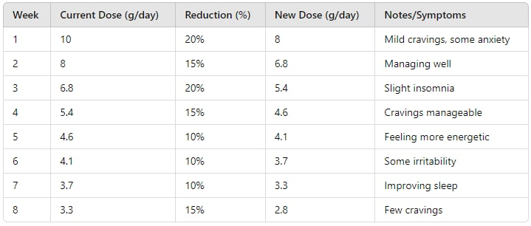

#### **4. Monitor Withdrawal Symptoms**

* **Common Symptoms**: Anxiety, irritability, insomnia, muscle aches, fatigue.
* **Self-Assessment**: Keep a journal to track symptoms and any triggers.

#### **5. Implement Supportive Strategies**

* **Hydration**: Drink plenty of water to help flush out toxins.
* **Nutrition**: Eat a balanced diet rich in fruits, vegetables, and whole grains.
* **Exercise**: Engage in regular physical activity to boost mood and energy.
* **Mindfulness**: Practice meditation or deep-breathing exercises to manage anxiety.

#### **6. Seek Support**

* **Professional Help**: Consider talking to a healthcare provider for personalized guidance.
* **Support Groups**: Look for local or online support groups where you can share experiences and gain motivation.

#### **7. Adjusting the Plan**

* **Listen to Your Body**: If you experience severe withdrawal symptoms, consider slowing your tapering pace.
* **Flexibility**: It’s okay to extend the timeline or take breaks as needed.

#### **8. Celebrate Milestones**

* **Acknowledgment**: Celebrate each reduction milestone to stay motivated.
* **Rewards**: Treat yourself to something enjoyable for each successful week or milestone reached.

#### **9. Post-Taper Considerations**

* **Aftercare**: Consider ongoing support groups or therapy to prevent relapse.
* **Healthy Coping Strategies**: Develop new hobbies or interests to fill the time previously spent using kratom.

### **Customization Tips:**

* **Adjust Dosage Reductions**: Tailor the percentage reduction based on your comfort level; some may need slower tapering.
* **Personal Triggers**: Identify and note specific situations that trigger cravings or urges to use kratom.
* **Incorporate Alternatives**: Explore natural alternatives (like herbal teas or supplements) if they help ease withdrawal symptoms.

### **Final Thoughts:**

Tapering off kratom can be a challenging process, but with a structured plan and support, it’s entirely achievable. Remember, the journey is personal, and adjusting the approach to suit your needs is key. If you ever feel overwhelmed, reach out for help—you're not alone in this.