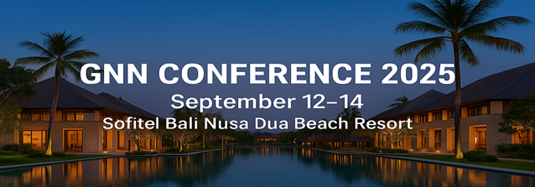
EVENT REGISTRATION FORM
- Please fill out the form and email it to info@gnn2025bali.com
Company Name
Company Regn No(S)
Company Address
Country
Tel No(S)
Fax No(S) |  |  | Website
Shareholders Names | 1.  2.
Date of Establishment
Type of Business
Name of the Attendee
Designation
Mobile Number |  | Email
Event Registration Fee | USD 800 – First Attendee  USD 750 – Second Attendee from the Same Company  USD 400 - spouse |  | Payment Date
Approved By
Kindly be informed that the registration for the event will close on 31st August 2025.

Explore the sponsorship opportunities listed below

Gold Sponsorship  $ 5,000 | - VIP table for meetings.  - Mention during the Chairman’s opening speech.  - Company advert on the backdrop n stand banners  - Company presentation during the event.  - Company logo on all promotional items.  - Company advert in notebook
Silver Sponsorship  $ 3,000 | - VIP table for meetings.  - Mention during the Chairman’s opening speech  - Company advert on the backdrop and stand banners  - Company presentation during the event.  - Company advert in notebook
Bronze Sponsorship  $ 2000 | - VIP table for meetings.  - Mention during the Chairman’s opening speech  - Company advert on the backdrop n stand banners  - Company presentation during the event.  - Company advert in notebook
Cocktail Sponsorship  $ 2,000 | - VIP Table for meetings.  - One banners at the cocktail venue.  - Company advert in note book.

Other Advertisement Opportunities
T-shirt sponsor ($ 1,500) , Name tags + Conference bags : USD1,000.00

Bank Details
Beneficiary: Global NVOCC Networks Sdn Bhd
Bank: RHB Bank Bhd, Jalan Stesen, Klang, Selangor D.E., Malaysia
Account Number: 61242400002884
SWIFT Code: RHBBMYKL

Kindly use the link below to proceed with direct hotel booking
https://www.idem.events/r/bahari-cahaya-raya-indonesia-964fa8c1

Remarks:
All companies must submit their soft copies of company name, address, tel nos, logos.
Delegate names + contact nos which to be printed in the notebook. Deadline: 31/08/25.

Terms and Conditions

All registered participants will be subject to screening and approval by the GNN Board, which reserves the right to reject any AGM registration without providing a reason.

