Literature Review
Exported on: June 25, 2026 at 07:28 PM

Literature Details
Start

1 Chapter 1 Introduction
This is a marker page to set Literature Review as Chapter 2.

2 Chapter 2 Lit Review
Consuming green tea as part of a daily routine has been associated with potential benefits for weight management and overall health. Schneider and Segre (2005) noted that regular intake, particularly when combined with a balanced diet and active lifestyle, may support metabolic processes and enhance fat utilisation. Schneider (2005) further highlighted that consistency in consumption is important to achieve sustained effects, suggesting that green tea should be integrated into daily habits rather than used occasionally.

2.1 Weight Control
Research Gap 1: Customer satisfaction is the key for repeated sales for a sustainable business. Many studies have been conducted on how timely delivery is important for project success.
Weight control is a key consideration in maintaining overall health, particularly among women undergoing physiological changes (Cabrera & Artacho, 2006). Regular consumption of green tea has been associated with improved metabolism and fat oxidation, which may support gradual weight reduction when combined with a balanced lifestyle. This suggests its potential role as a supportive dietary component in weight management strategies (Auvichayapat, 2008). Contrary to the findings of Chen et al., (2016) we did not find any indication of the method used here.
Research Gap 2: Customer satisfaction is the key for repeated sales for a sustainable business.
Table 1: Designer names and department.
Name | Role | Department | Status
Sudip White | Designer | Product | Active
Bob Smith | Engineer | Engineering | Away
Carol White | Manager | Operations | Active
Sudip Clark | Analyst | Finance | Inactive

2.1.1 Food Choices
Food choices play a critical role in determining body weight and overall health outcomes. Selecting nutrient-dense foods while limiting high-calorie, low-nutrient options can support effective weight management. In the context of menopausal women, balanced diets rich in fruits, vegetables, and whole grains are particularly beneficial in managing weight changes (Chen et al., 2016).
Research Gap 3: The Project Manager’s Leadership and Competence are inevitable factors for the construction projects to be successful.

2.1.2 Calorie Intake
Research Gap 4: Many studies in this section show that the human factors are important facts that must be associated with the levels of customer satisfaction.[(Auvichayapat, 2008)] Many studies in this section show that the human factors are important facts that must be associated with the levels of customer satisfaction.
Managing human factors is thus crucial for business success for any organization. Managing human factors is thus crucial for business success for any organization. Managing human factors is thus crucial for business success for any organization.

2.2 Physical Activity
Since obesity is associated with an increasing risk of developing serious weight issues, it is important to take precautions that can alleviate the problem (Kovacs, 2004).
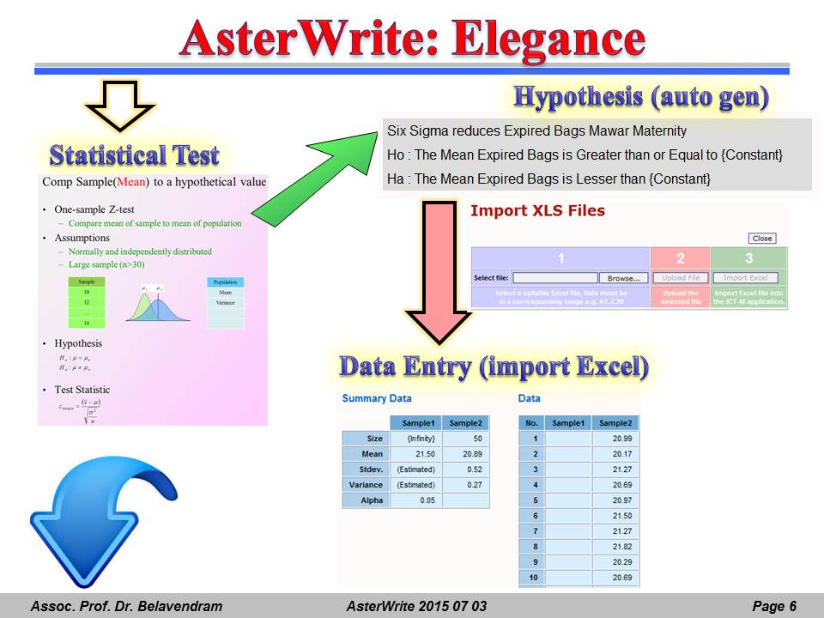
Figure 1: Elegance of AsterWrite.

2.2.1 Type of Exercise
The lifestyle is an important aspect of weight management in menopausal women (Dubnov, 2003). Different researchers have highlighted varying perspectives on the most effective types of exercise for weight management. Diepvens and Kovacs (2004) emphasised the role of aerobic exercise in increasing calorie expenditure and promoting fat loss. In contrast, Dubnov (2003) highlighted the importance of incorporating resistance training to improve muscle mass and metabolic rate. Meanwhile, Auvichayapat (2008) suggested that combining both aerobic and strength-based exercises yield more balanced and sustainable weight control outcomes.

2.2.2 Effect on Body Weight
Green tea, containing caffeine and catechin-polyphenols, may have effects on body weight (Diepvens & Kovacs, 2006). Several options for weight loss are available, yet lifestyle modification is essential in managing postmenopausal obesity and overweight. While this demands dietary and behavioural changes, a major element of this. Diepvens & Kovacs, (2006) claims that tea is good for you. However, it is believed that too much tea is not good (Dubnov, 2003).

2.3 Lifestyle Habits
Lifestyle habits play an important role in influencing body weight and overall health. Daily routines such as regular meal timing, adequate hydration, and consistent physical activity contribute to better weight management. In addition, managing stress and maintaining a balanced lifestyle can further support metabolic health and well-being (Auvichayapat, 2008).

2.3.1 Importance of Sleep
Chen et al. (2010) highlighted the importance of adequate sleep for regulating body weight, noting that insufficient sleep can disrupt hormonal balance, particularly hormones related to appetite control such as leptin and ghrelin. This imbalance may lead to increased hunger and higher calorie intake, thereby contributing to weight gain.
Gamboa-Gómez et al. (2015) emphasised the role of sleep quality in metabolic health, suggesting that poor sleep patterns can reduce energy levels and limit engagement in physical activity. This reduction in daily movement may indirectly affect weight management, especially among individuals already experiencing metabolic changes.
Gamboa-Gómez et al. (2017) further explored the relationship between sleep and stress, indicating that inadequate sleep can elevate stress levels, which in turn may trigger unhealthy eating behaviours. This connection highlights the broader lifestyle impact of sleep on weight control and overall well-being.

2.3.2 Daily Routine and Stress
Daily routine and stress levels have a significant influence on body weight and overall health. Singh and Bhanwaria (2012) noted that irregular daily schedules, combined with high stress levels, can disrupt eating patterns and lead to unhealthy food choices. Additionally, elevated stress may contribute to hormonal imbalances that promote weight gain, highlighting the importance of maintaining a structured routine and effective stress management practices.

2.4 Green Tea as a Support
This chapter reviews existing literature related to green tea consumption and its potential role in body weight management among menopausal women. It examines key factors such as diet, physical activity, lifestyle habits, and physiological changes. The purpose is to provide a clear understanding of current knowledge and identify areas where further research is needed to support effective weight management strategies.

2.4.1 How Green Tea Helps
Research on how green tea supports weight management presents slightly different perspectives. Schneider and Segre (2005) emphasised the role of green tea in enhancing fat oxidation and improving metabolic efficiency, particularly through its active compounds such as catechins. In contrast, Diepvens and Kovacs (2004) focused on its ability to increase overall energy expenditure, thereby contributing to calorie burning. However, both studies agree that green tea can play a supportive role in weight control when combined with appropriate lifestyle practices.

2.4.2 Consuming Green Tea
Consuming green tea as part of a daily routine has been associated with potential benefits for weight management and overall health. Schneider and Segre (2005) noted that regular intake, particularly when combined with a balanced diet and active lifestyle, may support metabolic processes and enhance fat utilisation.&#x20;
Schneider (2005) further highlighted that consistency in consumption is important to achieve sustained effects, suggesting that green tea should be integrated into daily habits rather than used occasionally.

2.5 Challenges Faced
Challenges were encountered in identifying consistent and high-quality studies on green tea consumption and its effects on adolescent weight outcomes. Variations in methodologies, sample populations, and measured outcomes made synthesis and thematic alignment more complex (Stubbs, 2013).

2.5.1 Hormonal Changes
Hormonal changes during adolescence influence metabolism, appetite regulation, and fat distribution, making it challenging to isolate the specific effects of green tea consumption on weight outcomes across different studies (Stubbs, 2013).

2.5.2 Difficult to Lose Weight
Adolescents often face difficulty in losing weight due to metabolic variability, lifestyle habits, and hormonal fluctuations, which complicates the assessment of green tea’s effectiveness in influencing weight reduction outcomes (Belavendram, 2025).

2.6 Lacking Research
Effect sizes (mean weight change in treatment versus control group) were computed and aggregated based on a random-effects model. The influence of several moderators on the effect sizes was examined. (Hursel, Viechtbauer, and Westerterp, 2009).

2. Conceptual Map
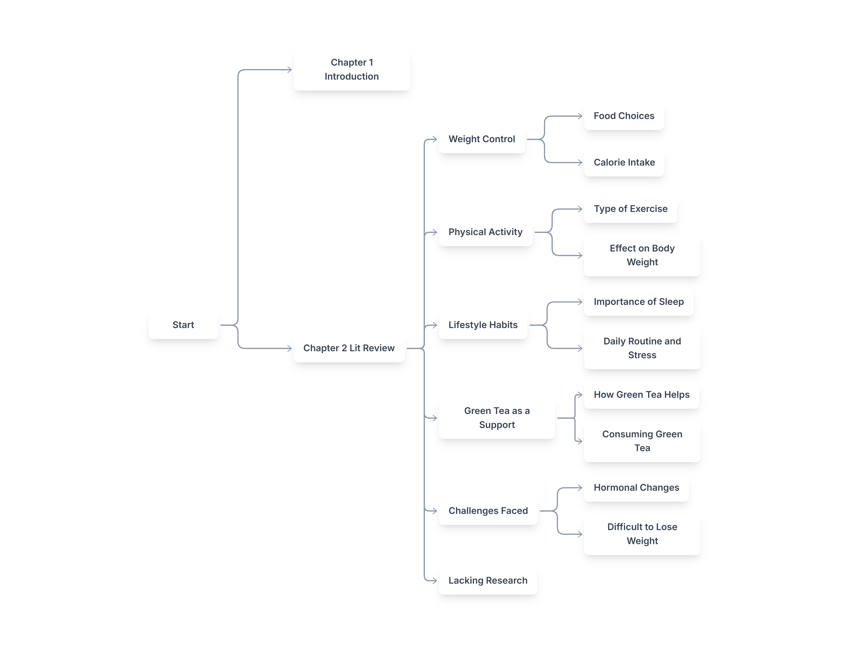
Figure 2: Conceptual Map

3. Literature Map
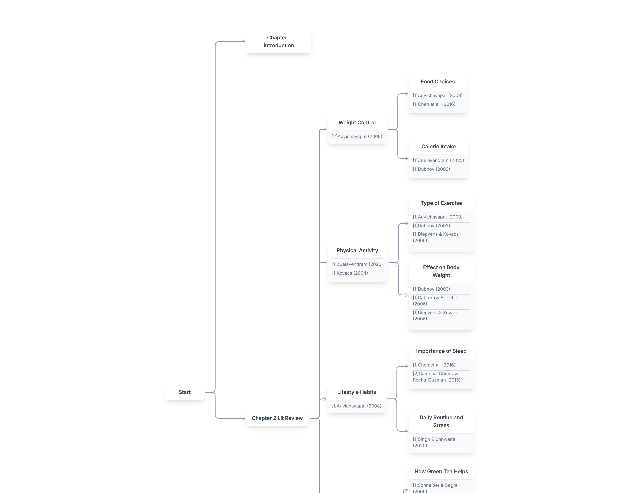
Figure 3: Literature Map

Bibliography
Auvichayapat, P. (2008). Effectiveness of green tea on weight reduction in obese Thais: A randomized, controlled trial. Physiology & Behavior, 93(3), 486-491. https://doi.org/10.1016/j.physbeh.2007.10.009
Cabrera, C., & Artacho, R. (2006). Beneficial Effects of Green Tea—A Review. Journal of the American College of Nutrition, 25(2), 79-99. https://doi.org/10.1080/07315724.2006.10719518
Chen, I., Liu, C., Chiu, J., & Hsu, C. (2016). Therapeutic effect of high-dose green tea extract on weight reduction: A randomized, double-blind, placebo-controlled clinical trial. Clinical Nutrition, 35(3), 592-599. https://doi.org/10.1016/j.clnu.2015.05.003
Diepvens, K., & Kovacs, E. M. R. (2006). Metabolic effects of green tea and of phases of weight loss. Physiology & Behavior, 87(1), 185-191. https://doi.org/10.1016/j.physbeh.2005.09.013
Dubnov, G. (2003). Weight control and the management of obesity after menopause: the role of physical activity. Pub Med, 44(2), 89-101. https://doi.org/10.1016/s0378-5122(02)00328-6
Gamboa-Gómez, C. I., & Rocha-Guzmán, N. E. (2015). Plants with Potential use on Obesity. Experimental and Clinical Sciences Journal, 14(1), 809-831. https://doi.org/10.17179/excli2015-186
Gamboa-Gómez, C. I., & Rocha-Guzmán, N. N. (2015). Plants with Potential use on Obesity and its Complications. Experimental and Clinical Sciences Journal , 14(1), 809-831. https://doi.org/10.17179/excli2015-186
Ghoflchi, S., Hosseini, H., & Rafiee, S. (2025). Impact of green tea on obesity-related hormones in postmenopausal women: A systematic review and meta-analysis of randomized controlled trials. Avicenna Journal of Phytomedicine.
Hursel, R., Viechtbauer, W., & Westerterp, M. P. (2009). The effects of green tea on weight loss and weight maintenance: a meta-analysis. International Journal of Obesity, 33(1), 956-961. https://doi.org/10.1038/ijo.2009.135
Janssens, P. H. R. L., Hersel, R., & Westerterp-Plantenga, M. S. (2016). Nutraceuticals for body-weight management: The role of green tea catechins. Physiology & Behavior, 162(1), 83-87. https://doi.org/10.1016/j.physbeh.2016.01.044

