Ending Well
By Brad Olson, Psy.D.,M.Div.
I didn’t really know my grandpa. Even though we went fishing, dad brought him with us, and he never talked much. Even though he came to the ballgame with us, he didn’t say too much. It’s not like I was afraid of him. He was the grandpa who came over and played ping-pong, followed by intense Scrabble games with dad. He liked to tease the cat. But mostly, he was the grandpa who smelled like cigarettes and coffee.
He was an orphan. Adopted as a child. Spent his life in Minneapolis and married a nice Christian girl he met at Bethel Academy. They met at a Christian college, so It’s not like Grampa didn’t know who Jesus was. But they had their struggles. His jobs reflected his discontent. He spent all night in the pool halls in South Minneapolis. That continued after marriage, kids, and even grandkids. It’s not like he was getting in trouble with the law or getting arrested. It’s just that he was absent, like he was running away from something.
There were the years that Grandma took the kids to live on the farm in northern Minnesota. We were told it was because of finances. But there was suspicion that it had as much to do with a marriage in distress, as it did with money. Maybe she had enough of him being irresponsible and disconnected. Maybe he simply needed to earn money. He did what he could to earn a living. They always had a place to live, but he never had much of a career. He had jobs. He drove a street car, and sold insurance among a couple of them. He lived this way much of his life.
When Grandpa was older, he got in a small fender-bender one day with his car. That day he walked up to my dad and handed him the car keys. He said he was done driving. He knew it. He accepted it. He never drove again. But he didn’t quit.
I remember asking my aunt one day why grandpa worked as janitor of the church when he was old? She told me those seem to be the happiest days of his life. He started working as a janitor there after he re-committed his life to Christ. I imagine him waking each day, glad to go to work cleaning the church his children grew up in. He quit smoking. He went to church every day. He found some peace and contentment sweeping floors.
Maybe my ability to accept my limitations as I age, helps me to finish well. If I can’t accept that I am no longer a safe driver and hand over my keys, how will I end well?
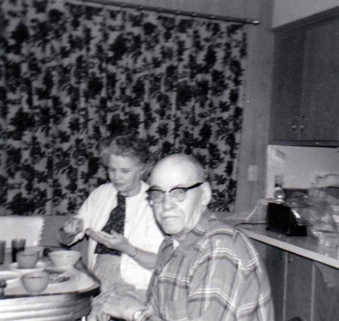
Sadly, an aggressive growing brain tumor took his life quickly, just weeks after Christmas. I was in 8th grade, and he was 76. He died shortly after his life had just begun. But, he didn’t sit in a chair and watch TV because he couldn’t drive a car anymore. He didn’t give up. He seemed to finish well.
Apart from the cross of Christ, I’ve never met anyone who has managed to beat death. But we keep trying. We fight it. We assume that our bodies never age, and what I did at 20, I can do at 40. What I did at 40, I can do at 65. But death is real. Our bodies are human. But this doesn’t mean I give up and quit. It doesn’t mean I become obsolete. It means I can choose to live with integrity, purpose, and meaning at every stage of life.
May I accept changes and my own limitations at every stage of life, and find God’s purpose, kingdom focus, and personal meaning that keeps me running the race, even when my feet can only shuffle.

