Lab 3 - SQL Injection with Burp Suite
Alexander Rodriguez

Tasks

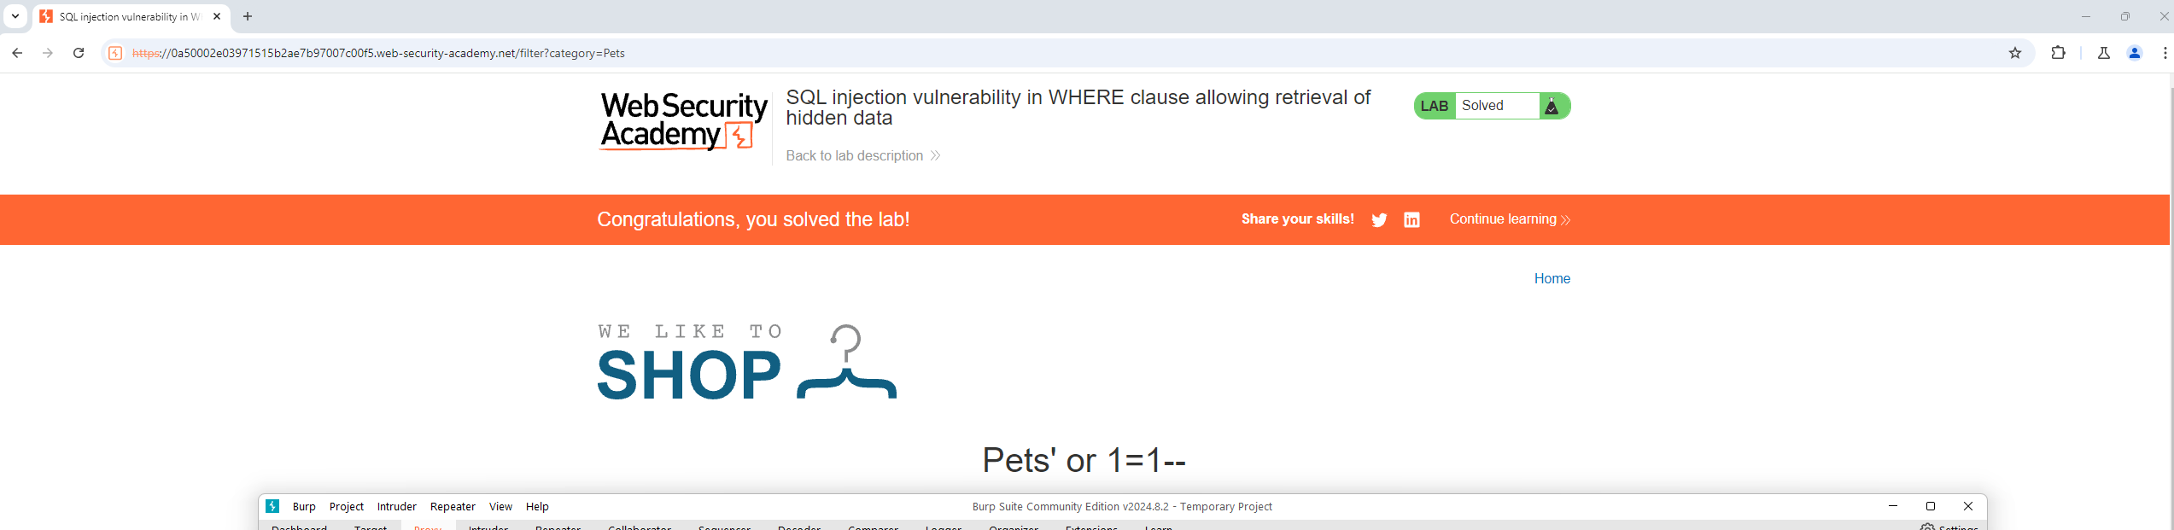
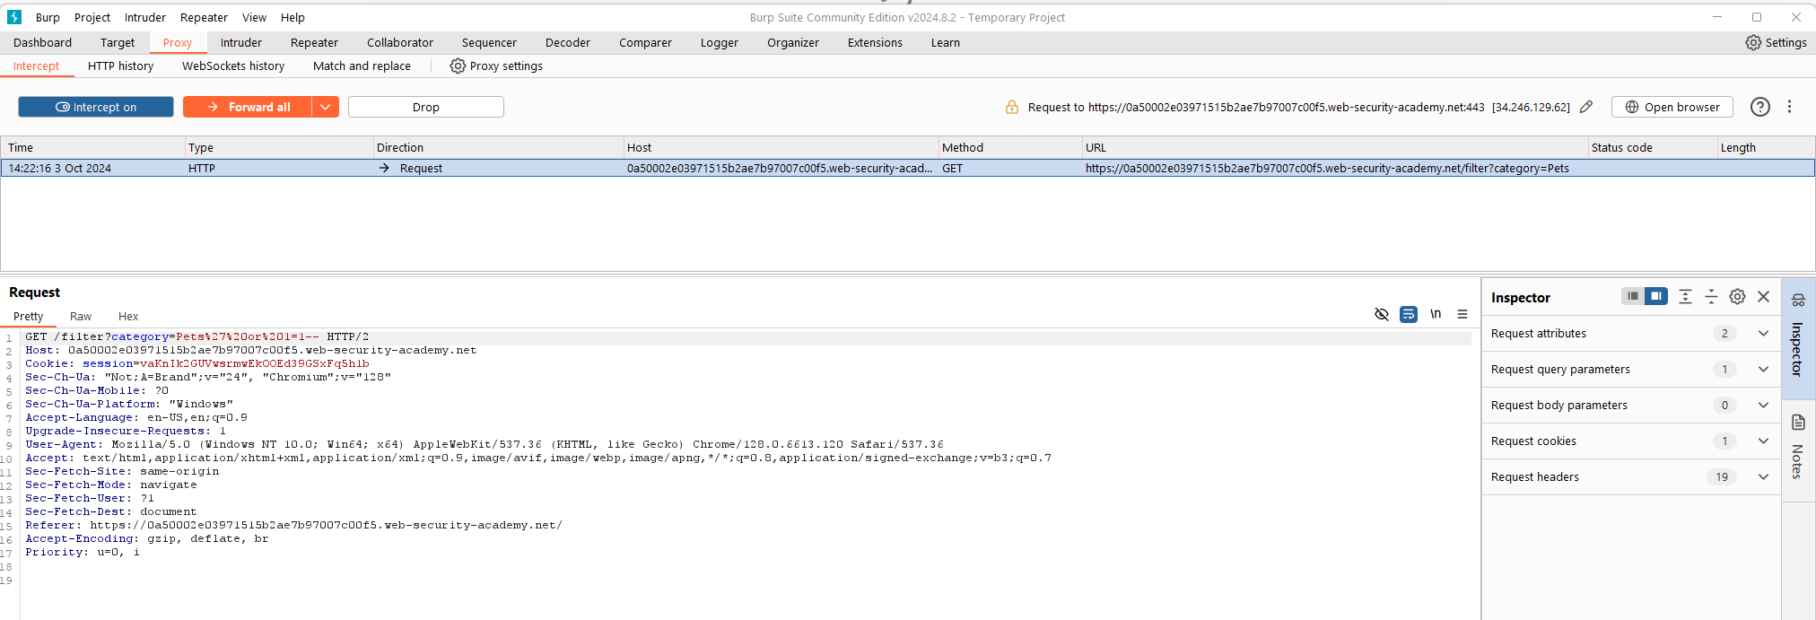
1. Retrieving hidden data

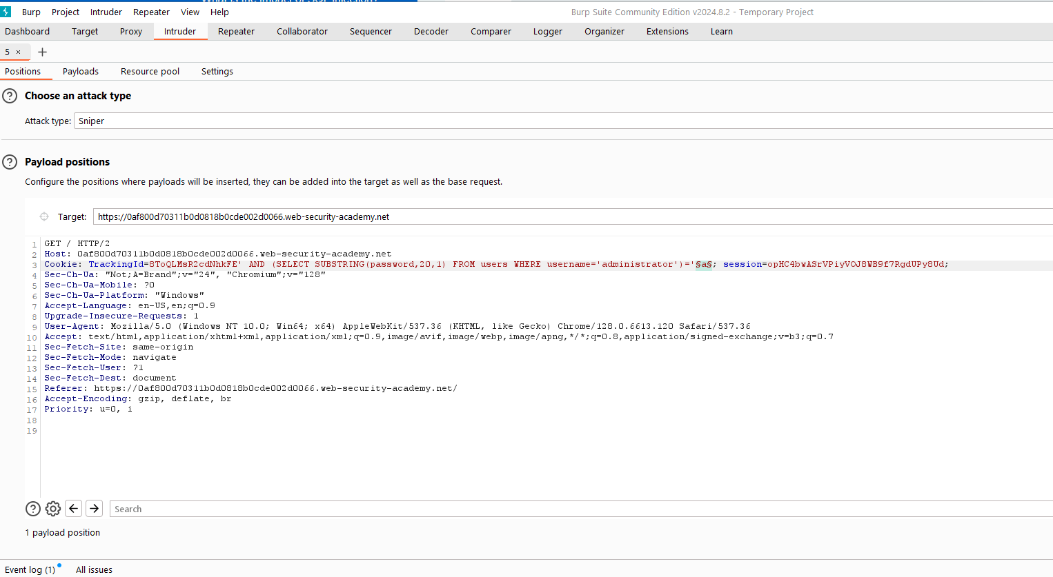
2. Blind SQL injection

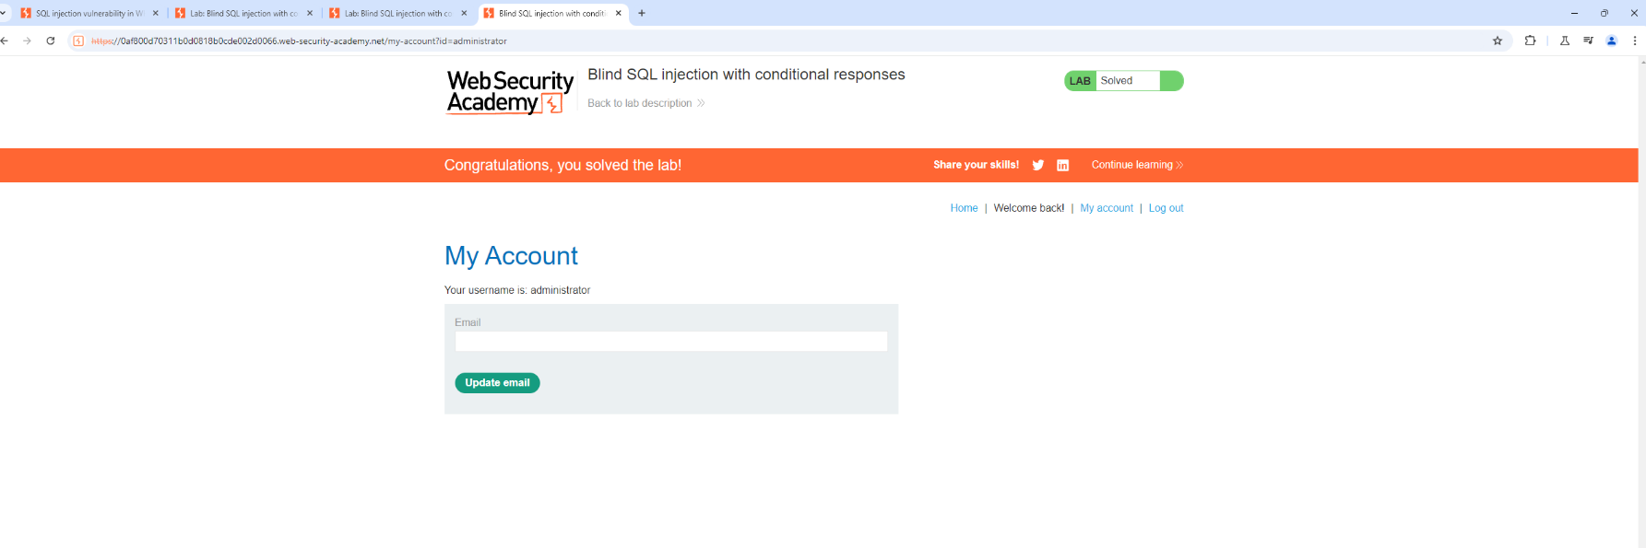

Password = pp8fatf3ftaor8qmcnnd

