Report

Summary
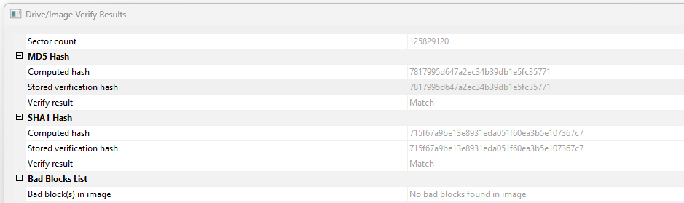
- Fixed drive identifying information
  - Computer name = PerryWinkler-PC (originally 37L4247F27-08 then WIN-38GNMIDB6BM then PerryWinkler-PC)
  - VSN: D86DC3E7
  - OS information
    - Windows 7 Professional
    - Version 6.1 build 7601
    - Build date Fri, 15 Jan 2016 21:06:55
  - Primary user account = PERRYWINKLER-PC\Perry (S-1-5-21-3461440871-1589894493-1829873476-1000)
- Yes there is evidence of credit card fraud and potential drug activity.
- Yes there is evidence that Perry attempted to cover or delete evidence using scheduled tasks, batch scripting, and a program called Eraser
- Removable drive info:
  - Kingston&Prod_DT_101_G2&Rev_PMAP with serial number 0013729B678DEB20C51F0216
  - SanDisk&Prod_Cruzer&Rev_1.20 with serial number 20035001811625714CA7
- It appears there are many search results leading to the southwest airlines domain, which could indicate that there is a plan to flee. More certainly, there is an accomplice that goes by the name of “Rick Shoner”. There is also a picture of Iguazu falls in Argentina, which could be linked to the drug activity or possibly a lead to where the person would flee.
- Time zone = Eastern Standard Time

Analyzing Registry Hives:
NTUser:
Analyzing the NTUser\Software\Microsoft\Windows\CurrentVersion\Explorer\UserAssist hive using RegistryExplorer shows us the number of times applications on the system were run by Perry. Most notably the examiner finds that Windows Remote Desktop was run six times, Big Air War game was run once, a tor browser installer was run once, and Eraser.lnk was run 4 times. Further examination into the NTUSER.DAT: Software\Microsoft\Windows\CurrentVersion\Explorer\RecentDocs hive shows the examiner recent files. Notably, there is a SDelete .ZIP file that was recently accessed, which corresponds with the batch file and scheduled tasks found other sections. The .contact files show that there were two recent contact documents accessed, one named “Parry.contact” and the other named “Rick Shoner”. Next, the examiner moved to typed URLs located in the NTUSER.DAT: Software\Microsoft\Internet Explorer\TypedURLs hive. The most notable search history items include “how to skim credit cards”. This corresponds with the conversations found in the rich text file speaking about buying prepaid credit cards.
System:
Analyzing the SYSTEM: ControlSet001\Enum\USBSTOR hive using RegistryExplorer indicates that two USB devices that have been connected to the host computer. Device Disk&Ven_Kingston&Prod_DT_101_G2&Rev_PMAP with serial number 0013729B678DEB20C51F0216&0 and device Disk&Ven_SanDisk&Prod_Cruzer&Rev_1.20 with serial number 20035001811625714CA7&0.
Software:
Analyzing the SOFTWARE: Microsoft\Windows\CurrentVersion\Run hive using RegistryExplorer the examiner identified currently installed software. This included a video game called Big Air War, DropBox, and Eraser 6.2.0.2970 found in the C:\Users\Perry\AppData\Local\Temp\eraserInstallBootstrapper location.

SAM:
User Information
-------------------------
Username : Administrator [500]
SID : S-1-5-21-3461440871-1589894493-1829873476-500
Full Name :
User Comment : Built-in account for administering the computer/domain
Account Type : Default Admin User
Account Created : Sat Jan 16 00:03:55 2016 Z
Name :
Last Login Date : Sat Nov 20 21:48:12 2010 Z
Pwd Reset Date : Sat Nov 20 21:56:34 2010 Z
Pwd Fail Date : Never
Login Count : 6
--> Password does not expire
--> Account Disabled
--> Normal user account

Username : Guest [501]
SID : S-1-5-21-3461440871-1589894493-1829873476-501
Full Name :
User Comment : Built-in account for guest access to the computer/domain
Account Type : Default Guest Acct
Account Created : Sat Jan 16 00:03:55 2016 Z
Name :
Last Login Date : Never
Pwd Reset Date : Never
Pwd Fail Date : Never
Login Count : 0
--> Password does not expire
--> Account Disabled
--> Password not required
--> Normal user account

Username : Perry [1000]
SID : S-1-5-21-3461440871-1589894493-1829873476-1000
Full Name :
User Comment :
Account Type : Default Admin User
Account Created : Fri Jan 15 21:06:54 2016 Z
Name :
Password Hint : it's your name, idiot
Last Login Date : Sun Feb 28 15:45:38 2016 Z
Pwd Reset Date : Fri Jan 15 21:06:54 2016 Z
Pwd Fail Date : Wed Feb 24 22:50:54 2016 Z
Login Count : 9
--> Password does not expire
--> Password not required
--> Normal user account

Analyzing Windows events:
The examiner used Autopsy to extract Evt logs from the C:\Windows\System32 directory, then proceeded to parse the files using EvtCMD for futher examination. While examining event logs, the events were grouped by “map description” to easily group events by certain activities. The first thing noticed was that an administrator account was created/enabled on 1/15/2016 and given the SID S-1-5-21-3461440871-1589894493-1829873476-1000. This account is named Perry and appears to have signed in 9 times between 2016-02-28 15:45:38 and 2016-01-15 21:06:55, which appears in Windows events under “administrator logon”. What is also interesting is that the event ID generated for these logons, is 4648 which indicates the logon was attempted “using explicit credentials”. Based on Windows documentation this means this could mean the account was used via batch scripting or command line using a command like “RUNAS”. This account appears to have also enabled automatic updates for DropBox at 2016-02-24 22:56:40, which led the examiner to look further at DropBox related activities under installer events. Notably, there were four successful installations completed by the local Perry account which were the “Dropbox Update Helper”, “Eraser 6.2.0.2970”, Microsoft .NET Framework Extended, and Microsoft .NET Framework Client Profile. The DropBox install is timestamped at 2016-02-24 22:56:58 but the other three installs are timestamped within seconds of each other between 2016-02-21 22:34:22 and 2016-02-21 22:33:09.
Other notable events found during the examination of Windows events are mentioned below. Successful Remote Desktop logons under local account “Perry” totaled seven times between 2016-01-15 21:06:57 and 2016-02-28 15:45:38 with the last log off being 2016-02-28 15:49:29. USB event count is 18 between 2016-01-26 21:48:14 and 2016-02-28 15:49:21. Computer name was changed from 37L4247F27-08 then to WIN-38GNMIDB6BM then to PERRYWINKLER-PC. Events generated for “Unable to notify user of blocked application” totaled seven times for C:\windows\system32\lsass.exe between 2016-02-28 15:45:33 and 2016-01-16 00:00:14. Suspicious activity includes remote host WIN-38GNMIDB6BM logged into the computer via a loopback address at 2016-01-15 21:06:55, and at 2016-01-15 21:06:54 just one second before there was an attempt by WORKGROUP\WIN-38GNMIDB6BM$ (S-1-5-18) to reset the local “Perry” account password. Time changes: PreviousTime: 2016-01-16 00:06:54.4256759 to NewTime: 2016-01-15 21:06:54.2070000, OldTime: 2016-01-16 00:06:54.4256759 to NewTime: 2016-01-15 21:06:54.2070000, and OldTime: 2016-01-16 00:06:54.4256759 to NewTime: 2016-01-16 00:06:54.4256759.

Analyzing Task Scheduler:
Scheduled tasks include a “delete” task created on 2016-02-24 by “Perry”, which looks to run a batch script found at C:\Windows\SDelete\delete.bat when there is a failed login attempt. The script appears to use a Windows utility and will likely result in zeroing out any areas of storage not currently in use. Notably, this could be an anti-forensic tactic aiming to hide deleted files. Other tasks include a DropBox update and DropBox uninstall task which is used to automatically update the program or uninstall the program if it’s no longer in use.

Analyzing Recycle Bin:
The most notable documents are a few gun pictures in JPG files, and an RTF file that shows a conversation in clear text. The communication reads “Rick, Thanks for your help! I will do wat you said with the task thing on the computer. Im glad you printed instructions for me or i woudl never figure it out lol. anyways ill destroy this and will look for your email with further instructions. cant wait to ditch this place! Yours truly, Perry”. This document appears to be created on 2016/02/21 17:22 and deleted on 02/28/2016 15:47:37 UTC. There is also a deleted contacts which reads “Mary Reister” with corresponding email mreister@gmail.com.

The evidence provided below is simply deleted pictures found in the recycle bin, and not a direct indication of other crimes.
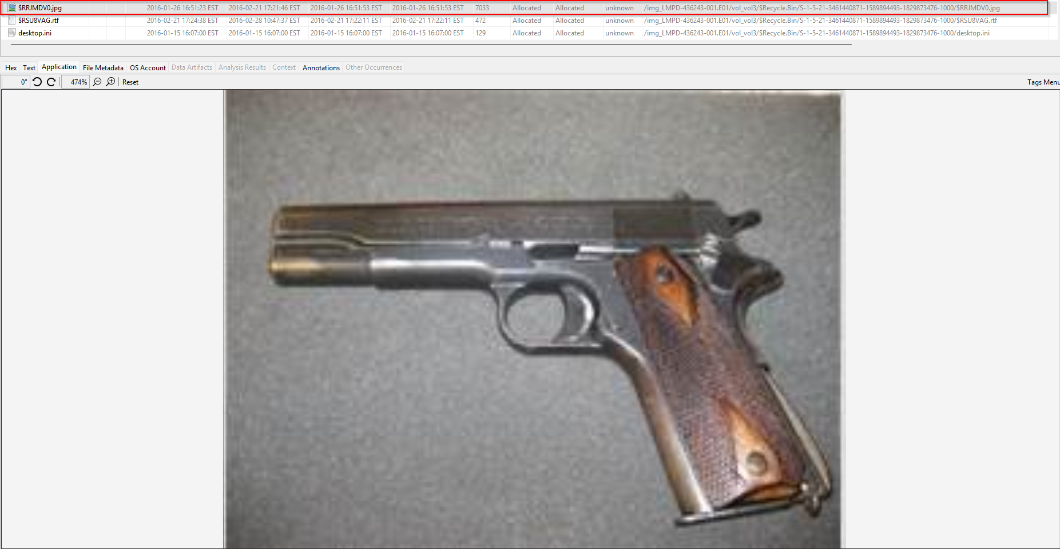
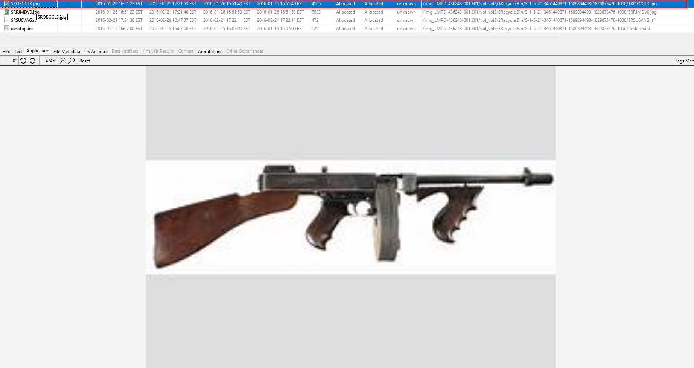
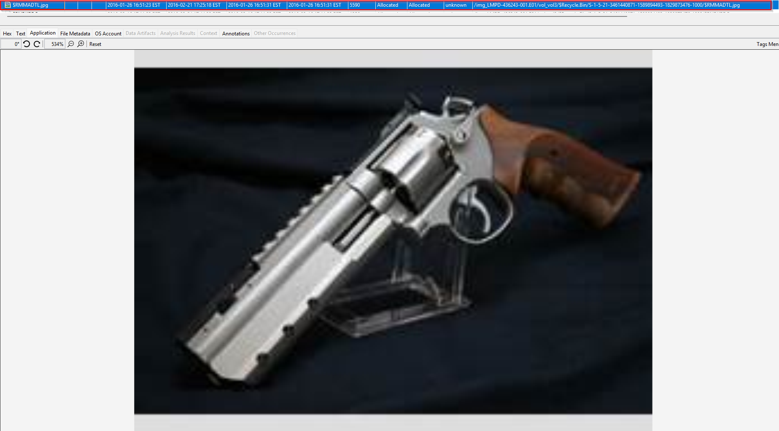

Analyzing files:
Using Autopsy, the examiner identified a variety of documents but most notably one Office and one PDF document that suggest potentially illegal activity. The PDF was Eraser a user guide that shows the possible ways to erase the recycle bin, browser caches, and more through tasks and/or shell commands. This is confirmed to be downloaded as noted in previous sections. 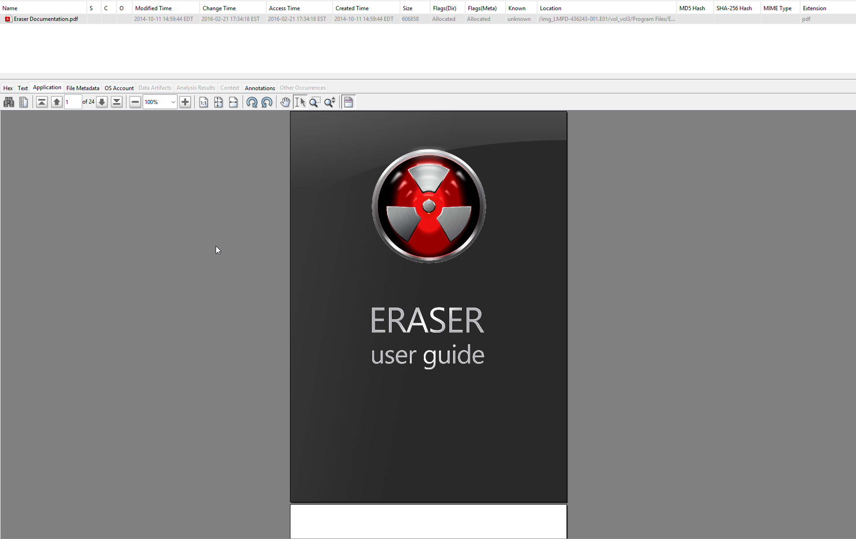

The Office document titled “Book2.xlsx” shows some data that indicates money was owed to different individuals for various purposes. The specific dollar amount, the name of individual, and “fav” information is listed and provided below. The word “crack” is mentioned which could be an indication of drug activity.
name | $$ owed | fav
MC Teller | 450 | tails
ronchop | 500 | angel
newbber | 950 | crack
nile | 100 | header
p dawg | 50 | lice
randy | 1040 | erthing

Analyzing the rich text files found in the file view of Autopsy, it appears there were a few RTF files that contain clear text conversations between Rick and Perry. Three files can be found in Perry’s “Documents” folder, titled Letter3, Letter, and Latter2. The conversations include these correspondents:
Date: 2016/02/16 17:08 EST
“Rick,
I think there onto us. What shud I do ? I know about getting rid of the stuff in the kitchen and bedroom but what about the computer? Please call me - i need to fugure this out.
Signed,
Perry”
Date: 2016/02/21 17:22 EST
“Rick,
Thanks for your help! I will do wat you said with the task thing on the computer. Im glad you printed instructions for me or i woudl never figure it out lol. anyways ill destroy this and will look for your email with further instructions. cant wait to ditch this place!
Yours truly,
Perry”
Date: 2016/02/27 10:16 EST
“Rick,
What should I do? I havent hurd from you and im getting worried. are you there yet? i need an email to know. Also, i bought those credit card numbers you showd me. There supporsed to be all prepaid too so we are set! lol well i hope your safe and will look for your email.
Sincerely,
perry”

Analyzing Web History:
Using Autopsy, it’s clear that there were many searches on how to “get rid of evidence”. There are also web searches involving “how to batch script” which is presumably how the script to run SDelete came to be. Other web searches include finding Eraser as well as DropBox. Web downloads correspond with the searches where an SDelete.zip file and Eraser installer were actually downloaded for further installation. Other notable downloads include two pictures of what appears to be drugs, one titled “da stuff” and the other titled “mike’s desk” (see below).
