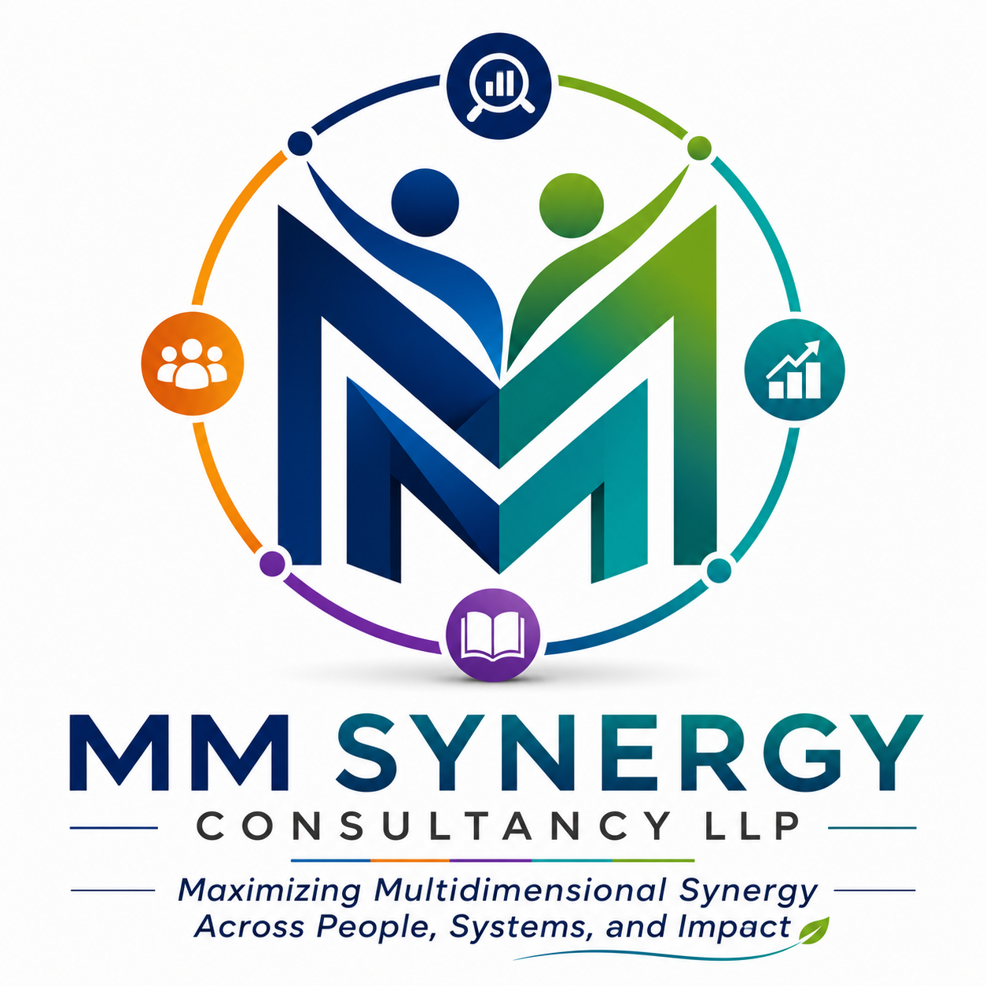

MM SYNERGY CONSULTANCY LLP
Maximizing Multidimensional Synergy Across People, Systems, and Impact
About Us
MM Synergy Consultancy LLP is a research, evaluation, and advisory firm dedicated to helping organizations strengthen impact, improve accountability, manage risks, and make evidence-informed decisions for sustainable development.
We work with development organizations, foundations, CSR initiatives, businesses, social enterprises, industry associations, and public institutions to generate actionable insights through rigorous research, assessments, evaluations, and advisory services.
Our approach combines in-depth field experience, participatory methodologies, stakeholder engagement, analytical rigor, and practical recommendations that support institutional learning, responsible business conduct, and sustainable development outcomes.
Contact Information
Website: www.mmsynergyconsultancy.com
Partner Contact
Manas Bhattacharyya
Managing Partner and Co-Founder
Mobile: +91 9711714204
Email: manas@mmsynergyconsultancy.com
Partner Contact
Mrinmay Bhattacharyya
Chief of Operations and Co-Founder
Mobile: +91 9971644646
Email: mrinmay@mmsynergyconsultancy.com

RESEARCH AND EVALUATION VERTICAL

Monitoring, Evaluation and Impact Assessments
Monitoring of Development Projects / Programs
We provide systematic monitoring services to track the progress, performance, and implementation quality of development projects and programs. Through regular data collection, field verification, indicator tracking, and reporting mechanisms, we help organizations assess whether activities are being implemented as planned, identify emerging challenges, and make timely course corrections to improve effectiveness and accountability.
Mid-Term and End-Term Evaluations of Development Projects and Programs
Our evaluation services assess the relevance, effectiveness, efficiency, sustainability, and overall performance of projects at key stages of implementation. Mid-term evaluations provide actionable insights for adaptive management and strategic adjustments, while end-term evaluations examine the extent to which intended objectives and outcomes have been achieved, generating lessons for future programming and decision-making.
Feasibility Assessments / Pre-Funding Appraisal of New Projects and Programs
We conduct comprehensive feasibility assessments to evaluate the practicality, viability, and potential success of proposed interventions before implementation or funding approval. These assessments examine contextual needs, stakeholder readiness, technical feasibility, resource requirements, risks, and expected outcomes, enabling donors and implementing agencies to make informed investment decisions.
Impact Assessment
Our impact assessment studies measure the long-term and significant changes attributable to an intervention, including intended and unintended effects on individuals, communities, institutions, and systems. Using rigorous qualitative, quantitative, or mixed-method approaches, we generate evidence on the effectiveness and value of development investments and their contribution to broader social, economic, or environmental outcomes.
Organizational / Institutional Assessment
We assess the capacity, governance structures, systems, processes, and overall effectiveness of organizations and institutions. These assessments help identify strengths, gaps, and opportunities for improvement in areas such as leadership, program management, financial systems, human resources, compliance, and strategic planning, supporting institutional strengthening and organizational development.
Outcome Mapping / Outcome Harvesting
We facilitate outcome-focused assessment approaches that capture behavioral, relational, and systemic changes resulting from development interventions. Outcome Mapping helps organizations define and track progress among key stakeholders and boundary partners, while Outcome Harvesting identifies and verifies significant outcomes after they have occurred, particularly in complex and dynamic development environments.
SROI (Social Return on Investment) Assessments
Our Social Return on Investment (SROI) assessments quantify and demonstrate the social, economic, and environmental value generated by projects and programs relative to the resources invested. By assigning monetary values to outcomes wherever appropriate, SROI studies provide stakeholders with a clear understanding of the broader impact and return generated by development investments.
Project / Program Sustainability Assessment
We evaluate the likelihood that project benefits and outcomes will continue beyond the period of direct funding or external support. Sustainability assessments examine institutional ownership, financial viability, stakeholder engagement, capacity development, policy alignment, and environmental considerations to identify factors that support or hinder long-term impact.

Research and studies
Situational / Needs Assessments
We conduct comprehensive situational and needs assessments to understand existing conditions, challenges, opportunities, and stakeholder priorities within a specific geographic area, sector, or target population. These studies provide evidence-based insights that inform program design, policy development, resource allocation, and strategic planning.
Baseline, Midline, and Endline Surveys / Studies
Our survey and study services generate robust evidence throughout the project lifecycle. Baseline studies establish pre-intervention benchmarks, midline studies assess progress and emerging trends during implementation, and endline studies measure changes achieved over the course of the intervention, enabling organizations to track results and demonstrate impact effectively.
Landscape Mapping Studies
We undertake landscape mapping studies to analyze the ecosystem surrounding a specific sector, issue, or thematic area. These studies identify key stakeholders, institutions, initiatives, policies, funding flows, partnerships, opportunities, and gaps, helping organizations better understand the operating environment and identify strategic entry points for engagement and investment.
In-Depth Studies on Socio-Economic Issues / Themes
We design and implement rigorous research studies on complex socio-economic issues affecting communities, institutions, and development systems. Through qualitative, quantitative, and mixed-method research approaches, we generate nuanced insights on emerging trends, policy challenges, behavioral dynamics, and development outcomes that support evidence-based decision-making and advocacy.
Process Documentation
Our process documentation services systematically capture and record the implementation journey of projects and programs, including key activities, decisions, innovations, challenges, lessons learned, and stakeholder experiences. By creating a structured narrative of program implementation, we help organizations preserve institutional knowledge, support learning, and showcase good practices for replication and scale-up.
Our Approach
At MM Synergy Consultancy LLP, we adopt an objective and rigorous approach grounded in evidence, methodological excellence, and analytical integrity. Our work combines innovative mixed-methods research with participatory and facilitative processes that actively engage stakeholders and promote ownership of findings. We are learning-driven in our pursuit of generating actionable insights and practical knowledge that support continuous improvement and adaptive decision-making. At the same time, our approach is accountability-oriented, strengthening transparency, responsiveness, and responsible use of resources across development initiatives. We place strong emphasis on utilization-focused assessments, ensuring that research findings and recommendations are relevant, practical, and directly inform policy, programming, and organizational strategy. Underpinning all our engagements is a commitment to the highest standards of ethics and quality, ensuring credibility, inclusiveness, and professional excellence in every assignment we undertake.
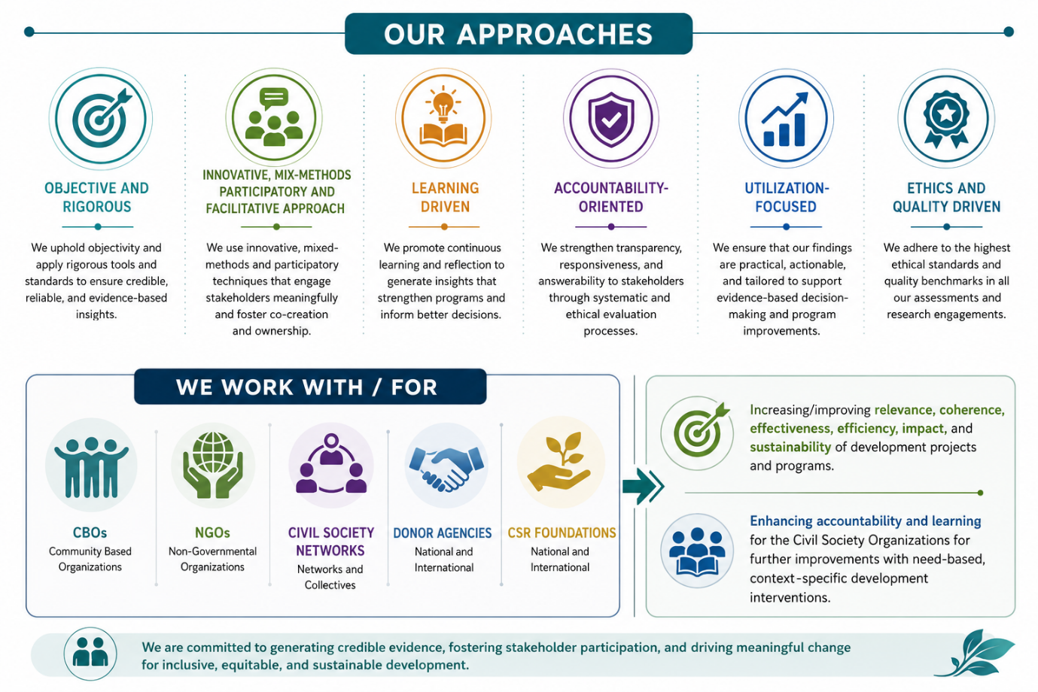

SUSTAINABLE AND RESPONSIBLE BUSINESS VERTICAL
Business Supply Chain Mapping
We conduct comprehensive supply chain mapping exercises to identify and analyze the various actors, relationships, operational processes, and risk points across business value chains. Our mapping services help organizations gain greater visibility into their supply chains, understand sourcing and production networks, identify potential social, environmental, and compliance risks, and strengthen responsible business practices through informed decision-making.
Comprehensive Social, Legal, and Ethical Assessments of Business Operations (ESG and Compliance Risks)
We undertake detailed assessments of business operations to evaluate compliance with applicable laws, ethical standards, human rights principles, labor requirements, and environmental expectations. Drawing upon Environmental, Social, and Governance (ESG) frameworks and responsible business conduct standards, these assessments help organizations identify risks, gaps, and areas for improvement while strengthening regulatory compliance and sustainability performance.
Issue-Based Investigations
Our investigation services provide independent and evidence-based inquiries into specific concerns, allegations, incidents, or operational challenges within business operations and supply chains. Through rigorous fact-finding, stakeholder consultations, document reviews, and field assessments, we help organizations understand root causes, assess risks, and develop appropriate corrective and preventive actions.
Factory / Workplace Improvement and Remediation Programs
We design and facilitate workplace improvement and remediation programs aimed at addressing identified gaps in labor standards, occupational health and safety, human rights compliance, and working conditions. Through collaborative engagement with management, workers, and other stakeholders, we support businesses in implementing practical corrective actions that foster safer, more inclusive, and more productive workplaces.
Facilitation of Human Rights, Health & Safety, and Environmental Policies and SOPs
We support organizations in developing, reviewing, and strengthening policies and Standard Operating Procedures (SOPs) related to human rights, occupational health and safety, environmental management, and responsible business conduct. These frameworks are tailored to organizational contexts while aligning with national regulations and internationally recognized standards and best practices.
Training and Capacity Building on National and International Legal and Human Rights Frameworks
We deliver customized training and capacity-building programs for businesses, suppliers, workers, and other stakeholders on responsible business conduct and relevant legal frameworks. This includes capacity building on international standards such as the UN Guiding Principles on Business and Human Rights (UNGP-BHR) and the OECD Guidelines for Responsible Business Conduct (OECD-RBC), as well as applicable national laws and compliance requirements.
Development and Strengthening of Management Systems at Business Houses and Units
We assist organizations in establishing and strengthening management systems that promote effective governance, compliance, risk management, continuous improvement, and responsible business practices. Our support includes system design, process documentation, monitoring frameworks, internal controls, and capacity-building initiatives that enhance operational efficiency and accountability.
Strengthening Grievance Redressal Mechanisms within Workplaces
We help businesses design, assess, and strengthen grievance redressal mechanisms that are accessible, transparent, confidential, and responsive to workers and other stakeholders. By aligning grievance systems with international good practices and human rights principles, we enable organizations to identify concerns early, address issues effectively, and build trust among stakeholders.
Thematic / Issue-Based Studies on Decent Work Conditions
We conduct research and assessment studies on specific labor and workplace issues affecting workers and supply chains, including wages, occupational health and safety, gender equity, migrant labor, working hours, social protection, freedom of association, and worker well-being. These studies generate evidence that supports policy development, program design, advocacy, and business improvement initiatives.
Living Income / Living Wage Studies and Facilitation
We undertake living income and living wage studies to assess whether workers, producers, and households earn sufficient income to achieve a decent standard of living. Through data-driven analysis, stakeholder engagement, and benchmarking methodologies, we help organizations understand income and wage gaps and facilitate the development of strategies and roadmaps to promote fair compensation and sustainable livelihoods within supply chains and business operations.
Our Approach
At MM Synergy Consultancy LLP, our approach is participatory and objective, ensuring that diverse stakeholder perspectives are meaningfully incorporated while maintaining independence, credibility, and evidence-based analysis. We place strong emphasis on capacity building and sensitization, empowering businesses, suppliers, workers, and other stakeholders with the knowledge and skills needed to promote responsible business practices and sustainable improvements. Our interventions focus on strengthening internal systems, processes, and mechanisms that enable organizations to proactively manage social, legal, ethical, and sustainability risks. We adopt a constructive and facilitative multi-stakeholder engagement approach, fostering dialogue, collaboration, and consensus-building among businesses, workers, communities, civil society organizations, and other key actors. Underpinning all our work is a commitment to national and international legal, human rights, and sustainability frameworks, ensuring that our assessments, recommendations, and capacity-building initiatives align with evolving regulatory requirements and globally recognized standards of responsible business conduct.
