Portfolio Performance* as on Mar 31st , 2026 – ( % CAGR over 1 year are annualized)
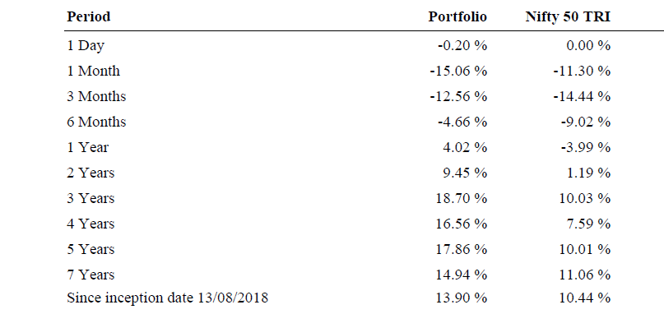
Sector Weights as on 31st Mar 2026(%)
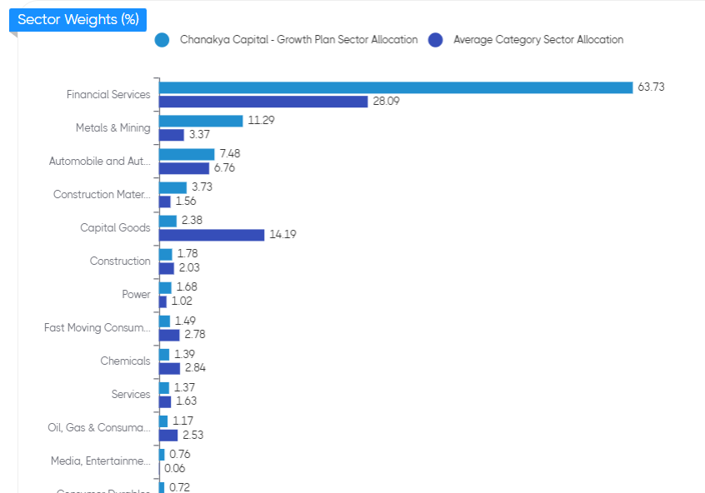

Market Cap Composition 31th Mar 2026
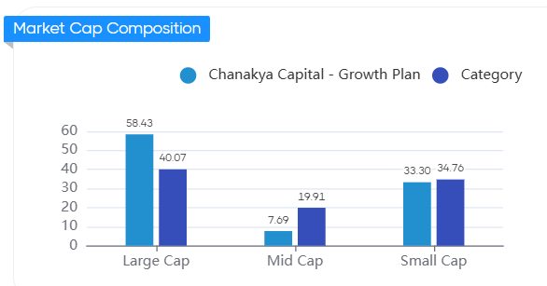

Our Top Holdings as on 31st Mar (76%)
Script Name | Weights %
Axis Bank Ltd | 19%
Bajaj Holdings & Investment Ltd | 9%
HDFC Bank Ltd | 8%
Karur Vysya Bank Ltd | 8%
The South Indian Bank Ltd | 6%
Samvardhana Motherson International Ltd | 5%
Shriram Finance Ltd | 5%
Tata Steel Ltd | 5%
Steel Authority of India Ltd | 4%
Ramco Industries Ltd | 4%
City Union Bank Ltd | 4%

