Chanakya Capital Services Pvt Ltd Factsheet
Portfolio Performance* as on Feb 28th , 2026 – ( % CAGR over 1 year are annualized)

Period | Portfolio (In %) | Nifty 50 TRI (In %)
Since Inception (13.08.2018) | 16.56 | 12.33
7 Years | 18.93 | 14.20
5 Years | 21.42 | 12.95
4 Years | 21.68 | 11.95
3 Years | 24.20 | 14.64
2 Years | 15.97 | 8.29
1 Year | 30.55 | 15.07
6 Months | 16.34 | 3.36
3 Months | 3.93 | -3.80

*Net of all expenses and fees
Statutory Disclaimer: Performance figures are not verified by SEBI

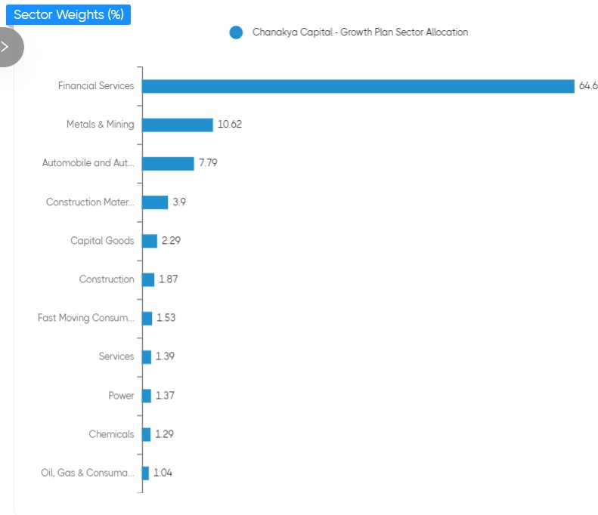
Sector Weights as on 28th Feb 2026(%)

Market Cap Composition 28th Feb 2026
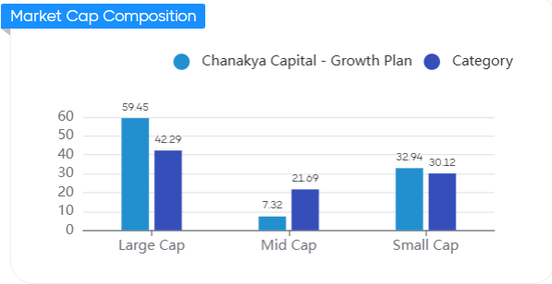

Our Top Holdings as on 28th Feb (76%)

Script Name | Weights  %
Axis Bank Ltd | 19%
Bajaj Holdings & Investment Ltd | 9%
HDFC Bank Ltd | 8%
Karur Vysya Bank Ltd | 7%
The South Indian Bank Ltd | 6%
Samvardhana Motherson International Ltd | 6%
Shriram Finance Ltd | 5%
Tata Steel Ltd | 4%
Ramco Industries Ltd | 4%
Steel Authority of India Ltd | 4%
City Union Bank Ltd | 4%

