Chanakya Capital Services Pvt Ltd Factsheet
Portfolio Performance* as on May 11th , 2026 – ( % CAGR over 1 year are annualized)
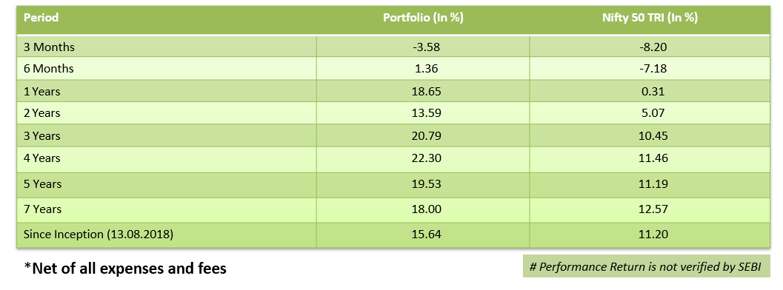
Sector Weights as on 30th April 2026(%)
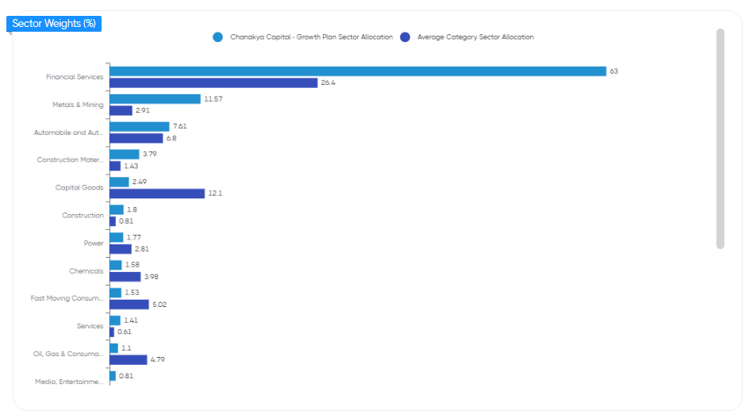
Market Cap Composition 30th April 2026
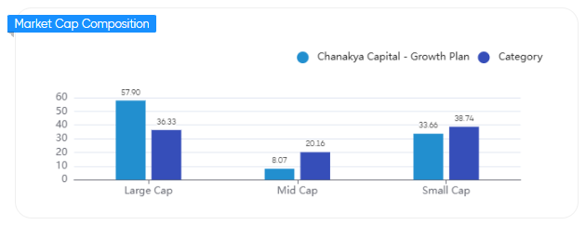

Our Top Holdings as on 30th April 2026 (75%)
Script Name | Weights %
Axis Bank Ltd | 19%
Bajaj Holdings & Investment Ltd | 9%
HDFC Bank Ltd | 7%
Karur Vysya Bank Ltd | 7%
The South Indian Bank Ltd | 6%
Samvardhana Motherson International Ltd | 6%
Shriram Finance Ltd | 5%
Tata Steel Ltd | 5%
Steel Authority of India Ltd | 4%
Ramco Industries Ltd | 4%
City Union Bank Ltd | 4%

