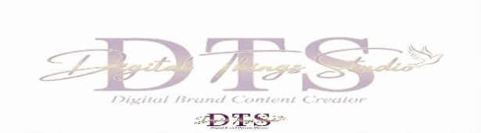

Thank you for choosing Digital Things Studio! This Intake Form helps us gather the details needed to create high-impact, results-driven marketing content tailored specifically to your business. Complete
the fields that you feel are applicable to you.
Business Name: _______________________________________________ Phone:__________________________
Full Name (PRINT): __________________________________ Email: _____________________________________
Name of Product or Service the ad will be promoting:
_______________________________________________________________________________________
What is the goal of using your product/service?
_____________________________________________________________________________________________
What are the pain points your ideal customer is experiencing right now that your product/service solves?
_____________________________________________________________________________________________
Website or Social Media Link __________________________________________________________________
What is your call to action (i.e. click the link, DM, etc)? ________________________________________
_______________________________________________________________________________________
Are you currently running ads? Yes______ No _______
Please advise if you have a business card, logo and/or any assets (pictures, product, props, book, etc) that you’d like added into your video: Yes______ No _______
Please advise tone/vibe of video “funny” or more “serious”? _____________________________________
* Once you have confirmed that you’d like to book your video services with us – please advise if we will
be using YOUR likeness or a choice of a random subject (i.e. female, description of subject, etc):
_______________________________________________________
Feel free to add any additional requests: ________________________________________________________
________________________________________________________________________________________________
** Completed form can be emailed to: shevon@digitalthingsstudio.com
*Submitting this form does not guarantee services until confirmed”)
** Payment link options will be sent upon confirmation of booking your video services

Thank you for partnering with Digital Things Studio. 💜✨
We’re excited to support your business growth with creative, results-focused content. 📣🚀

