USER LOGIN MANUAL
PARICHAY



Submitted By:


National Informatics Centre

4th Floor, Block III, Delhi IT Park,
Shastri Park, New Delhi – 110053
Website: www.nic.in

Table of Content

1 Introduction 3
2 How to Login Parichay 3
2.1 Password-based Authentication 3
2.2 Password-less Authentication 5
3 Dashboard Insights 7
3.1 Recently Used Services 7
3.2 Activities 7
3.3 Other Settings 11
4 MFA based Authentication 26
5 Timeout 31
6 Help & Support 31
7 Multiple Accounts Selection – Manage Primary Id 32
8 Login via Integrated Service 34

Introduction
This manual contains a step-by-step process of understanding how to login Parichay with different authentication methods. User can follow the steps to understand all the authentication methods and select the best option to secure their Parichay account.

This manual is an intuitive and helpful document for the user logging for the first time.

How to Login Parichay

Password-based Authentication
Following are steps to login Parichay (https://parichay.nic.in) using password-based authentication where user needs to:
Step 1: Enter their login credentials (Username and Password). Username should be in the format of “userid@domainname” (Example: xxxxx@nic.in). Then, they need to provide the consent and click “Next” button. [Refer fig. 1]

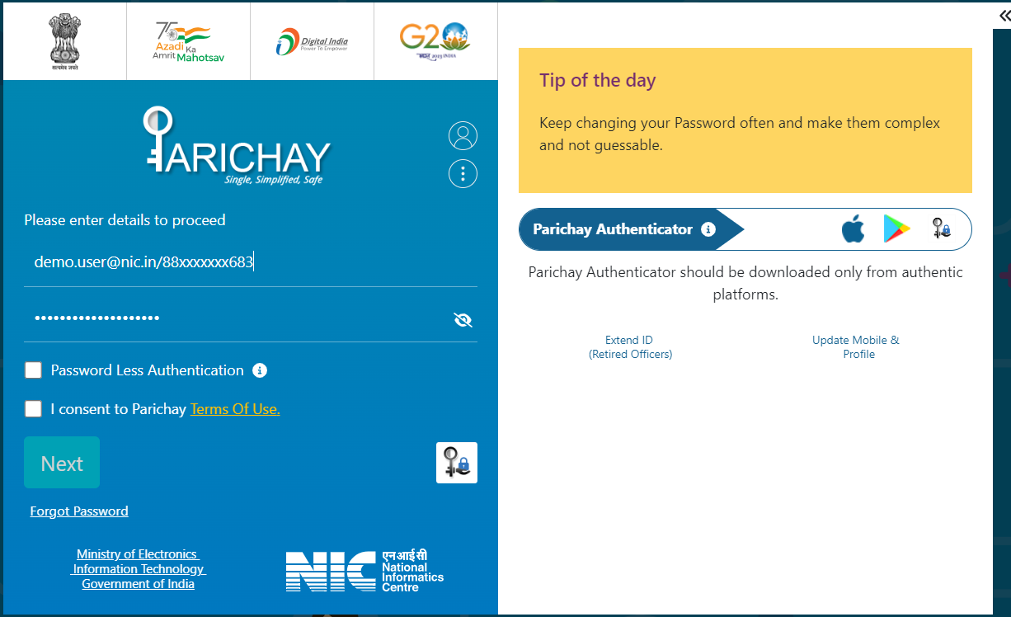
Fig. 1

**Please Note: After 3 unsuccessful username and password attempts, the user will be redirected to the login with Captcha page.

>>Now, the user will be prompted to OTP verification Page.

Step 2: OTP Authentication on SMS and on Sandes:

Enter the 6-digit OTP received on the registered mobile no. and click Next to login. [Refer Fig. 2]

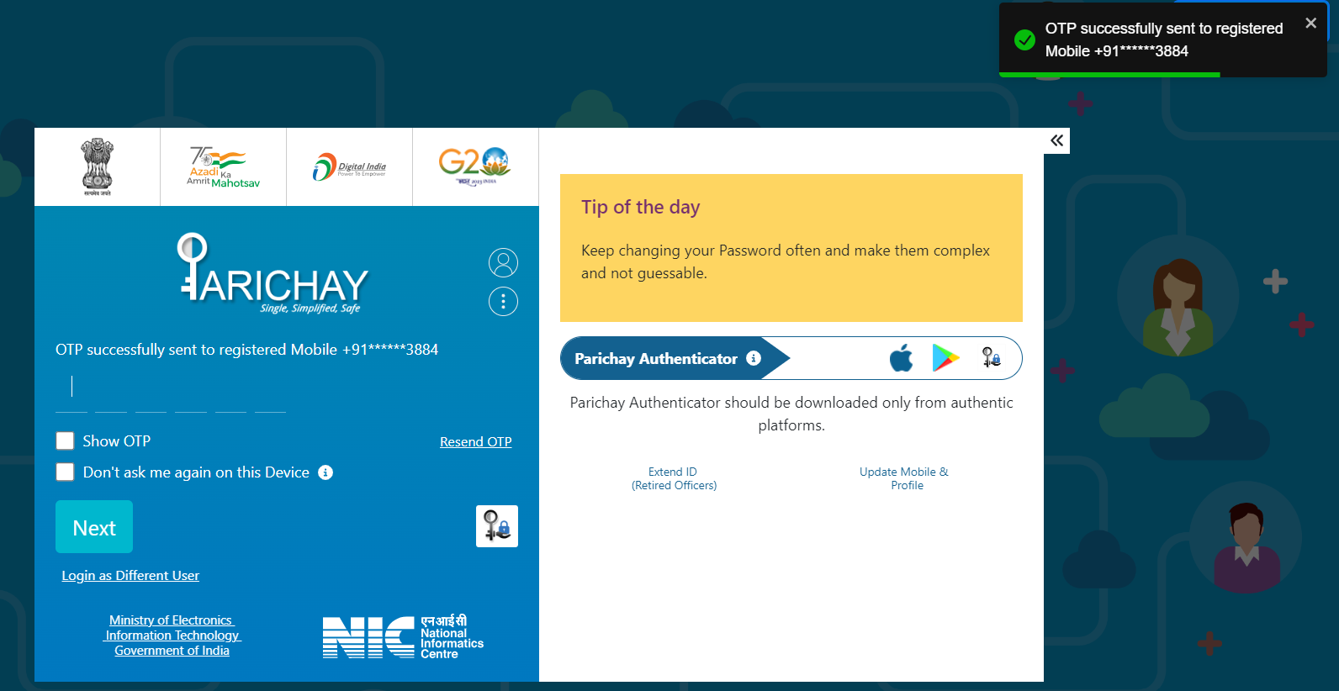

Fig. 2

**Please Note: After 3 unsuccessful OTP attempts, the user will be redirected to the login page and resend OTP option will be disabled after 3 attempts.

>> Post-successful OTP based verification, user will be redirected to Parichay Dashboard. [Refer Fig. 3]

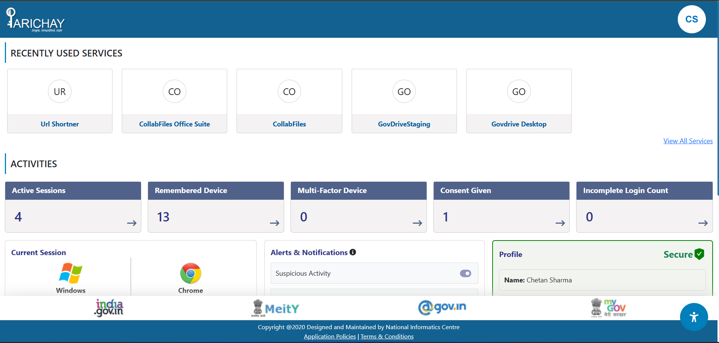
Fig. 3

2.2 Password-less Authentication
Following are steps to login Parichay (https://parichay.nic.in) using password-less authentication where user needs to:
Step 1: Enter either Email or Mobile Number and mark the checkboxes to enable Password-less option and provide consent to Parichay Terms of Use. [Refer Fig. 4]
Fig. 4
Step 2: Now, click the “Next” button to continue. [Refer Fig. 5]
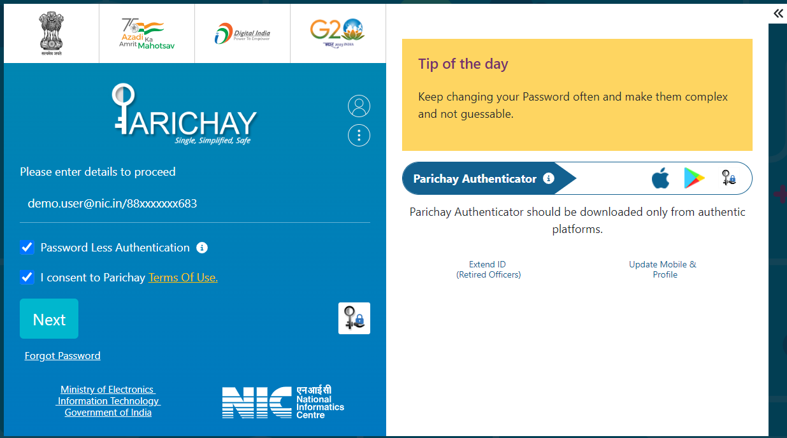
Fig. 5
>> User will be redirected to OTP based verification Page.

Step 3: Enter the 6-digit OTP received on the registered mobile no. and click Next to login. [Refer Fig. 6]
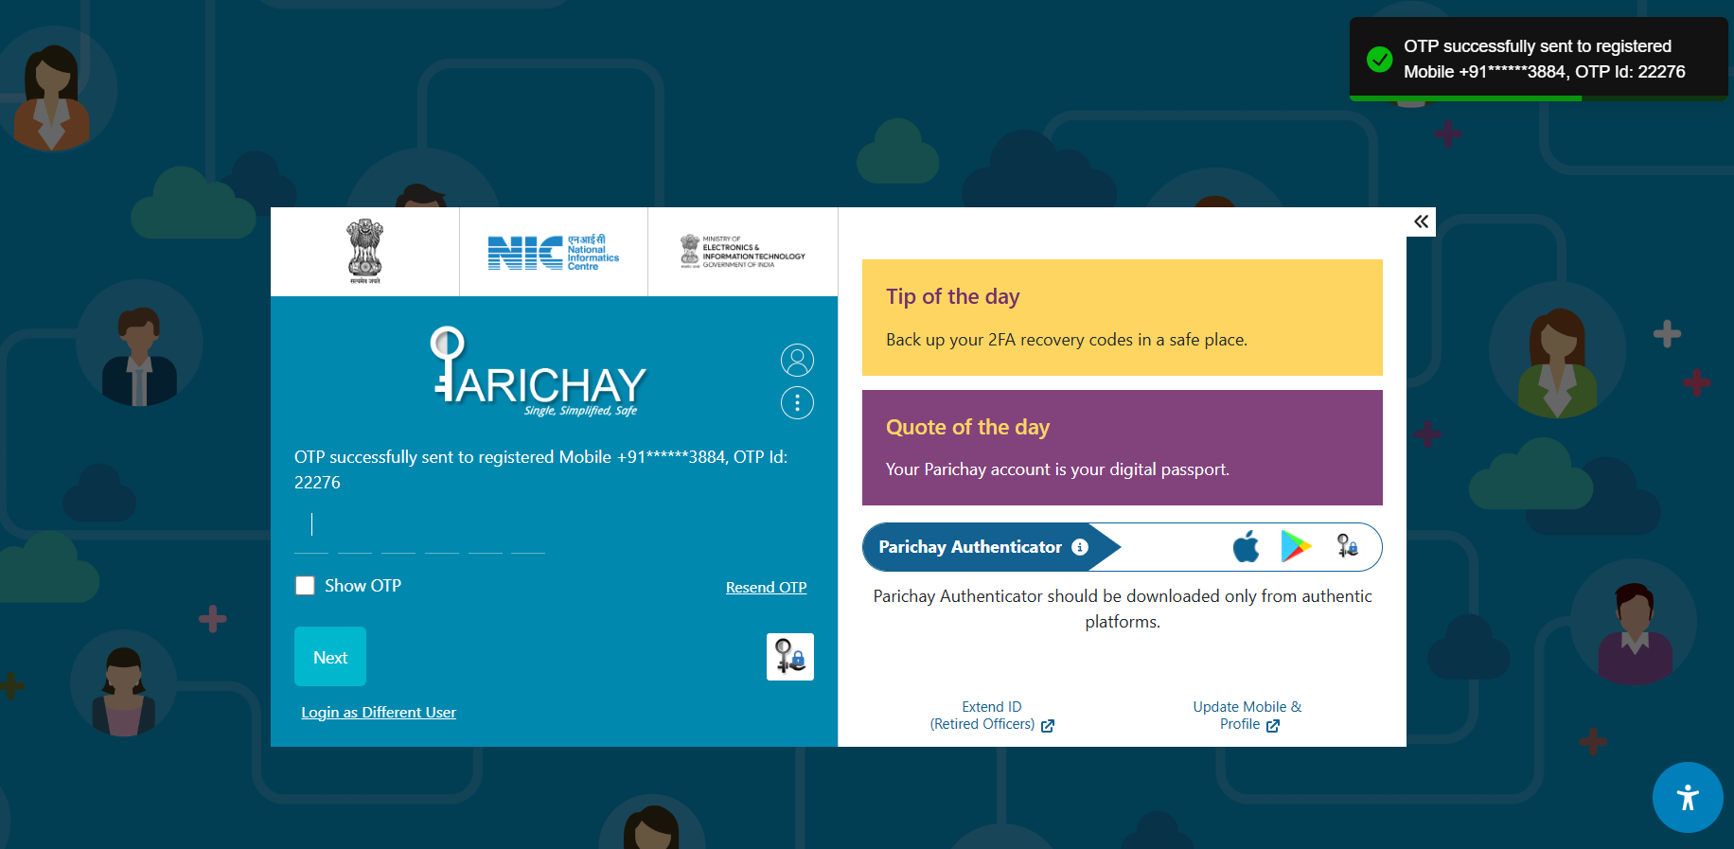
Fig. 6

>> Post-successful verification, user will be redirected to Parichay Dashboard. [Refer Fig. 7]

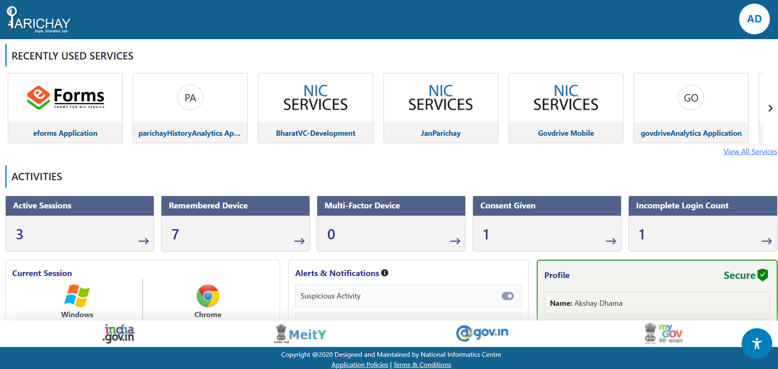
Fig. 7

Dashboard Insights
The dashboard helps end-users audit their Parichay Account related Activities in form of some comprehensive insights. It highlights the statistics as well as crucial details of user login activities.

Recently Used Services
It shows the list of Parichay integrated services, user has accessed most frequently in last 30 days. [Refer Fig. 8]
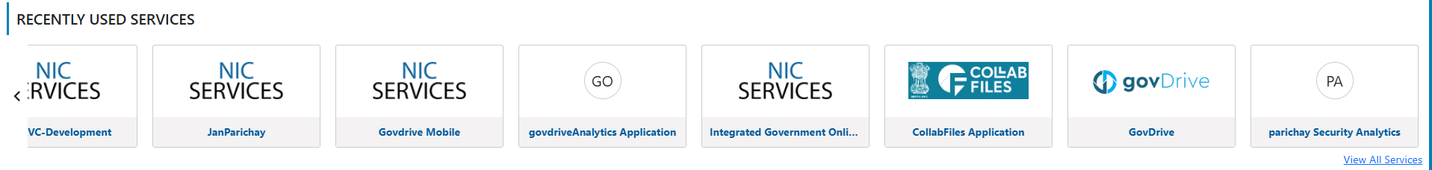
Fig. 8

Activities
The section shows counts for various user activities on Parichay Application.

Active Sessions
It shows the count for number of currently active user sessions for the respective Parichay Account. [Refer Fig. 9]
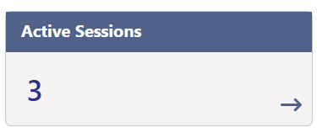
Fig. 9
>> Users can click the button to view a detailed info of active sessions. [Refer Fig. 10]
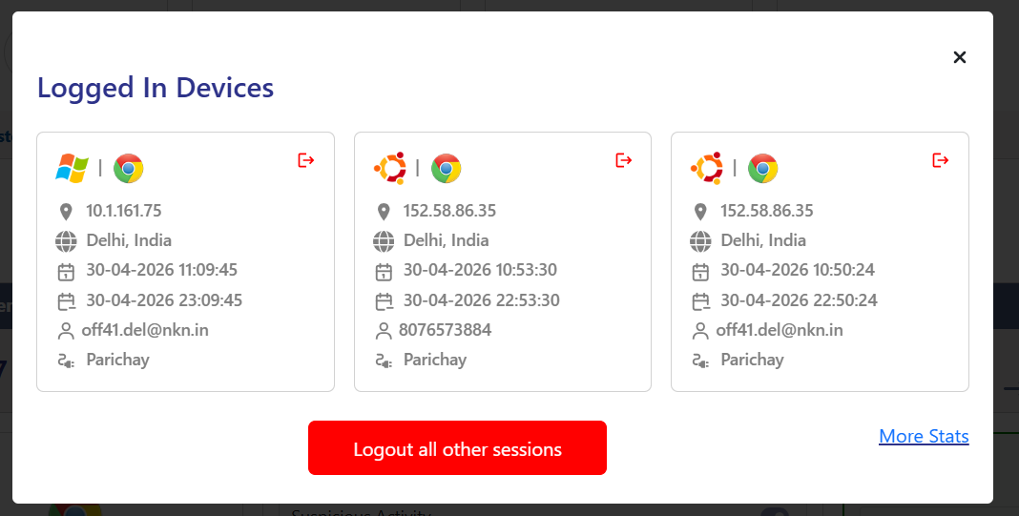
10.x.xxx.xx
XXXXXXX
XXXXXXX
XXXXXXX
XXXXXXX
Parichay
10.x.xxx.xx
XXXXXXX
XXXXXXX
XXXXXXX
XXXXXXX
Parichay
10.x.xxx.xx
XXXXXXX
XXXXXXX
XXXXXXX
XXXXXXX
Parichay
Fig. 10
>> User can also choose to logout their Parichay account from other active session(s) or click “More Stats” to visit Parichay Analytics Dashboard.

Remembered Devices
It shows the count for the number of devices, user has marked recognizable to access Parichay Account. [Refer Fig. 11]
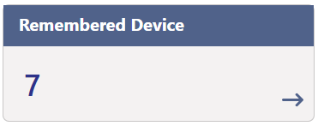
Fig. 11
>> Users can click the button to view more info about the remembered devices. [Refer Fig. 12]
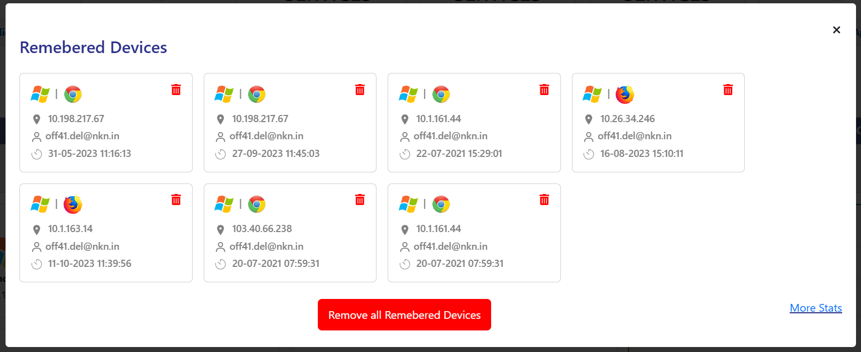
10.x.xxx.xx
XXXXXXX
XXXXXXX
10.x.xxx.xx
XXXXXXX
XXXXXXX
10.x.xxx.xx
XXXXXXX
XXXXXXX
10.x.xxx.xx
XXXXXXX
XXXXXXX
10.x.xxx.xx
XXXXXXX
XXXXXXX
10.x.xxx.xx
XXXXXXX
XXXXXXX
10.x.xxx.xx
XXXXXXX
XXXXXXX
Click to remove Device from the List
Fig. 12
>> Users can click the respective delete icon to remove a remembered device or delete the entire list by clicking “Remove all Remembered Devices” button.

Multi-factor Device
It shows the count for the number of devices configured for Multi-factor Authentication by the user to access their Parichay account. [Refer Fig. 13]
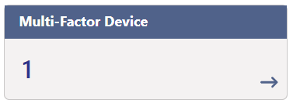
Fig. 13
>> Users can click the button to view the list of configured MFA devices. [Refer Fig. 14]
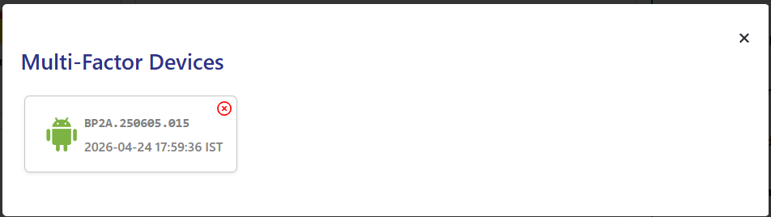
Fig. 14
>> User can also click the “Delete” icon to remove the configured device.

Consent Given
It shows the count for the number of devices configured for Multi-factor Authentication by the user to access their Parichay account. [Refer Fig. 15]
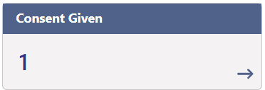
Fig. 15
>> User can click the button to view the consent dashboard. [Refer Fig. 16]
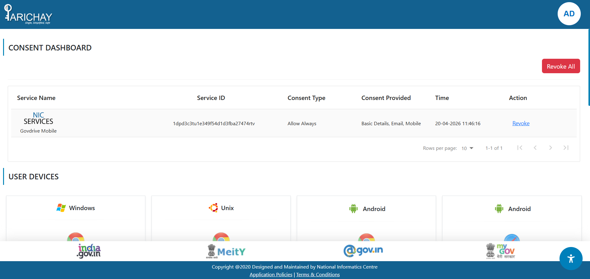
Fig. 16
>> Here, user can view and manage their existing consent settings and user devices.
Ex: User can click “Revoke” button for the existing consent for a specific service to reset the access settings accordingly. [Refer Fig. 17]
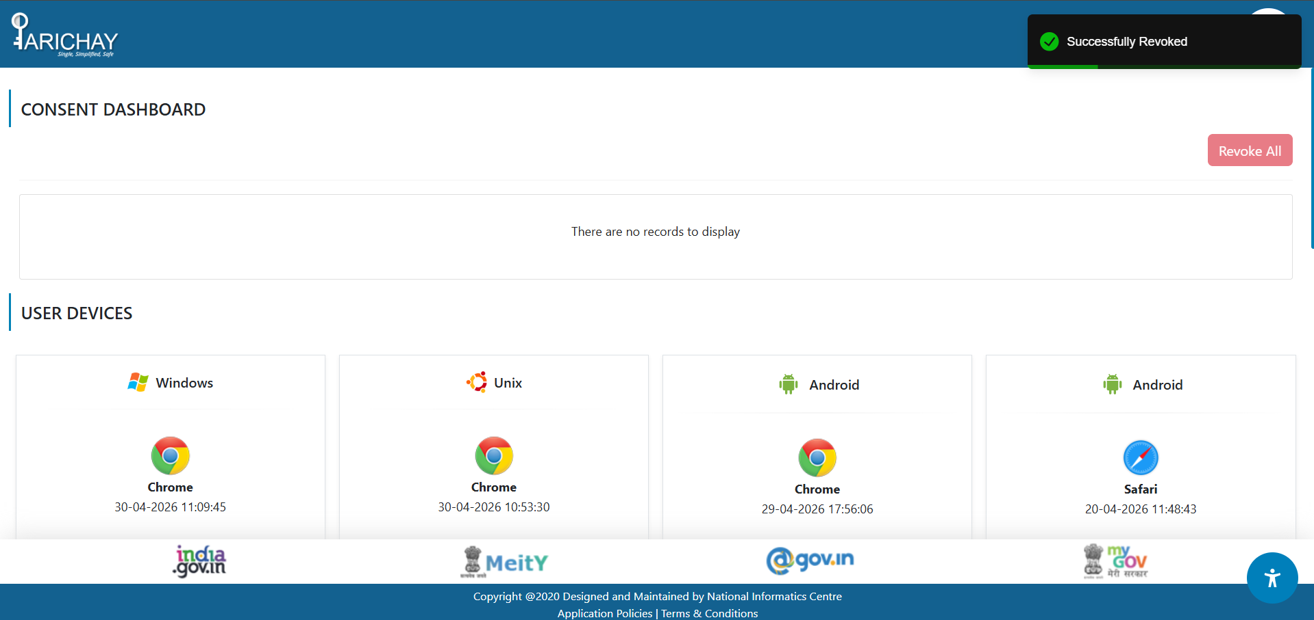
Fig. 17

Incomplete Login Count
It shows the count for the number of incomplete attempts made by the user to access Parichay due to various kind of failure events like Incorrect Password, OTP Failure, MFA failure, etc. [Refer Fig. 18]
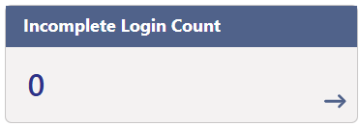
Fig. 18
>> Click the button anywhere redirects user to Parichay Analytics dashboard.

Other Settings
The section shows counts for various user activities on Parichay Application.

Current Session
It shows the details of current user session on Parichay i.e. Operating System and Browser details. [Refer Fig. 19]
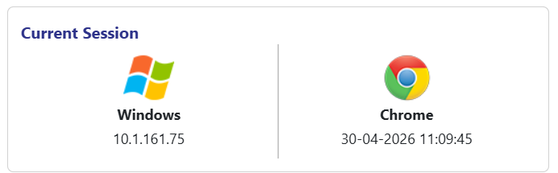
10.X.XXX.XXX
Fig. 19

User Devices
It shows the details of current user session on Parichay i.e. Operating System and Browser details. [Refer Fig. 20]
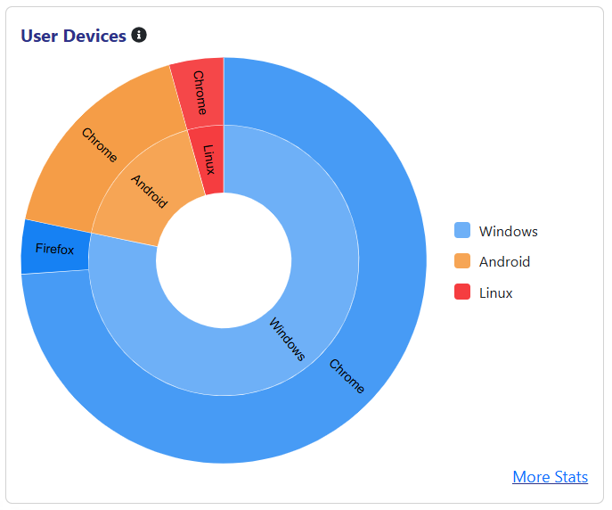
Fig. 20

>> User can also click the “More Stats” link to view details by visiting Parichay Analytics Dashboard.

Alert & Notifications
The table helps user view and manage few important alerts and Notifications settings. [Refer Fig. 21]
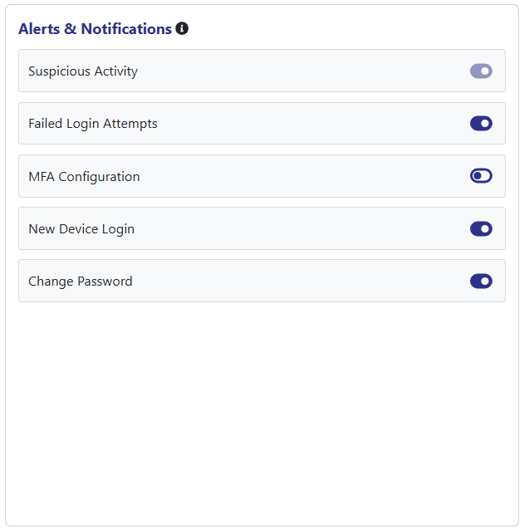
Fig. 21

Profile
The profile section comprises user’s basic details including his/her Name, Mobile Number, Email Id, Primary Parichay Account, Password, and most used Browser-OS. [Refer Fig. 22]
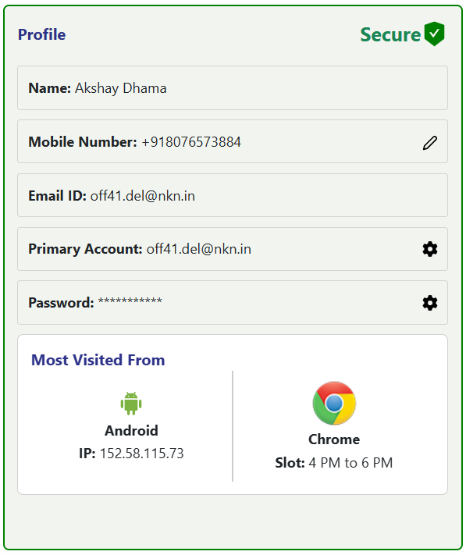
15X.XX.XXX.XX
Demo.user@xyz.in
Demo.user@xyz.in
+91 88XXXXXX84
Fig. 22
>> a. User can change their “Mobile Number” by clicking the “Edit” icon and proceeding with the required steps on https://eforms.nic.in [Refer Fig. 23]
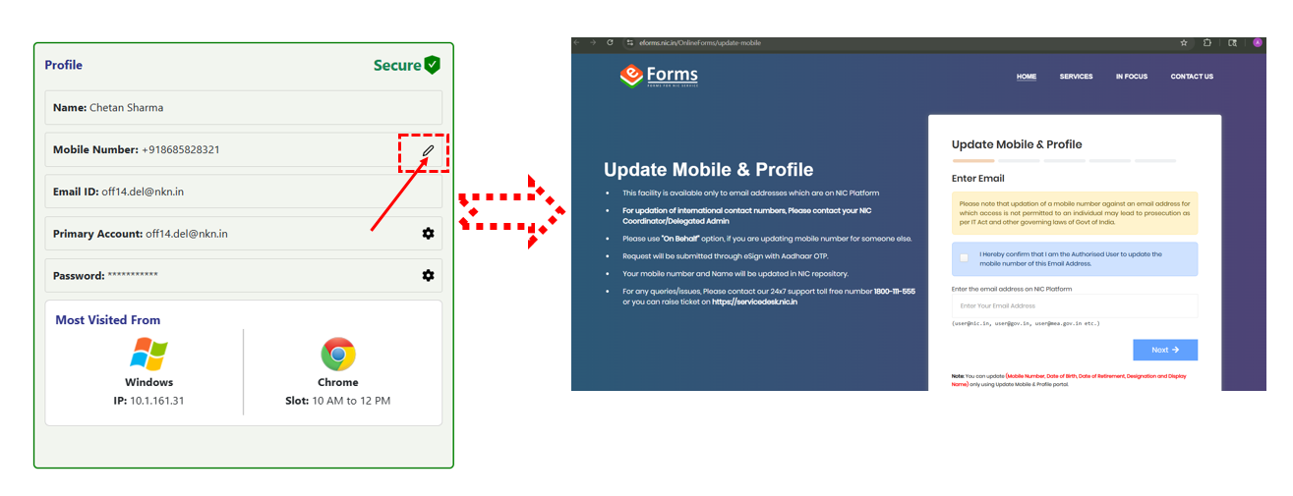
15X.XX.XXX.XX
demo.user@xyz.in
demo.user@xyz.in
+91 88XXXXXX84
Fig. 23

>> b. User can also change their Password by clicking the “Settings” icon given in Password field and entering the new password twice to provide confirmation. [Refer Fig. 24-25]
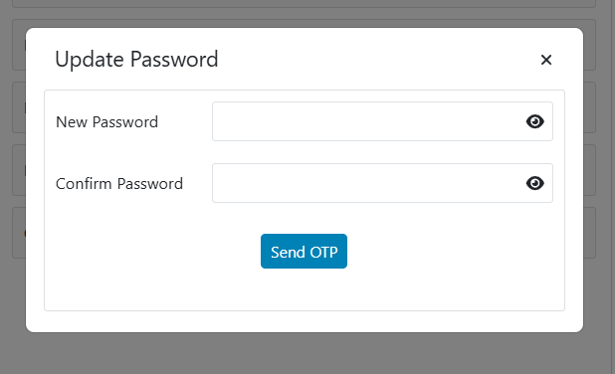
Fig. 24
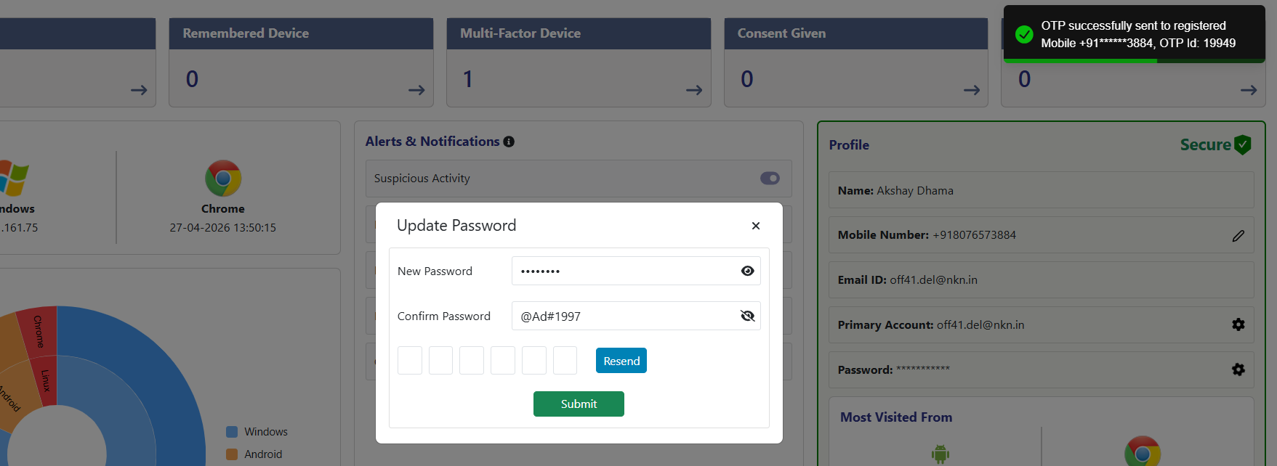
xxxxxxxxxxxxxx
Demo.user@xyz.in
Demo.user@xyz.in
+91 88XXXXXX84
Fig. 25
>> c. One can also change their Primary account if have more than one by clicking the respective “Settings” icon, choosing one of the available ids, and clicking the” update” button. [Refer Fig. 26-28]
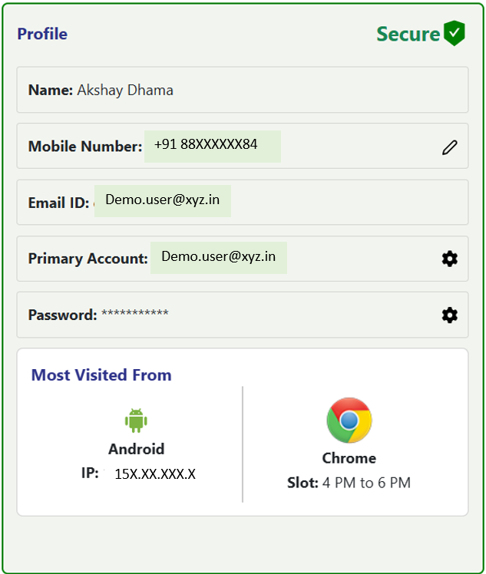
Fig. 26
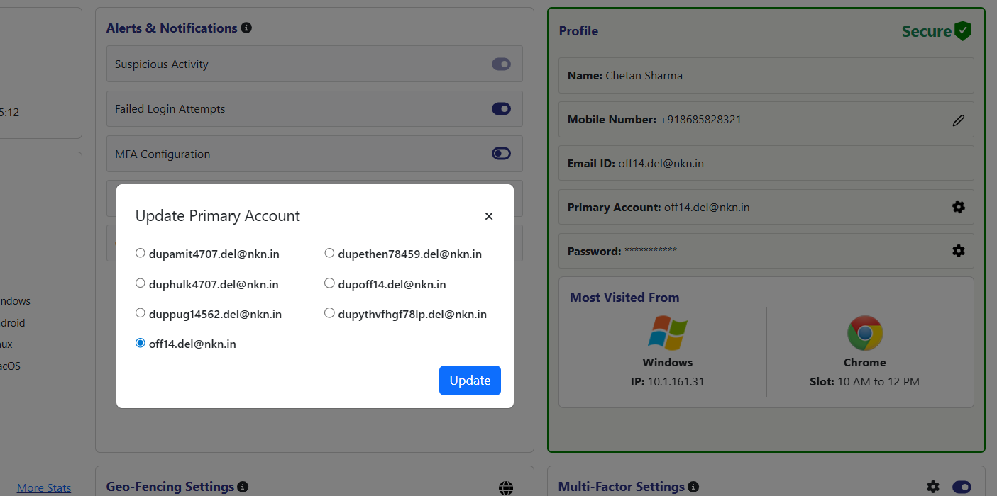
Aba34.123@xyz.in
Aba34.123@xyz.in
Aba34.123@xyz.in

Aba34.123@xyz.in
Aba34.123@xyz.in
Aba34.123@xyz.in
Aba34.123@xyz.in

xxxxxxxxxxxxxxx
Demo.user@xyz.in
Demo.user@xyz.in
+91 88XXXXXX84
Fig. 27

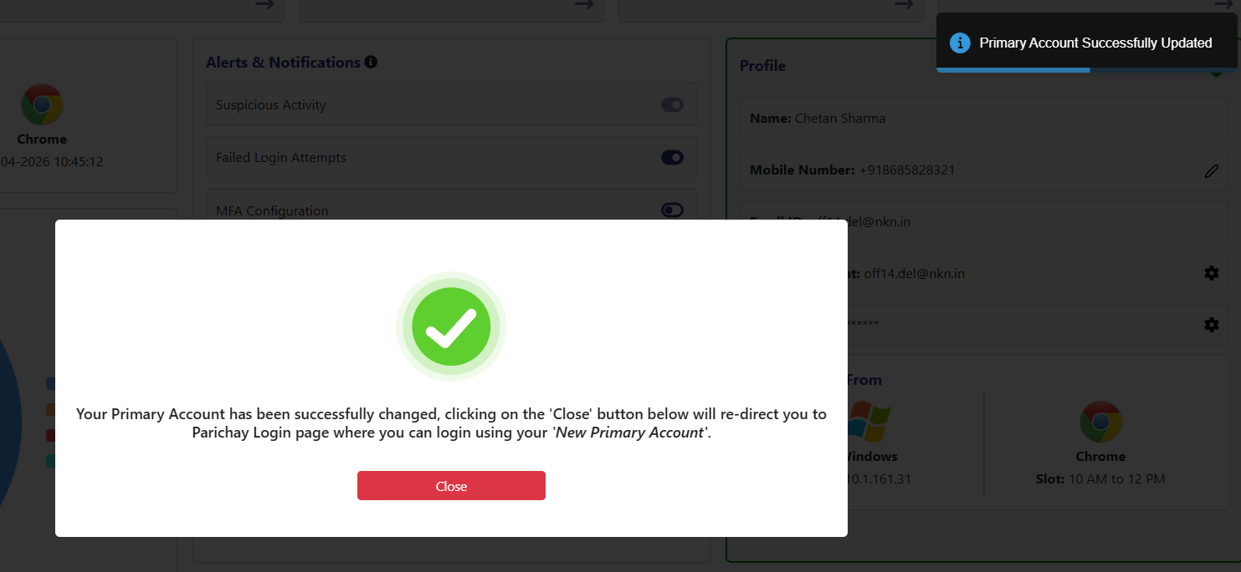
Fig. 28
- Post-successful change in Primary Account, user will be logged out of Parichay Account.
Additionally, this section also showcases the details of user’s device and browser most frequently used to access respective Parichay account. [Refer Fig. 29]
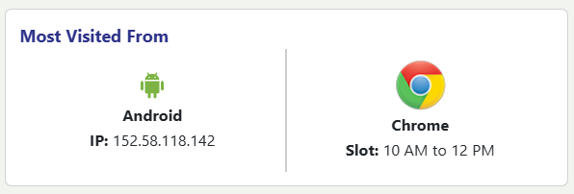
15X.XX.XXX.XX
Fig. 29

Multi-factor Settings
The option helps user manage multi-factor authentication settings for his/her Parichay account. [Refer Fig. 30]
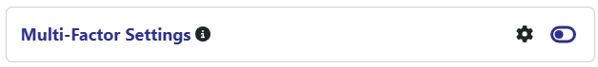
Fig. 30
>> User can enable/disable multi-factor authentication for his/her Parichay account by click the “On/off” icon respectively. [Refer Fig. 31]
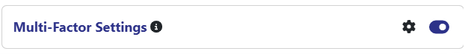
Fig. 31
>> User needs to click the “Settings” icon to view already configured devices or add a new one. [Refer Fig. 32]
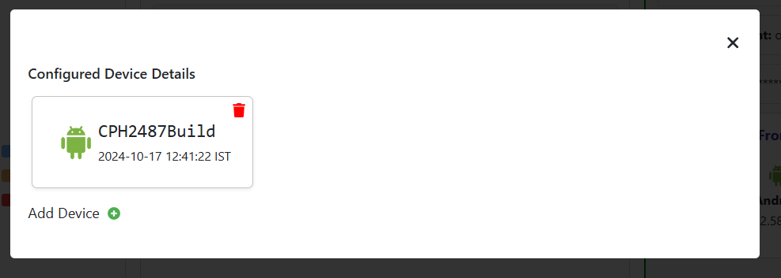
Fig. 32

>> To add a new device for multi-factor authentication, user needs to click the “Add Device” button. [Refer Fig. 33]
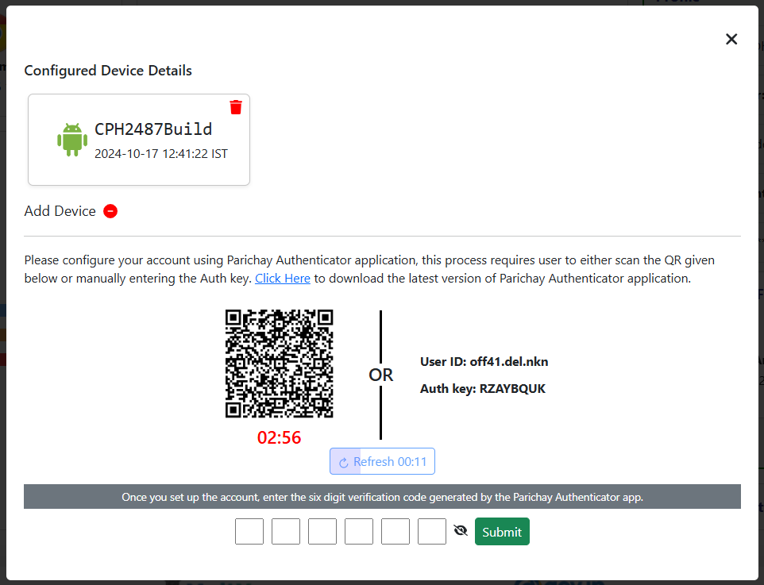
Fig. 33

Enabling multi-factor authentication requires few steps on Parichay Authenticator Application.

Step 5: Open the Parichay Authenticator application on your smartphone (Android/iOS). Slide forward or click on the “Skip/Proceed” button. [Refer fig. 34]
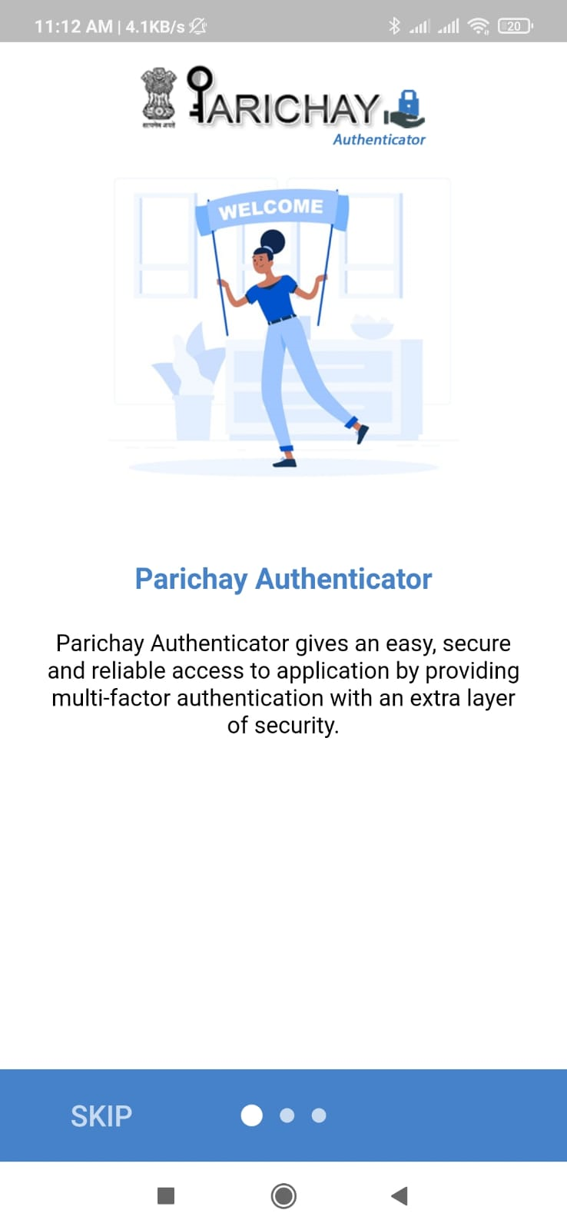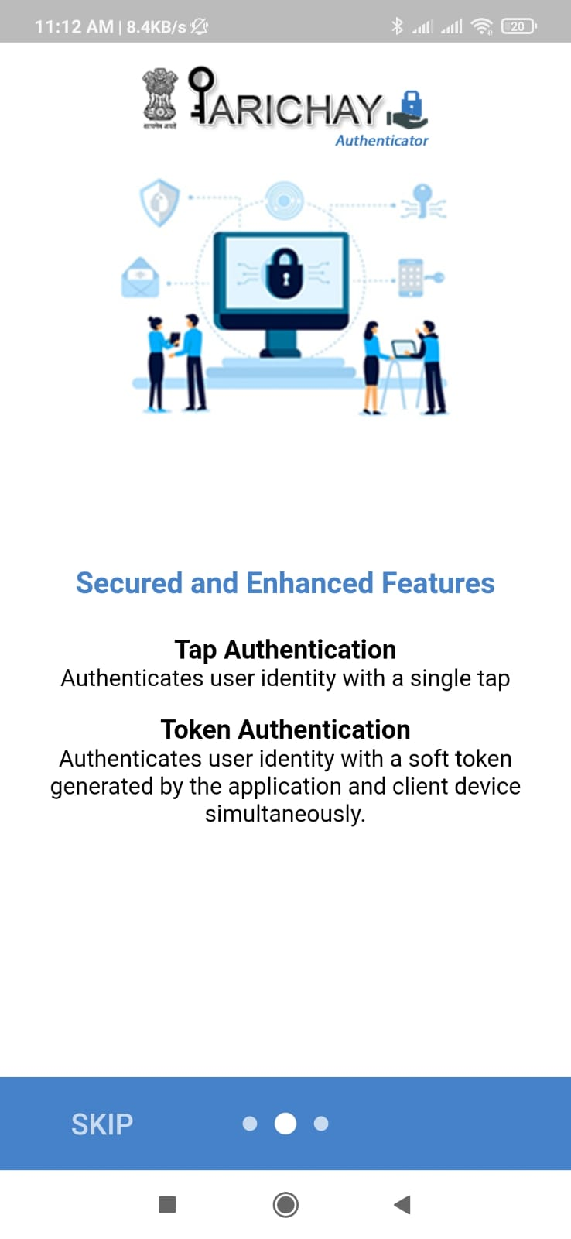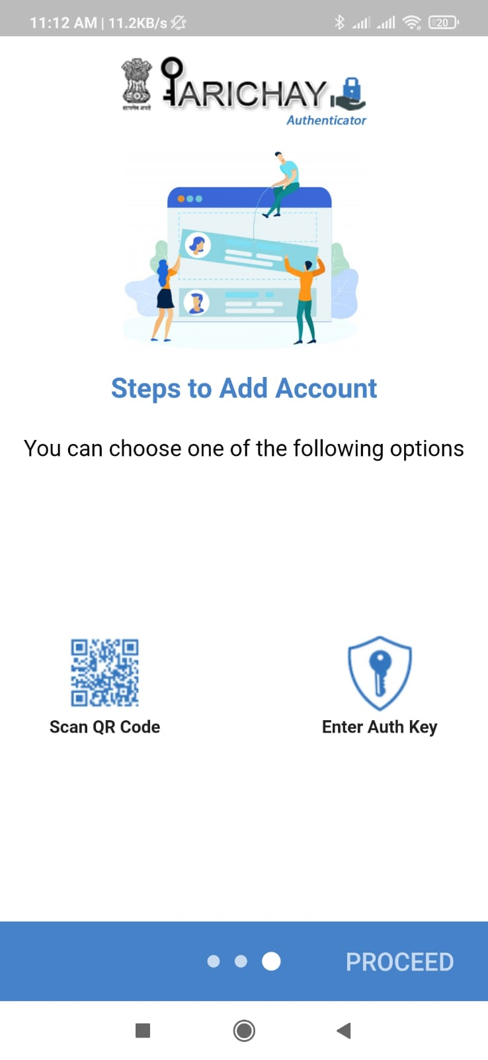
Fig. 34
Step 6: Click to choose the “Screen lock type” or “Skip” to continue. [Refer fig. 35]
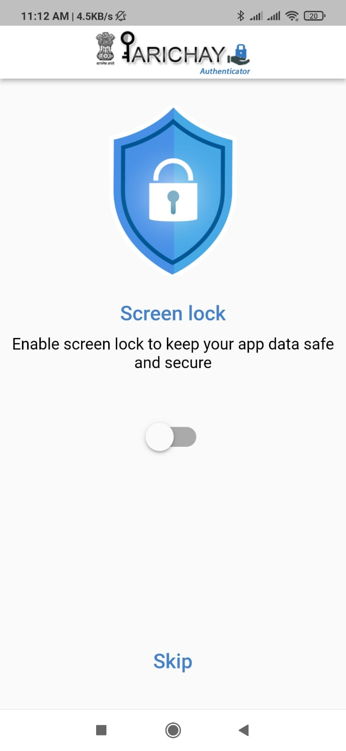
Fig. 35
Step 7: Click on the “Scan QR Code” Button. [Refer fig. 36]
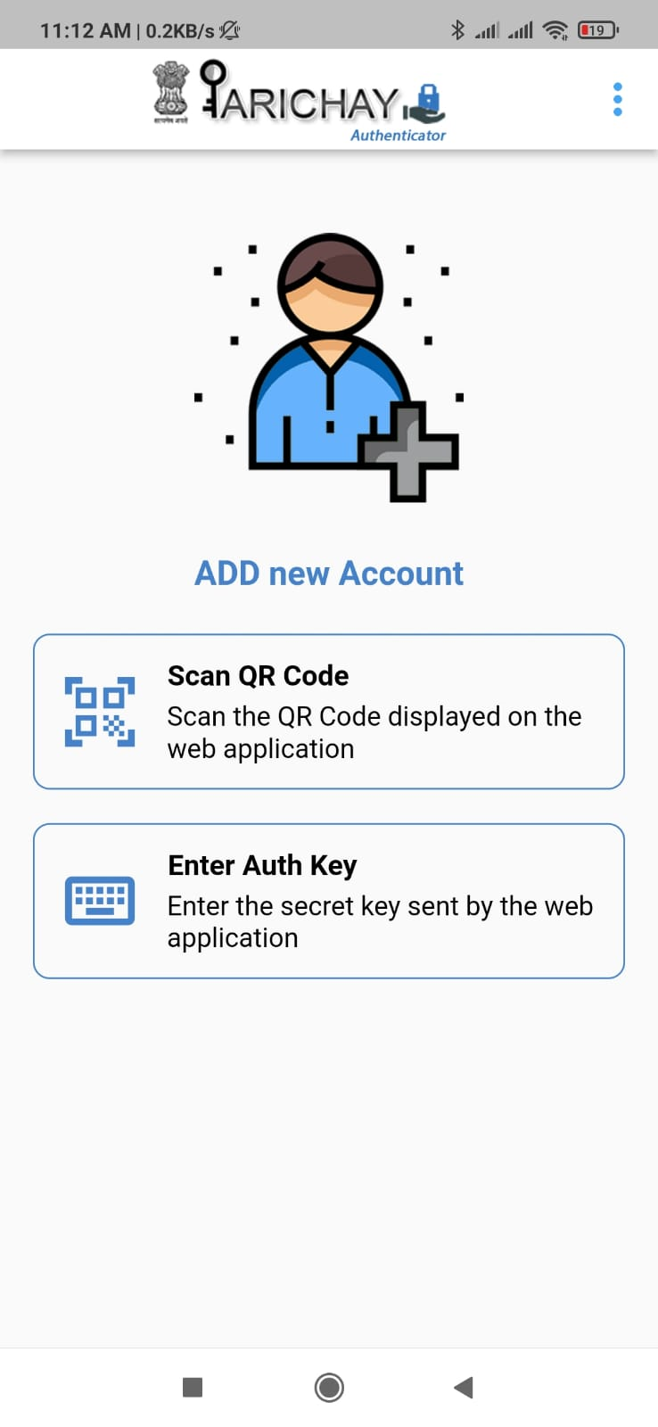
Fig. 36

Step 8: Scan the QR [Refer fig. 33] using the scan feature of Parichay Authenticator application. [Refer fig. 37]

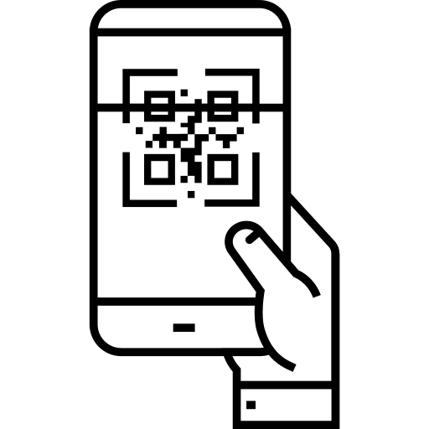
Parichay Authenticator App
Web Application
Fig. 37
Now, the user will be able to see the token on Parichay Authenticator, use this to configure your account. [Refer fig. 38]
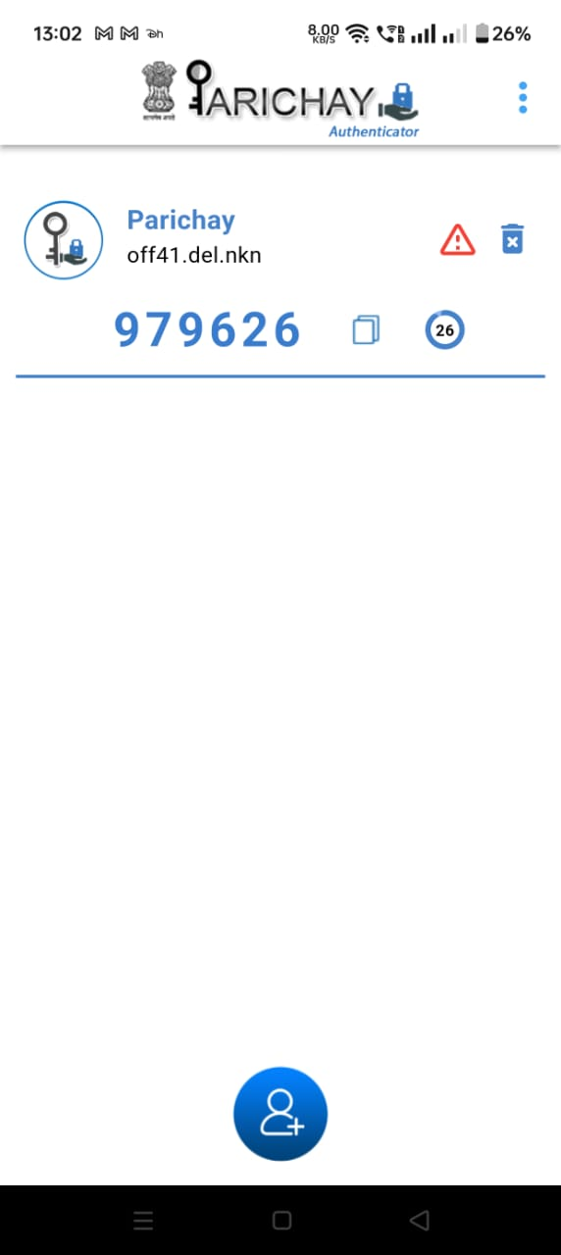
Parichay
Test User
Token
Add New Account
Delete Service
Token Timer: 30 secs
Tap to copy the Token
Fig. 38
Step 9: Enter the six-digit token number in the required field below the QR Code. [Refer Fig. 39]
Fig. 39
Now, the user has successfully configured their account with Parichay Authenticator for both tap and token authentication.

Geofencing
The option helps user view the current geofencing settings (allowed access for various countries) for his/her Parichay Account accessibility. [Refer Fig. 40]

Fig. 40
User can manage geofencing for their Parichay Account accessibility via Parichay Authenticator Application. Following is the step-wise procedure:
Step 1: Open the Parichay Authenticator application configured with Parichay Account and Click the “Geofencing” icon to proceed. [Refer Fig. 41]
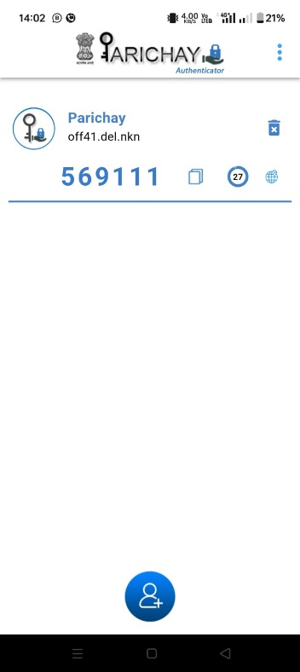
Parichay
Test User
Fig. 41
Step 2: Click to switch the button and enable Geofencing Settings. [Refer Fig. 42]
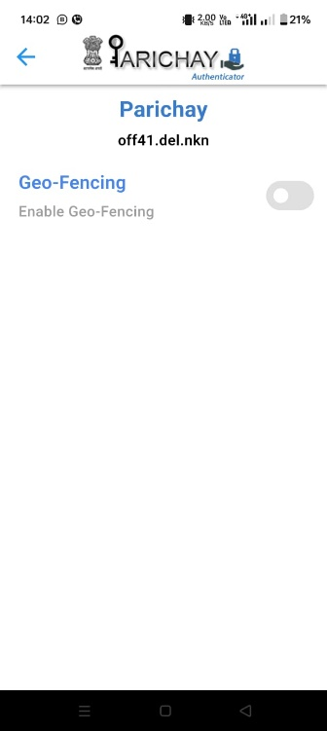
Parichay
Test User
Fig. 42
Step 3: Now, click the “Manage” button to view the list of countries. [Refer Fig. 43]
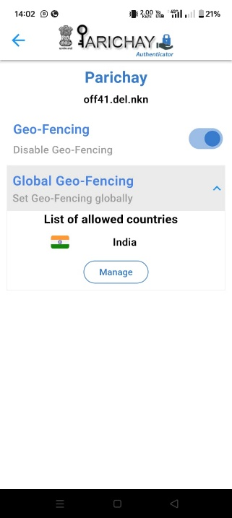
Parichay
Test User
Fig. 43
Step 4: Mark/unmark to choose the countries as per your requirements. [Refer Fig. 44]
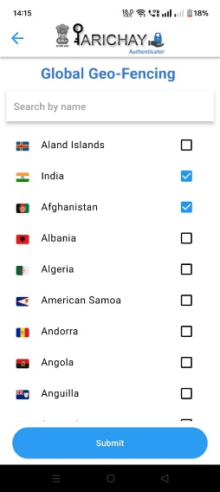
Fig. 44
Step 5: Now, click the “Submit” button and press back to view the applied changes. [Refer Fig. 45]
Parichay
Test User
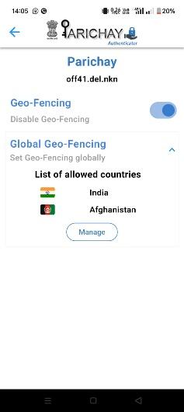
Fig. 45

MFA based Authentication
Step 1: User can choose either password-based or password-less authentication in the first step of login process: [Refer Fig. 46]
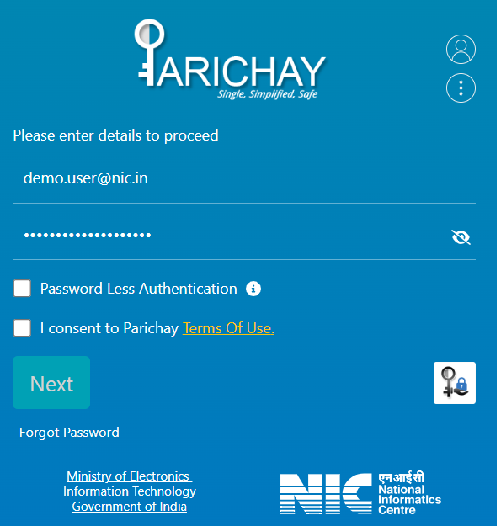 OR
Fig. 46
>> The user will be prompted to MFA page.
Step 2: Now, choose any of the MFA options to continue. [Refer fig. 47]
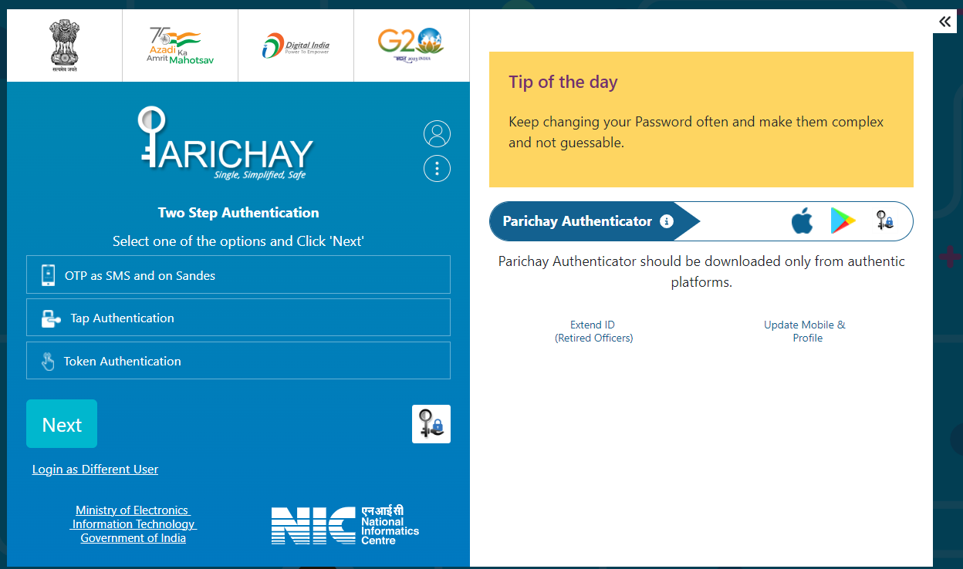
Fig. 47
>> User can choose any of the MFA options and following will be the authentication scenarios:
Step 3.1: OTP as SMS and on Sandes
Enter the 6-digit OTP received on the registered mobile no. and click Next to login. [Refer Fig. 48]

Fig. 48

>> Post-successful verification, user will be redirected to Parichay Dashboard.
Step 3.2: Tap Authentication
- User needs to choose the “Tap Authentication” and click “Next” to proceed. [Refer Fig. 49]
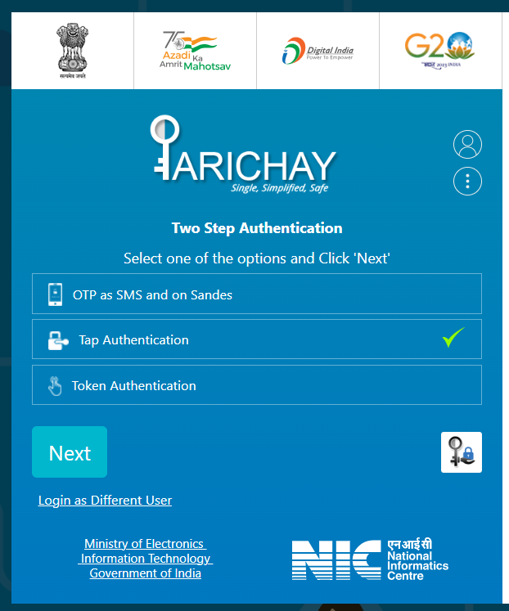
Fig. 49
Now, User needs to check the pull notification for their Parichay Authenticator App.
- Tap the “Accept” option to continue. [Refer Fig. 50]
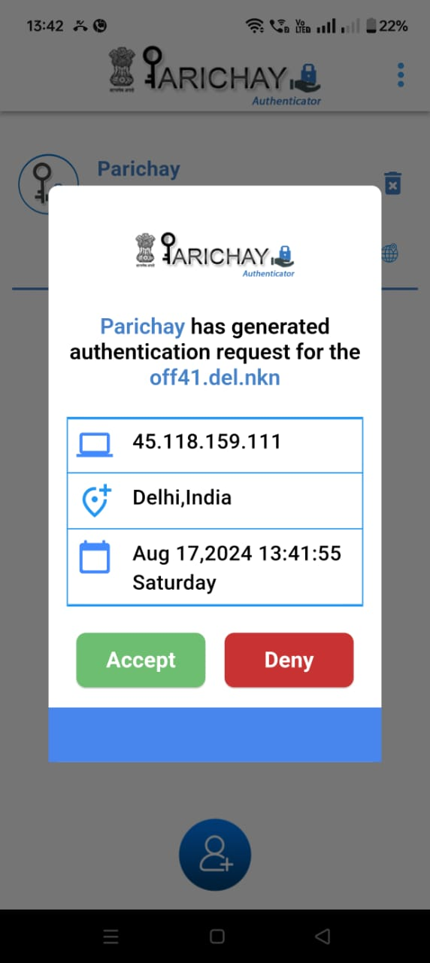
Demo.user@xyz.in
XXX.XXXX.XXX
Fig. 50
>> Post-successful verification, user will be redirected to Parichay Dashboard.

Step 3.3: Token based Authentication
- Choose the “Token Authentication” and click “Next” to proceed. [Refer Fig. 51] 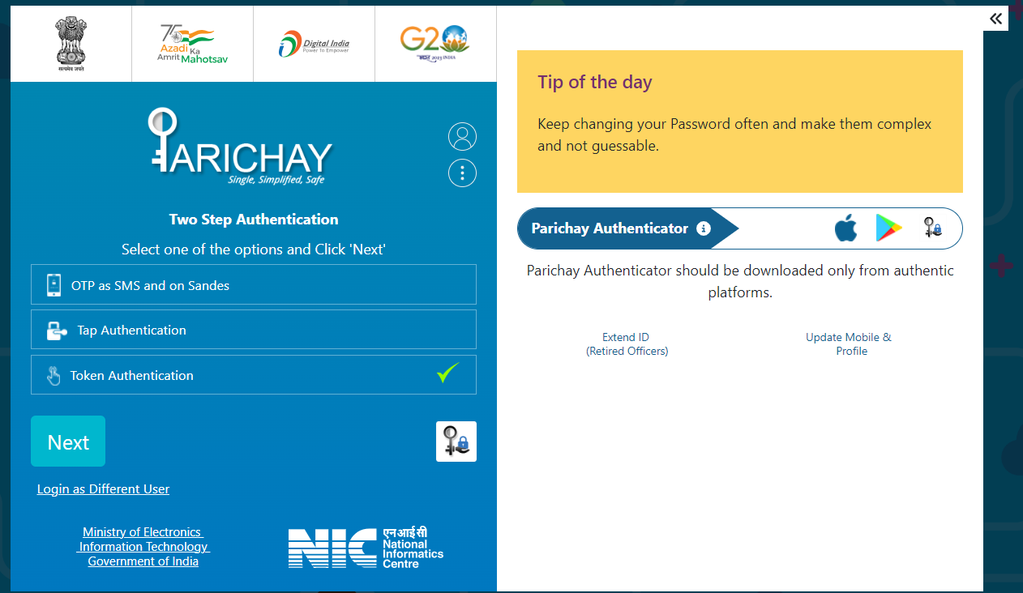
Fig. 51
Now, User needs to check the 6-digit “Token” for their Parichay Authenticator App.
- Enter the “Token” in the required field to continue. [Refer Fig. 52]
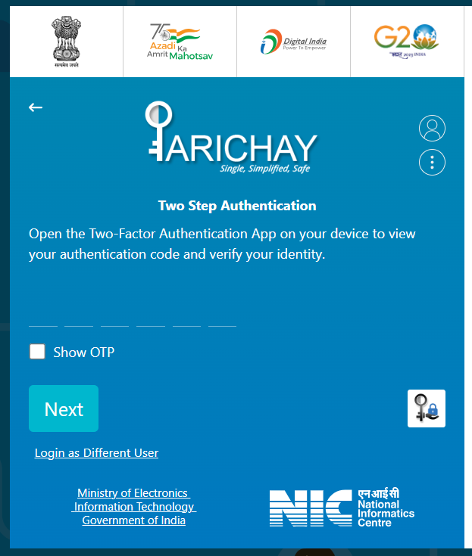
Fig. 52
>> Post-successful verification, user will be redirected to Parichay Dashboard.

Timeout
The session expiration time may vary from service to service. After the service timeout, the user will be redirected to the password page. [Refer Fig. 53]

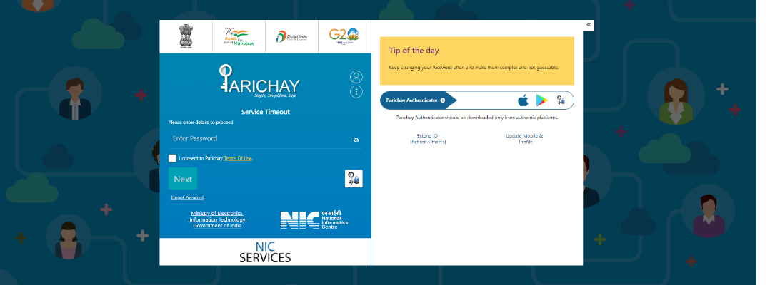
Fig. 53

Step 1: Enter Password again
Step 2: User will be prompted for the two-step authentication in case of forced authentication settings by the service.

Help & Support
Click on the Menu button given over the login fields and then, choose “Register Complaint” to register any complaint or
“FAQ” to see the frequently asked questions. [Refer Fig. 54]

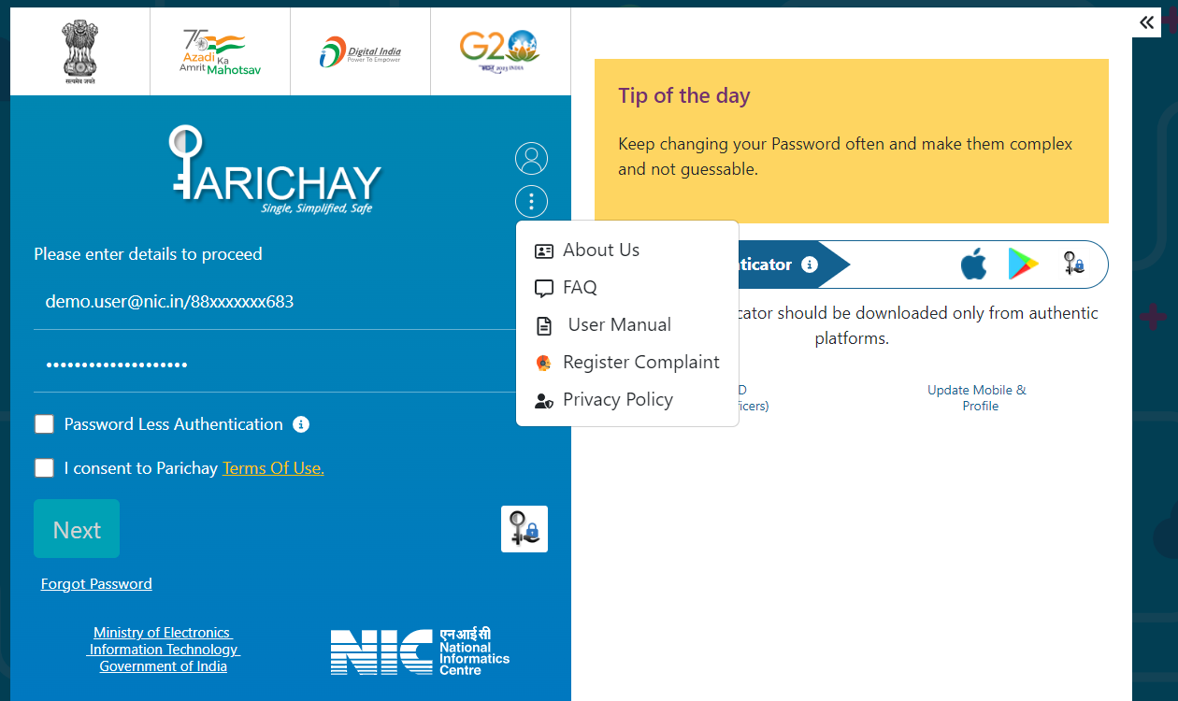

Fig. 54

Multiple Accounts Selection – Manage Primary Id

Multiple Account Selection during Login
When multiple Parichay IDs are mapped to a single mobile number or email, the system prompts the user to select any of the one account to proceed. Steps for the same are given below:
Step 1: Enter registered mobile number/email (either with password or password-less) on login screen and then, click “Next” to proceed. [Refer Fig. 55]
Fig. 55
>> A list of linked accounts (masked with special characters i.e. **## for enhanced security) will appear on the screen.
Step 2: User needs to select any one account and click “Next” to continue. [Refer Fig. 56 - 57]
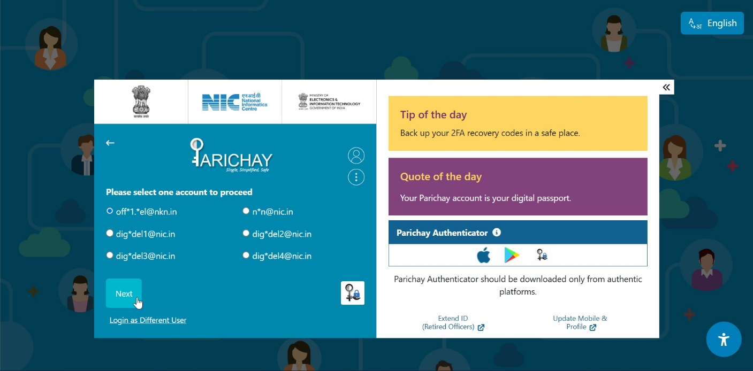
Fig. 56
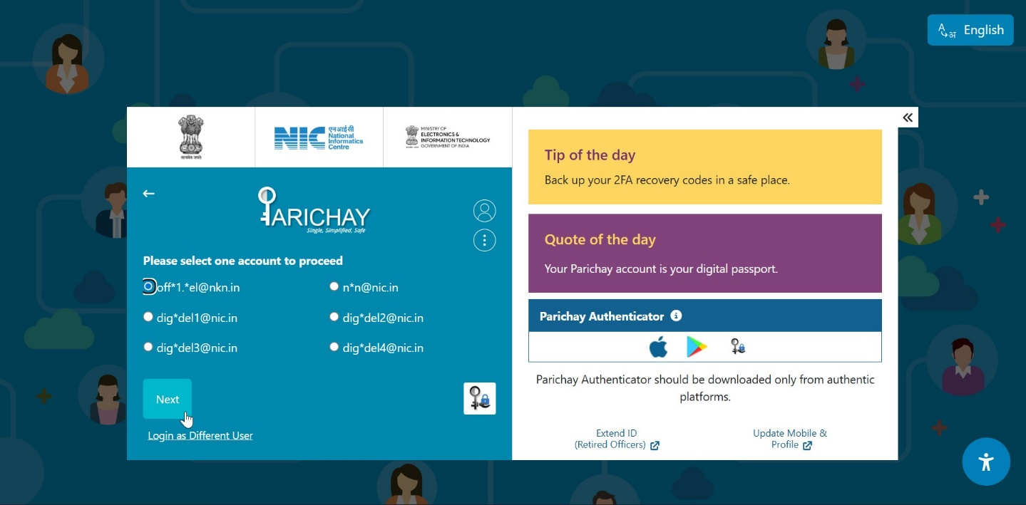Fig. 57
>> A prompt asking “Do you want to use this ID as your primary account?” will appear on the screen. [Refer Fig. 58]
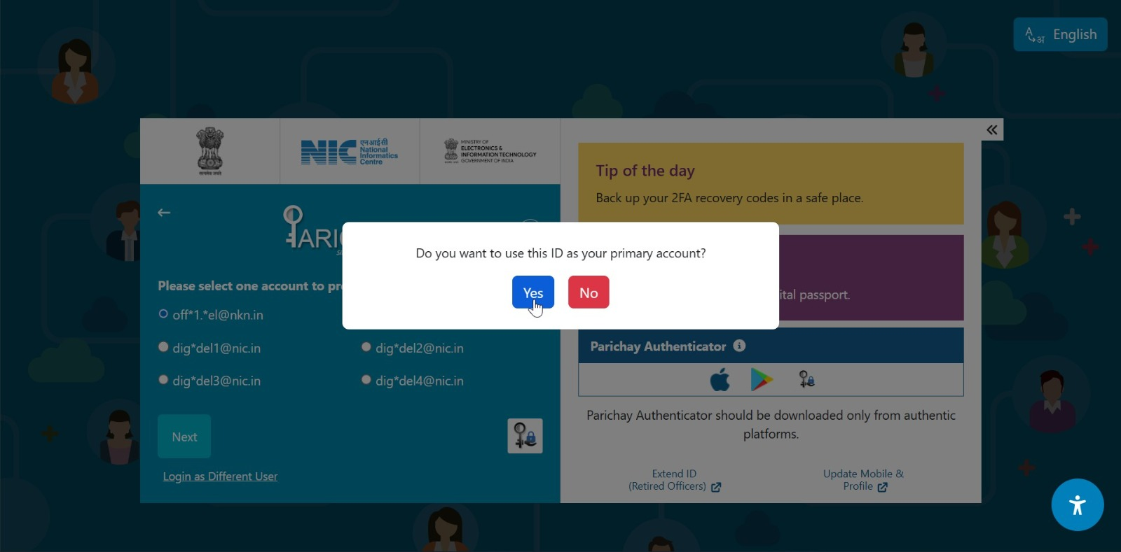
Fig. 58
Step 3: Now, user can either choose “Yes” or “No” to continue by either making the same Id as his/her primary account or continue anyways respectively.

Login via Integrated Service
For example: The user wants to login to Analytics (analytics.gov.in) service integrated using service through service homepage. Following are the required steps:
Step 1: Visit the service URL (ex: https://analytics.gov.in) [Refer Fig. 59]

Fig. 59

Step 2: Click the “Login with Parichay” option to continue. [Refer Fig. 60]
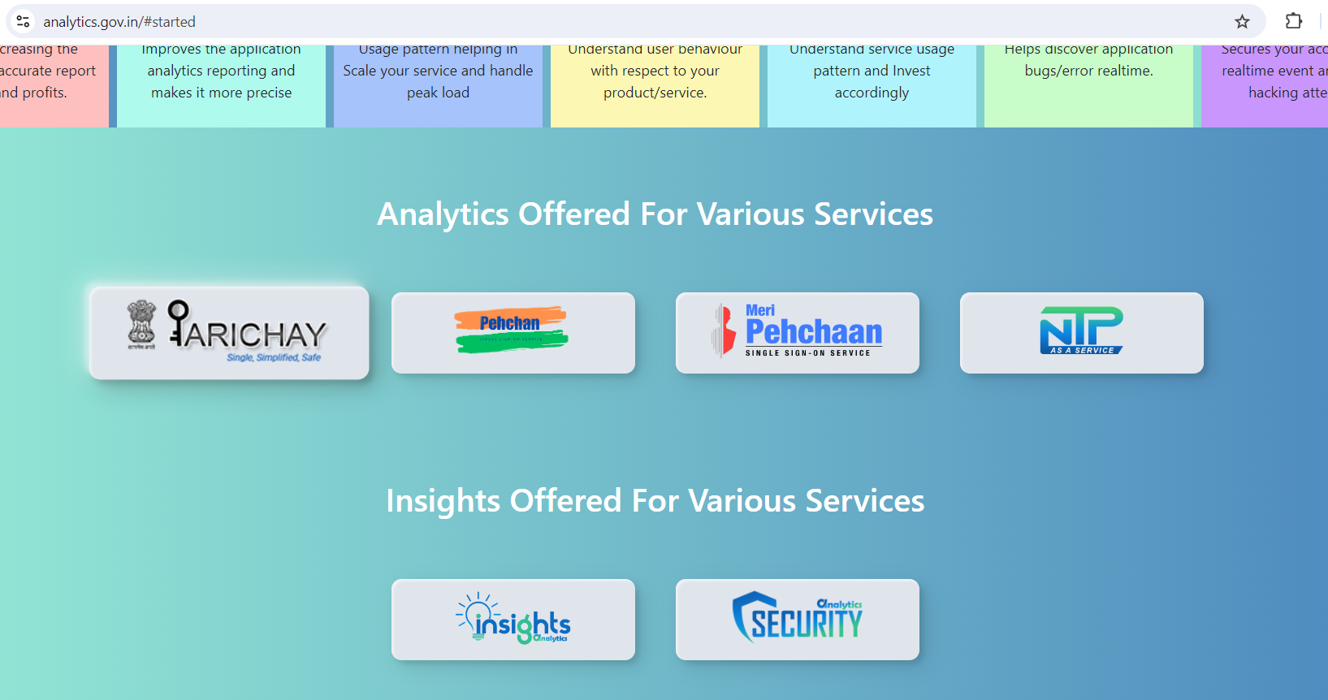
Fig. 60
>> User will be redirected to Parichay Login Page.
Step 3: Now, user can login either using the Password-based or Password-less authentication procedures mentioned above. [Refer Fig. 61]
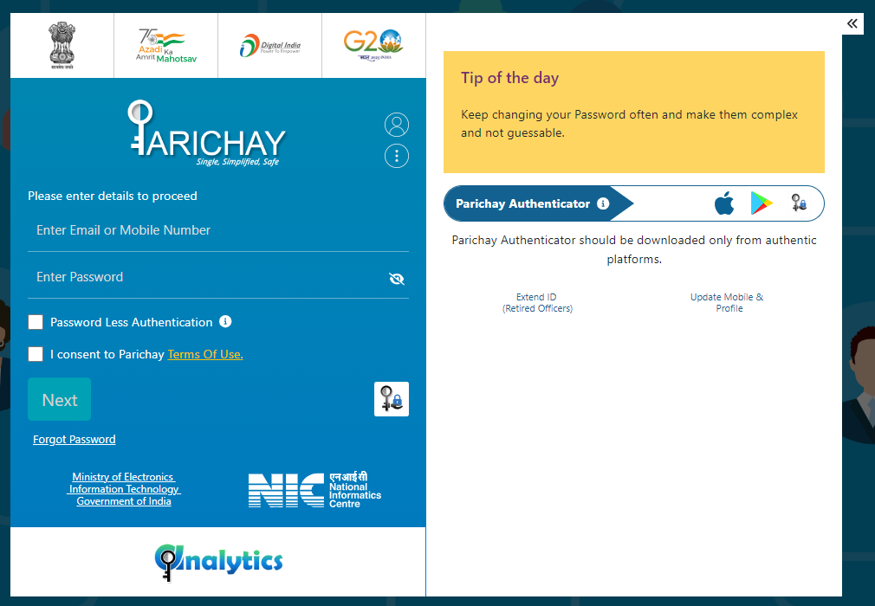
Fig. 61

