A Report on Site Visit to West Kallada Floating Solar Project

Submitted by
Ananthakrishnan G S

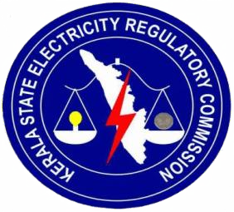

Kerala State Electricity Regulatory Commission
Thiruvananthapuram
Kerala
February 2026

ABSTRACT

West Kallada Floating Solar Project is a 50 MW grid-connected floating solar photovoltaic (PV) system implemented in the Kollam district of Kerala. The project makes use of waterlogged and uncultivable paddy lands by setting up solar panels on floating structures, thus overcoming land issues and encouraging the development of renewable energy sources. Implemented by NHPC Limited in partnership with Kerala State Electricity Board Limited, the project falls under the Solar Park Scheme of the Ministry of New and Renewable Energy. The project features cutting-edge system configuration, effective power evacuation through a 110 kV transmission system, and novel revenue-sharing models with the landowners. With an estimated annual electricity production of 99.9 MU and a planned CUF of 22.79%, the project is technically and socio-economically viable, thus marking a major milestone in the development of sustainable energy resources in Kerala.

CONTENTS
- Introduction
- Project Overview
- Land Acquisition and Revenue Sharing
- System Design
- Technical Specifications
- Grid Connectivity and Power Evacuation
- Operational Performance and Revenue Estimates
- Conclusion

CHAPTER - 1
INTRODUCTION
The growing need for clean and sustainable energy has resulted in the swift evolution of renewable energy sources in India. Among these, solar energy has been identified as one of the most promising alternatives to the traditional fossil fuel-based energy sources. In recent years, the concept of floating solar photovoltaic (PV) systems has attracted considerable attention as a novel solution to the problems of land availability and environmental sustainability.
The West Kallada Floating Solar Project, situated in the West Kallada village of the Kollam district in the state of Kerala, is a groundbreaking venture in this area. The project proposes the setting up of solar panels on floating platforms above water bodies, particularly in waterlogged and uncultivable paddy lands. Through the use of such unproductive lands, the project successfully tackles the problem of land availability in the state of Kerala, which has a high population density and limited open land resources.
The project has a planned capacity of 50 MW and is being developed under the Solar Park Scheme of the Ministry of New and Renewable Energy (MNRE), Government of India. The project is being developed by NHPC Limited in partnership with Kerala State Electricity Board Limited (KSEBL). The power will be fed into the state transmission network and will be used to meet the growing demand for electricity in Kerala.
One of the special things about the West Kallada project is that it is community-based. The project uses waterlogged agricultural land belonging to farmers in the area, which gives them economic benefits through land leasing and revenue sharing. This not only helps in the development of renewable energy but also gives socio-economic benefits to the community.
Besides the use of solar energy for power production, other benefits of the floating solar plant include the reduction of water evaporation, increased efficiency as a result of the cooling effect created by water, and the minimal effect on the environment compared to ground-mounted solar plants. The West Kallada Floating Solar Project is an important milestone in the development of sustainable energy in Kerala.

CHAPTER - 2
PROJECT OVERVIEW
The West Kallada Floating Solar Project is a flagship 50 MW (AC) grid-connected floating solar photovoltaic (PV) project located in the Kollam district of Kerala. The project uses the Mundakapadam polders, which are waterlogged and uncultivated areas, to promote the growth of renewable energy without the land-use conflicts that are normally experienced in conventional ground-mounted solar power plants.

The main participants of the project include NHPC Limited, which is the developer and joint developer as a Navratna company. Apollo Green Energy Limited (AGEL) is the EPC contractor, who is also the joint developer and lead engineer. WKNPCEPL is the landowner entity and is a special purpose vehicle representing the landowners’ company.

The Kerala State Electricity Board (KSEB) is the off-taker, who is also the state utility with the responsibility of purchasing the power generated from the project. The Ministry of New and Renewable Energy (MNRE) is the central government entity that gives the central financial assistance (CFA). The Kerala State Electricity Regulatory Commission (KSERC) is the regulatory entity that has the responsibility of determining the tariff and approving the power purchase agreement (PPA).

CHAPTER - 3
LAND ACQUISITION AND REVENUE SHARING
The project covers a total footprint of about 340 acres in the Mundakapadam polders, which is the largest floating solar project in Kerala. Of this, 291.68 acres have been leased from the landowner entity.
Revenue Sharing Mechanism
In a innovative departure from the conventional fixed-lease rental agreement, NHPC has signed a revenue-sharing agreement. As per this arrangement, NHPC shares 3% of the total revenue generated with WKNCEPPL, which is then shared with the landowners. This "innovative finance" solution ensures long-term community support and converts the uncultivated polders into high-return energy resource
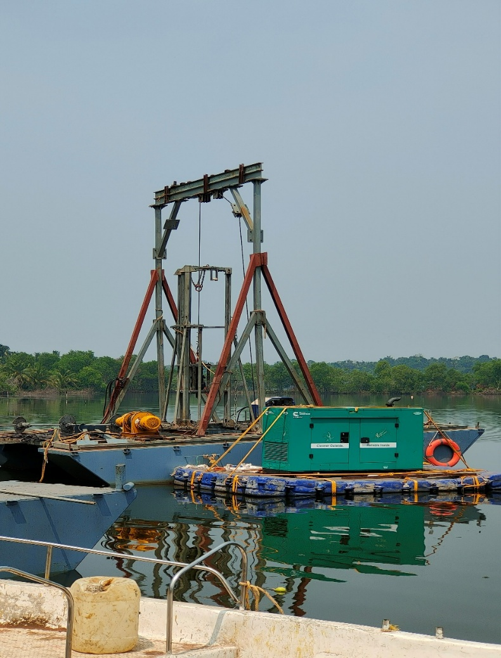
CHAPTER - 4
SYSTEM DESIGN
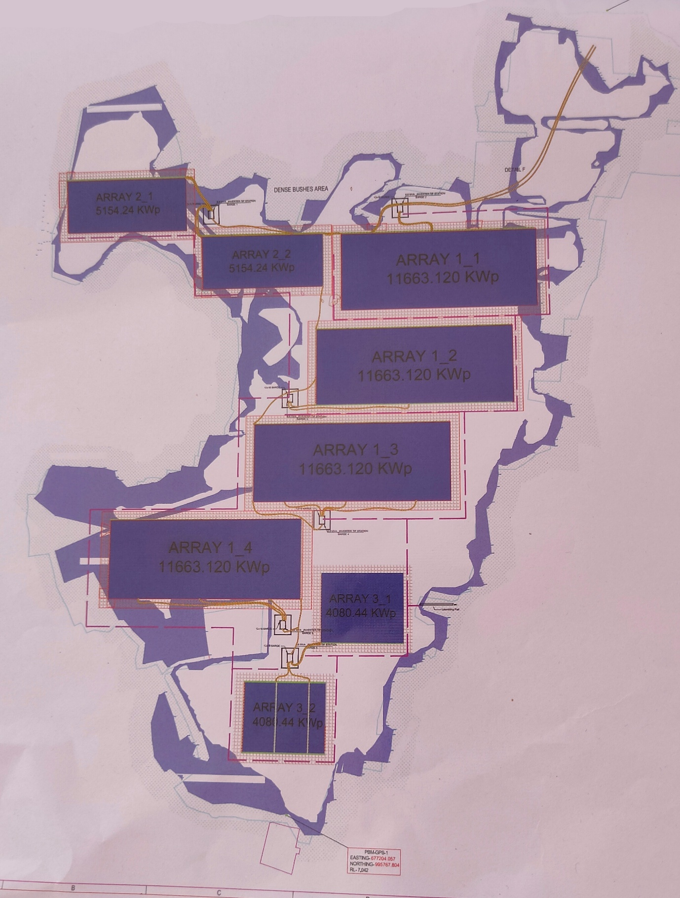
CHAPTER - 5
TECHNICAL SPECIFICATIONS
Core Technical Parameters
Installed Capacity | 65 MWp DC / 50 MW AC.
PV Modules | 1.10 lakh monocrystalline modules (590-Watt peak rating).
String Architecture | 28 modules in series; two strings in parallel per input to the String Combiner Box (SCB)
Power Conversion | 10 units of 4.4 MVA and 2 units of 3.3 MVA inverters
Inverter Duty Transformers (IDTs) | 5 units of 8.8 MVA and 1 unit of 6.6 MVA
Main Power Transformers | 2 units of 31.5 MVA (33/110 KV)

Array Configuration
The system is divided into eight distinct floating arrays:
• 4 Arrays: 11.663 MWp each.
• 2 Arrays: 5.154 MWp each.
• 2 Arrays: 4.080 MWp each.

The DC power is aggregated through six barge stations, which are located in a strategic manner within the water body. The stations act as the point of collection for the 33 KV AC power before it is transmitted to the onshore facility.
Power Flow
1. DC Aggregation: Energy is gathered at the SCB with an operating voltage of roughly 1200 V DC.
2. Inversion: Central inverters transform DC inputs into 660 V AC. A key technical detail is the IDT arrangement, which consists of two inverters supplying one IDT (two primary and one secondary winding).
3. Intermediate Step-up: IDTs increase the voltage to 33 KV.
4. Collection & Transmission: Energy from the six barge stations is transmitted through underwater/floating cables to the Main Control Room (MCR).
5. Final Transformation: High-tension (HT) switchgear panels provide inputs for the 33/110 KV power transformers in a dedicated 110 KV switchyard with two incomer and two outgoing bays.

CHAPTER - 6
GRID CONNECTIVITY AND POWER EVACUATION

The power evacuation is done through a strong 110 KV network that is designed to improve the stability of the local grid.
• Evacuation Infrastructure: 1.2 km Line-In-Line-Out (LILO) on the existing 110 KV Kundara-Chavara line. This route will require the erection of 7 towers, with the LILO located 1.1 km from the plant switchyard.
• Grid Impact: The 50 MW injection of power has greatly reduced the burden on the 220 KV Kayamkulam, Sasthamkotta, and Kundara substations.
• Economic & Technical Gains: In addition to the nameplate capacity, the project also ensures a system power loss reduction of about 1.33 MW. This reduction in the transmission losses is an important economic advantage for the state utility, thus enhancing the project's contribution to the grid.

CHAPTER - 7
OPERATIONAL PERFORMANCE AND REVENUE ESTIMATES

Performance Parameters
Estimated generation in first year: 99.909 million units (MU)
Designed CUF: 22.79%
Annual gross revenue: ~ ₹26 crores

Battery Energy Storage System (BESS) Context: In the context of the new Kerala state policy for “prosumers” and solar and storage projects, the inclusion of BESS will enable the project to feed into a higher Feed-in Tariff rate of ₹7.5 per unit during peak hours.
The annual revenue per acre corresponding to a CUF of 0.22 is ₹9.8 lakhs; however, when the CUF decreases to 0.19, the revenue per acre per year correspondingly reduces to ₹8.4 lakhs.
CHAPTER – 8
CONCLUSION

The West Kallada Floating Solar Project is a significant step forward in the implementation of renewable energy projects by making optimal use of waterlogged land for the generation of electricity. The project not only uses innovative floating solar technology but also has an optimal grid connection system and a community development-based revenue sharing approach, which will help in making it economically viable and socially acceptable. With an installed capacity of 50 MW, a stable power evacuation system, and optimal operational performance, the project will go a long way in meeting the increasing demand for electricity in Kerala without relying on conventional sources of energy.

