A Report on Visit to West Kallada Floating Solar Project Plant

Submitted by

Aparna Prasad

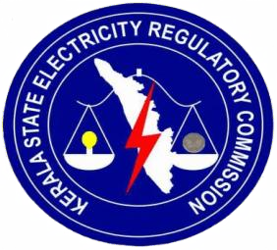

Kerala State Electricity Regulatory Commission Thiruvananthapuram
Kerala February 2026

Contents

- Introduction

- Project overview

- Site description and existing condition

  - Available area and utilization constraints

  - Existing site status during visit

  - Proposed Switchyard location and soil conditions

  - Floating structure procurement and handling area

  - Anchoring requirements for floating solar arrays

4 Technical Configuration

  - Overview of system configuration
  - Photovoltaic generation and DC system
  - Power conversion and AC collection system
  - Grid interface and power evacuation
5 Environmental and social considerations
5.1 Environmental setting of the project area
  - Land use and resource optimization
  - Impact on water body and aquatic environment
  - Social aspects and community acceptance
  - Land leasing and revenue sharing mechanism
  - Environmental safeguards and compliance measures
  - Overall environmental and social significance

6 Challenges observed and mitigation measures
6.1 Irregular site geometry and area utilization
6.2 Soil conditions at the switchyard location
6.3 Anchoring complexity in a floating environment
6.4 Electrical cable routing over water
6.5 Power evacuation coordination
6.6 Environmental and weather related challenges
6.7 Social and land related consideration
7 Key learnings and observation from the site visit
7.1 Practical understanding of floating solar technology
7.2 Integration of civil and electrical engineering
7.3 Importance of site – specific design
7.4 Grid integration and power evacuation planning
7.5 Socio- Economic considerations in project development
7.6 Professional and technical exposure
7.7 Overall learning outcome
8 Conclusion

List of Figures

Sl no | Figure | Page No
3.1 | General view of the water body proposed for floating solar array installation | 10
3.2 | Area identified for placing solar arrays | 11
3.3 | Site levellingand preparatory civil works observed during the visit | 12
3.4 | Land parcel initially identified for the proposed 110 KV switchyard | 13
3.5 | Floating pontoon for movement | 14
3.6 | Floating pontoon for solar panels | 14
3.7 | Anchoring arrangement explained during the site vist | 15
4.1 | Single line diagram illustrating the electrical configuration and power evacuation scheme | 16

CHAPTER - 1
INTRODUCTION

A site visit was conducted to the proposed West Kallada Floating Solar Photovoltaic (FSPV) Project in Kerala to gain practical exposure to the planning, design, and implementation aspects of a utility-scale floating solar power plant. The visit was technically guided and explained by Mr. Dileep, Manager (Electrical Wing), NHPC, and Mr. Sreekumar, Deputy Manager (Civil Department), NHPC, who provided detailed insights into both electrical and civil components of the project.
The West Kallada project is planned with a total installed capacity of 65 MWp (DC), which after accounting for conversion and system losses, delivers 50 MW (AC) to the grid. The project adopts a floating solar configuration to optimally utilize the available water body while minimizing land acquisition challenges. Kerala State Electricity Board Limited (KSEB) is responsible for power evacuation and grid interconnection of the plant.
During the visit, the officials explained the overall project concept, electrical configuration, power evacuation scheme, transmission infrastructure, and civil feasibility aspects. Technical drawings such as the Single Line Diagram (SLD), transmission line profile drawings, switchyard electrical layout, and tower foundation drawings were reviewed in detail. In addition, handwritten technical notes were discussed, covering inverter ratings, voltage levels, transformer capacities, expected CUF, and generation estimates.
At the time of the visit, the project was in the pre-construction stage, with site levelling and preliminary civil activities in progress. The team identified the proposed floating solar area, the initially planned switchyard location, and the procurement and handling area for floating pontoons. This report consolidates the observations, technical explanations, and learnings obtained during the site visit.
CHAPTER- 2

PROJECT OVERVIEW

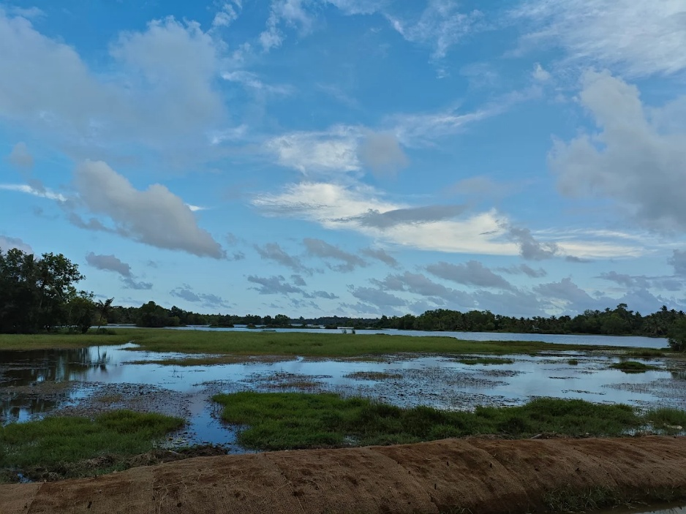
Fig 2.1 : West Kallada

The West Kallada Floating Solar Power Project is a grid-connected floating solar photovoltaic project proposed at West Kallada in Kerala. The project aims to generate clean electricity by utilizing a waterlogged area that is otherwise unsuitable for conventional land-based development. By adopting floating solar technology, the project makes effective use of available natural resources while supporting the state’s renewable energy objectives.
The basic details of the project are as follows:

Type of Project | Floating Solar Photovoltaic Power Plant
Location | West Kallada, Kerala
Project Developer | NHPC Limited
EPC Contractor | Apollo Green Energy Limited
Power Evacuation & Off-taker | Kerala State Electricity Board Limited
Installed DC Capacity | 65 MWp
Delivered AC Capacity | 50 MW
Evacuation Voltage Level | 110 kV
Total Project Area | Approximately 291.68 acres
Project Status During Visit | Site levelling and preliminary works in progress

The plant is designed with a DC capacity of 65 MWp so that, after accounting for inverter and system losses, a stable output of 50 MW AC can be delivered to the grid. The solar modules are mounted on floating platforms placed over the water body, which helps avoid the use of productive agricultural land. Power generated from the floating arrays is collected through a medium-voltage system and evacuated to the state grid at the 110 kV level through infrastructure coordinated by KSEB.
Although the total site area is large, the effective capacity of the project is limited due to the irregular shape of the water body. Since floating solar arrays require rectangular layouts for proper installation and anchoring, only a portion of the available area is suitable for deployment. At the time of the site visit, no major installations had begun, and activities were limited to site preparation and leveling, with detailed technical planning already finalized
CHAPTER - 3
SITE DESCRIPTION AND EXISTING CONDITION
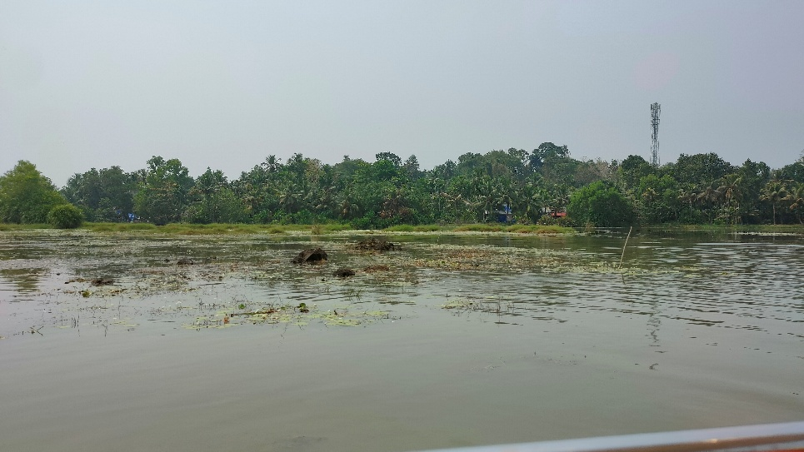
Fig 3.1 General view of the water body proposed for floating solar array installation

The proposed West Kallada Floating Solar Power Project is located at West Kallada, an area dominated by low-lying, waterlogged paddy fields. Due to prolonged water retention, the land remains unsuitable for conventional agricultural practices for a major part of the year. These conditions make the site suitable for the deployment of floating solar photovoltaic systems, enabling productive use of the existing water body without disturbing cultivable land.

3.1 Available Area and Utilization Constraints
The total area identified for the project is approximately 291.68 acres. However, it was explained during the site visit that only a portion of this area is practically usable for floating solar deployment. The water body has an irregular geometry, whereas floating solar arrays require rectangular layouts for structural stability, effective anchoring, and ease of electrical routing. As a result, only about one-third of the available area can be utilized, which limits the effective plant capacity to 50 MW (AC) despite the large overall site extent.

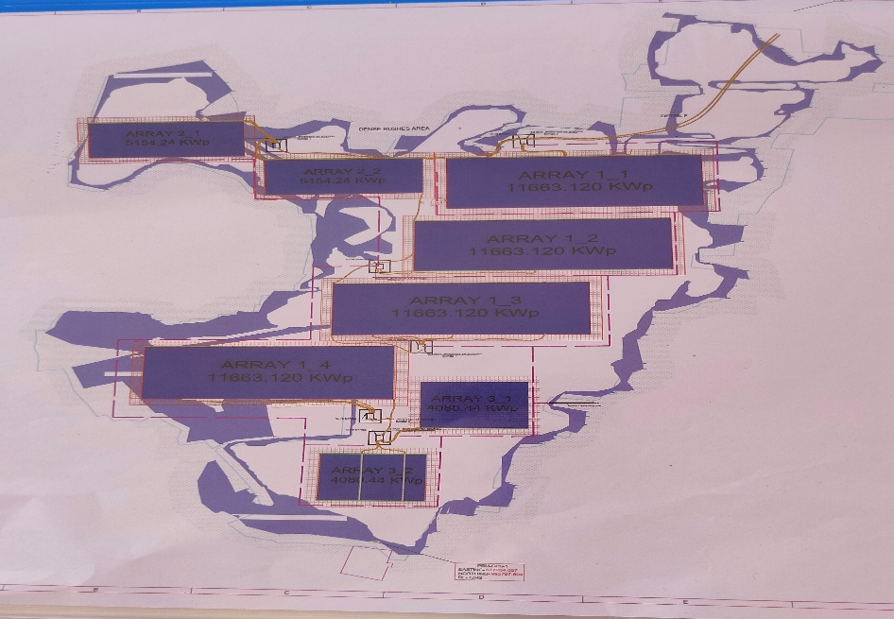

Fig 3.2 Area identified for placing solar arrays

3.2 Existing Site Status During the Visit
At the time of the site visit, the project was in the early pre-construction phase. Physical activities at the site were limited to initial levelling and preparatory civil works, mainly focused on making the land accessible for future construction activities. No permanent civil structures, floating platforms, or electrical installations had been executed at this stage.
The visit primarily involved identifying and visually marking the proposed floating solar area, explaining the planned layout of arrays over the water body, and discussing the sequence of upcoming construction activities. This stage of development highlights the importance of careful planning and site readiness before the commencement of major installation works.

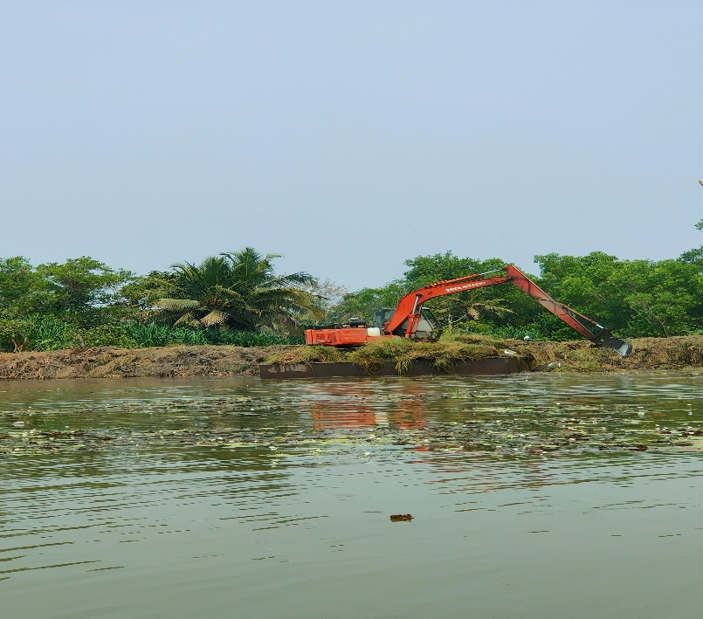

Fig 3.3 Site leveling and preparatory civil works observed during the visit

3.4 Proposed Switchyard Location and Soil Conditions
During the site visit, the project team identified the initially proposed location for the 110 kV switchyard, which is a critical component of the power evacuation system. Detailed geotechnical investigations carried out at this location indicated poor soil bearing capacity, necessitating deep piling of approximately 20 meters to achieve foundation stability.
Such deep piling significantly increases civil construction cost and extends construction timelines, thereby affecting overall project economics. Considering this constraint, the project authorities informed that alternative switchyard locations with better soil conditions are being explored. This highlights the importance of integrating geotechnical feasibility with electrical planning in large-scale renewable energy projects.

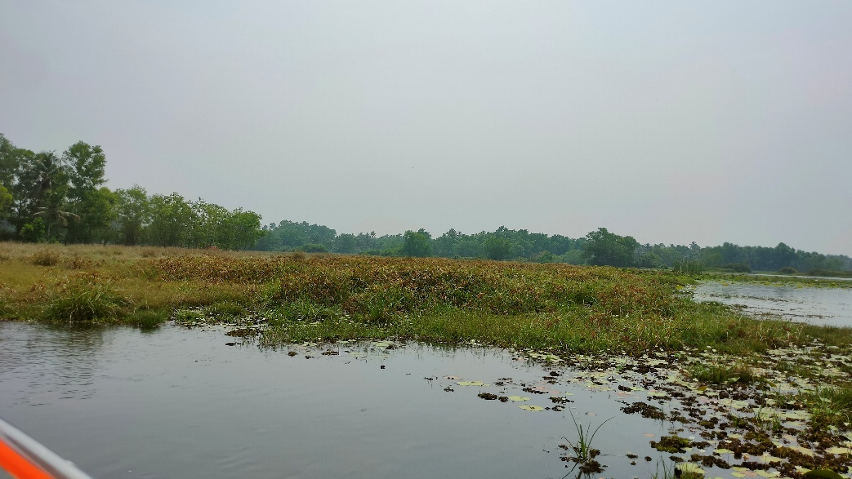

Fig 3.4 Land parcel initially identified for the proposed 110 kV switchyard

3.5 Floating Structure Procurement and Handling Area
The site visit also covered the procurement and handling area for floating pontoons, which forms an essential logistical component of the project. This area is used for receiving, storing, and assembling modular floating structures before their deployment into the water body.
The pontoons act as the primary support system for the solar modules and are designed to withstand continuous exposure to water, wind loads, and environmental conditions. Proper handling and staging of these components are crucial to ensure quality control and smooth installation during the construction phase.

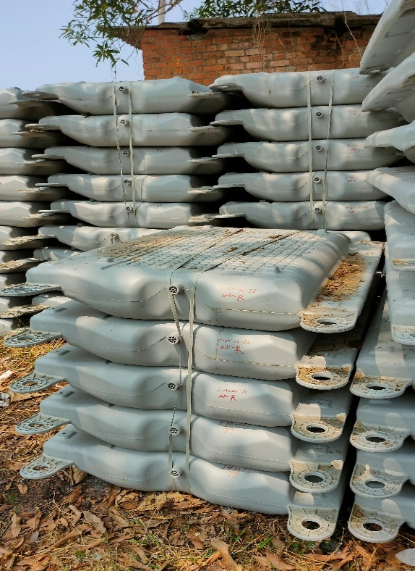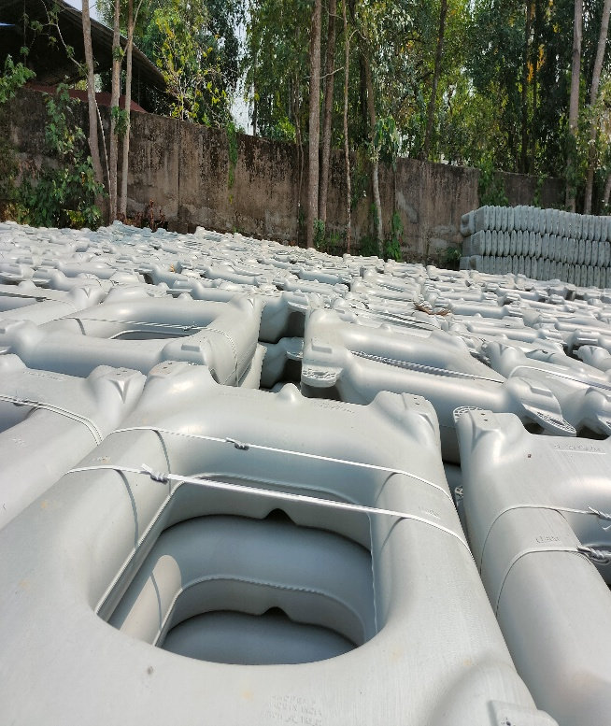

Fig 3.5 Floating pontoon for movement
Fig 3.6 Floating pontoon for solar panels

3.6 Anchoring Requirements for Floating Solar Arrays
Anchoring was emphasized as one of the most critical design aspects of the floating solar system. It was explained that each floating array requires approximately 100 anchoring points to ensure positional stability. The anchoring system is designed to resist wind forces, water currents, and seasonal fluctuations in water level.
Effective anchoring prevents drift and rotation of floating platforms, thereby protecting both the structural integrity of the system and the associated electrical cables. Improper anchoring could lead to mechanical stress, misalignment, and long-term reliability issues, making this aspect particularly important for floating solar installations.

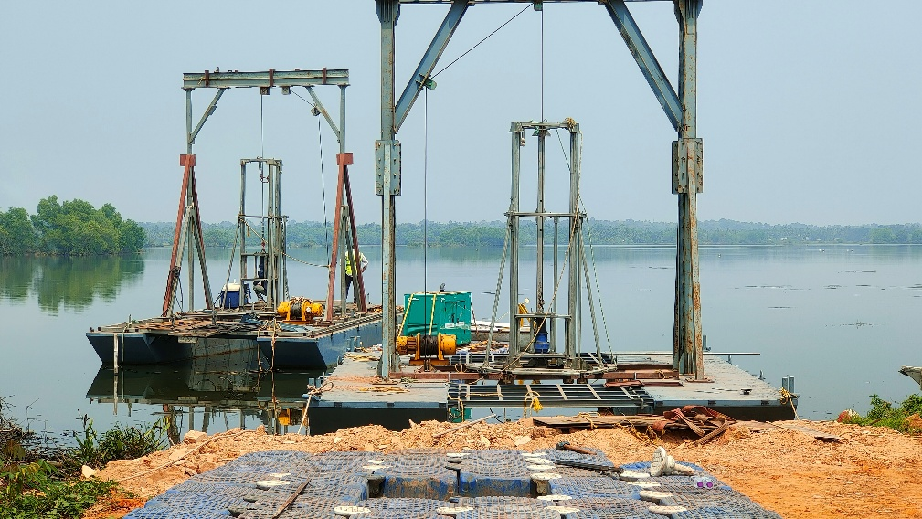

Fig 3.7 Anchoring arrangement explained during the site visit

CHAPTER - 4
TECHNICAL CONFIGURATION

4.1 Overview of System Configuration
The West Kallada Floating Solar Power Project is a 50 MW grid-connected floating photovoltaic installation developed by NHPC Limited with power evacuation and offtake by Kerala State Electricity Board. The plant is designed with a DC capacity of 65 MWp to deliver 50 MW AC to the grid, adopting a DC overloading strategy to improve inverter utilization and annual energy yield.
The electrical configuration integrates TopCon bifacial photovoltaic modules, modular floating platforms, centralized inverters, and barge-mounted electrical infrastructure, as represented in the project Single Line Diagram (SLD).

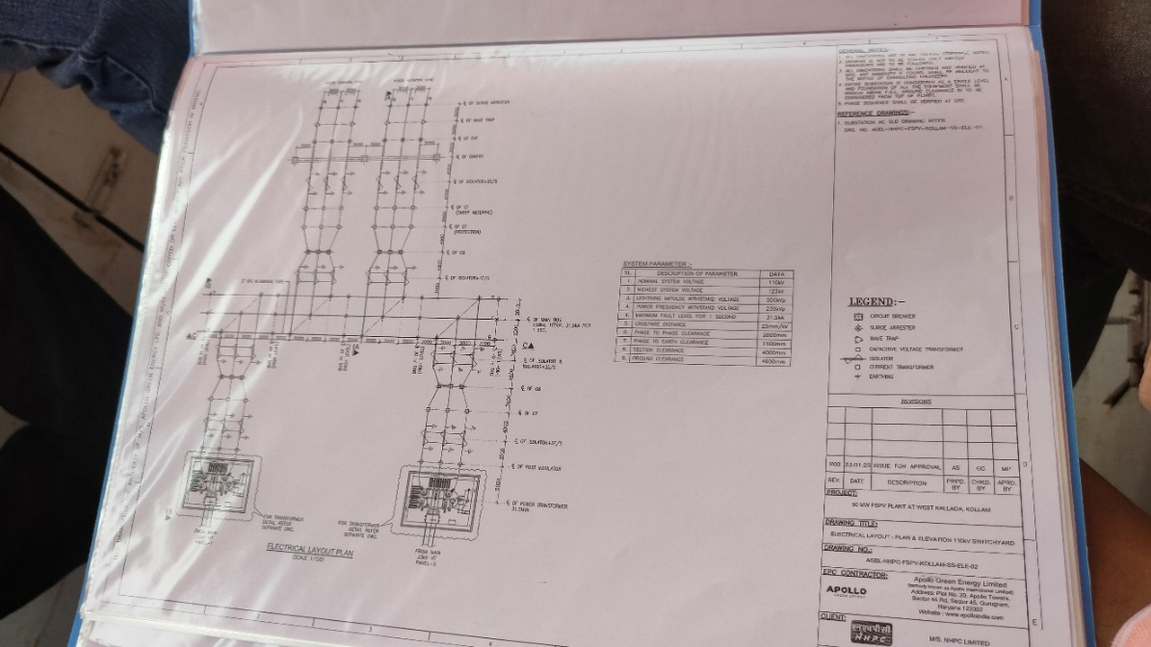
Fig 4.1 Single Line Diagram illustrating the electrical configuration and power evacuation scheme

  Installed DC Capacity
  65 MWp
  Installed AC Capacity
  50 MW
  PV Module Technology
  TopCon bifacial monocrystalline
  Module Rating
  590 Wp
  Total Number of Modules
  ~1.10 lakh
  Inverters
  10 × 4.4 MVA and 2 × 3.3 MVA
 | 660 V AC
  Inverter Output Voltage
 | 5 × 8.8 MVA and 1 × 6.6 MVA
  Inverter Duty Transformers (IDTs)
  Intermediate Voltage Level
  33 kV
 | 2 × 31.5 MVA (33/110 kV)
  Main Power Transformers
  Number of Floating Arrays
  8
  Barge Stations
  6
 | 110 kV LILO on Kundara–Chavara line
  Power Evacuation Scheme
 | 7 towers, ~1.2 km 110 kV line
  Transmission Infrastructure

4.2 Photovoltaic Generation and DC System
The project utilizes high-efficiency TopCon bifacial monocrystalline photovoltaic modules, each rated at 590 Wp, selected for their improved performance under diffuse and reflected irradiance conditions typical of floating solar installations. The reflective water surface enhances rear-side irradiance, resulting in increased energy output compared to conventional monofacial modules.
Approximately 1.10 lakh modules are mounted on modular floating pontoon platforms designed specifically for aquatic environments. The arrays are arranged in rectangular blocks to ensure mechanical stability, uniform load distribution, ease of electrical routing, and effective anchoring. A robust anchoring system secures the floating arrays against wind forces, water currents, and seasonal variations in water level.
The DC electrical system follows a standardized string configuration, with 28 modules connected in series and two such strings connected in parallel to form one input to a String Combiner Box (SCB). The SCB output operates at approximately 1200 V DC, which reduces current levels and minimizes DC cable losses. DC aggregation up to the SCB level is carried out directly on the floating arrays in alignment with the SLD.

4.3 Power Conversion and AC Collection System
DC power collected from the SCBs is routed to centralized inverters installed on barge-mounted platforms within the water body. The inverter configuration consists of ten units rated at 4.4 MVA and two units rated at 3.3 MVA, converting DC input to 660 V AC. Centralized inverter placement simplifies protection coordination, monitoring, and maintenance while limiting the dispersion of electrical equipment across the floating arrays.
Each pair of inverters feeds into an Inverter Duty Transformer (IDT), adopting a two-inverter–one-transformer configuration. The project includes five IDTs rated at 8.8 MVA and one IDT rated at 6.6 MVA. In this arrangement, two inverter outputs are connected to two primary windings of the IDT, with a single secondary winding stepping up the voltage from 660 V AC to 33 kV AC. This configuration optimizes transformer utilization, reduces equipment redundancy, and improves overall system efficiency.
The floating solar plant is electrically segmented into eight independent floating arrays, with capacities of 11.663 MWp, 5.154 MWp, and 4.080 MWp, enabling better load distribution and operational flexibility. Power from these arrays is consolidated through six barge-mounted stations, each functioning as a 33 kV collection node housing inverters, IDTs, protection systems, and auxiliary equipment.

4.4 Grid Interface and Power Evacuation
The stepped-up 33 kV AC power from the barge stations is transmitted to the onshore facility through floating and underwater power cables, which terminate at the Main Control Room (MCR). At the onshore end, incoming 33 kV feeders are connected to high-tension switchgear panels and routed to the main step-up transformers.
The project includes two main power transformers, each rated at 31.5 MVA with a voltage ratio of 33/110 kV. A 110 kV switchyard is proposed with two incomer bays and two outgoing bays, ensuring redundancy and reliable grid interfacing.
Power evacuation to the state grid is carried out through a 110 kV Line-In Line-Out (LILO) arrangement on the Kundara–Chavara transmission line, involving approximately 1.2 km of transmission line and seven transmission towers. This configuration enables seamless integration of the project into the existing grid network while complying with applicable grid codes and protection requirements.

CHAPTER - 6
ENVIRONMENTAL AND SOCIAL CONSIDERATIONS

6.1 Environmental Setting of the Project Area
The West Kallada Floating Solar Power Project is located in a region dominated by low-lying, waterlogged paddy fields that remain submerged for most of the year. Due to prolonged water stagnation, these areas have limited agricultural productivity and are largely underutilized. The adoption of floating solar technology allows productive use of this landscape without altering the existing land-use pattern.
By installing photovoltaic arrays on the water surface, the project avoids large-scale land clearance and minimizes disturbance to the surrounding environment. This approach aligns well with sustainable development principles and reduces the ecological footprint compared to conventional land-based solar projects.

6.2 Land Use and Resource Optimization
The project makes use of water-covered land through a lease-based model, ensuring that land ownership remains unchanged. Onshore land usage is limited to essential infrastructure such as the Main Control Room, switchyard, and access facilities. No permanent conversion of agricultural land is involved.
This form of land utilization:
- Prevents loss of cultivable land
- Avoids deforestation and extensive earthworks
- Enables renewable energy generation from otherwise unproductive areas
Overall, the project demonstrates effective resource optimization by balancing energy generation with land conservation.

6.3 Impact on Water Body and Aquatic Environment
The floating solar arrays partially cover the water surface, while maintaining adequate spacing between array blocks to allow sunlight penetration and water circulation. The anchoring and mooring systems are designed to minimize disturbance to the waterbed and surrounding aquatic environment.
Materials used for floating platforms and anchoring components are non-toxic and corrosion-resistant, ensuring long-term compatibility with the aquatic setting. During the site visit, it was observed that the water body is not intensively used for fishing or biodiversity-sensitive activities, reducing the likelihood of ecological conflict.

6.4 Social Aspects and Community Acceptance
One of the significant advantages of the project is the absence of residential displacement. Since the land has remained largely unused due to persistent waterlogging, the project does not interfere with existing livelihoods or settlements.
The project also generates local employment opportunities during construction and operation phases, contributing to the regional economy. Community acceptance is further strengthened through institutional implementation by NHPC Limited, ensuring transparency and regulatory compliance, with power evacuation managed by Kerala State Electricity Board.

6.5 Land Leasing and Revenue Sharing Mechanism
A key socio-economic feature of the West Kallada Floating Solar Power Project is its land leasing and revenue-sharing framework. The land required for the project is taken on lease rather than through permanent acquisition, allowing landowners to retain ownership.
As part of this arrangement, 3 percent of the total project revenue is shared with the landowners. This provides them with a continuous and predictable income stream from land that would otherwise remain unproductive. The revenue-sharing model reduces social resistance, encourages long-term cooperation, and creates a direct financial link between project performance and community benefit.

6.6 Environmental Safeguards and Compliance Measures
Environmental protection measures are incorporated throughout the construction and operation phases of the project. These include:
- Controlled handling of construction materials to prevent water contamination
- Proper waste management and disposal practices
- Electrical safety and oil-spill prevention measures at barge stations and transformer locations
- Periodic inspection and monitoring of floating and electrical systems
Compliance with applicable environmental regulations and standards ensures that the project remains environmentally responsible over its operational life.

6.7 Overall Environmental and Social Significance
The West Kallada Floating Solar Power Project illustrates how renewable energy infrastructure can be integrated into environmentally sensitive and socially complex settings. By transforming underutilized waterlogged land into a clean energy asset while ensuring community participation through leasing and revenue sharing, the project establishes a balanced model of sustainable development.

CHAPTER – 7
CHALLENGES OBSERVED AND MITIGATION MEASURES

7.1 Irregular Site Geometry and Area Utilization
Challenge:
Although the total available project area is large, the water body and surrounding land have an irregular shape. Floating solar arrays are typically designed in rectangular blocks for mechanical stability, standardized electrical routing, and efficient anchoring. Due to this mismatch, a significant portion of the available area cannot be effectively utilized.
Mitigation:
The project capacity has been optimized to 50 MW (AC) by utilizing only the technically feasible sections of the site. Careful array layout planning ensures maximum utilization of usable water surface while maintaining structural and electrical integrity.

7.2 Soil Conditions at the Switchyard Location
Challenge:
Geotechnical investigations at the initially identified switchyard site indicated poor soil bearing capacity, requiring deep piling of approximately 20 meters to achieve foundation stability. This significantly increases civil construction costs and impacts overall project viability.
Mitigation:
Alternative locations with improved soil characteristics are being evaluated for switchyard construction. This approach reduces foundation costs and construction complexity while maintaining electrical design requirements.

7.3 Anchoring Complexity in a Floating Environment
Challenge:
Floating solar installations require a robust anchoring system to withstand wind forces, water currents, and seasonal variations in water level. The large size of each floating array necessitates approximately 100 anchoring points per array, increasing design and installation complexity.

Mitigation:
A detailed anchoring design has been adopted based on site-specific conditions. The use of distributed anchoring points ensures uniform load sharing and long-term stability of floating platforms.

7.4 Electrical Cable Routing Over Water
Challenge:
Routing DC and AC cables across floating arrays and underwater introduces risks such as mechanical damage, insulation degradation, and maintenance difficulty due to constant exposure to moisture.
Mitigation:
The project employs water-resistant, UV-protected cables supported on floating trays and protected conduits. Cable routes are designed with adequate slack to accommodate movement of floating structures without inducing mechanical stress.

7.5 Power Evacuation Coordination
Challenge:
Power evacuation involves a 110 kV LILO arrangement on an existing transmission line, requiring careful coordination to ensure grid safety and minimal disruption.
Mitigation:
Close coordination with Kerala State Electricity Board ensures compliance with grid codes, proper protection coordination, and smooth grid integration.

7.6 Environmental and Weather-Related Challenges
Challenge:
The project site is exposed to monsoon conditions, high humidity, and strong winds, which can affect construction schedules and equipment durability.
Mitigation:
Construction activities are planned in phases to avoid peak monsoon periods. All mechanical and electrical components are selected for high corrosion resistance and long-term performance in humid environments.

7.7 Social and Land-Related Considerations
Challenge:
Large infrastructure projects often face resistance due to land acquisition and long-term land use concerns.
Mitigation:
The adoption of a lease-based land model with 3 percent revenue sharing ensures continuous benefits to landowners and strengthens local acceptance of the project, reducing social risk.

CHAPTER – 8
KEY LEARNINGS AND OBSERVATION FROM THE SITE VISIT

8.1 Practical Understanding of Floating Solar Technology
The site visit provided valuable exposure to the practical implementation of floating solar photovoltaic systems. Observing the planned array layouts, anchoring strategy, and barge-mounted electrical infrastructure helped bridge the gap between theoretical knowledge and real-world application of floating solar technology.
The visit highlighted how floating solar installations differ from ground-mounted systems in terms of mechanical design, electrical routing, and maintenance considerations.

8.2 Integration of Civil and Electrical Engineering
One of the key takeaways from the visit was the strong interdependence between civil and electrical design in floating solar projects. Issues such as soil bearing capacity, water depth, anchoring requirements, and switchyard location directly influence electrical layout and project cost.
The challenge associated with deep piling at the proposed switchyard location emphasized the importance of early geotechnical assessment in large infrastructure projects.

8.3 Importance of Site-Specific Design
The limitation imposed by the irregular shape of the available land demonstrated that project capacity is not solely determined by total area, but by the usability of that area based on array geometry and technical constraints. This reinforced the need for site-specific planning rather than standardized design assumptions.

8.4 Grid Integration and Power Evacuation Planning
The explanation of the 33 kV collection system, 110 kV switchyard, and LILO-based power evacuation provided insight into the complexities of grid integration. Coordination with state utilities and adherence to grid codes were observed to be critical for successful commissioning and operation.

8.5 Socio-Economic Considerations in Project Development
The land leasing and 3 percent revenue-sharing model illustrated how infrastructure projects can be structured to include community participation. This approach not only reduces social resistance but also contributes to long-term project sustainability.

8.6 Professional and Technical Exposure
Interaction with project officials, including representatives from the electrical and civil departments, provided a clear understanding of professional roles, project coordination, and decision-making processes in large-scale renewable energy projects. The visit offered valuable insight into project execution from planning to implementation stages.

8.7 Overall Learning Outcome
The site visit to the West Kallada Floating Solar Power Project offered comprehensive learning across technical, environmental, and social dimensions. The experience enhanced understanding of floating solar technology and reinforced the importance of integrated planning, stakeholder coordination, and site-specific design in renewable energy projects.

CHAPTER – 9
CONCLUSION

The West Kallada Floating Solar Power Project represents a well-planned application of floating solar technology to address land constraints while supporting Kerala’s renewable energy objectives. By utilizing waterlogged and underutilized land through a floating photovoltaic system, the project demonstrates an effective approach to sustainable energy generation without competing with agricultural or residential land use.
The site visit provided a clear understanding of the project’s technical configuration, including bifacial photovoltaic modules, modular floating arrays, centralized inverters, barge-mounted electrical systems, and a structured power evacuation scheme. Observations related to site geometry, soil conditions, anchoring requirements, and grid integration highlighted the importance of site-specific design and interdisciplinary coordination in large-scale renewable energy projects.
Equally significant is the project’s social and environmental framework. The lease-based land utilization model, combined with a 3 percent revenue-sharing mechanism for landowners, promotes community participation and long-term social acceptance. Environmental safeguards integrated into both construction and operation phases further reinforce the project’s sustainability.
Overall, the West Kallada Floating Solar Power Project serves as a strong example of how technical innovation, environmental responsibility, and social inclusion can be effectively combined in renewable energy development. The insights gained from the site visit contribute to a deeper understanding of floating solar power plants and their role in meeting future energy demands.

