Mad Hatters Kitchen
Guest Folder
Le Logis, Le Breuillac, Caunay

Welcome
We are delighted to welcome you to Mad Hatters Kitchen. This folder contains the practical details for your stay, together with breakfast and dining options, house notes, local suggestions and useful information for the area.
If there is anything you need, please ask. We want you to feel relaxed, comfortable and at home.

Wi-Fi: Mad Hatters Guest - no password required

Welcome to Mad Hatters Kitchen
Mad Hatters Kitchen is tucked away at Le Logis, Le Breuillac, on the edge of Caunay. Once a tea garden, the house has grown into a much-loved restaurant, bar and place to stay, known for seasonal food, rustic charm and a relaxed countryside atmosphere.
We hope you feel completely at home during your stay and enjoy the house, the gardens and the surrounding area. Tea and coffee are supplied in your room, and we have a fully licensed bar for drinks in the bar, on the terraces or, by arrangement, in your room.
Restaurant reservations are strongly recommended, especially for evening meals and Sunday lunch. We are always happy to help with breakfast choices, dinner bookings, local recommendations, directions and onward travel plans.

Your stay at a glance
Wi-Fi | Mad Hatters Guest - no password required.
Check-in | Rooms are normally ready from 17:30.
Check-out | Please vacate your room by 10:00 on the day of departure.
Early check-in | Available from 12:00 by prior arrangement, subject to room availability. Charge: €20 per room.
Late check-out | Available until 14:00 by prior arrangement, subject to room availability. Charge: €20 per room.
Breakfast | Served downstairs in the restaurant between 08:30 and 09:30. Breakfast boxes may be possible if arranged in advance for earlier check-outs.
Room keys | Keys are normally left in your room door. On departure, you may leave the key in the door unless we have agreed otherwise.
Front door | The front door is usually open until 21:00. If you expect to return later, please arrange a key with us in advance.
Multi-night stays | If you are staying more than one night, please speak to us about daytime access and housekeeping arrangements, as rooms may need to be serviced during the day.

Please speak to us as early as possible if you would like to add early check-in, late check-out, an earlier breakfast or a dinner reservation to your stay.

Breakfast at Mad Hatters
Whether you would like a light start to the day or something more generous, we offer three breakfast options. If breakfast is included in your booking, this includes our Light Continental Breakfast.
For the smoothest service, please let us know your breakfast choice in advance whenever possible. Full English breakfasts and the Mad Hatters Continental are best ordered the night before.

Light Continental Breakfast | €8
Fresh bread with butter and jam
One croissant or breakfast pastry
A glass of orange juice
One freshly served tea or coffee
Included where a booking includes our standard breakfast.

Mad Hatters Continental | €12
Everything included in the Light Continental Breakfast
Selection of cold meats
Boiled eggs
Fresh Greek yoghurt with fruit compote
Refillable orange juice
Unlimited tea and coffee
Upgrade from Light Continental: €4 per person.

Mad Hatters Full English Breakfast | €15
A freshly cooked full English breakfast
Toast with butter and jam
Refillable orange juice
Unlimited tea and coffee
Upgrade from Light Continental: €7 per person. This is a separate cooked breakfast option and does not include the cold meats, boiled eggs or yoghurt with fruit compote selection.

Evening meals at Mad Hatters
Fresh, seasonal food is at the heart of what we do. Our menus are based on honest cooking and ingredients that speak for themselves. Menus change regularly and fresh daily options are often available on the specials board, so please ask to see what is on offer during your stay.

Restaurant opening | The restaurant is normally open from 19:00 to 21:00 on Thursday, Friday and Saturday evenings.
Other evenings | Meals may be arranged on Monday, Tuesday, Wednesday and Sunday evenings by prior agreement.
Booking | Pre-booking is essential for evening meals and Sunday lunch, especially during quieter periods.
Dietary options | Vegetarian options are available. Vegan main courses can be prepared by arrangement.
Sunday lunch | Traditional three-course Sunday lunch is available every Sunday lunchtime. Charge: €25.50 per person.

Main dinner menu
Three courses | €27.50
Starters | €6 each
Mains | €17.50 each
Desserts | €6 each

Typical starters
- Home-made quiche of the day, served with salad.
- Home-made Pâté, served with pickles and chutney.
- Goat’s cheese with beetroot and walnut salad, with honey dressing.
- Cheddar Cheese Jalapenos, served with salad.

Typical mains
- Scampi and chips with peas and tartare sauce.
- Steak, served with chips, mushrooms, onion rings, grilled tomato and salad.
- Home-made pie with seasonal vegetables and a choice of chips or mashed potato, served with gravy.
- Fish of the day, pan-fried with seasonal vegetables and a cream & mushroom garlic sauce.
- Vegetable lasagne with chips and salad.

Typical desserts
- Home-made Seasonal fruit crumble with ice cream, cream or custard.
- Home-made Chocolate Nemesis (a delicious soft and gooey grenache served by the slice).
- Home-made Sticky toffee pudding with ice cream, cream or custard.
- Home-made Crème brûlée.

Please ask us about the day's specials before ordering, as fresh daily choices may also be available on the board in the restaurant.

The bar, terrace and gardens
In warmer weather, the terrace is the perfect place to relax with an aperitif before dinner, a light lunch or an afternoon drink. Inside, the bar is well stocked with hand-pull artisan real ale, draught Belgian lager, bottled beers, spirits and soft drinks, alongside a choice of speciality gins, whiskies and rums.
Mad Hatters also hosts special events across the year, including music evenings, bistro evenings and themed food nights. If you would like drinks before dinner, a table on the terrace or details of any upcoming events during your stay, please speak to us.
The gardens and terraces are available for guests to enjoy on both sides of the house. Depending on the time of day, you may find sunshine on one side and shade on the other. There is also a small lake to the left behind the wall, where it is fun to watch the frogs jump in.
Please enjoy the garden and terrace areas respectfully, keeping noise to a considerate level for other guests, especially later in the evening.

Children, animals and dogs

Children
Mad Hatters is a lovely place for children, and it is wonderful to see them enjoying the freedom of the gardens and countryside. Please remember, however, that other residents may be staying for a peaceful break, so children should be supervised by an adult.
There may be horses, alpacas, chickens, cats and dogs around the property. Children are very welcome to look at the animals, but please do not allow them to chase, frighten or round them up.

Dogs
Dogs are welcome by arrangement. Please always keep dogs on a lead while on the premises, as we have animals and free-range chickens in the grounds.
- Please walk your dog outside the premises for toileting.
- Dog waste bags should be placed in the municipal bins on the corner of the road.
- Please do not leave your dog alone in the bedroom if you go out for the day.
- There are woodland and track walks nearby, which are excellent for dogs.

Discover the local area
Gentle walks, Romanesque heritage, family days out and unusual local discoveries, all within easy reach of Mad Hatters Kitchen.
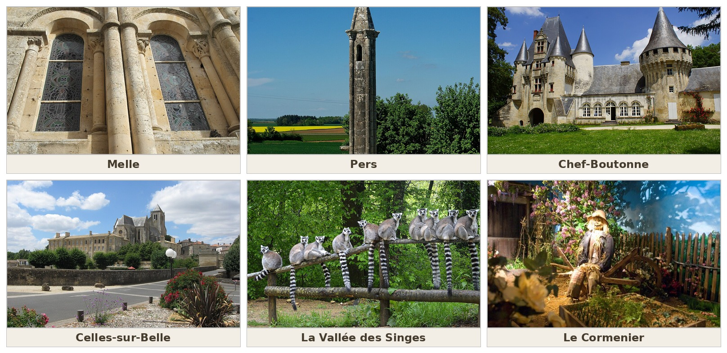

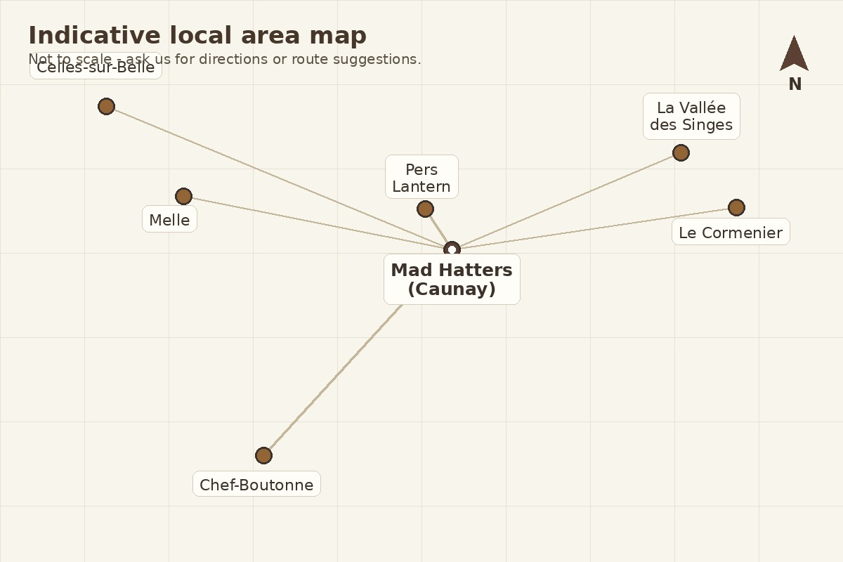  Map is indicative only; please check opening times and routes before making a special journey. | A gentle starting point  For a relaxed local outing, start with the church at Caunay, the nearby Fontaine de Fontadam and the Circuit des Meulières woodland walk. These make an easy way to enjoy the countryside without a long drive.  Worth knowing  • Some attractions have seasonal opening times.  • Markets, public holidays and lunch breaks can affect plans.  • Please ask us if you would like directions or a route suggestion.

History and heritage  • Lanterne des Morts de Pers, a rare medieval “Lantern of the Dead” in the nearby village of Pers and an interesting short stop for unusual local heritage.  • Melle, with its Romanesque churches, the UNESCO-listed Saint-Hilaire church and the Mines d’Argent des Rois Francs.  • Chef-Boutonne, with the Château de Javarzay, gardens and attractive green spaces.  • Celles-sur-Belle, home to the impressive Abbaye Royale de Celles-sur-Belle. | Family days out  • La Vallée des Singes, a primate park near Romagne, set in a natural wooded setting.  • Le Cormenier, an immersive family attraction exploring rural village life of the past through scenes, sounds, smells and special effects.  Walking, cycling and treasure trails  If you enjoy walking, cycling or geocaching, ask us about local Tèrra Aventura trails and the Vélidéale cycling route through the Pays Mellois.

Ask us for directions or a route suggestion if you would like to make a day of it.

Useful local information

Visitor information
For visitor information, maps, brochures and what's on, the most useful local resource is the tourist information office in Melle, 2 Place Bujault. Telephone: 05 49 29 15 10.

Groceries and supplies
Super U | 2 Route de Montalembert, BP 21, 79190 Sauzé-Vaussais / Sauzé-entre-Bois.
Intermarché Super Lezay | Rue de Melle, 79120 Lezay.
U Express Chef-Boutonne | 17 Place Cail, 79120 Chef-Boutonne.
Intermarché Super Melle | 41 Route de Poitiers, 79500 Melle.

Local markets
Monday | Chaunay
Tuesday | Lezay
Thursday | Sauzé-Vaussais
Friday | Melle
Saturday | Chef-Boutonne

Public holidays and seasonal variations can affect market schedules, so it is best to check locally if a particular market is central to your plans.

Onward travel
The nearest major rail stations worth noting are Ruffec and Poitiers. The nearest airport is Poitiers-Biard Airport. If you need help arranging a taxi, please ask us and we will do what we can to help.

Emergency and medical help
In an emergency, call the appropriate French emergency service. If you are unsure which number to use, 112 is the European emergency number.
112 | European emergency number.
15 | Urgent medical help / SAMU.
17 | Police.
18 | Fire brigade.
114 | Emergency SMS service for deaf or hard-of-hearing users.

Nearby medical details
Hospital | Centre Hospitalier Haut Val de Sèvre et Mellois, Route de la Roche, 79500 Melle. Telephone: 05 49 27 44 00.
Pharmacy | Pharmacie du Centre, 49 Rue de la Chevalonnerie, Sauzé-Vaussais / Sauzé-entre-Bois. Tel: 05 49 07 60 06. Lezay: Pharmacie Centrale, 9 Place de la Payse. Tel: 05 49 29 40 22.
GP practices | Cabinet Médical, 22 Rue Treille Bourgeau, Sauzé-Vaussais / Sauzé-entre-Bois. Tel: 05 49 07 60 60. Appointments may be required; visitor availability can vary.
On-duty pharmacy | Outside normal opening hours, call 3237 or use 3237.fr to find the nearest on-duty pharmacy.

Before you leave
- Please vacate your room by 10:00 unless late check-out has been agreed in advance.
- Please leave your room key in the door unless we have agreed another arrangement.
- Please check that you have all personal belongings, chargers and travel documents.
- Please leave this guest folder in the room for the next guest.
Thank you for staying with us. We hope you have enjoyed your time at Mad Hatters Kitchen and would be delighted to welcome you back again.

