Project Synopsis
Design and Development of a Passive Thermally-Activated Gas Fire Suppression System for Sleeper Bus Cabins
1. Background and Motivation
Sleeper buses present a unique fire safety challenge due to confined cabin volumes, high combustible material content, and the presence of sleeping passengers who may not respond immediately during a fire emergency. Conventional fire suppression systems in buses rely on manual intervention, electrical sensors, or centralized actuation, which can be unreliable during accidents involving power loss or rapid fire growth.
There is a critical need for a passive, self-actuating fire suppression mechanism that can operate without electrical input, activate at early fire temperatures, and be localized to individual sleeper cabins to improve survivability.
2. Problem Statement
Current vehicle fire suppression approaches suffer from limitations such as dependence on electrical systems, delayed activation, lack of localized protection for sleeper berths, and non-resettable designs. These limitations increase response time and reduce the effectiveness of fire suppression in sleeper bus environments.
3. Objective of the Project
The objective of this project is to design and demonstrate a passive, thermally-activated gas release system capable of automatically discharging an inert fire-suppression gas into a sleeper bus cabin when local temperatures exceed a critical threshold (100–120 °C), without requiring electrical power or manual intervention.
4. Proposed Solution
The proposed system consists of a closed-loop steel gas storage tube routed around the perimeter of a sleeper cabin. The tube stores compressed inert gas and incorporates localized thermal-activation points at geometric fillets, which are regions most exposed to rising hot gases during a fire.
Key functional elements:
- Circular steel tubing (50 mm internal diameter, 4 mm wall thickness)
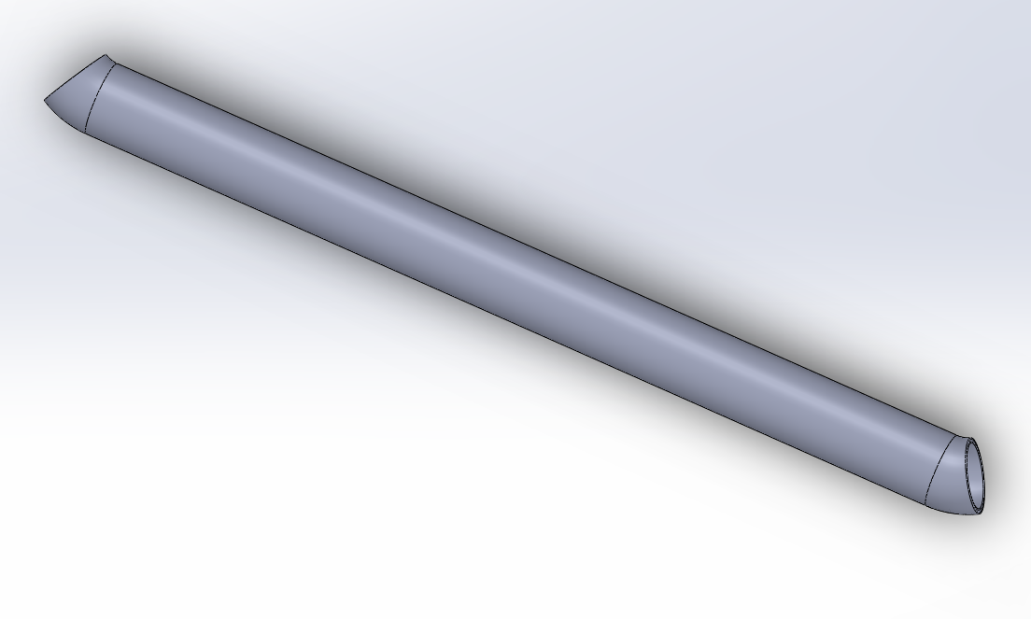
- Square loop geometry with rounded corners to maximize exposure to hot gas layers

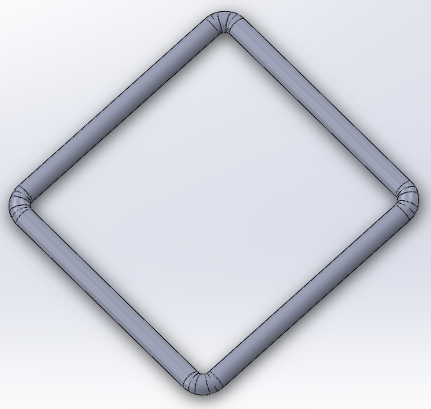
- Thermal fuse inserts made from low-melting fusible alloys (100–120 °C)
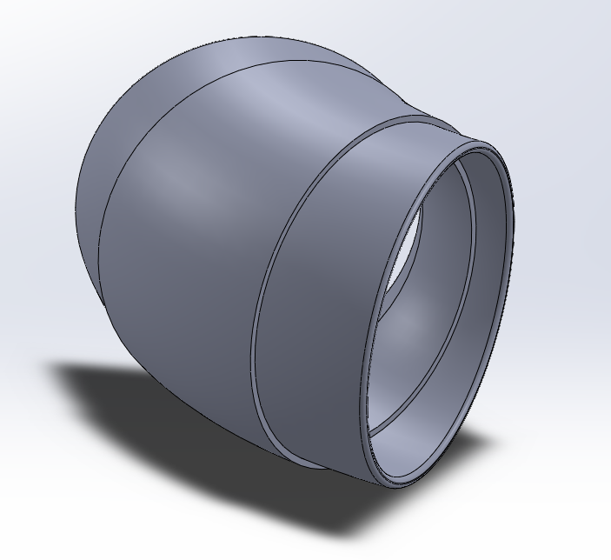
- Modular tab-and-slot connector mechanism for replaceable thermal elements

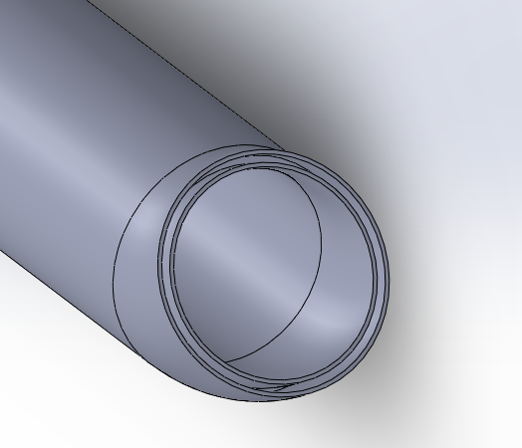
5. Working Principle
Under normal operating conditions, the gas remains sealed within the steel tube. During a fire, hot gases accumulate near the ceiling and corners of the sleeper cabin, raising the local temperature at the tube fillets. A low-melting fusible alloy insert melts at approximately 100–120 °C, creating an opening in the tube and releasing the stored inert gas into the cabin. After activation, only the thermal insert requires replacement.
6. Design Features
- Passive operation without electrical components
- Localized suppression for individual sleeper cabins
- Early activation before flashover conditions
- Resettable and modular design
- Steel tube as the primary pressure boundary
7. Expected Outcomes
The project is expected to demonstrate a mechanically simple, reliable, and passive fire suppression concept that improves fire response time and enhances passenger safety in sleeper bus cabins.
8. Applications
Applications include sleeper buses, enclosed vehicle cabins, rail sleeper compartments, and other confined passenger enclosures.
9. Conclusion
This project proposes a passive, thermally-activated gas fire suppression system tailored for sleeper bus cabins. By combining steel pressure vessels with low-melting thermal fuse elements, the system provides early, automatic fire suppression while remaining simple, reliable, and resettable.

