Enhancing the Longevity of Drill Pipes: The Role of Nanoparticle-Enhanced Drilling Muds in Erosion Control
Dhanush Eshwar Rendi ¹, Muttevi Chinmaya Datta ¹, P Upendra Taraka Sai ¹
and Smita Singh ^{1,} *
¹ Dept. of Mechanical Engineering, Amrita School of Engineering, Amrita Vishwa Vidhyapeetham, Bengaluru, KA, 560035.
Corresponding author email: smita_singh@blr.amrita.edu

Abstract: This study investigates the impact of drilling mud characteristics, including shear stress, pressure, and particle velocity, on the erosion and wear of drill pipes during deep-sea drilling operations. We test how well water-based, oil-based, and nanoparticle-enhanced drilling fluids work by using both MATLAB-based erosion models and ANSYS CFD simulations. The most important results show that the speed of the fluid, the size of the particles, and the addition of nanoparticles all have a big effect on erosion rates. Graphene oxide was the best additive for stopping erosion, followed by carbon nanotubes and titanium dioxide. The study gives important information about how to improve drilling fluid formulations to make drill strings last longer while considering both environmental and economic factors. This is done by looking at erosion patterns and fluid properties. Keywords: Erosion Prediction, Computational Fluid Dynamics (CFD), Discrete Phase Module (DPM).

1. Introduction
For many years, getting oil and gas from deep underwater sources has played a key role in the world’s energy supply. Drilling muds, also known as drilling fluids, are vital for ensuring that the drilling process is safe and effective in these situations. The main tasks of drilling mud are to cool and lubricate the drill bit, hold the cuttings in place, and transport them to the surface. It also stabilizes the wellbore and manages pressure changes. [1] Drilling mud, however, can cause many problems, especially when it comes into contact with drill pipes. As drilling goes deeper, the drill pipes face significant stress from mechanical forces, fluid dynamics, and erosion. All of these factors greatly affect the durability and performance of the drill string and drill bit. [2]
This study aims to understand how different drilling mud properties, such as shear stress, wall shear strength, pressure, and velocity, affect the material properties of drilling fluids and drill pipes. We seek to improve the formulation and use of drilling fluids to lessen the negative impacts of these interactions by looking at how these factors influence drill pipe erosion and wear. We also want to examine how different drill muds affect the drill pipe. Additionally, we are researching various drill fluids and their influence on the drill pipe. The goal is to evaluate how well different drilling fluids can erode pipe materials. This work takes a unique approach by assessing the performance of different drilling muds and their effect on the drill string through simulations. This will help us make more accurate erosion rate predictions, leading to better choices when selecting drilling fluids to extend the lifespan of drill pipes and create a more cost-effective strategy.

Our study focuses on the use of both water-based and oil-based muds, each with its own pros and cons. For instance, water-based muds are often preferred for their low environmental impact and cost efficiency, but they may have issues with fluid stability and erosion control [3]. Oil-based muds provide better lubrication and stability. However, they are more expensive and have environmental issues [4]. Our research examines these fluids in practical drilling situations. We aim to evaluate their impact on drill pipe wear and find the best drill mud that balances performance with cost.

Regarding other studies, Zhao et al. [5] researched the torsional dynamics of a drilling robot system. They analyzed vibrations, fluid movement, and pressure changes. Their work offers a method for suppressing torsional vibrations in the CTD robot drilling system, which aids in precise control. Finnie et al. [6] noted that erosion from solid particles relies on the motion of the particles in the fluid and the surface behavior when the particles hit it. They discussed the effects of various factors like particle speed, size, and hardness.

Singh et al. [7] studied how different slurry particles erode pipe bends. They discovered that the shape of the particles relates to the erosion rate, which decreases as the CF value increases. Agarwal et al. [8] investigated nanoparticles to see if they could serve as additives for drilling fluids in high-temperature, high-pressure (HTHP) processes.

In the erosion context, solid particle erosion is a key concern. This type of erosion happens when abrasive particles in the drilling mud hit the drill pipe walls, leading to material loss and wall weakening over time [9]. This issue is especially significant in deep drilling since high pressures and speeds increase these erosive effects. To address this, we developed an erosion model in MATLAB and validated it using CFD simulations in ANSYS [10]. Combining these two methods allows us to verify the data, ensuring our results are reliable and relevant to real-world drilling operations.

In the next sections, we will detail the methodology used in this study. This includes a brief overview of the oil and gas drilling process, the role of erosion in drill pipes, the materials used for analysis, and the outcomes of our ANSYS CFD and MATLAB simulations.

2. Methodology
2.1. Materials
In this study, we looked at how different drilling muds perform, each with its own unique characteristics and effects on drill pipes. The types of drilling muds we tested include water-based muds (WBMs), oil-based muds (OBMs), and nanoparticle-based muds. We chose each of these muds because they are widely used in the drilling industry and offer specific advantages and challenges.

We used nanoparticles such as graphene oxide, silicon dioxide (SiO2), tungsten carbide, and carbon nanotubes (CNTs) in standard drilling fluids to see how they influenced erosion reduction and fluid performance in drilling applications. Due to their small size and high surface area-to-volume ratio, these nanoparticles have special mechanical, thermal, and lubrication properties. For example, graphene oxide helps with fluid loss management and strengthens the mud cake. Silicon dioxide increases thermal stability and reduces friction. Carbon nanotubes, known for their excellent suspension and lubricity, can significantly improve cuttings transport efficiency and lower drill pipe wear. Adding these nanoparticles to drilling fluids may enhance drilling performance while reducing the effects of erosion.

Table 1 Properties of the drill mud.
Fluid | Graphene  Oxide | Carbon  Nanotubes | Titanium  Dioxide
Concentration (by weight) | 0.1% | 0.05% | 0.2%
Yield Point (lbf/100 sq ft) | 20 | 15 | 25
Plastic Viscosity (cP) | 10 | 8 | 12
Apparent Viscosity (cP) | 30 | 23 | 37
Thermal Conductivity (W/mK) | 0.6 | 0.8 | 0.5
Specific Heat Capacity (J/g°C) | 3.5 | 4.2 | 3.8
Density (g/cm³) | 1.05 - 1.10 | 1.08 - 1.15 | 1.0 - 1.05

2.2. Mathematical Approach:
For our study, we used the K-epsilon (k-ε) turbulence model in our simulation to analyze different characteristics of the drill muds. This model is useful for confined flows where the Reynolds shear stresses are most important. We also applied the K-omega (k-ω) turbulence model for our erosive wear simulation of the drill string. This model is better for resolving internal flows, separated flows, and flows in curved geometries. We assumed that the phase of the drill mud is homogeneous. Below, we briefly explain the governing equations for continuity and momentum, based on the default ANSYS governing equations used for our evaluation.

2.2.1. Continuity Equation
This mathematical expression reflects the principle of mass conservation. It means that mass cannot be created or destroyed within a control volume. The rate of mass entering the volume must equal the mass that exits plus any accumulation within the volume. For a fluid with density ρ and velocity vector v, the general form of the continuity equation is:
(∂ρ/∂t) + ∇⋅(ρv) = Sm (1)
In this equation, ∂ρ/∂t represents the time rate of change of mass density ρ within a control volume. ∇⋅(ρv) is the divergence of the mass flux, showing how mass is transported through space. Sm is the source term, accounting for any mass added or removed from the system, such as through phase change (e.g., vaporization of droplets).
For two-dimensional axisymmetric flows, we adjust the continuity equation to account for the cylindrical coordinates (x, r), where x is the axial coordinate and r is the radial coordinate. The equation becomes:
$\frac{∂ρ}{∂t}+\frac{∂}{∂x}\left(ρv_{x}\right)+\frac{1}{r}\frac{∂}{∂r}\left(rρv_{r}\right)=S_{m}$-------(2)

Here, v_x and v_r are the axial and radial components of velocity, respectively.

2.2.2. Momentum Conservation Equation
The momentum conservation equation, known as the Navier-Stokes equation, describes the conservation of linear momentum in a fluid. It comes from Newton’s second law, which states that the rate of change of momentum within a control volume equals the sum of external forces acting on the fluid. For an incompressible fluid, the momentum equation can be expressed as:
$\frac{∂}{∂t}\left(ρ\vec{v}\right)+∇⋅\left(ρ\vec{v}\vec{ν}\right)=-∇p+∇⋅\overline{τ}+ρ\vec{g}+\vec{F}$- (3)

In this equation, $\frac{∂}{∂t}\left(ρ\vec{v}\right)$is the time derivative of momentum, representing the change in momentum over time, $∇⋅\left(ρ\vec{v}\vec{ν}\right)$ describes the convective transport of momentum, $-∇p$ represents the force due to pressure gradients, $∇⋅\overline{τ}$ accounts for the viscous stresses within the fluid, where $\overline{τ}$is the stress tensor given by:
$\overline{τ}=μ\left[\left(∇\vec{v}+\left(∇\vec{v}\right)T\right)-\frac{2}{3}∇⋅\vec{v}I\right]$-----(4)
Where, $μ$ is the molecular viscosity and I is the unit tensor.

2.3. Erosion Model
2.3.1. Oka Erosion model
The Oka Erosion model estimates the volumetric erosion rate (E) caused by particle impact as a function of three key factors: Size (diameter), Impact velocity, Eroded wall material properties like Vickers hardness (Hv). It uses a set of equations to calculate the erosion rate. The core equation relates the erosion rate at a specific impact angle (α) to a reference erosion rate at a normal impact (E90):
$E\left(α\right)=g{\left(α\right)}^{*}E90$ (5)
Where, E(α) is the volumetric erosion rate at angle α (mm³/kg), g(α) is a function accounting for the impact angle dependence of normalized erosion (dimensionless), E90 is the erosion rate at a normal impact angle (α = 90°) (mm³/kg). The g(α) function considers the impact angle's influence on erosion severity. It's typically defined as:

$g\left(α\right)=\sin{{\left(α\right)}^{n_{1}}}*\left(1+H_{v}^{*}{\left(1-\sin\left(α\right)\right)}^{n_{2}}\right)$ (6)

Where n1 and n2 are constants dependent on the eroded material's Vickers hardness (Hv) (values provided in references). The only limitation of the erosion model is that the model assumes spherical particles, which might not hold for all applications. And material properties beyond Vickers hardness might influence erosion in some cases.

2.3.2. Finne Erosion model
The Finnie erosion model offers another approach to predicting erosion rates in CFD simulations. Compared to the Oka model, it focuses on a different erosion mechanism. This model assumes erosion occurs due to a "cutting" action by the impacting particle. It predicts the erosion rate based on the following factors i.e., Particle properties like Impact velocity, Impact angle relative to the surface and Eroded wall material properties like density. The Finnie model expresses the erosion rate (E) as:

$E=C*ρ_{p^{*}}v_{n^{*}}\sin^{m}\left(α\right)$ (7)

Where, C is a dimensionless constant dependent on material properties, ρ is the particle density (kg/mm³), V is the impact velocity (mm/s), n and m are constants related to the erosion process (values provided in references), α is the impact angle (degrees).

2.3.3. DNV Erosion model
The DNV erosion model is a well-established method used in the oil and gas industry to predict erosive wear in piping systems caused by sand particles. It's outlined in DNV's recommended practice RP-O501, titled " Erosive Wear in Piping Systems." In DNV erosive wear prevention practice there are certain provided procedures for different piping systems, configurations. However, in our case we considered erosive wear predication for bent pipe orientation. For this case the erosion can be predicted using the following equation.

${\dot{E}}_{L}=\frac{{\dot{m}}_{P}*k*U_{ρ}^{n}*F\left(α\right)* \sin\left(α\right)}{ρ_{t^{*}}A_{pipe}}⋅{G.C_{1}.C}_{unit }\left[\frac{mm}{year}\right]$ (8)

Where, ${\dot{m}}_{P}$​ is the mass flow rate of particles, k is an erosion constant, $U_{ρ}^{1}$is the velocity-related term, n is an exponent, $ρ_{t^{1}}$​is the target density. In this Equation, $C_{unit}$ is considered to be $3.15*{10}^{10}$ for converting the erosion to mm/year. And $C_{1}$ is taken as 2.5 per DNV documentation. For detailed procedures please refer to DNV et al.

2.4. Finite Element Model Approach
A finite element model has been created and simulated in Ansys to test Erosion in the model with varying different parameters
2.4.1. Part Modelling
The geometry of 50 mm diameter and 90 deg pipeline was designed in Inventor software and further modified in Space claim in ANSYS. Mild steel properties were used for the pipe bend due to its adaptability over long range pipelines in the industry. Its density was taken as 7860 kg/m3 while defining the material.
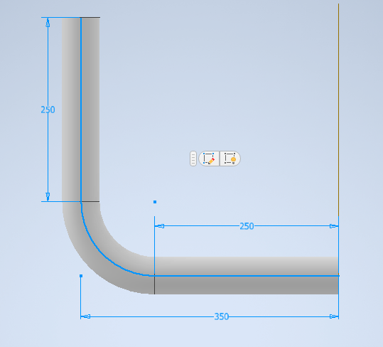

2.4.2 ANSYS Analysis

2.4.2.1 Meshing
Mesh independence refers to the condition where further refinement of the mesh no longer significantly affects the outcome of the simulation. This is achieved by systematically refining the mesh and comparing results until they converge, indicating that the solution is independent of the mesh size.

The model's structure features a pipe bent at a 90-degree angle, segmented into three designated parts: the inlet, outlet, and walls. The inlet and outlet serve as the entry and exit points for the fluid, respectively, while the walls represent the pipe's inner surface, where no-slip boundary conditions are enforced. For a refined mesh, a body sizing parameter with an element dimension of 0.006 meters was utilized.
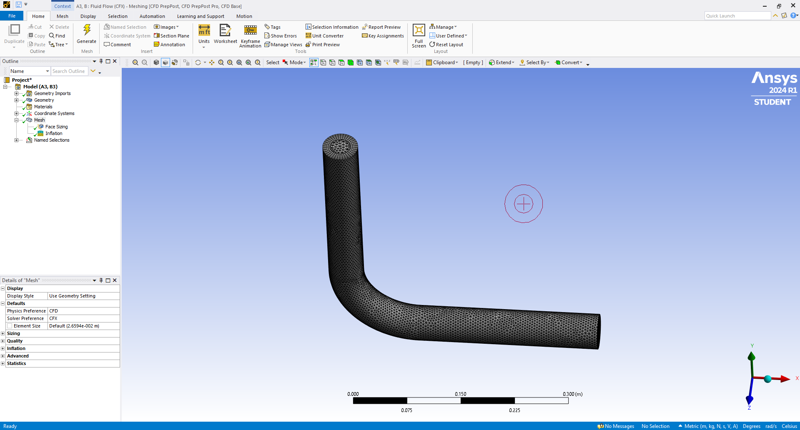
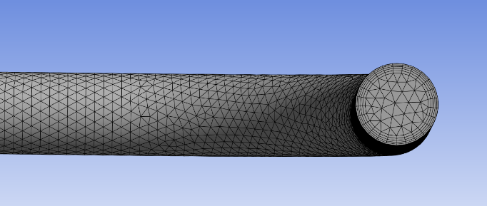

2.3.3 UDF Modelling:

User Defined Functions(UDFs) provide powerful customization capabilities in ANSYS FLUENT, allowing users to tailor simulations to their specific needs. By understanding the structure, compilation, and execution of UDFs, users can effectively enhance the functionality of their FLUENT simulations. The UDF for this Ansys analysis is made based on DNV erosion model.
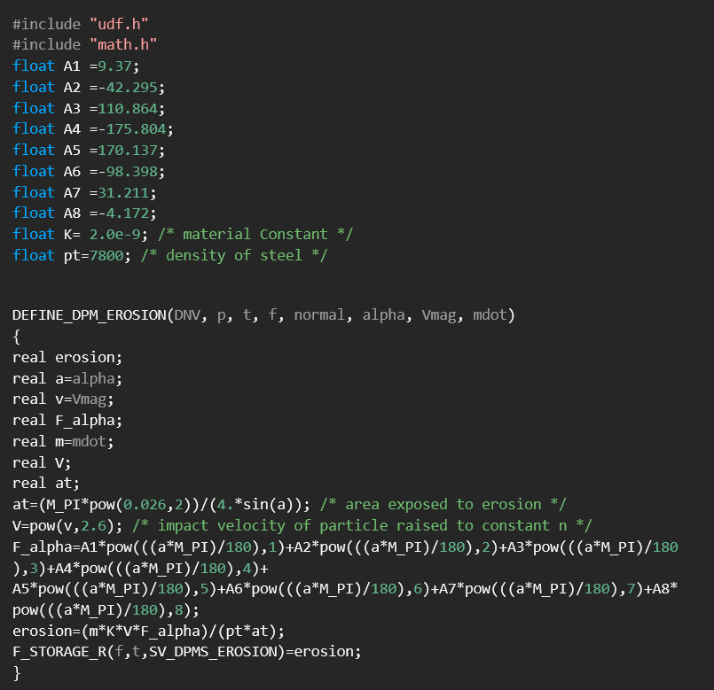

2.3.4 MATLAB Simulation

A MATLAB function is built to calculate erosion rate numerically and as well as to validate the analysis results obtained. It uses DNV Erosion model standard to calculate the erosion rate and details on the erosion rate prediction
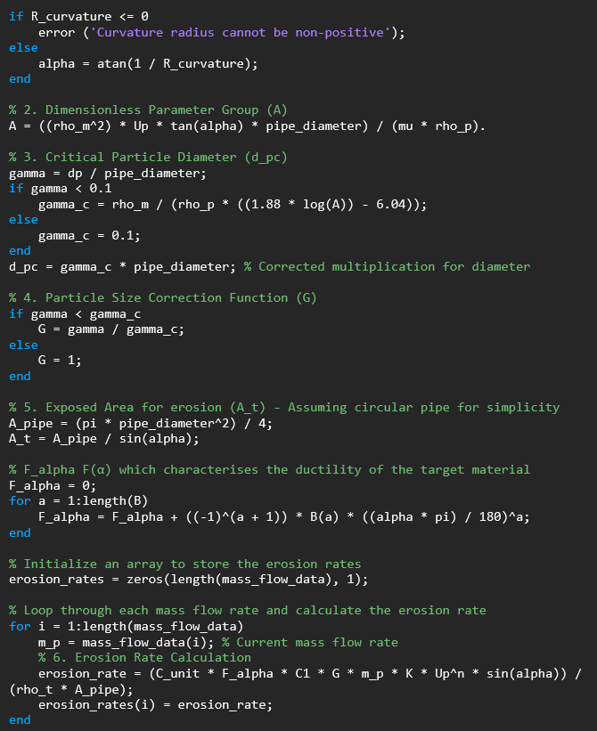

3. Results and Discussion
This section provides a detailed look at the factors that affect erosion in drilling systems. It focuses on the relationship between erosion rate and key parameters like fluid velocity, mass flow rate, and particle size. It also examines erosion patterns specific to bent pipe shapes, which are often found in directional drilling operations. The study evaluates how well nanoparticle-enhanced drilling muds work to reduce erosion. By investigating these aspects step by step, this study seeks to improve our understanding of how operational and material variables influence erosion and to explore ways to enhance the durability of drilling components.
The study of erosion rate has been done with the parameters: Velocity, Mass Flow Rate, Particle size theoretically in MATLAB and also been tested practically with respect to Mass Flow Rate in ANSYS.
3.1. Erosion Rate vs. Velocity
The simulations revealed a significant correlation between fluid velocity and erosion rate, confirming that the relationship is exponential. As the velocity of the fluid increased, the erosion rate also rose sharply. For instance, at fluid velocities around 15 m/s, muds containing titanium dioxide exhibited erosion rates that were approximately 25% higher compared to muds with graphene oxide. This suggests that the erosive impact of the drilling mud is considerably influenced by the flow velocity, making it a critical factor to monitor in deep-sea drilling applications.
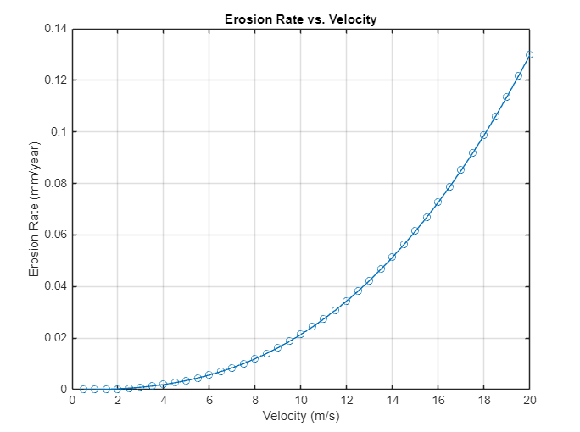
Fig. 1 Variation in erosion rate with velocity in MATLAB
3.2. Erosion Rate vs. Mass Flow Rate
The results indicated a linear relationship between the mass flow rate of the drilling fluid and the erosion rate. As the mass flow rate increased, the erosion rate also grew proportionally. Fluids with higher mass flow rates, particularly those containing titanium dioxide, showed a noticeable increase in erosion rates. Interestingly, graphene oxide-based fluids consistently demonstrated better resistance to erosive wear across various flow rates, suggesting that their unique properties offer protective benefits to the drill pipe material even under high mass flow conditions.
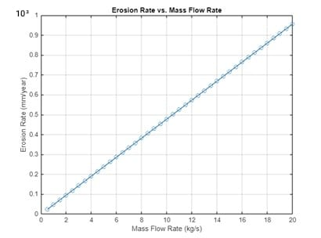
Fig. 2 Variation in erosion rate with Mass Flow Rate in MATLAB
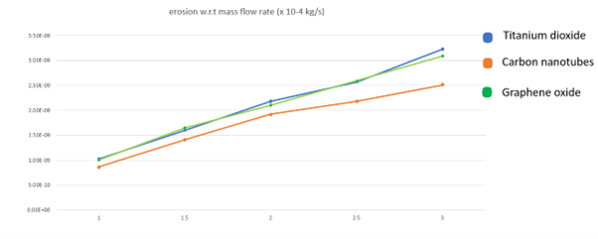
Fig. 3 Experimental Variation in erosion rate with Mass Flow Rate in ANSYS
3.3. Erosion Rate vs. Particle Size
Particle size had a pronounced effect on erosion. Larger particles (e.g., 400 µm) caused more extensive material wear on the drill pipe walls compared to smaller particles. The simulations also indicated that at higher velocities, the impact of larger particles was exacerbated, leading to significantly higher erosion rates. This highlights the importance of controlling particle size within drilling fluids to minimize erosion, especially in conditions involving high fluid velocities.
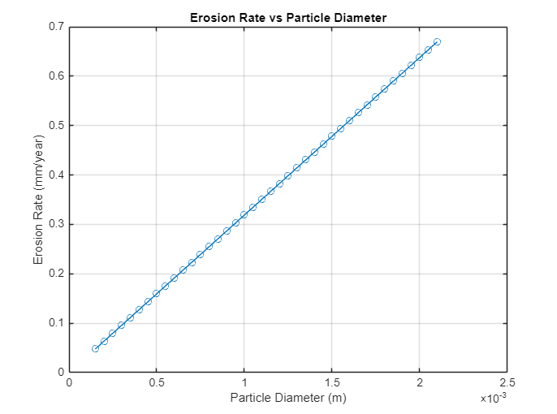
Fig. 4 Variation in erosion rate with particle diameter in MATLAB
3.4. Erosion Patterns in Bent Pipes
The computational fluid dynamics simulations of bent drill pipes showed that erosion was not uniformly distributed. The highest erosion rates were observed at the outer walls of the bends, where fluid velocity and particle impact angles were greatest. These findings underscore the need for targeted protective measures in pipe bends, where erosion is most likely to compromise the structural integrity of the drill string.

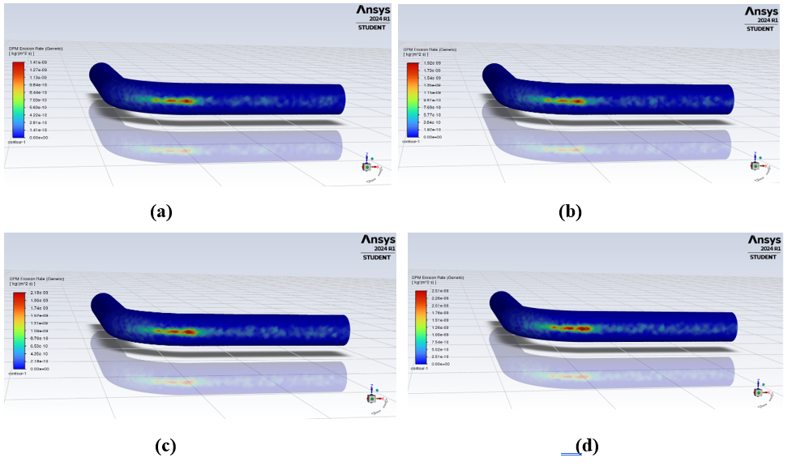
Fig. 5 Erosion contour for carbon nanotubes (a) 5m/s (b) 10m/s (c) 15m/s (d) 20m/s.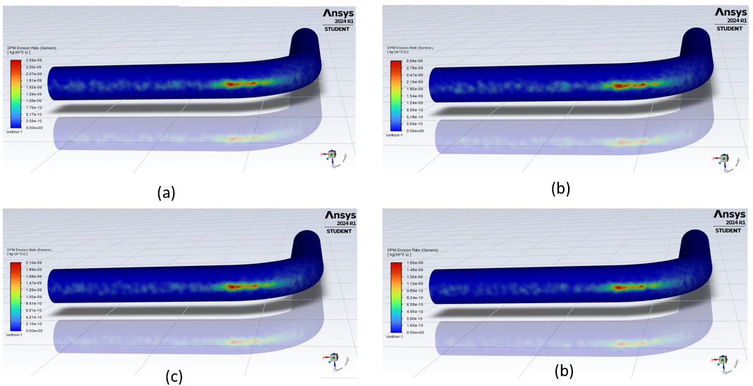
Fig. 6 Erosion contour for Graphene oxide (a) 5m/s (b) 10m/s (c) 15m/s (d) 20m/s.
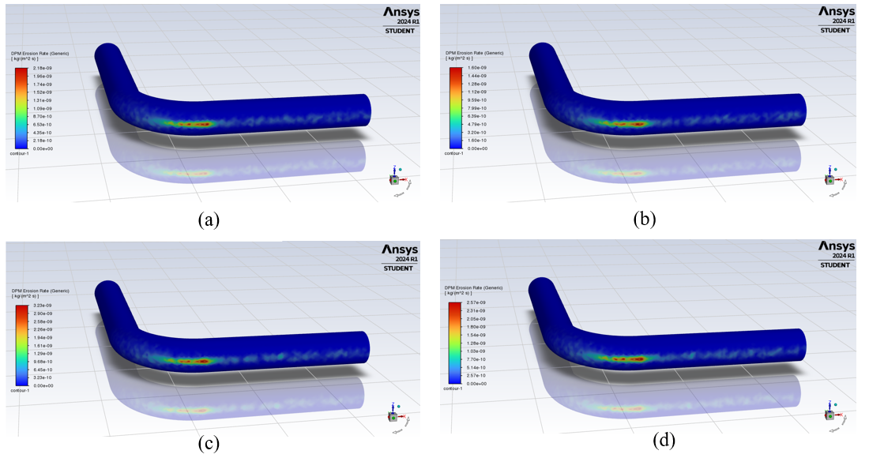
Fig. 7 Erosion contour for titanium dioxide (a) 5m/s (b) 10m/s (c) 15m/s (d) 20m/s.

3.5. Impact of Nanoparticle-Enhanced Drilling Muds
Nanoparticle additives played a significant role in modifying the erosion behavior of drilling muds. For instance:
Graphene Oxide: Drilling fluids with graphene oxide exhibited improved erosion resistance, likely due to the formation of a protective layer on the drill pipe surface. This helped in reducing the overall erosion rate, especially at higher velocities.
Titanium Dioxide: While providing enhanced thermal stability to the mud, titanium dioxide contributed to higher erosion rates compared to other nanoparticle-enhanced fluids, particularly at higher fluid velocities.
Carbon Nanotubes: These exhibited a balanced performance, offering good lubrication properties that reduced erosion in certain scenarios, but their benefits were more apparent at moderate velocities rather than extremes.
The results demonstrated that graphene oxide was the most effective in reducing erosion rates across various testing conditions, followed by carbon nanotubes and then titanium dioxide. These outcomes suggest that selecting the appropriate nanoparticle additive can optimize drilling mud performance, balancing the benefits of erosion resistance and thermal stability.

4. Conclusion
This study highlights the critical role of drilling mud properties in determining the erosion and wear of drill pipes in deep-sea operations. The results demonstrated that fluid velocity, particle size, and mass flow rate significantly influence erosion rates, with higher velocities and larger particles exacerbating material wear. Erosion patterns observed in bent pipes emphasized the need for targeted protective measures, as the outer walls of bends experienced the highest erosion rates.
The results of this study showed that fluid velocity, particle size, and mass flow rate significantly impact the erosion rate of drill pipes. Higher velocities and larger particles caused more severe erosion, with the outer walls of pipe bends experiencing the most wear. Among the tested drilling muds, graphene oxide-based fluids provided the best erosion resistance, followed by carbon nanotubes and titanium dioxide. These findings highlight the importance of selecting the right drilling fluid to reduce erosion and extend the lifespan of drill pipes in deep-sea operations.

References
- S. Liu, H. Zheng, and X. Zhu, “Drill string failure analysis and erosion wear study at key point for gas drilling,” 2014.
- D. O. Njobuenwu and M. Fairweather, “Modelling of pipe bend erosion by dilute particle suspensions,” Comput Chem Eng, vol. 42, pp. 235–247, Jul. 2012, doi: 10.1016/j.compchemeng.2012.02.006.
- N. H. Kamarudin, A. K. Prasada Rao, and A. Azhari, “CFD Based Erosion Modelling of Abrasive Waterjet Nozzle using Discrete Phase Method,” in IOP Conference Series: Materials Science and Engineering, Institute of Physics Publishing, Mar. 2016. doi: 10.1088/1757-899X/114/1/012016.
- A. Berghuvud, G. A. Bth, N. Zarruk, and A. Abdulla, “Estimating Erosion in Oil and Gas Pipeline Due to Sand Presence,” 2011.Author 1, A.B. (University, City, State, Country); Author 2, C. (Institute, City, State, Country). Personal communication, 2012.
- J. Zhao, S. Fang, X. Xiao, X. Zhao, R. Yang, and S. Han, “Study on axial-torsional dynamics characteristics of the drilling robot based on a fluid-structure interaction model,” Geoenergy Science and Engineering, vol. 229, Oct. 2023, doi: 10.1016/j.geoen.2023.212108.
- I. Finnie, “EROSION OF SURFACES BY SOLID PARTICLES.”
- J. Singh, H. S. Gill, and H. Vasudev, “Computational fluid dynamics analysis on role of particulate shape and size in erosion of pipe bends,” International Journal on Interactive Design and Manufacturing, vol. 17, no. 5, pp.2631–2646, Oct. 2023, doi: 10.1007/s12008-022-01094-7.
- S. Agarwal, T. X. Phuoc, Y. Soong, D. Martello, and R. K. Gupta, “Nanoparticle-stabilised invert emulsion drilling fluids for deep-hole drilling of oil and gas,” Canadian Journal of Chemical Engineering, vol. 91, no. 10, pp. 1641–1649, Oct. 2013, doi: 10.1002/cjce.21768.
- K. G. Budinski, Friction, wear, and erosion atlas. CRC Press, 2014.
- https://www.afs.enea.it/project/neptunius/docs/fluent/html/th/node11.htm. Accessed in March, 20 in 2024.
- Smita Singh, M. U. Aswath, Tanushree B. S, “Effect of silica on the properties of red mud based geopolymer mortar for synthesis of sustainable bricks”
- Smita Singh, Manjunath Amalkar, Muttevi Chinmaya Dutta, Dhanush Eshwar Rendi, “Mechanically Activated Red Mud Based Geopolymer for Advanced Concrete Applications: Synthesis and Properties”
- KG. Thirugnanasambantham, T. Sankaramoorthy, Medagam Kesava Reddy, Mantri Pragada Venkata Sesha Aditya, “A review: Analysis of load transfer effect in carbon nanotube (CNT) reinforced aluminium (Al) composites”

