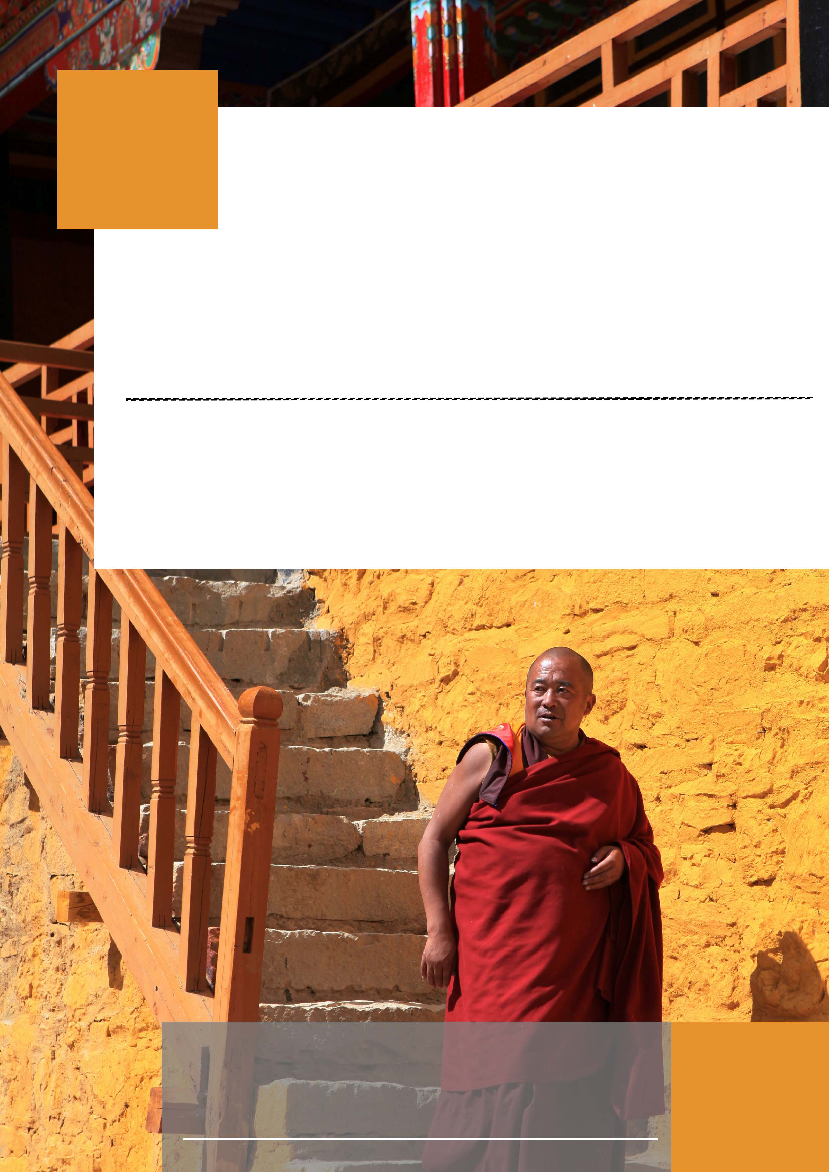
Shigatse
Essential of Central Tibet
Lhasa-Gyantse-Shigatse 6 Days Tour
We will visit the two largest cities in Tibet, Lhasa and Shigatse, taking you to experience the vibrant culture of Lhasa, Gyantse and Shigatse. You will visit the magnificent Potala Palace and Temples; the beautify of nature at the tranquil Yamdrok Lake and the Karola Glacier; Passing through the farmland of Gyantse, you will witness the prosperous agriculture on the snow-covered plateau; in Shigatse, you will visit Tashilhunpo Temple, the most magnificent temple in Tibet, visit the home of Tibetan Panchen Living Buddha, and visit local markets. In these 6 See the spiritual soul of Tibetan people and feel the magnificence of nature during this trip.


- Cities and Attractions

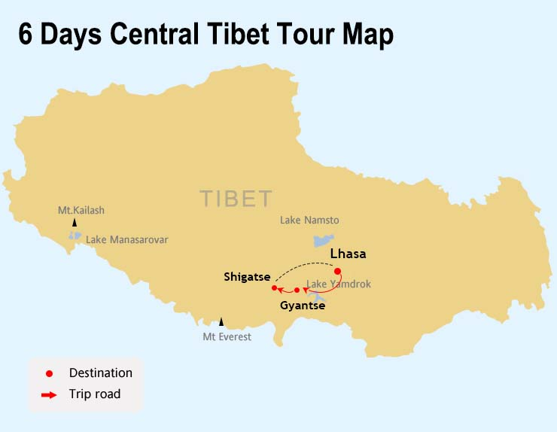
- Tourist Map

- Attractions and Activities
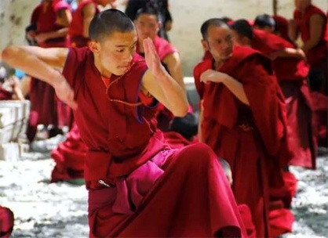 | Lhasa Debating in Sera Monastery
 | At Sera Monastery, the debating courtyard session takes place every afternoon at 3 o'clock. The monks engage in lively debates, standing or sitting, questioning and answering, and discussing Buddhist philosophy. This ritual is one of the most intriguing and visually captivating activities during visits to Tibetan monasteries.
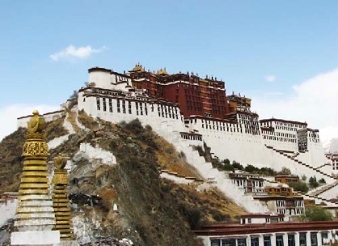 | Potala Palace
 | Potala Palace is the world's highest and most magnificent palace. It once served as the administrative and religious center for past Dalai Lamas, equivalent to the imperial palace of old Tibet. It houses countless stupas, murals, Buddha statues, and treasures, making it an absolute treasure among World Heritage sites.
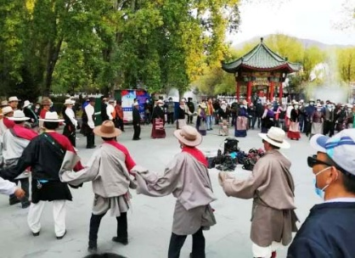 | Local folklore events and local markets
 | In Lhasa and Shigatse, we will take you to participate in local folk activities, such as dancing and praying with the common people. In Shigatse, watching the panoramic view of Tashilhunpo Monastery and Shigatse halfway up the mountain; go to the Samdruptse Old Market in Shigatse to explore the exquisite works of traditional craftsmen in western Tibet.
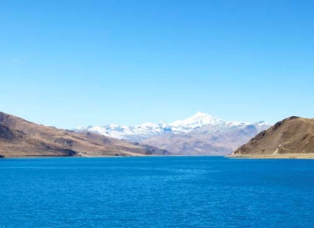 | Visit to a Local Family by the Shore of Yamdrok Lake
 | We have crafted a leisurely and delightful journey for you at Yamdrotso Lake. You'll have the opportunity to enjoy a panoramic view of the lake from the mountaintop and experience an encounter with the lake waters at the lake shore, as well as pay a visit to a local farmhouse at the tail end of Yamdrok Lake, where you can explore a Tibetan farmer's home.
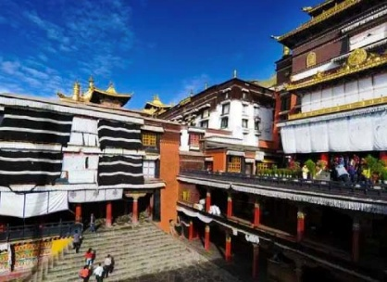 | Tashilunpo Monastery
 | The Tashilhunpo Temple is the largest temple in Shigatse. It covers an area of 150,000 square meters and has 3,600 temples and houses. The temple has solemn The magnificent Pagoda of the Panchen Lama, the world's largest gilt-bronze Maitreya Buddha statue, and countless precious murals and Buddhist scripture collections attract an endless stream of pilgrims to the temple every day.
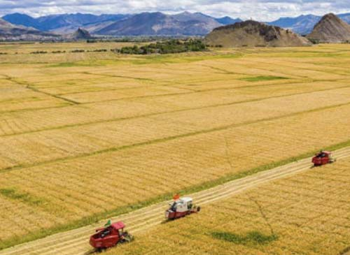 | Gyantse Barley Farmland
 | The barley farmland in Gyantse is like a green and golden quilt covering the earth. This is the most famous highland barley agricultural production area in Tibet. Barley is similar to wheat and is the staple food that Tibetans have relied on for thousands of years. When you see the vast fields of barley, your impression of Tibet's barrenness and desolation will definitely be rewritten in your mind. Tibetans use highland barley to make dry food, staple food and make wine.


- Tibetan Hotels Throughout the Journey
Throughout your journey, we will arrange comfortable and cozy hotels each day, many of which are locally owned and operated by Tibetans with rich ethnic charm. They are strategically located near Tibet's most vibrant cultural attractions or old city areas, making it convenient for your exploration and shopping. All accommodations are twin rooms or king-size beds in 3 to 4 star hotels, with private bathrooms and a warm and comfortable ambiance. In Everest Base Camp (spring, summer, and fall seasons), you will stay in tent guesthouses operated by local Tibetan villagers, where you can appreciate the beautiful sunset and the brilliant night sky over Everest.
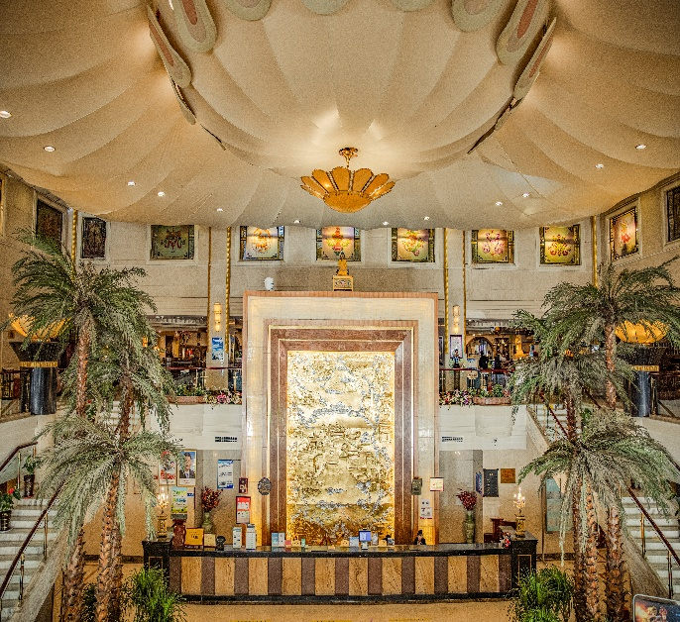 | 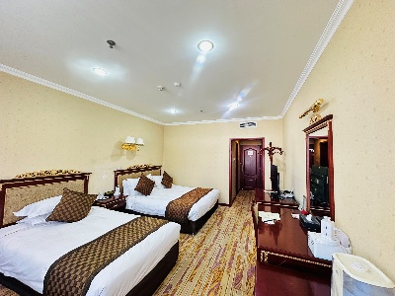 | 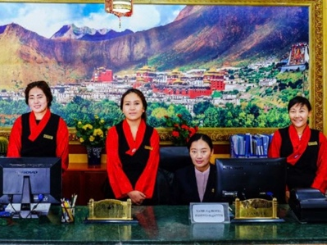
 | 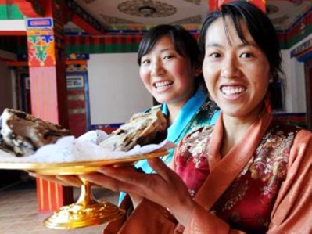 | 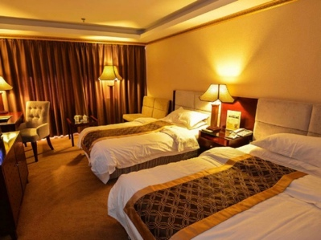

- Comfortable Transportation Arrangements
You will travel in our dedicated tourist vehicles. For 2-5 people, we provide comfortable 7-9-seater tourist vans; for 6-13 people, we offer comfortable tourist minibuses or mid-sized buses. We ensure small group size that each guest receives attentive care and service from both the driver and guide. Our drivers conduct regular safety checks and cleaning of the vehicles each day, creating a comfortable living space for you throughout the journey.
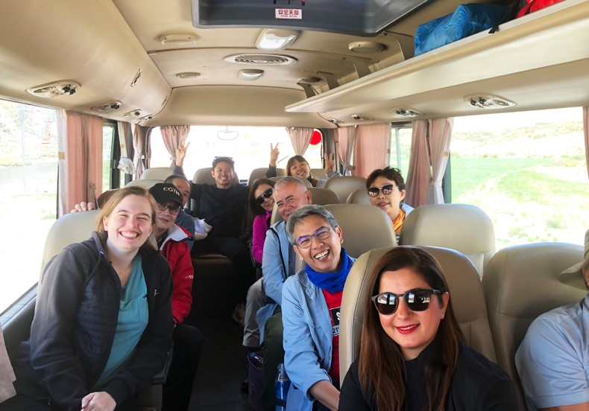 | 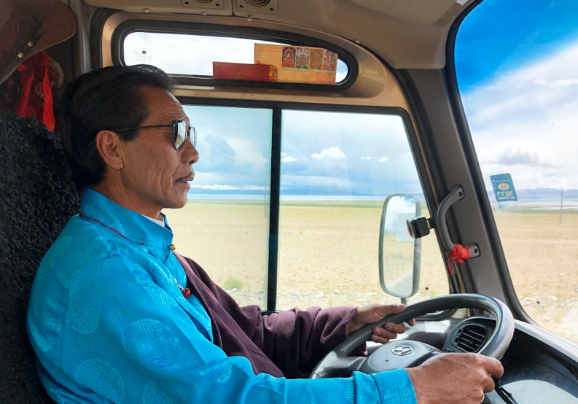

- High-altitude Travel Safety Assurance
Every visitor to Tibet may experience varying degrees of symptoms related to high-altitude sickness. This is because the body undergoes an adaptation process when transitioning from lower altitudes to the higher. The majority of tourists adjust quickly with proper rest upon reaching Lhasa. However, to alleviate any concerns and to provide assistance in case of unexpected health issues, we are here to support you to the best of our ability.
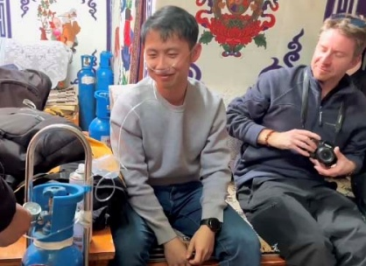 | Medical Oxygen Tanks Equipped with the Vehicle
 | When traveling to higher altitudes such as Everest, we equip the vehicle with medical oxygen cylinders. If you continuously feel uncomfortable during the journey, you can use the medical oxygen provided for the entire group, ensuring a supply of oxygen for several hours.
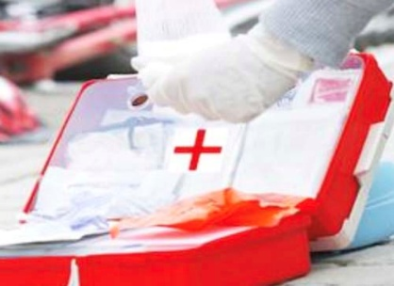 | Insurance for High-altitude Sickness Assistance
 | In addition to providing accidents insurance, we have specifically supplemented your coverage with high-altitude sickness. In case you experience high-altitude sickness and require emergency medical assistance during the trip, this service can be utilized to alleviate the financial burden associated with seeking medical attention in a foreign country.

- Application of Tibet Permits for Foreigners and Taiwanese

Foreigners (including overseas Chinese) need to provide information to the Tibet Tourism Bureau to apply for “ Tibet Travel Permission”. You need to provide documents according to our guidance.
- If you are coming to China for tourism purpose with “L” Chinese tourist visa, you need to provide clear and complete passport page images and Chinese visa images.
- If you are working, studying, residing in China, or visiting China for business, in addition to your passport and visa images, you also need to provide certificate from your Chinese company or school.
- If you plan to enter Tibet directly from Nepal, you need to personally visit the Chinese Embassy in Kathmandu to apply for a Chinese visa(Single Entry 30 days). Please go to our local office in Kathmandu at least 3 working days in advance, We will arrange all the procedures for your Chinese visa application. If you previously have a Chinese visa, your existing visa will be revoked upon obtaining the new visa. In addition to the visa fee charged by the embassy, you are required to pay an additional $20 service fee for visa processing.
The entire procedure is fully serviced, you just simply provide the documents to our travel agency. The deadline for submitting the application is 10 working days before the tour departure. If want to go to Mt.Kailash, you need to send the documents to us 15-20 working days in advance.
Once all approval procedures are completed, we will send the Tibet Travel Permission to your designated address via email or mail (within China only). When boarding the train/flight, the staff at the port will check your Tibet Travel Permission, please ensure its proper safekeeping.

- Airport and Train Station Shuttle Service
Our services include shuttle transfers between Lhasa Airport or train station to downtown in Lhasa. Upon your arrival , our airport service coordinator will arrange for your transfer from the airport or train station to your hotel in the city. Similarly, when you depart from Lhasa, your airport drop-off service will be pre-arranged.
As the arrival times of tourists vary, we have specified several time slots for your service. When booking your flight, please try to choose a flight that arrives in Lhasa around the scheduled shuttle service times to avoid extended waiting times at the airport. if the number of arriving tourists is less than 3 at the same time, we may use public transport to take you from the airport to the city.
Shuttle Schedule from Airport to Lhasa | Shuttle Schedule from Lhasa to Airport
10:00（Morning Arrival）  13:30（Afternoon Arrival 1）  16:00（Afternoon Arrival 2）  18:30（Evening Arrival） | 06:30（Morning Departure 1）  08:00（Morning Departure 2）  12:00（Afternoon Departure）
Airport to Lhasa covers a distance of 70 kilometers and takes approximately 60 minutes.
Arrival in Lhasa by train, we will pick you up according to your arrival time with no waiting required.
For arrivals at non-scheduled times, delayed or early arrival flights, we may use airport shuttle for airport-downtown transfer service.

- Happy Moment
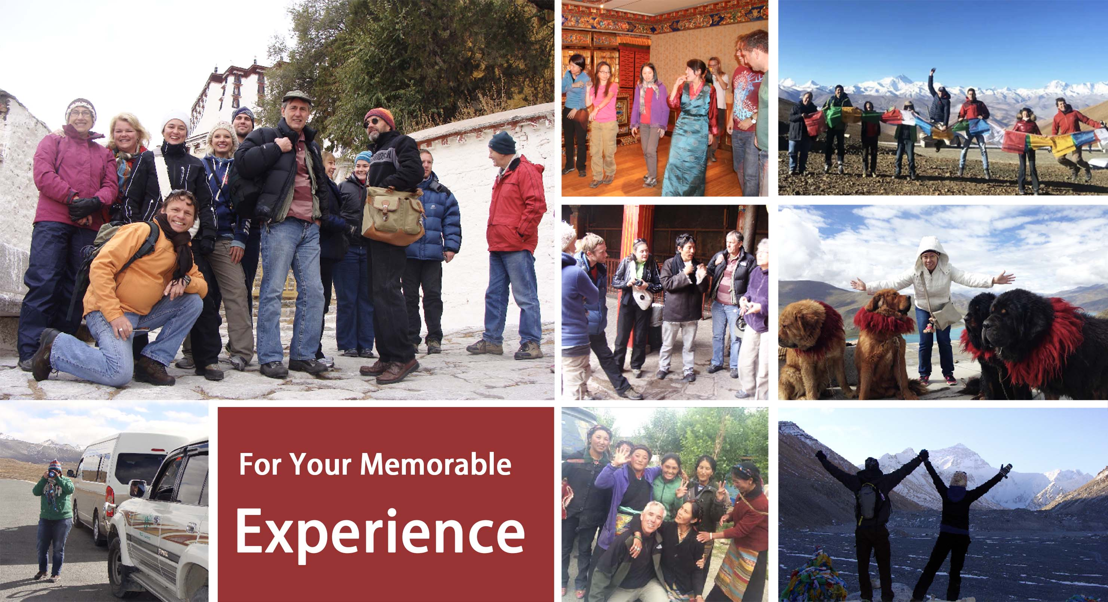
- Brief of the Itinerary
Days | Place and Distance | Tour and Activities | Meals | Hotels
Day01 | Arrive in Lhasa  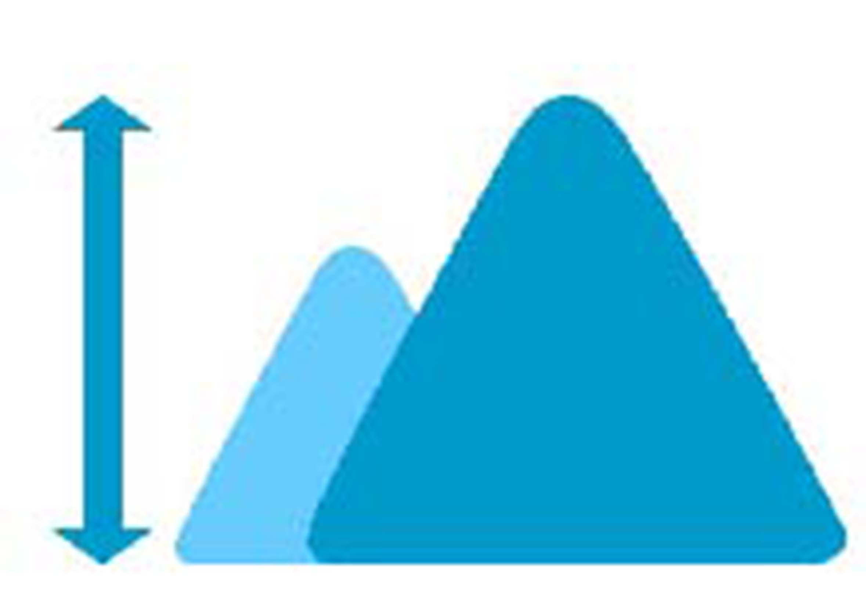 3650m  70kms/1hr Driving | Upon arrival in Lhasa, our tour guide will meet you at the airport/train station and take you to hotel in Lhasa. In the rest of the day, please rest well and adapt to the altitude. | / | Xinding Hotel Lhasa or similar
Day02 | Lhasa City Sightseeing | Visit the Drepung Monastery in the morning, in the afternoon, visit the Sera Monastery and watch the monks’ debate activities. | Breakfast  /Welcome Dinner | Xinding Hotel Lhasa or similar
Day03 | Lhasa City Sightseeing | Visit the Potala Palace, and participate in local Tibetan folk activities in the Local Park under the palace; Visit the Jokhang Temple and Barkor Street. Having tea the sweet tea house to experience Tibetan social culture. | Breakfast  /Tea Break | Xinding Hotel Lhasa or similar
Day04 | Lhasa – Yamdrotso Lake - Gyantse - Shigatse  3650-5030-3600m  360kms/8hrs Driving | Depart from Lhasa and head west to Gyantse, pass by Yamdrok Yumco Lake, visit rural families by the lake and enjoy farm lunch.  Visit Karola Glacier and Gyantse Bally farm land. | Breakfast  /Farm house Lunch | Shiga-Yangcha Hotel Shigatse or similar
Day05 | Shigatse-Lhasa  3650m  280km/5hrs | In the morning, visit Tashilhunpo Temple, walk in circles around the Tashilunpo Kora with local Tibetan believers, on the mountainside to overlook the panoramic view of Tashilhunpo. After lunch, we went to the Samdruptse Old Market in Shigatse, the most unique market in Tibet. Then take a bus/or train back to Lhasa along the Brahmaputra River. | Breakfast | Xinding Hotel Lhasa or similar
Day06 | Lhasa Departure | Escort tourists from the hotel to the airport/train station to end their Tibet trip. | Breakfast | /

*The travel agency may arrange for tourists to take a train from Shigatse back to Lhasa instead of taking a car.
*Due to the need for official reservations for the Potala Palace visit, we are unable to confirm the specific timing of the Potala Palace ticket reservation in advance. The sequence of the itinerary may undergo adjustments.

- Service
Service included
- Tibet Travel Permit application service and mailing service within China
- Entrance tickets to listed attractions and activities, Mt. Everest Environmental Vehicle Cost
- Accommodation in star hotels and local guesthouses with breakfast throughout the journey
- Transportation in a comfortable tourist vehicle with attentive and reliable driver service
- Excellent Tibetan English-speaking guide
- Farm house lunch, welcome dinner
- Travel accident insurance and High altitude sickness insurance
- On-board medical oxygen supply for travel in high-altitude areas
- Exquisite Tibetan gifts and travel map
- Shuttle service between Airport/Train station and Lhasa City
Service Excluded
- International and domestic Transportation to and from Tibet
- Single room supplement for solo travelers who require single room
- Some Meal expenses not included in the Tour (the guide will assist in arranging and recommending meals; you are responsible for the cost)

Required Tips
While you traveling in Tibet, it is kindly required to tip the guide and driver if you are satisfied and appreciate their services. We recommend tipping $7 per day per person to be shared between the driver and guide.

- Tour Notice
- Before applying for the Tibet Travel Permit, please ensure that your passport has a validity period of at least 6 months.
- When entering Tibet from Kathmandu, China visa needs to be processed in Kathmandu. Please do not apply in your home country in advance. If tourists previously had a long-term valid Chinese visa, it will be replaced with a 30-day valid group tourist visa when applying in Kathmandu.
- Only Chinese Yuan is accepted in Tibet. If you need Chinese Yuan, you can exchange it with US dollars locally or withdraw cash from ATMs.
- Maintain good health before entering Tibet and avoid catching a cold.
- When traveling on transportation to Tibet, both the airport and train station will check the Tibet Travel Permit. Please keep this official document safe and avoid writing or drawing on it.
- Before traveling to Tibet, please confirm that you have received the Tibet Travel Permit and check and verify your personal information.
- People with serious hypertension, heart disease, asthma, pregnant women, etc., are not recommended to travel to Tibet.
- If worried about altitude sickness after entering Tibet, you can take a moderate amount of Rhodiola oral liquid or capsules before entering.
- During the Tibet tour, you are required to travel with the group throughout the journey and cannot leave the group activities at will.
- Pack vitamins and regular medications in your luggage.
- When traveling at high altitudes, drink plenty of water, engage in slow-paced activities, and consume fruits and vitamin supplements.
- Avoid smoking and drinking alcohol when you are new to high altitudes.

- Tour Itinerary day by day in Detail
Day 01 Arrive in Lhasa, Airport/Train Station Pickup, Check-in at the Hotel
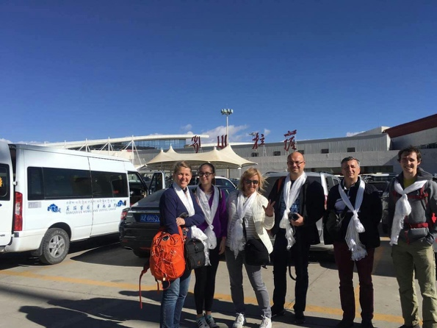 | Meals：/ | Hotel：Xinding Hotel Lhasa or similar
 | Welcome to Tibet! Upon your arrival, our friendly guide and driver will warmly welcome you at the airport, presenting you with a traditional Tibetan white scarf called "Khata." With just a one-hour drive on the expressway (70 kilometers), the driver will take you to comfortable hotel in downtown Lhasa. After checking in at the hotel, take the time to rest and acclimatize to the altitude (3,650 meters), ensuring a good and healthy start to your journey on the plateau.

Day 02 Lhasa City Tour: Visit Drepung Monastery and Sera Monastery Debating
Meals：Breakfast  /Welcome Dinner | Hotel：Xinding Hotel Lhasa or similar | 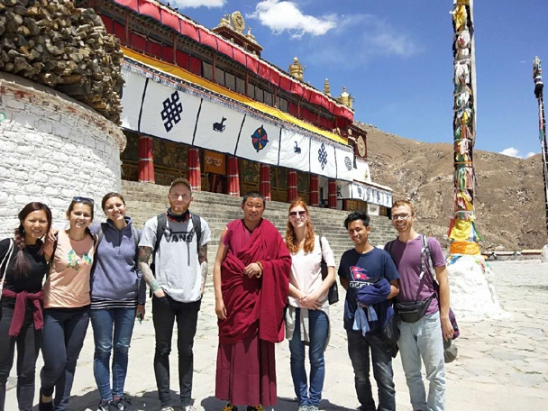
Today, you will explore two distinctive Monastery in Lhasa, Drepung and Sera, both offering a unique insight into Tibetan Buddhism. You will visit the Buddhist halls, Buddhist colleges, and the monks' kitchen, witnessing how they engage in special debates to study Buddhist teachings.

Sera Monastery is renowned for its lively Buddhist debates,
showcasing the essence of Tibetan Buddhism. Monks employ exaggerated body language, engaging in dance-like discussions about Buddhist philosophy, demonstrating their knowledge in a spirited manner.  In the evening, the guide will accompany the group to a local restaurant for a welcome dinner, marking the beginning of your journey in Tibet. |  | 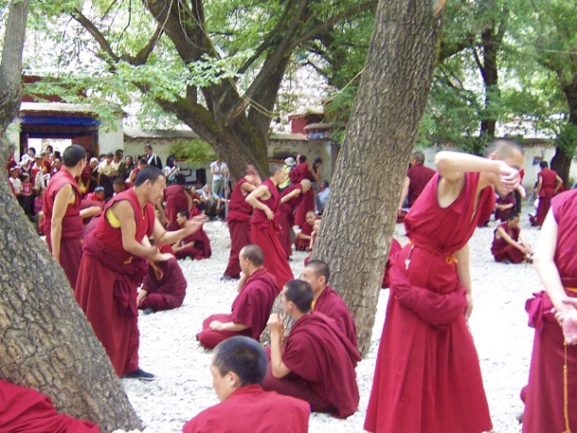

Day 03 Lhasa City Tour: Visit Potala Palace and Johkang Temple
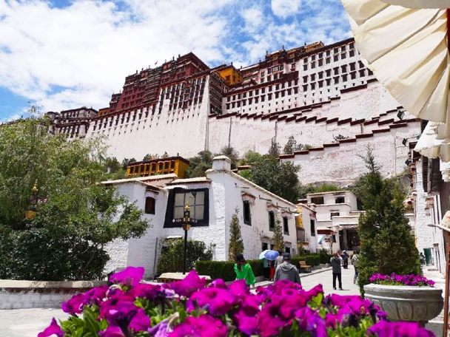  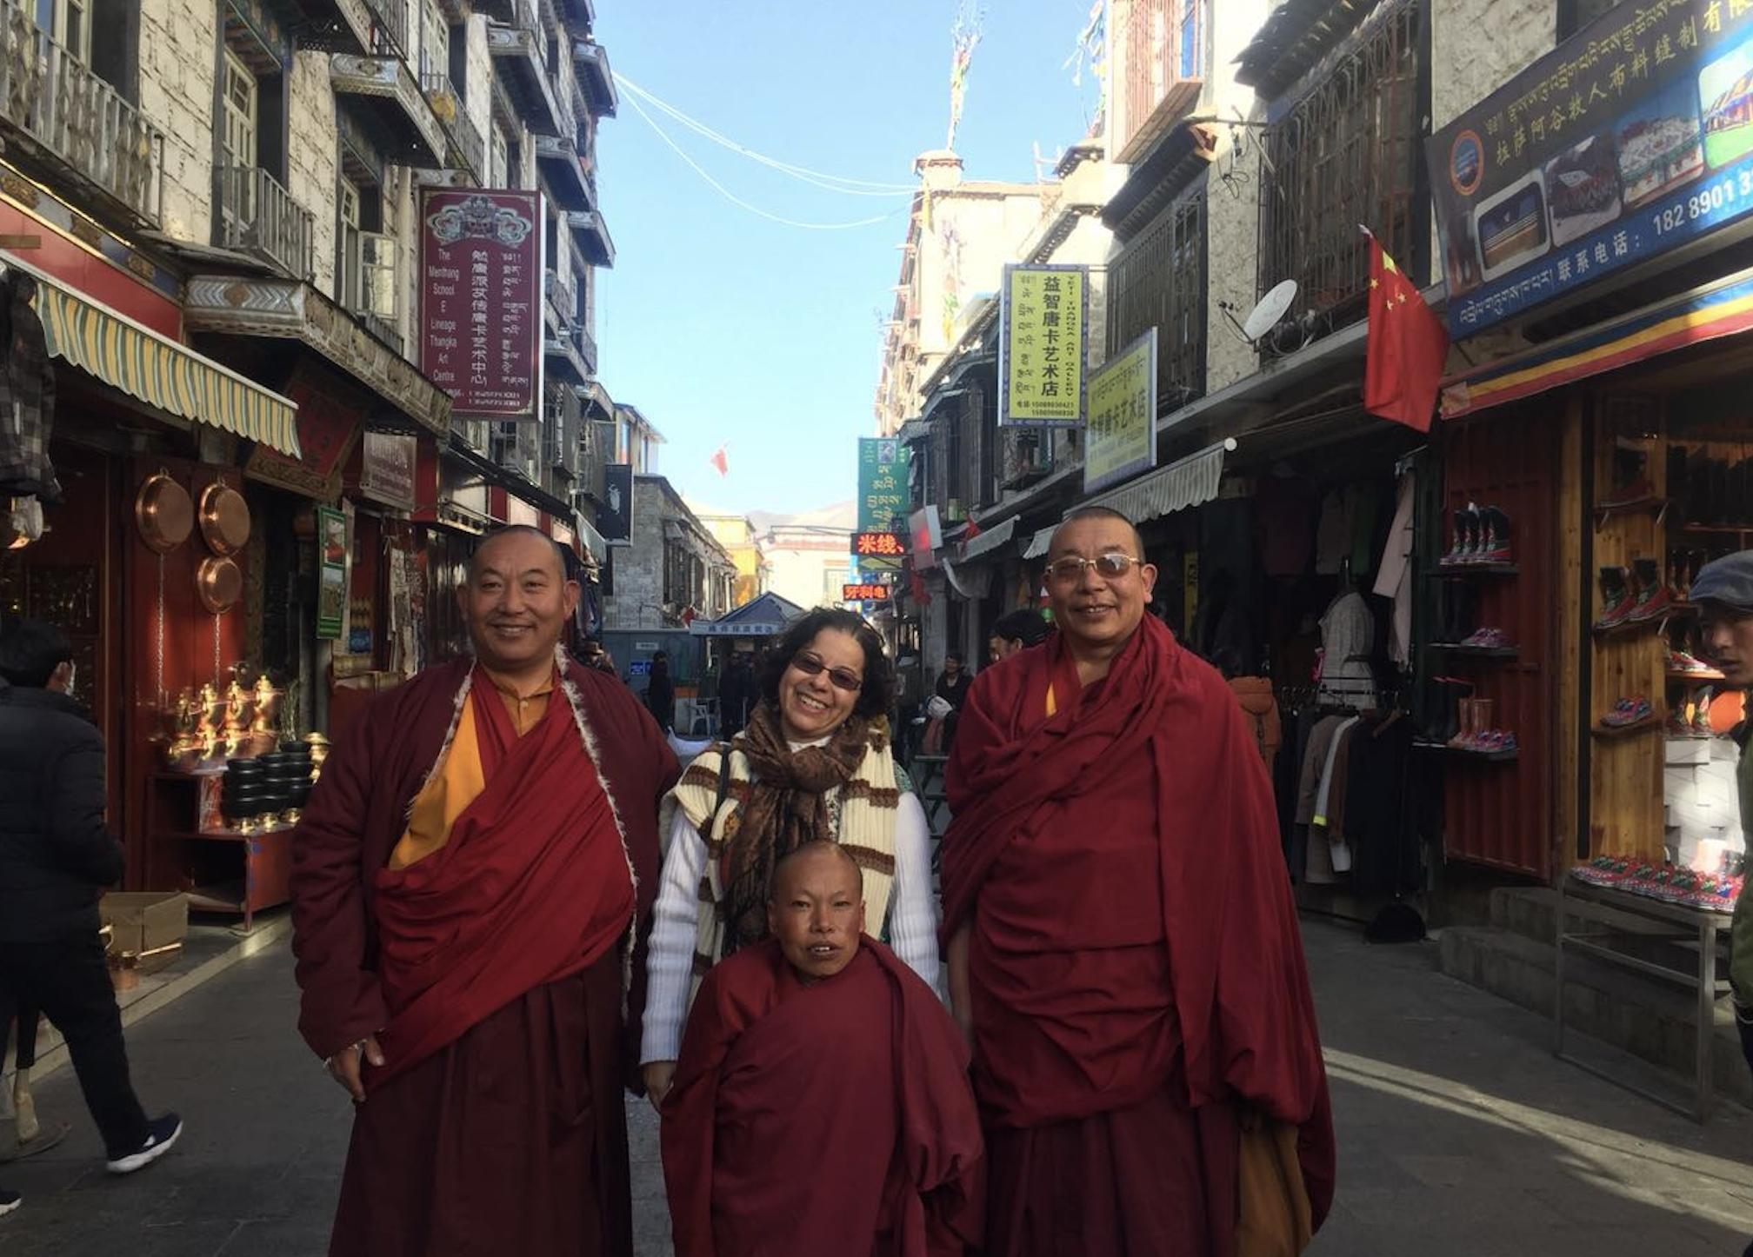 | Meals：Breakfast | Hotel：Xinding Hotel Lhasa or similar
Today, let's explore into the treasures of Lhasa, the Potala Palace, the former residence of the Dalai Lama and acclaimed as the world's highest palace. The Jokhang Temple and Barkhor Street, the Center of Tibetan Faithboth, both designated UNESCO World Heritage Sites.

The Potala Palace, towering majestically over the red hills in the center of Lhasa, was once the religious and political center of Tibet. As you climb the 365 steps to the main building, you'll explore the Dalai Lama's former political hall, the prayer halls, and the tomb stupa. Here, you'll encounter remarkable murals and exquisite Buddha statues, showcasing the accumulated wealth and treasures of ancient Tibet.

The Jokhang Temple, revered for housing the 12-year-old statue of Shakyamuni, is considered the holiest site in Tibet and a lifelong pilgrimage destination for Tibetans. You can join the pilgrims to walk in Barkor street and experience the soul of the city. The guide will also accompany you to a local Tibetan teahouse, offering insight into the social culture.

Day 04 Lhasa-Gyatse-Shigatse：Yamdrotso Lake, Karola Glacier
Meals：Breakfast/ Farm house Lunch | Hotel: Shiga-Yangcha Hotel Shigatse or similar |  | 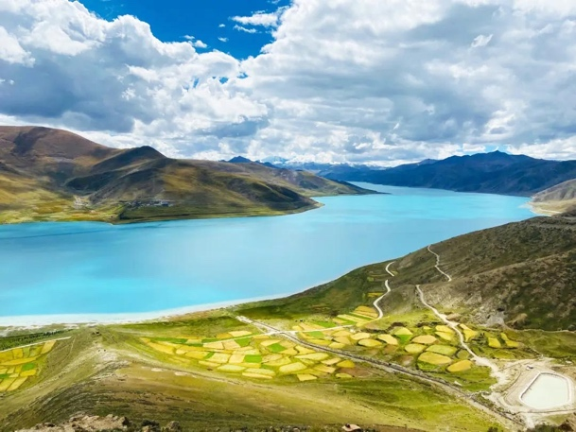
Drive for approximately 7 to 8 hours (340 kilometers) to reach Shigatse. Along the way, you will visit two breathtaking natural landscapes – Yamdrok Lake and the Karola Glacier. You will enjoy a scenic 20-kilometer drive following the disappearing shoreline of the Lake. We will stop at a village by the lake, where you can walk into the homes of lakeside farmers, explore their households, and indulge in a delightful farmhouse lunch.
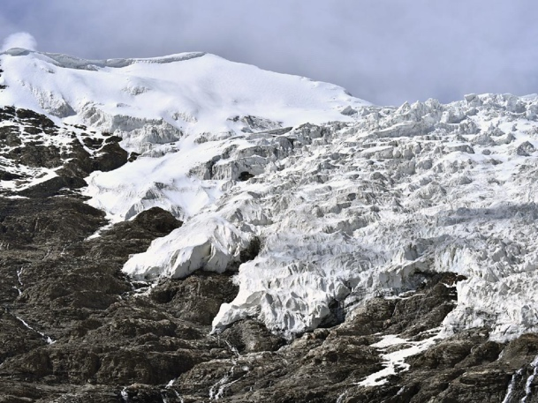 |  | After lunch, drive for approximately 1 hour to visit one of Tibet's most beautiful glaciers – the Karola Glacier, the enormous glacier tongue extends to the roadside, resembling a frozen waterfall hanging over the road and above your head.  Following the Karola Glacier, we will pass by Lake Manla and the ancient town of Gyantse, proceed to Shigatse, the second-largest city in Tibet.

Day 05 Shigatse- Lhasa: Tashilunpo Monastery, Shigatse Samdroptse Market, Brahmaputra Grand Canyon
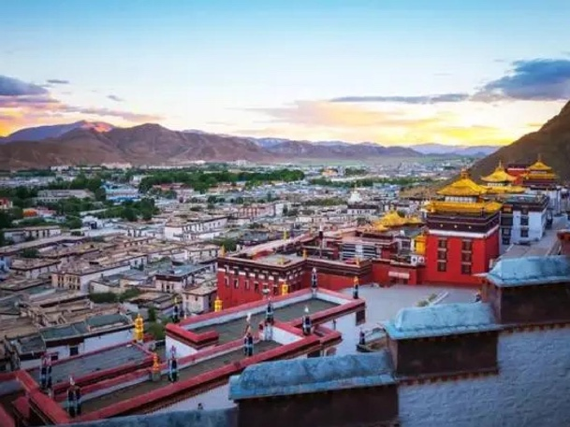  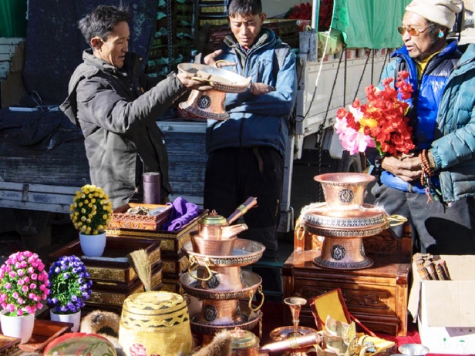 | Meals：Breaks | Hotel：Xinding Hotel Lhasa or similar
You will visit the largest monastery in western Tibet, the Tashilhunpo Monastery. This is the residence of Panchen Lamas, featuring grandeur and magnificence. It houses the world's largest gilded copper statue of Maitreya Buddha, stupas of the Panchen Lamas, and exquisite Buddhist murals.

In addition to exploring the monastery, your guide will accompany you in the Tashilhunpo Monastery's kora (circumambulation) activity. Together with local, you'll walk around the monastery on the hillside, reaching the highest point where you can enjoy panoramic views of Tashilhunpo Monastery and the city of Shigatse. After the monastery visit, your guide will take you to the distinctive Shigatse Samdroptse Old Market, where various traditional handicrafts from different parts of Shigatse are showcased, including jewelry, clothing, and accessories, offering a different experience from Lhasa's Barkhor Street.

Later, we will return to Lhasa along the Yarlung Tsangpo River valley. (Depending on the circumstances, the travel agency may arrange for the group to take a train back to Lhasa.)

Day 08 Depart from Lhasa, Airport/Train Station drop off
Meals：Breakfast | Hotel：/ | 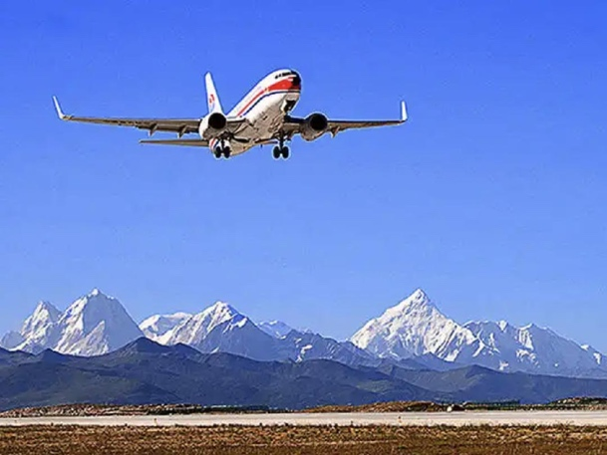
Your Tibet journey officially concludes today, and We will accompany you to the airport/train station. We appreciate to spend this wonderful time with us in Tibet. Wishing you a safe journey ahead!

