Induction and mentoring for novice principals EU
Jan Arend Brands
Version 3.2
21-12-2018

1.0 Introduction
This report is a product of the Framework for Induction of School Principals Project
(Technical Assistance for the SA-EU Dialogue Facility (EuropeAid/137708/DH/SER/ZA)

It is one of the two desk-study reports presenting an overview of the approaches to induction of principals in South Africa respectively, Europe.

For this report the following required activities were carried out:
- To consider the latest research indicating the current status as well as progress made in the area of induction of principals in Belgium/the Netherlands and at least 2 other European countries;
- To map and analyse these induction approaches and frameworks;

As additional EU countries were chosen: UK (England, Scotland) and Finland.
The report also presents information from other countries that was inspiring for European countries (Mainly the USA).

The structure of the report:
1. Introduction (1.0) and Executive summary (1.1) with Main lessons (1.1.1) Main design issues (1.1.2) and Current global discussions (1.1.3)
2. Inspiration for European developments (2.0) with a focus on the USA (2.1)
3. Documents on supranational level (OECD/EU)
4. Flanders (Belgium)
5. Netherlands
6. UK (England, Scotland)
7. Finland
8. Mapping and analysing the induction approaches and frameworks (to be detailed after completion of the report on South Africa)
Annex: List of references

Each country description starts with a general characteristic and/or overview of main developments in that country.
The country descriptions for a large deal consist out of quotations of the most relevant reports in those countries. That is done by purpose to offer the reader real opportunities to make her or his own judgement.
The quotations are presented in chronological order (with an exemption for England where the most promising activity for novice principals (New Visions 2003) is dealt with after completing the description of NPQH (the general course for school managers)).

Chapter 8 just presents a start for identifying main design issues and solutions relevant for South Africa in establishing a system for induction and mentoring of novice principals (IMNP).

General introductions to the educational systems of the countries included can be found at EURYDICE https://eacea.ec.europa.eu/national-policies/eurydice/national-description_en

This report is not about induction and mentoring as such. Much has been written about that subject. This report is about the place of IMNP within Continuing Professional Development (CPD) of principals. It is about how in a set of countries principal organisations, ministries of education and other stakeholders have struggled to create conditions for well functioning CPD-systems and induction and mentoring within such systems.
1.1 Executive summary

1.1.1 Main lessons from the countries chosen
USA
- The history of in-service support to principals in the USA is loaded with dissatisfaction, mainly about the theoretical approach of universities.
- Characteristics of good support are known, but for the institutes involved it is difficult to maintain the right conditions.
- The University Council for Educational Administration played an important and central role in supporting the formulation of performance standards (ISLLC, PSEL, and NELP). NELP is for beginning level building and district leaders.
- Performance standards were (re)formulated with extensive cooperation of many stakeholders.
- Standards were formulated in a clear way but not too detailed leaving space for local interpretation and adjustment
- Changes in standards were underpinned by research evidence
- Standards do not focus any more on discrete functions of leadership (e.g. personnel administration) but on the core function of student instruction
- Standards now elaborate more on core values, professional norms, ethics and equity
- Induction programmes have a positive impact on retention and student outcomes
- Mentoring plays a key role in effective induction programmes
- Induction programmes are not wide-spread (only 16 states). Several studies reflect on the programme in Kansas.

EU/OECD
- OECD studies (2008 and 2012) have been very influential on issues of developing school leaders.
- Induction programmes are particularly valuable to prepare and shape initiating school leadership practices, as well as to provide networks for principals to share concerns and challenges.
- These programmes provide a combination of theoretical and practical knowledge and self-study. They are designed in coherence with the broader development framework to provide the appropriate focus.
- EC volumes (2012) sketch 5 scenarios that can be used as support for defining a strategy for induction and mentoring (Vol. 1)
- The more a school shows the characteristics of a learning organisation the more one can work with internal support for a new principal. (Vol. 3)
- European School Heads Association (ESHA) just started a far-ranging international project: School Leadership Coaching and Mentoring project. A coaching and mentoring programme for new school leaders and a set of pilot training modules will be developed and published on an online platform with a virtual community and a networking tool
- The European Policy Network on School Leadership (EPNoSL) explicitly chose to influence policy on equity and learning (in contrast with the neutrality of many frameworks for principal training).

Flanders (Belgium)
- Umbrella organisations for schools (either faith-based or public schools-based) play an important role in in-service education for principals. Their approach is strong identity-driven.
- In Flanders, every two years, the central government authorities decide on a number of themes for CPD projects that are needed to support the implementation of educational reforms.
- The Flemish Government in 2014 published a report on competences and professionalization of school leaders. Recommendations were formulated on
  - The level of education: Masters level and beyond, with a focus on experience-based learning (different from the regular Masters).
  - Cooperation between universities and existing training organisations from umbrella organisations like those for catholic education (VSKO)
  - Quality assurance: Accreditation for lengthy trajectories.
- Another study formulated recommendations for resilience against stress fostering well-being and promoting self-management, a focus less seen in other countries.
- VSKO offers extensive support for (beginning) principals. It includes training, cohort groups for three consecutive years, reflection groups and groups working like Professional Learning Communities.
- The offer of VSKO has grown in an organic way, based on intense continuous discussions with stakeholders.

Netherlands
- Main characteristic of the support for principals in the Dutch educational system is a market-orientation.
- Funding for training and other support to school leaders goes to the schools. Principals are free to choose whatever support they need.
- The ministry subsidises sometimes for a certain period promising initiatives of e.g. principal organisations.
- At other times the ministry tenders (development) projects that fit its policy.
- Recently principals of primary schools are obliged to register and proof that they followed the right training. (This does not hold (yet) for principals of secondary schools).
- A range of organisations offers standard and tailor-made training for principals (and assessment, coaching, consultancy, interim management etc.).
- The two organisations representing the principals of primary schools (AVS) and the boards of secondary school (VO-raad) started their own training and support centres (AVS Centrum Educatief Leiderschap en VO-academie)
- Recently the Dutch Register of School Leaders in Secondary Education (Schoolleidersregister VO or SRVO) broadened its scope. Not only focusing on registration of school leaders but also supporting them and uniting them in their interests (for professional development).
- In a vivid and flourishing market one would expect a lot of experimentation and renewal of the offer of this diversity of organisations. In reality new initiatives (if at all) were copied quickly so that the offer much looks the same.
- For several reasons small and large providers collapsed or merged. New organisations started.
- Recently OECD urged the ministry to take a more active stance in training of principals. The reaction of the ministry focused on a more strategic position for the principal (next to the board) and support to achieve that.

UK England
- Importance of budget: Rise and fall of the National College for School Leadership
- Effects of change of innovation strategy Department (from support to self-improving schools)
- Negative effects of (perceived) dominance of one organisation (NCSL)
- Careful (multi-step) preparation of becoming a Head: National Professional Qualification for Headship (NPQH)
- A promising New Visions programme for school leaders in their first three years of headship. Experiences with regional groups focussing on experiential learning and working on school issues identified by participants. Discontinued.
- Discussions in British Educational Leadership and Educational Research Society (BELMAS) show the current disarray and the confusion in support to school leaders

UK Scotland
- Attention for a coherent strategy to build leadership capacity in Scottish education
- Warnings for creating an artificial divide between teaching and leadership
- Attention for experiential learning in contrast with knowledge – or apprentice based approaches
- The Scottish College for Educational Leadership cooperating with ‘Regional improvement collaboratives’
- The aims of the programme ‘In Headship’ (e.g. develop a critical understanding of professional learning as collective and emergent)
- A wide array of support by an organisation of school leaders

Finland
- A successful educational system fundamentally different from others
- Action Plan Report for Global Education Brand Finland
- School leadership programs: 5 categories and a large diversity
- No urgent need for a coherent IMNP

General lessons
The context of a specific country is all-important on structure, content and spread and felt need of IMNP.
Crucial factors are:
- Budget
- Dominant management style
- Trust between levels of management in the educational system
- Ownership
- Variety in solutions chosen
- Quality pre-service
- Attitude of responsibility of principals for students, teachers and personal development
With a low budget, a prescribing and controlling management style and low trust IMNP will not flourish even if needed much. With a good quality of pre-service and a perceived positive attitude of responsibility less need is felt to build and structure a system of IMNP.

For ministries coherence of the system is important. Coherence of IM for novice principals with the systems of support for HOD’s, assistant principals and senior principals
For principals themselves trusting the mentor is the main relevant factor.
In general principals are (extremely) positive about the relevance of mentorship.
There have been attempts to research other effects of mentorship but such research is complicated if not impossible.

1.1.2 Main design issues
The main lessons above learn that there exists a large variety of solutions for a satisfying IMNP approach and framework
It also becomes evident that one has to carefully choose an approach that fits the needs, context and budget of South Africa (see JET report on teacher induction).
An approach that has solutions for the main design issues.

Main design issues
System level, funding
- Initiator (or main responsibility) of developments (e.g. state, province, principal/teacher organisations)
- Involvement of principal organisations, (local) government, research organisations, NGO’s (etc.) in planning and execution.
- Funding of some initiatives or sustainable covering of all costs
- Coordination of IMNP (development), national or regional
- Tendering of governmental initiatives
- Quality assessment of providers of training or other activities (or none)

IMNP standards
- Focus on neutral functions or on norms, ethics and preventing inequity
- Coherence of pre-service and in-service standards (loose or strict)
- Level of detailing performance standards
- Standards formulated in ‘Knowledge, skills and attitudes’ or ‘Competences’ or ‘Practices’

Register
- Register of principals
- Levels of required competences (or no requirements) for registration

Elements of IMNP
- Training
- E-learning platform
- Professional development plan for mentees
- Portfolio of induction activities

Mentoring
- Choice of mentors (free or prescribed, within or outside school)
- Kind and umber of mentors (not only experienced principals but also district personnel, teachers, parents, directors SMEs, CEO’s LE etc.)
- Training for mentors
- Requirements set for mentors, selection process of mentors
- Quality assessment of mentors (or none)
- Requirements for mentoring process (or none)

PLC’s, self-evaluation
- Requirements for professional learning communities (e.g. agenda, procedures or not)
- Development of self-evaluation instruments

Conditions
- Conditions for induction, mentoring, self-evaluation

Research
- Inventories of needs of novice principals
- Evaluation of induction and mentoring (satisfaction mentees)
- Evaluation of results of induction and mentoring (storytelling or measuring)
- Research programme on induction and mentoring

Large-sale innovation
- Experiences with large-scale innovations (what works as incentive or regulations)
- Unintended effects (e.g. actions that might look like corruption)

1.1.3 Current global discussions
In choosing an approach one has also to choose a position in current global discussions about actual characteristics and ‘fashions’ in (the context of) Continuing Professional Development for school principals.

Current discussions about the context of CPD are e.g.:
- The contrast between the Global Education Reform Movement (with negative connotations) and education as has been developed e.g. in Finland (Pasi Sahlberg). The negative connotations regard perceiving schools as competing in a market, strong accountability, results-based management, evidence-based innovation, working with a small curriculum and deprofessionalisation of teachers.
- Growing inequality in developed countries (e.g. USA, Australia, the Netherlands) which is in sharp contrast with official national policies.
- The growing influence of large businesses (like publishers) or huge business-originated funds not only on school level but also on policymaking at national and state level. Influence without hardly any democratic control.
- The movement towards Charter schools (USA), Academies (UK) or for profit-schools (Chile). Mainly initiatives that started with a right focus on fighting inequality but now captured for other agenda’s like reducing the role of public education.
- Fast spreading 'Low-Cost Schools' like the Bridge International Academies. Initiatives that are strongly contested (Norrag).
- A seemingly new balance in the discussion about the role of the school leader and the role of the teacher. Not only focusing on the school leader who distributes leadership and stimulates the development of teachers, but a new focus on the teachers themselves working together as professionals (sometimes defined as self-improving schools)
- A rather massive movement towards Professional Learning Communities for principals as well as teachers (also already existing in bureaucratic versions – Peru USAID)
- The growing interest in research and evidence, while at the same time doubts about the usefulness of research results for practice gain importance.

2.0 Inspiration for European developments
In the USA support for principals originated already in the eighties of the nineteenth century. Given the differences between the educational system of the 50 states the variety was huge and interesting. So it is understandable that e.g. in the Netherlands we searched for examples in the USA when we a century later started to think about how selection of principals could be professionalised (just one of the examples).
Later Canada (OISE) became the place to visit (Ken Leitwood, Michael Fullan) and it still is.
The UK during the heydays of the National College for School Leaders also was a source of inspiration (see chapter 6 about developments in the UK).
In those days and thereafter large consultancy firms like McKinsey (Barber 2010) and PricewaterhouseCooper played an important role.
Nowadays inspiration can be found also elsewhere e.g. in Australia where the State Victoria (the Education State) chose to use Professional Learning Communities (PLCs) not only as a means of training, but as a main building block for restructuring the organisation of their education system.
From Africa Ubuntu also was a very relevant source of inspiration.
A global initiative was the International Study of Principal Preparation (ISPP). The network has carried out cross-cultural research on novice principals in 15 countries on five continents since 2004.

To learn from elsewhere we in the Netherlands went on study visits, invited famous professors, visited conferences of AERA, CCEAM, UCEA, ICP, AITSL (and organised our own ENIRDELM). We read the scientific journal (for the most influential ones see https://freemanmc.com/index.php/emd-journals.html).
We developed our own systems to support principals, systems that fitted our context, our history and the zeitgeist. Are we fully satisfied with the results? Not completely, we continue to develop new solutions, reacting on changes in the balance of priorities, striving for the better reckoning with budget (im)possibilities.

2.1 USA
From the USA we borrowed a range of ideas about how to organize schools: from Effective Schools to Distributed Leadership

It was possible to visit great schools and strong programmes for training principals.
Mainly our experiences were very positive and we used the good examples.

That however in hindsight was in rather sharp contrast with the dissatisfaction about training of principals in the USA itself.
Training of (future) principals in the USA was mainly taken care of in Schools of Education in colleges and universities. Bu that has changed in the last decennia because of the dissatisfaction with the training. Principals looking back on their studies criticized the gap between theories offered and actual practice. In-service education was not much better.

Already in the early eighties, in a reaction on the dissatisfaction, the National Network of Principals’ Centers was founded by Roland Barth. His philosophy was that principals could and should take responsibility for their own professional development. The NNPC (later international: INPC) at the top of its success in the nineties counted some 100 centers in the USA and some 20 abroad. (There are parallels with the PLCs from today).

Barbour in 2005 categorised the alternatives for Non-University Based Preparation Programs as:
1) For Proﬁt Preparation Programs
2) State-based Alternative Preparation Programs
3) Foundations Driven Preparation Programs
4) Partnership Preparation Programs
5) Out-sourced Preparation Programs the School Leaders Licensure Assessment.

Still the majority of the training takes place in colleges and universities. The dissatisfaction with what is offered is high.

A special issue of Educational Administration Quarterly (2002, Vol 38(2)) was dedicated to:
Ensuring the Capacity of University-Based Educational Leadership Preparation).
The dissatisfaction is seen throughout the 6 articles.

The dissatisfaction was also very clear from the report of Levine ‘Educating School Leaders’ 2005. The findings of this report were very disappointing. ‘Collectively, educational administration programs are the weakest of all the programs at the nation’s education schools’ (p. 13) and ‘This study found the overall quality of educational administration programs in the United States to be poor’. The majority of programs range from inadequate to appalling, even at some of the country’s leading universities’ (p. 23).
‘The typical course of study for the principalship has little to do with the job of being a principal. In fact, it appears to be a nearly random collection of courses.’ (p. 27)
Soon UCEA, AERA and other organisations published a common defense.

In 2007 however not much seemed to have changed:
‘Yet study after study has shown that the training principals typically receive in university programs and from their own districts doesn’t do nearly enough to prepare them for their roles as leaders of learning. A staggering 80 percent of superintendents and 69 percent of principals think that leadership training in schools of education is out of touch with the realities of today’s districts, according to a recent Public Agenda survey. (DeVita in the introduction to Darling-Hammond 2007).

The positive side of the report of Darling-Hammond was that she clearly identified:
All of the pre-service programs in our sample shared the following elements:
- A comprehensive and coherent curriculum aligned with state and professional codes, in particular the ISSLC standards (see below), which emphasize instructional leadership;
- A philosophy and curriculum emphasizing instructional leadership and school improvement;
- Active, student-centered instruction that integrates theory and practice and stimulates reflection. Instructional strategies include problem-based learning; action research; ﬁeld-based projects; journal writing; and portfolios that feature substantial use of feedback and assessment by peers, faculty, and the candidates themselves;
- Faculty who are knowledgeable in their subject areas, including both university professors and practitioners experienced in school administration;
- Social and professional support in the form of a cohort structure and formalized mentoring and advising by expert principals;
- Vigorous, targeted recruitment and selection to seek out expert teachers with leadership potential; and
- Well-designed and supervised administrative internships that allow candidates to engage in leadership responsibilities for substantial periods of time under the tutelage of expert veterans. (p. 27)

One would expect that most of this still will be very relevant also for training for novice principals. But a warning: in later years investigations like Darling-Hammond were replicated. The elements identified to be important did not change much. But the institutions identified as good changed rather quickly overtime. One might conclude that it is very difficult to stay as good as one is at a certain moment. Maybe it is too hard or it asks too much resources to become sustainable.

The Wallace report ‘Becoming a Leader: Preparing School Principals for Today’s Schools’ (Lee Mitgang 2008) summarizes the situation at that time.
‘Indeed a wide body of research has cited persistent weaknesses in many university-based
school leadership preparation programs, including:
- Admission standards that allow leadership preparation participants to essentially “self-select” themselves without having to demonstrate either the potential or the intention to assume school leadership positions;
- Curricula and knowledge base that may not adequately take into account the needs of schools, districts and increasingly diverse student bodies;
- Weak connections between theory and practice;
- Faculty who may have little field experience as leaders; and
- Shallow or poorly designed internships and field-based experiences that are not sufficiently connected to the rest of the program.

Good Principals Aren’t Born — They’re Mentored: Are We Investing Enough to Get the School Leaders We Need? (Gray 2007)
The Southern Regional Education Board published this report in which mentoring (for aspiring principals) is central.
It draws on survey data from a sample of seasoned principal mentors who have guided interns in university-based principal preparation programs in the SREB region. The report describes the then present condition of mentoring for aspiring school leaders. As the report makes clear, the “present condition” is far from satisfactory. The paucity of quality mentoring programs is retarding states’ efforts to ensure that every student attends a school where strong leadership results in high academic performance.
This report lays out a course of action for policy-makers and the leaders of universities and school districts who share the responsibility to ensure that every beginning principal comes to the job fully prepared to make a difference in teaching and learning. This report also describes the necessary (and often non-monetary) investments required to create internships that can help aspiring school principals become transformational school leaders.

Although this report is about mentoring in university-based principal preparation programs it is a challenging report when thinking about policies, resources and structures for mentoring for novice principals with statements like:
‘The prevailing assumption is that it takes no special talents, training, tools or resources to provide effective mentoring’ (p. 14)
‘Good will has its limitations, even among the most dedicated mentors, and quality is compromised when mentoring goes unrewarded and is perceived as an add-on duty’
(p. 15)

The Professional Standards for Educational Leaders (PSEL) 2015 and the Interstate Leaders Licensure Consortium (ISLLC) Standards 2008: A Crosswalk (2016)
PSEL, the latest version of ISLLC is an enormous performance. Because of the national support from all relevant stakeholders, but especially because this document explains for what reasons (research-based) changes have been made.

From the introduction and purpose of the document:
‘Expectations of current school leaders and conversations surrounding educational leadership are rapidly evolving. In addition to managing daily school activities, today’s principals must also focus on instructional leadership, the cultivation of diversity in schools, and the assurance of equal access to equitable opportunities leading to the highest levels of learning and achievement for all students.
The next iteration of standards that define effective educational leadership is the Professional Standards for Educational Leaders (PSEL), released in October 2015. The PSEL were developed to replace the Interstate Leaders Licensure Consortium (ISLLC) standards, which had been introduced in 1996 and revised in 2008. The PSEL were designed to respond to the new context of public education as well as to recent research studying the influence and impact of school principals on teaching and learning. The PSEL are intended to inform the work both of school leaders and of central office administrative leaders and school boards. The standards will impact leadership development over the next decade or, if the longevity of the ISLLC standards serves as an example, possibly longer. Some states have already begun the process of comparing their current educational leadership standards with the new PSEL and working to identify key areas of alignment or disconnect.’ (p. 1)

‘Purpose
State leaders should consider this crosswalk as one of many resources that can help inform conversations at the state level or with district leaders regarding aligning current leadership standards with the new PSEL. This comparison of ISLLC and PSEL standards enables educational leaders to review how leadership standards have evolved since 2008 and to discuss key differences that will need to be addressed in existing state standards.’ (p. 1)

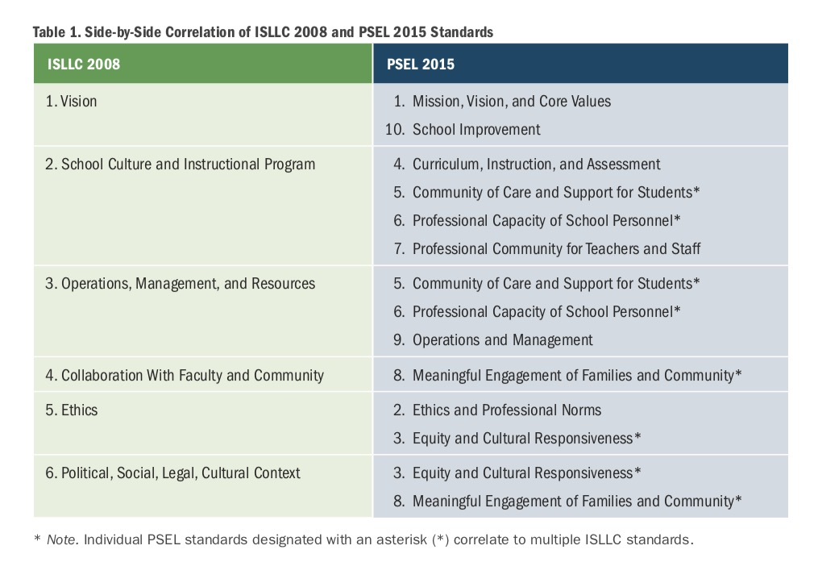

Best Practices in Teacher and Administrator Induction Programs (2016)
This report was published by the California County Superintendents Educational Services Association.

Preliminary key findings are
- Induction programs have a positive impact on retention and student outcomes.
However, not all induction programs are created equal. Programs with more supports and greater mentee/mentor contact are strongly correlated with retention and student outcomes while programs that only provide basic supports have little or no impact on retention and student outcomes.
- Mentoring plays a key role in effective induction programs for teachers and administrators.
o When selecting mentors, important attributes include: character, competence, experience, communication skills, interpersonal skills, and an understanding of the setting and context in which a mentee works.
o The type and intensity of training and support provided to mentors may impact the efficacy of an induction program. Ongoing support and scheduling adjustments to compensate for the time and effort needed to sustain effective mentorships encourages participation and raises overall program quality.
- Although induction is correlated with positive outcomes for both teachers and administrators, support for, and participation in, administrator induction programs has lagged behind teacher induction programs. 27 states require that all new teachers participate in some form of induction or mentorship program. Alternatively, only 16 states require that new administrators receive “some form of professional support” and only 3 of those states require new administrators to participate in a full induction program. (p. 3)

About mentoring for administrators is said (amongst other things):
Experts consistently emphasize the value of mentorships in administrator induction programs. The Southern Regional Education Board (SREB), for example, describes high-quality mentors as “the key” to improving training for aspiring principals in an effective manner. However, the ability of a mentorship to improve new administrators’ skills and capabilities depends on factors such as program length and funding, as well mentor quality and training. (p. 16)

Selecting and Supporting Mentors
Careful selection of mentors helps foster the development of substantive relationships with mentees. Experts recommend the selection of instructional leaders who possess a “solid knowledge about current learning theories, curriculum, assessment and school organization,” a successful record, and a detailed understanding of the organizational context in which the mentee is operating. Although experts suggest that the mentor should have some familiarity with the mentee’s environment, employment in the same district does not appear to be essential. Philosophical compatibility also may factor into strong mentorships, as mentees may struggle to work with leaders who advocate educational theories and beliefs wildly different from their own.

Logistically, researchers urge the selection of mentors who are capable of committing the time required of a meaningful mentorship. Specifically, the Connecticut Principals’ Center observes that, when selecting current principals as mentors, “care must be taken to select only those principals whose schools are sufficiently strong so that the school will not suffer as a result of the time and energy spent by the principal.” Likewise, the NYC Leadership Academy, a privately-funded organization designed to recruit, prepare, and support the city’s principals, previously abandoned the use of sitting principals as mentors in the belief that retired leaders could “spend more time and attention on their new principals.”
Notably, mentor compensation may affect the quality and quantity of leaders who participate in mentorship programs, leading some researchers to conclude that stipends should be “commensurate with the importance and time requirements of the task.” In Kentucky, for example, Jefferson County Public Schools found that the $1,400 annual stipend provided to mentors was an insufficient incentive to attract high-quality principals to mentorship roles. In addition to the low stipend, two other factors posed a challenge to mentorship in the district: a requirement that mentors spend at least 50 contact hours with new principals and be consistently available for advice beyond those hours; and a reliance on active principals as mentors.
As with teacher induction, research suggests that the type and intensity of training that administrator mentors receive may impact a mentor’s ability to cultivate the specific skillset needed to successfully coach mentees. The Wallace Foundation identifies “weak or non-existent training for mentors” as a key problem underlying contemporary mentorship programs, even in states that mandate mentorships, and advises mentorship programs to provide high-quality training for mentors on a routine basis. (p. 16)

Accountability
Overall, experts and policy-makers emphasize the importance of external standards in ensuring that mentorships meet established guidelines. Massachusetts Department of Elementary and Secondary Education regulations, for example, require districts to report the number of site-based visits made by mentors and the number of hours mentors spend with mentees. The Wallace Foundation also recommends explicit accountability measures, stating that all organizations requiring mentorships should gather “meaningful information about its efficacy: especially, how mentoring is or is not contributing to the development of leadership behaviors and dispositions that are needed to change the culture of school towards improved teaching and learning.” Surveys and other forms of self-reporting may be insufficient means of gathering comprehensive and/or reliable information on program activities, outcomes, and satisfaction levels. Thus, states and districts may need to conduct more formal evaluations of the extent to which mentees have gained useful skills and habits as a result of the mentorship. (p. 18)

Comparable States of Interest

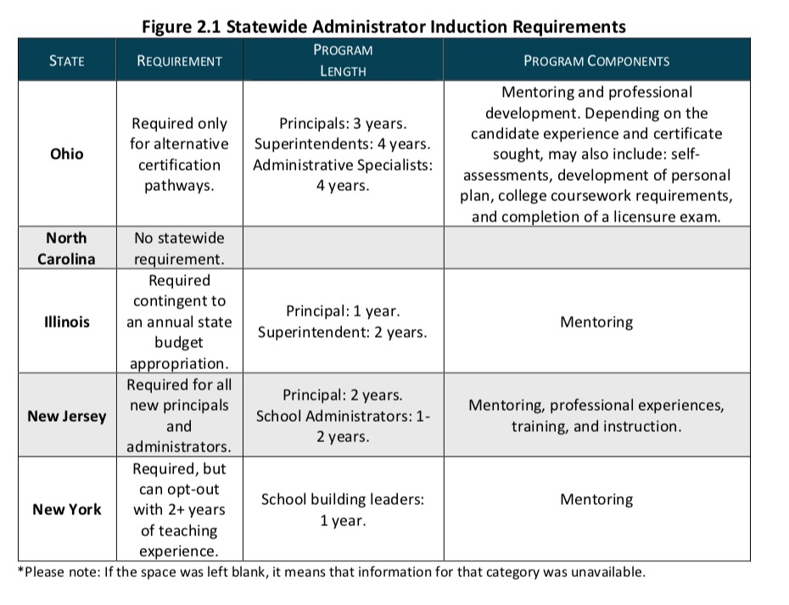

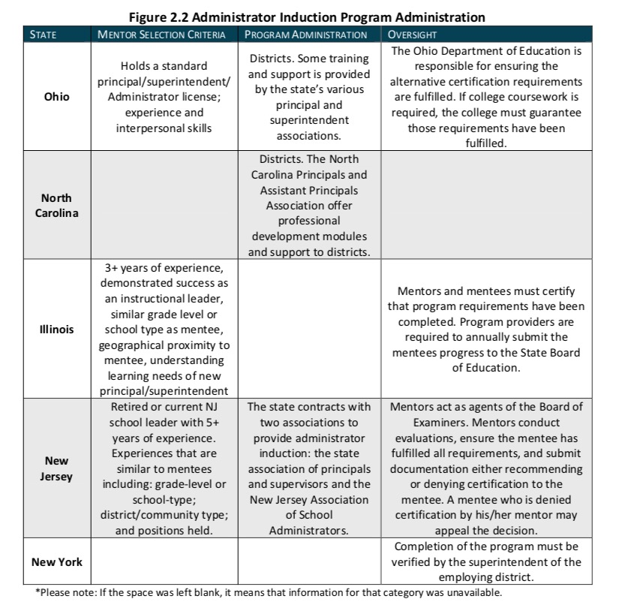

The National Educational Leadership Preparation (NELP) Standards (2018)
The NELP standards, while aligned with the PSEL standards, serve a different purpose and provide greater specificity around performance expectations for beginning building level and district leaders. Whereas the PSEL standards define educational leadership broadly, the NELP standards specify what novice leaders and preparation program graduates should know and be able to do as a result of their completion of a high quality educational leadership preparation program.

What’s New?
When compared to the 2011 ELCC standards there are several important differences. Perhaps most noticeable is the number of standards. The six content standards found in the 2011 ELCC standards have been expanded to seven in the draft NELP standards. The expansion enabled the NELP committee to develop standards that more closely reflect current understandings of school leadership, and to more clearly delineate several core leadership functions. For example, the 2011 ELCC standards addressed core values, professional norms, ethics, and equity within one standard. The new NELP standards include a standard for both ethics and professional norms (standard 2) and equity and cultural leadership (standards 3), which addresses capabilities for ensuring equitable protocols, access, and practices not present in the previous standards. Furthermore, the NELP standards address community and external leadership (standards 5) in a way that more clearly address the need for communicating, engaging, and partnering with families and the community.
Finally, the NELP standards more strongly distinguish between the unique knowledge and skills needed for the principalship and the superintendency. For example, the NELP building level standards include a specific standard on human resource leadership, while human resource leadership is included as one of several managerial functions in the district standard. Similarly, the district level standards place increased emphasis on the role of the district-level educational leader in instructional leadership and include a specific standard on policy, governance and advocacy. These changes reflect both the research base and the changing demands of school and district level leadership. (p. 2)

For a detailed study of the changes, comments of stakeholders and the research supporting those changes see:
National Educational Leadership Preparation (NELP) Program Recognition Standards - Building Level (2018)
The NELP standards are:
- Mission, Vision, and Improvement
- Ethics and Professional Norms
- Equity, Inclusiveness and Cultural Responsiveness
- Learning and Instruction
- Community and External Leadership
- Operations and Management
- Building Professional Capacity
- Internship

Building Capacity for Program Excellence 2018
In the Fall issue of UCEA Review the director for two decades Micelle D. Young looks back on the role of the University Council for Educational Administration. It is a magnificent overview of a very important organisation in a complex field. It tells the story behind the reports mentioned above.
‘Over the course of its history, UCEA has supported, sponsored, and engaged in significant efforts to support quality leadership development (e.g., sponsoring national commissions, supporting research taskforces, developing publication outlets, and facilitating
professional learning opportunities for university faculty).’ (p. 13).

In the same issue Mark Smylie and Joseph Murphy sketch the history from a different perspective: School Leader Standards From ISLLC to PSEL: Notes on Their Development and the Work Ahead.
They see as major developments in defining standards (just a selection of some important quotes)
- The standards are based now both on research and on the practice of leadership.
- From a focus on discrete functions of leadership (e.g. personnel administration) towards the core function of student instruction.
- Initially reflecting a managerial view of leadership, the standards have come to embody a more positive, future-oriented, and aspirational vision of leadership.
- As statements of principles and values, the standards now provide clear direction without being overly prescriptive and restrictive of practice across situations, settings, and time.
- Whereas the 1996 and 2008 versions of the standards referred generally to “student success” as the focus of leadership work, PSEL 2015 frames student success as both “academic success” and student “well- being.”
- PSEL 2015 set forth a more systemic and potentially more efficacious “theory-of-action” of how standards might function to enhance leadership practice and outcomes.
Maybe the most important is the fourth quote on balancing direction while giving leeway to define local solutions.

Principals and Administrators Induction Program Evaluation Rubric 2018
For IMNP in South Africa the ‘Principals and Administrators Induction Program Evaluation Rubric’ from the Colorado Department of Education might be very instructive to identify in a very practical way which indicators (and criteria) might be relevant for South Africa.
The criteria cover:
- Program components
- Induction content
- Mentor selection
- Mentor development
- Mentor responsibilities
- Program impact
(One would hope that such a detailed instrument not is a signal for a very bureaucratic approach to IMP)

See also
- Principal Preparation Program Quality Self Assessment Rubrics (n.d.) Department of Education Colorado.

Studies in mentoring practice
From small scale dissertations to state-wide studies (e.g. Kansas)
- D. Augustine-Shaw Embracing New Realities: Professional Growth for New Principals and Mentors 2016 (Kansas)
- D. Augustine-Shaw Strengthening Decision-Making Skills of New School Leaders through Mentoring and Service 2017 (Kansas)
- B. Barnett Assistant principals’ perceptions of meaningful mentoring and professional development opportunities 2017
- L. Hicks Design of Novice Principal Induction for a Central North Carolina School District 2017
- Ch. Lochmiller Leadership Coaching in an Induction Program for Novice Principals: A 3-Year Study 2014 (Pacific North-West)
- E. Martin Kansas Public School Principal Induction Practices and New Elementary Principals’ Perceptions of Satisfaction and Preparation (2016)
- D. Williams Mentoring School Leaders: Perspectives and Practices of Mentors and Their Protégés 2013 (Colorado)
- R. Young Novice Principal Mentoring: An Examination of How Mentoring Relationships Influence Professional Development 2017 (Illinois)
See also resources at the National Mentor Training and Certification Program of the National Association of Elementary School Principals. https://www.naesp.org/mentor

3.0 Documents on supranational level (OECD/EU).
This chapter starts with documents published by the OECD. Especially the reports of Pont et al. are important. Thereafter references from a set of recent EU publicatons. In the following paragraphs documents are discussed from European organisations:
- European School Heads Association (ESHA) https://www.esha.org/
- European Policy Network on School Leadership (EPNoSL) www.schoolleadership.eu
- European Network for Improving Research and Development in Educational Leadership and Management (ENIRDELM) https://enirdelm.net/https://enirdelm.net/4-page/

3.1 OECD/EU Documents
The OECD in 2008 published two documents that are referenced to in many other reports and articles. First author is Beatrice Pont: Improving School Leadership (David Hopkins, a very influential UK consultant is the third author).
The publications were followed by a third one in 2009 presenting a toolkit (Louise Stoll).

In 2012 the OECD published: Preparing Teachers and Developing School Leaders for the 21st Century: Lessons from around the World.

In 2018 the European Commission published a set of documents by the ET 2020 Working Group Schools.
These are:
- European ideas for better learning: The governance of school education systems
- Quality assurance for school development: Guiding principles for policy development on quality assurance in school education
- Continuity and transitions in learner development; Guiding principles for policy development on learner pathways and transitions in school education
- Teachers and school leaders in schools as learning organisations: Guiding principles for policy development in school education
- Networks for learning and development across school education: Guiding principles for policy development on the use of networks in school education systems.

OECD 2008
The 2008 OECD set Volume 1
Improving School Leadership, Volume 1: Policy and Practice explains why school leadership has become a key policy priority and sets out four policy levers which, taken together, can contribute to improve school leadership and school outcomes. The book is based on an OECD study of school leadership around the world, with the participation of Australia, Austria, Belgium (Flemish and French Community), Chile, Denmark, Finland, France, Hungary, Ireland, Israel, Korea, The Netherlands, New Zealand, Norway, Portugal, Slovenia, Spain, Sweden and the United Kingdom (England, Northern Ireland and Scotland).

Chapter 4 is on ‘Developing skills for effective school leadership’. In that chapter is a paragraph on ‘Induction programmes’ (p. 121). The paragraph describes characteristics of those programmes in ten countries. Apart from coaching and mentoring is mentioned:
- Helping principals to develop networks of support
- Professional co-operation networks
- An Austrian evaluation study to gauge the degree of improvement of school leaders’ competences through the programme.
Under ‘Other approaches’ (p. 130) one can find information on such issues as:
- Teaming up with the private sector
Under Methodology and content (4.4 p. 131) are features of successful development programmes discussed. Reference is made to a very influential study of Darling Hammond (p. 133) (See in this report under USA).
Under ‘Focus on mentoring and peer learning’ (p. 135) examples of studies on satisfaction about mentoring are given as well as early examples of PLCs (‘continuous discussion groups in which they form commitments to one another and build a web of ‘lateral accountability’).

In 4.5 ‘Summary conclusions and recommendations’- element b) deals with: Organise induction programmes
Induction programmes are particularly valuable to prepare and shape initiating school leadership practices, as well as to provide networks for principals to share concerns and challenges. They may contribute to reducing the costs of providing widespread training for anyone interested and target the training for the specific needs of beginning principals.
• These programmes should provide a combination of theoretical and practical knowledge and self-study. They should be designed in coherence with the broader development framework to provide the appropriate focus. (p. 137).

The 2008 OECD set Volume 2
Volume 2 with national case studies focuses on system leadership (Finland, England, Flanders, Victoria-Australia, Austria). Reference to novice principals is scarce in the document. Information on a more general level will be dealt with in the chapters on Flanders, England and Finland.

The 2008 OECD set, the Toolkit
This Toolkit is a professional development tool for individuals or groups. It is designed to help policy makers, practitioners and relevant stakeholders to analyse their current school leadership policies and practices, and develop a common understanding of where and how to take action based on the OECD Improving School Leadership policy recommendations.

In the Toolkit Module 1, Understanding and Analysis, Policy Lever 3 is: ‘Developing skills for effective school leadership’ (p. 19)
Five questions are to be answered by the people who use the toolkit.
- What new skills do you think are needed to lead a school in the 21st century?
- What mechanisms exist to identify school leaders' development needs? What scope is there to tailor development opportunities to meet individual needs? (Induction is mentioned here in the accompanying text)
- In your context, at what stage in a school leader's career does the majority of skills development take place?
- What criteria do you think should be used to evaluate the impact of leadership development programmes?
- How broad is the range of approaches used in leadership development programmes in your context?

In Module 2 Self Diagnosing and Auditing, Part 3 also has as title ‘Developing skills for effective school leadership’ (p. 29). In this part you are asked to analyse the current situation and the preferred future.
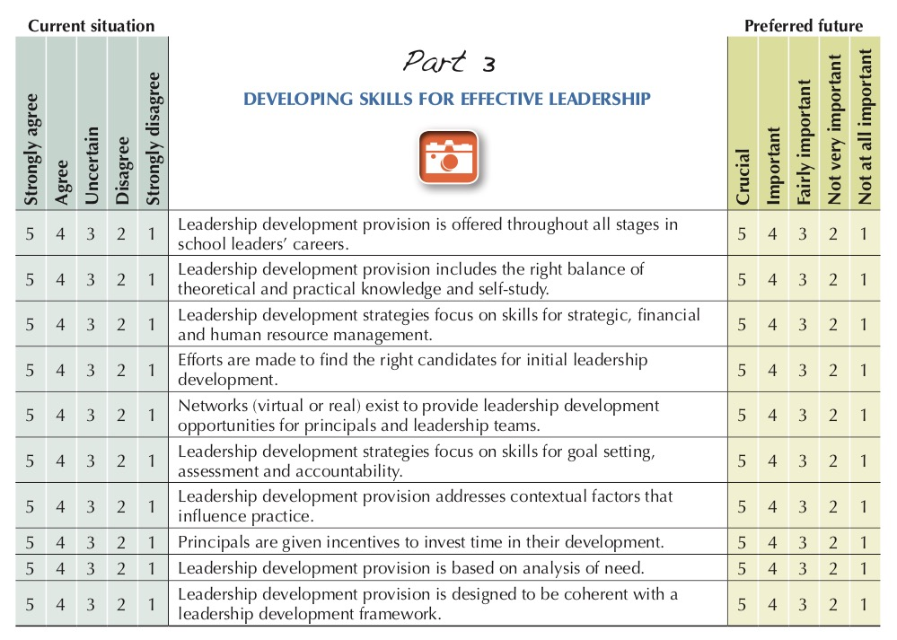

OECD 2012
A. Schleicher, Preparing teachers and developing school leaders for the 21st century: Lessons from around the world.

Training for school leaders is particularly important in countries where schools and school leaders have a high degree of autonomy. New Zealand, which has a highly decentralized school system, established four development initiatives for school leaders: an induction program for first-time school leaders; an electronic network for sitting school leaders (LeadSpace); development centers for school leaders (Principals’ Development Planning Centre); and guidelines on professional development for school leaders. (p. 27)

Induction programs
Many countries provide leadership training for newly appointed school leaders, however most of these programs are optional. By targeting new school leaders, these programs can help to shape initial school-leadership practices and build networks through which the leaders can share their concerns. they should provide a combination of theoretical and practical knowledge and self-study, and should be designed to cohere with the broader development framework.
in the United States, more than half of the 50 states now require that new school leaders receive some form of induction support. in Australia and Hungary, induction programs are short courses organized by local authorities to introduce school leaders to their surroundings. in Denmark, the courses may run to about a month, but in other countries, they may run from one to three years.
Ireland launched an induction program for newly appointed school leaders in 2001. Misneach (gaelic for “courage”) focuses on managing self, leading learning, leading the organization and leading people. only 18% of those who attended the program felt that they had been well-prepared to assume their role as school leader before they participated in the training. (p. 28)

EC 2018
Three of the five volumes are interesting for IMP

Vol. 1 | European ideas for better learning: The governance of school education systems  Interesting is Chapter 5 Policy Guidance in action.  This section translates the key policy messages from conceptual understanding into 5 coherent scenarios of practical application. The 5 scenarios can be used also as support for defining a strategy for induction and mentoring.
Vol. 4 | Teachers and school leaders in schools as learning organisations: Guiding principles for policy development in school education.  This topic is also relevant: What could or should be the balance between internal support to new colleagues and the external support. The more a school shows the characteristics of a learning organisation the more one can work with internal support for a new principal.  The paragraphs on ‘Supporting school leaders’ (p. 53) presents examples from Norway (with a link to evaluation results), Austria (with the Leadership Academy as a national forum), Ireland (the Centre for School Leadership) and Estonia and Slovenia with mentoring programmes for novice school leaders.  As a measure to consider the report formulates: Create transparency on the competences required from school leaders, for instance through competence frameworks or standards (p. 57).
Vol. 5 | Networks for learning and development across school education: Guiding principles for policy development on the use of networks in school education systems.  Although networks between (novice) principals can be important for the novice principal this document does not deal with that aspect.

3.2 European School Heads Association
ESHA is a professional organization for European School Heads. Members of ESHA are national organisations for school heads and deputy school heads within (pre-) primary, secondary and vocational education. Nearly all European countries (both EU and non-EU) are represented within ESHA by one or more organisations.
ESHA is an international community in which experiences, visions and views between members are exchanged and in which new ideas are born. ESHA connects school leaders, researchers and policy makers with the collective aim to learn from each other and improve education.

The site of ESHA does not include much information about induction and mentoring.
However, very interestingly, they recently started a far-ranging project on the topic. ESHA is contacted. We will be informed about progress.

School Leadership Coaching and mentoring
October 2017 – October 2019

Focus Professionalisation of new school leaders by experienced and recently retired school leaders

The aim of the School Leadership Coaching and Mentoring project is to develop an induction programme for newly appointed school leaders, which exploits the proven expertise and capacity of experienced and recently retired school leaders. This will be achieved by the following steps. First, the priority needs of new school leaders across the partnership is audited. In addition, a coaching and mentoring programme for new school leaders and a set of pilot training modules is developed. After the programme is developed, it is tested at 150 school leaders in order to improve and finalise the resources. Finally, the School Leadership Coaching and Mentoring programme is published on an online platform. The platform exists of downloadable blended learning training modules, a virtual community and a network building tool.

Assumed deliverables:

- a report on the needs of new school leaders
- an integrated platform with linked social media providing information about the project, promotional materials, and downloadable resources
- an EU level coaching and mentoring programme for new school leaders
- a set of training materials, which will be applicable to all countries
- a series of case studies, which reflect the different contextual and cultural backgrounds of the countries of the consortium
- a policy recommendation paper resulting from the project trials and outcomes
- a set of dissemination materials and seminars in 5 countries
- a final international conference to promote the training resources

Partners

- National Association of Headteachers (NAHT)
- National Association of Principals and Deputy Principals (NAPD)
- Associazione Nazionale Dirigenti e Alte Professionalita della Scuola (ANP)
- Drustvo Ravnatelj (DR)
- Vereniging Leidinggevenden Vlaams Onderwijs (VLVO)
- European School Heads Association (ESHA)

ESHA’s role

- Carrying out responsibilities from the dissemination plan
- Expanding the network
- Organising and running a workshop in the Netherlands to promote the resources and highlight the opportunities for the key target groups
- Promoting and contributing to the final conference

https://www.esha.org/esha-projects/coaching-and-mentoring/

3.3 European Policy Network on School Leadership
The European Policy Network on School Leadership (EPNoSL) is a partner-run consortium created in 2011 in response to the increasing European focus on school leaders’ professional development, including preparation and selection of school leaders. EPNoSL aims at improving policy and practice on school leadership in Europe.

EPNoSL has grown into a network of stakeholders from 42 European based institutions. EPNoSL partners include academic and other experts engaged in key thematic areas, education ministries and other policymakers, as well as professional associations at national, regional and European levels. In addition, research and capacity-building actors serve a fundamental role in enabling and facilitating meaningful exchanges among partners, as well as evaluation and dissemination of findings.

The latest news from EPNoSL on its website is from June 2016. The final EPNoSL Peer Learning Activity (PLA) took place in Heraklion, Crete in May, 2015. The 3rd EPNoSL Berlin Conference on School Leadership was in September 2015.

The Final Evaluation Report of the work of EPNoSL (Jacky Lumby) is very interesting reading. Not only because EPNoSL explicitly chose to influence policy on equity and learning (in contrast with the neutrality of many frameworks for principal training), but also because the report is very open about the (perceived) impact of the work of EPNoSL.

One of the results is the School Leaders Toolkit with a Educating School Leaders Toolset http://toolkit.schoolleadership.eu/development_questions.php
This includes:
- Questions for policy reflections
- School leaders' development indicators (with data from TALIS 2013, Eurydice 2013, TIMMS 2011)
- Data on school leaders' development
- Good practice examples (Austria and Sweden)
- Building a Competency Framework
- Recruitment & career of school leaders
- References and feedback
There are however no references to novice principals

3.4 European Network for Improving Research and Development in Educational Leadership and Management
“ENIRDELM is a self-funding network promoting critical and friendly professionalism to improve the quality of educational leadership & management development and research across the whole of Europe.

ENIRDELM seems to be only relevant by the papers for the annual conferences (which are not easily to be found).

4.0 Flanders (Belgium)
This chapter starts with the relevant parts of the OECD 2008 study and the report of Devos that was a preparation for that overview study.
Much of the situation sketched then is still recognizable in the current situation.
The report of Verbiest for the Flemish Government (2014) is based on an analysis in other countries and presents proposals (challenges) for the future.
Devos (2018) also formulates recommendations for the future and focuses especially on stress and well-being.
The role of the government is rather limited, but very important they fund the pedagogical counselling services of the umbrella organisations in education:
OVSG (Municipality schools), GO! (Flemish Public Education) and VSKO (Flemish Umbrella organization for Catholic Schools).

4.1 Publications
Improving School Leadership - Background Report for Flanders (Devos 2006)
This report includes much information on the professional development of school leaders (p. 55), with a focus on the community (umbrella) organizations in education.
Paragraph 6.2.2 states: … community education considers the support of newly-appointed headteachers as a continuation of the mandatory training they attended as candidate headteachers. Newly-appointed headteachers have the opportunity to attend in-service training that is developed according to need by the community education in-service training centre in consultation with the school group to which the headteacher belongs.
The Flemish Catholic education co-ordinating body VSKO does things differently. For its newly-appointed headteachers in mainstream and special elementary education it organizes a three-year training programme….
The OVSG also runs a basic training course for new headteachers. This is a two-year programme, which is open to new headteachers who have been in service for a maximum of three years.

Improving School Leadership’ (Pont 2008)
In Volume 2 from ‘Improving School Leadership’ one can find a lengthy chapter on
‘The Flemish (Belgian) approach to system leadership” (p. 153).
The descriptions in the report were based on the former report from Devos.
The chapter starts with an overview of the Flemish context. The focus thereafter is on communities of schools. Leadership training and support is mentioned on p. 172.
The focus is here on the role of the government.
‘There is no evidence that the Flemish authorities provide support to strengthen system leadership at the community level. There are no centrally organised support structures for principals, no monitoring and evaluation of leadership, and no dissemination of effective practices.’

The next paragraphs present information about training providers, provision from the co-ordinating bodies and provision from other training establishments. With the paragraphs on relevant research, recent policy measures and current needs and development all-in all a rich description of the situation at that time (2006).

Leading learning at a higher level (Leren leiden op niveau) (Verbiest 2014)
This report from Erik Verbiest presents the result of an investigation for the Flemish Government in competencies and professionalization of principals in basic and secondary education.
The report does not deal only with the situation in Flanders. It also presents and uses information on the situation in the Netherlands, Central Europe, USA, Canada, Australia and New Zealand.

Verbiest in his proposals sketches a continuum of 4 training phases.
Phase 1. Orientation on leading
Phase 2. Leading education (working with teachers)
Phase 3. Leading a school
Phase 4. Leading (in) the system
During these phases the person (first a teacher, later a school leader, a system leader) completes a Master study.

Verbiest reviews several elements of the positioning of this professionalization and chooses position in the national discussions (p. 116)
- Level of education: Masters level and beyond, with a focus on experience-based learning (different from the regular Masters). Cooperation between universities and existing training organisations from umbrella organisations like those for catholic education (VSKO).
- Obligated or voluntarily: Obligated given the importance of a high qualification of school leaders
- Pre- or in-service: A distinction less relevant. In the continuum most of the activities will be in-service based. For some target groups that might be interested to become a school leader pre-service is still relevant.
- Differentiation: Desirable given the different situations in primary and secondary education

Stress and well-being of school leaders (Devos 2018)
Geert Devos formulates current recommendations for the training of starting school leaders from a study into stress and well-being among school leaders. (p.35)
7.2 ... In addition to training and guidance in advance, also initial supervision of starting school leaders after the appointment and initiatives for experienced school leaders are very useful.
7.3. Training can take various forms
It is important that the training of candidate and starting school leaders consists to a large extent of personal guidance with an extensive practical component. For example, during the preparation of school leaders, internships can take place and when a school leader starts in the job, a coach can be assigned. This way of training responds to the specific needs of each school leader and the context in which this school leader ends up. The education field should devise a strategy to facilitate such start-up processes, with sufficient attention for competent coaches or fellow school leaders to guide starting school leaders.
In addition, intervision groups for starting school leaders or networks that are built up during training can also be very useful. A formal management training also offers possibilities. As part of such courses, (ex-) school leaders can share their insights with starting colleagues as experienced experts.
7.4. Relevant content
Naturally, the question arises as to which content should be addressed in this program for starting school leaders. Some relevant contents are listed below:
- Deepening pedagogical frameworks;
- Being able to retrieve administrative rules and legislation, but also knowing where
support or explanation is available;
- Dwelling on principles of self-care and resilience to stress;
- Paying attention to time use and self-management (e.g. learning to set priorities
and define preconditions so that school leaders succeed effectively to spend most of the time on tasks that gain them satisfaction);
- Learn to delegate and collaborate in a policy- or management team;
- People management (e.g. encouraging collaboration and professional development
of teachers, but also dealing with challenging situations such as conflicts, tensions and resistance among teachers).

Teachers and school leaders in schools as learning organisations (EC, 2018)
In Belgium(Flanders), every two years, the central government authorities decide on a number of themes for CPD projects that are needed to support the implementation of educational reforms. The training projects selected are then offered to schools free of charge. Intended initially for a small team of a school’s teaching staff, courses last one year (with the possibility of an extension for one year to involve additional support from their pedagogical counselling service). Following this phase, participants are expected to transfer their newly gained expertise to their local school context, sharing with colleagues at their school. (p. 50)

In Belgium(Flanders), schools and teaching staff are supported by pedagogical counselling services, which are set up by the educational umbrella organisations and funded by the Government. A decree sets out the tasks of Pedagogical counselling services, some of which specifically aim to support schools in becoming professional learning organisations, among other means by:
- promoting the establishment of networks and providing support to these networks;
- supporting and training managerial staff;
- supporting the professional competence of members of staff at school and cross-
school level by focussing on beginning staff and staff charged with specific tasks in particular;
- reinforcing the policy powers of schools;
- supporting quality assurance within schools. (p. 51)

4.2
Examples of support to starting principals from 3 umbrella organisations
OVSG (Municipality schools), GO! (Flemish Public Education), VSKO (Flemish Umbrella organization for Catholic Schools)

OVSG
OVSG comprises education of Flemish municipalities: some 700 schools and 185.000 students in primary and secondary education (apart from arts education).
OVSG started in September 2017 with a brand new training program for managers and future managers. The goal is to support and strengthen executives in education throughout their careers. The route consists of three stepping stones: Opstart, Topstart and Toproute.

The expectations and needs of our directors, the social expectations expressed in the Framework for Quality of Education and the findings from scientific research have been translated into six main lines that form the basis of the new training concept.
1. Professionalization is a continuous process in which prior education is a starting point.
2. We offer a coherent and gradually structured curriculum that consists of different learning lines that are addressed throughout the full continuum of professionalization. Within each learning line, attention is paid to vision, quality assurance and leadership in order to arrive at an integrated policy.
3. We pay attention to both theory and practice. Through various work forms and assignments we stimulate the participants to adopt an investigative attitude and to translate new insights and / or skills into their own context.
4. We strongly focus on reflection and dialogue. The use of a digital learning platform must reinforce this.
5. We choose to bring together (future) managers from all levels in order to utilize the wealth of experiences and ideas. But at the same time there are also opportunities to work with level-specific material within each level.
6. We want an effective and high-quality professionalization program for. Through systematic and in-depth evaluation, the supply is continually optimized and tailored to the social needs and the questions and expectations of the participants.

We translate these starting points into a course with 7 learning lines that will be dealt with more and more in depth according to the career phase.

For ‘Opstart’ (one year) these are detailed as:
- Leadership
- Vision makes the difference!
- Quality assurance – Reference framework quality of education and the role of school policy
- Educational policy: a broad road
- You make school together
- Self-care
- Communicating for motivating (Brochure Opstart p.3)

Opstart: Characteristic: Standard training (with space for self-care) with optional modules

GO!
GO! embraces education in the Flemish Community. It unites 1000 schools, 36.000 staff members and 320.000 students
A central document is: Competency profile for the office of (deputy) director in an institution of the GO!
The job training starts only when the staff member also effectively works in the relevant office and includes 10 months of effective service.
The job training is an essential part of the training and professionalisation of these employees. The school groups are fully involved in job training and integrate this training as it has been worked out in the general regulation on the professionalization and evaluation process of the staff members involved.
The job training is honoured by a job training certificate and can be part of the evaluation by the Board of the school group. The job training is phase 3 of the professional continuum.

The course consists of 7 lesson days, 2 x flipped classroom with self-study package + practicum (regulation), a practical (vision development) and a tutorial (case treatment)

Central in the course is the ‘Pedagocial Project: Together learning living together’

Characteristic: Identity driven standard training

VSKO
The organisation represents more than 2450 schools, 85 000 teachers and nearly 1.000.000 learners. It has 5 regional educational advisory services

ProfS: In service in house training for beginning school leader of the catholic primary schools (some 300 trainees each year for a training period of three years in a steady group of peers).
Prof+: Permanent professionalization; amongst other activities in Reflection Groups.

ProfS: main goal
To train school leaders
- to get a better understanding of responsibilities and challenges
- to become capable of leading their school in an constantly changing environment,
- to develop the policy making capacity of the school,
- to be willing to learn continuously in a never-ending interaction between action and reflection

ProfS: working principles
- In house training within the Catholic umbrella organisation
- Christian –dialogical/emancipatory in a leadership in a learning organisation
- Networking with colleagues (beginning)
- Through a long-term group process
- Intense cooperation with school boards, educational advisory services, within ‘Katholiek Onderwijs Vlaanderen’ (partners in CPD)
- Internal guidance of the participants’ learning process, no tests or exams.

ProfS Characteristic: Faith driven standard training with strong accent on group development in subgroups of cohort. Cluster groups for special interests

ProfS: Quality development: data
- Data about participant: systematic at the start
- Job satisfaction evolution (University of Gent, prof. Geert Devos (2014- ….)
- Registration of absences, link attest
- Development of a systematic inquiry of dropouts 09/10-…
- Automatic evaluation after each module (Event)
- Warm evaluation, yearly feedback of participants in every diocese
- Inquiry of Goals at the end of the third year (from 08/09-..)
Example: Feedbackrapport Functioneren en welbevinden directeurs ProfSopleiding (Geert Devos et al. 2014) (Feedbackreport Functioning and wellbeing directors ProfStraining)

Prof+: Reflection Groups (also an element in ProfS)
Common (structured) reflection on concrete practical problems guided by a diocesan education adviser

Prof+ Characteristic: Well-structured Professional Learning Communities (PLCs).

VSKO participated in the Linpilcare project http://www.linpilcare.eu/
LINPILCARE was an Erasmus+ KA2 strategic partnership for innovation in school education. LINPILCARE aimed to link practitioner inquiry via professional learning communities with the results of academic research, in order to use evidence based knowledge in their practice.
The tools developed in the project support structuring of working in PLCs.

Karel Binon who for a range of years was project leader of ProfS wrote about the characteristics of ProfS. A selection:
- As a school leader in a Catholic primary school you do not stand alone. You will be in touch with a lot of schools and with a rich history which mixes a radical message of love with innovating, high-standard education. In the context of an ever-changing society Catholic primary schools are challenged to make their identity more explicit and to guard their uniqueness over and over again.
With this in mind we want to present ProfS as a staff training, as an ‘in-house’ training within Catholic education. At the end of the training, this will be confirmed by means of a symbol, namely a certificate as a school leader of Catholic primary education.
- We underline the internal guidance of the participants’ learning process. There are no tests or exams; we merely demand that the participants are present during the sessions. In that way, participants are responsible for their own learning process.
- We try to strive for an optimal alignment between the learning or individual participant, the professional context (working environment, their own schools) and the professional training opportunities….
In this way, the participants develop their own unique identity as a school leader, linked to their own school situation.
- In this search for identity participants could allow their personal interpretative framework, based on their very own experiences (education, youth organizations, family, friends) to interact with the following points of reference within the training: the other participants, the professional training/educational supervisors, ProfS-organizers and the dialogue-focused, participatory and learning culture we hope to create.
- This growth of identity is not complete after three years…. This is why we want to look at ProfS as a start in a training continuum for school leaders.

5.0 Netherlands
Main characteristic of the support for principals in the Dutch educational system is a market-orientation.
The Ministry of Education, Science and Culture funded during an initial period (starting in 1976) just one organisation: Bijscholing Schoolleiders Voortgezet Onderwijs (later Interstudie).
In later years (earmarked) funding for training and other support to school leaders went directly to the schools.
Principals were free to choose whatever support they needed.

Only in recent years principals of primary schools are obliged to register and proof that they followed the right training. (This does not hold (yet) for principals of secondary schools).

The Ministry of ESC did not play an active role in establishing organisations for support of principals or in defining frameworks, nor did it initiate research (with some exemptions).
In contrast organisations of principals themselves were very active in the field. First in primary education, the AVS (General Association of Principals), later in secondary education. If positively judged initiatives from these organisations and others could be (temporarily) funded by the Ministry.

Standard and tailor-made training for principals (and assessment, coaching, consultancy, interim management etc.) was (and is) offered by a range of organisations: Universities (for professional education), national faith/public based support organisations (KPC, CPS, APS), regional support organisations for primary education (not faith-based), unions for principals (AVS), sector councils (PO-council, VO-council) for-profit organisations and not-for-profit organisations.

In a vivid and flourishing market one would expect a lot of experimentation and renewal of the offer of this diversity of organisations. In reality new initiatives (if at all) were copied quickly so that the offer looked much the same. (E.g. many organisations started around the same time with 360 degrees feedback). The scope of the common offer however was broad: For women (a two-year programme) who wanted to orientate themselves on school leadership to weeks of reflection for senior principals. From one day training to Masters (University or Professional Master).

The two organisations representing the principals of primary schools (AVS) and the boards of secondary school (VO-council) started their own training and support centres: AVS Centrum Educatief Leiderschap (Centre Educational Leadership) en VO-academie. Possibly (or apparently) their members were not satisfied (any more) with what was offered by other organisations. Or they wanted to have more ownership about what was offered.

Recently the Dutch Register of School Leaders in Secondary Education (Schoolleidersregister VO or SRVO) broadened its scope. Not only focusing on registration of school leaders but also supporting them and uniting them in their interests (for professional development). This is clear from their Publication Monitor, the possibility to add reviews to the catalogue of training and support and through new activities like Leiderschapslab and Edcamp.

In the last decade (but starting already earlier with the economic crisis of the nineties) many of these organisations experienced financial problems because of a shortage of clients. Even the sector training centres were confronted with fluctuating interest from principals.

Schools not any longer were interested to pay high fees. Added to that sometimes there was a feeling that trainers, consultants were not able to stay informed about the many complex changes in schools and their context. These changes in itself are very interesting (more autonomy for schools, merging of schools, other ways of funding, a changing population, searching for solutions for inequality in the system) but these are beyond the scope of this report.

Support organisations searched for solutions (by slimming and merging) and some organisations collapsed. That did not occur only to smaller for-profit organisations but also to large national organisations like APS. (The names of the other national organisations KPC and CPS continue to be used after take-over or merging, but their status might be perceived as not any longer the same).

When one consults the overview of support and training organisations for primary education (aanbieders) at http://www.professionaliseringsaanbod.nl/aanbieders/ there are still many of them (more than 60). It is still possible to earn a living in this field. But one has to stay on top of the developments in the schools and their context.

The developments of the last 15 years are reflected in some international reports (OECD).

5.1 Reports
Improving School Leadership - OECD Review Background Report for the Netherlands (Bal 2007)
Chapter 5 The appeal of the school leader’s profession
5.2 Policy developments and challenges for the future

Main (numbered) paragraphs of the chapter
236. Coaching and mentoring starting school leaders is very important. Without such support there is a considerable risk that they will leave the profession within not too long a time Since the school year of 2004/2005 the Ministry of OCW has given an annual subsidy of € 6.000 for a qualified authority that has appointed newly qualified school leaders. This subsidy has been extended to Augustus 2008.
237. The nurseries (In Dutch called fishing ponds) to train a management’s own potential (teachers and other members of staff) is an initiative that originated from the concern about the increasing number of unfilled vacancies for school leaders.
238. Policy initiatives have been taken, aimed at specific target groups, to deal with the short-age of school leaders in primary education for example “duo-jobs” and the project “bazen van buiten” (recruiting managers from outside education).

Chapter 6 Training and the professional development of school leaders
(Only primary and secondary education)
6.1 The actual situation in the Netherlands
273. The Nederlandse Schoolleiders Academie (NSA) plays a part in describing and assessing education and training for primary education. The ‘professionalisation indicator’ contained data about over 100 organisation and institutions and institutes and describes over 500 products and services. All these products and services are linked to the competences in the NSA vocational standard….
274. In addition to describing and assessing training the NSA also keeps up to date the Register of Educational Directors (RDO). (Not yet obligatory at that time)….
276. Registering directors in secondary education and the BVE sector is not yet under consideration. An initiative should come from the sector itself.

6.2 Policy developments and challenges for the future
277. From the interviews held to compile this country report it became apparent that interest in short courses in particular is declining. This decreasing interest is probably due to a certain “fatigue”, (we have heard this all before).it is considered by some to be more of a day out (“old boys network”), but little is learned. Schools seem to be becoming careful with what they do with their budgets (especially in the primary sector where block rate funding was recently introduced).
279. A relatively new development in the field of professionalisation is the creation of knowledge circles/knowledge centres and networks. There are knowledge circles in primary and secondary education that aim to distribute knowledge from research and the experience of schools among a much wider target group. The function of such an initiative by one of Fontys HBOs is to build up knowledge about collective learning. There is feed-back of knowledge not only to the schools but this knowledge is also available for types of training for school leaders. Another initiative for a knowledge centre (A11) originated from a HBO and a university This initiative describes the core function of the centre as “narrowing the gap between practical education and research by building a bridge to connect research, training and school development”. The AVS, with the School for Leadership also wishes to contribute to the development, research and innovation of leadership and knowledge with knowledge and new insights.
280. The Netherlands School Leaders Academy (NSA) took the initiative to establish a knowledge centre for leadership in primary education. This knowledge centre, called, “De Brink” intends from an independent position, to encourage leadership development, stimulate learning by school leaders and so contribute to the further professionalisation of this professional group. The Minister supported this initiative by granting a starting subsidy.
282. Another initiative to promote professionalisation is the website on Kennisnet that is intended specifically for the (profession of) school leader in primary education. The objective of the website (on line since October 2006) is, in addition to supplying information of interest to school leaders, providing inspiration and offering opportunities for interaction.
283. Finally, the project “Co-coaching” can also be seen as an initiative in which the exchange of knowledge and sharing experience are in the fore-front. The projects is similar to 'Partners in Leadership', a project that has been running in the United Kingdom for some years and that brings managers from education and business together ….
284. The first impressions of co-coaching, in which 60 couples are involved at the present time, are positive. The participants are enthusiastic. It does, however, appear to b e difficult to find businesses willing to co-operate.

OECD Reviews of National Policies for Education Netherlands 2016
Foundations for the Future (Nusche)
Chapter 6
Putting the spotlight on school leaders in the Netherlands

The limited profile of school leadership issues
- School leadership is critical but has received relatively little policy attention
- School leaders are not always involved in policy discussions
(Policy is discussed with the boards of education) (p. 122)
Defining what we expect of school leaders
- Leadership competences have been established for primary and secondary education
The MoECS Action Plan Teacher 2020 proposes that all primary and secondary school leaders, and the leadership/middle management team in upper secondary vocational education, should have a required set of professional competences (MoECS, 2011). For primary and secondary school leaders, recently revised competency profiles (Table 6.1) provide guidance on daily practice, appraisals and education programmes….
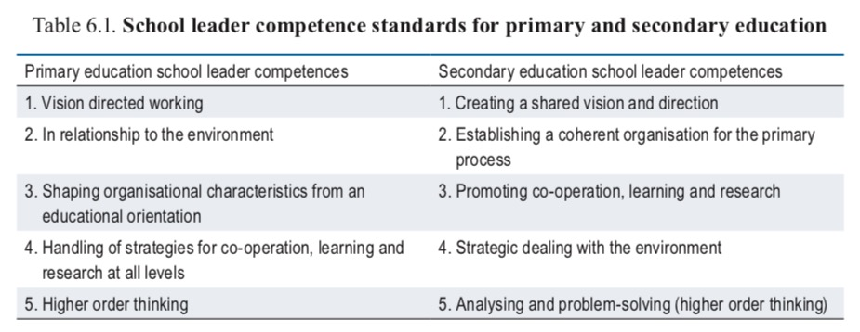
(p. 123)
- Current leadership competences provide limited guidance
The competence standards illustrated in Table 6.1 are relatively abstract, which leaves school boards with a limited basis on which to select, appraise and develop the skills of their school leaders (Inspectorate of Education, 2014a). The key issues of human resource management receive scant attention. Greater clarity on expectations could be provided, as is done in Australia and Singapore….

Becoming a school leader
- Most school leaders have some type of leadership training
School boards appoint school leaders after an open selection process. Unlike many countries, school leaders are not required to have teaching experience, although they usually do (Pont, Nusche and Moorman, 2008; Nusche et al., 2014). Most school leaders receive non-mandatory training (Bal and De Jong, 2007). The Teaching and Learning International Survey (TALIS) 2013 showed that almost all lower secondary leaders participated in a school administration or principal training course either before or after taking up duty (OECD, 2014).
- Induction of new school leaders is underdeveloped
Although research evidence suggests that quality induction programmes for new school leaders are valuable (Pont, Nusche and Moorman, 2008), they are not common practice in the Netherlands. Less than half of recently appointed school leaders in a recent study had participated in any sort of induction and mentoring programme, and only 12% had participated in a substantial programme (Andersen et al., 2012). MoECS could look towards the examples of Ontario (Canada), New Zealand and Victoria (Australia) that have integrated such training programmes as a mandatory requirement into their national improvement strategies (P. 125)

Continuous professional development
- A primary education school leaders register became mandatory in 2015
School leaders need to continuously upgrade their skills, not least to serve as role models for teachers to do the same (Fullan, 2014). Following the examples of Australia, Ontario (Canada) and Scotland (Schleicher, 2011; van Dijk, Gaisbauer and Scheeren, 2013) the Netherlands established a mandatory register for primary school leaders and (in 2016) a voluntary register for secondary school leaders. But these registers on their own are not sufficient and registration is disconnected from school leaders’ actual performance. Four out of ten school leaders also overestimate their own competence levels (Inspectorate of Education, 2014a). To make registration more meaningful, it could be linked with career advancement and used to hold school leaders accountable as in Australia and Scotland (Lawrence et al., 2006; Donaldson, 2010).
- Many school leaders face barriers to professional development
While, in principle, school boards play a pivotal role in managing school leaders, not all school boards do so adequately in respect of professional development (Inspectorate of Education, 2014a, 2015; AVS, 2012). Although almost all Dutch principals participated in some form of professional development in the 12 months prior to the TALIS 2013 survey, training intensity was low (half the cross-country TALIS average). About one in five did not participate because it was too expensive (19.4%) and conflicted with their work schedule (20.8%), and 12% said that lack of employer support was a barrier to participation (OECD, 2014). The General Association for School leaders (AVS) says that three quarters of primary education school leaders feel they face barriers to their professional development (AVS, 2012). School boards, however, say that the weak motivation of school leaders is a barrier to professional development. (p. 130)

Develop a leadership strategy that promotes professional collaboration and a culture of continuous improvement
Various initiatives have sought to strengthen school leadership in the Netherlands. But these need to be more systematic and more ambitious. The Netherlands should therefore develop a leadership strategy that includes (amongst other things):
- Promotion of collaboration among school leaders, teachers and school boards and the linked development of a culture of continuous improvement. This should fit MoECS ambitions of transforming all schools into a learning organisation.
- MoECS should consider establishing a mandatory national induction programme for school leaders, guaranteeing the quality of the induction and mentoring support. School boards should ensure that all new school leaders participate in the programme. Successful completion of the induction period could serve as a starting point for inclusion in mandatory school leadership registers (for all levels). (p. 130)

Empowering school heads (Onderwijsraad)
In 2018 the ‘Onderwijsraad’ (Education Council) the most important advisory council for the Ministry of Education Science and Culture, published an advice on school leaders (Een krachtige rol voor schoolleiders) with three main recommendations.

School heads play a key role in the quality of education. Their role has changed over time, with the emphasis increasingly coming to lie on educational development and improvement and providing a good working and learning environment for teaching staff. Collaboration with parties outside the school has also become increasingly important. In their day-to-day practice, school heads are having to devote more attention to leadership and less time to managerial tasks. To be able to do this, school heads must be empowered to think and act strategically.
There is room for improvement in the capacity of some school heads to think and act strategically. At present, school organisations offer heads insufficient opportunity for further development of that capacity. School heads could also be given a greater role in policy formulation and decision-making at management level. Further professionalisation and better positioning of school heads will be needed if they are to take on a more strategic role. School heads, school boards and government can work together to facilitate this.

Recommendation 1: Strengthen school leadership by creating a common professional profile
A number of good initiatives have been taken in primary and secondary schools and in senior secondary vocational education aimed at putting school heads on the map as a professional group. There are many correspondences between these sectors in terms of what constitutes a good school head: the competence profiles are virtually identical. However, the Council believes that successful professionalisation requires a sector-overarching approach….
The Council recommends working towards the development of a single, sector-overarching professional standard with one mandatory register.

Recommendation 2: Create an integrated leadership development system
Promoting good school leadership requires that all school heads work from a solid knowledge base. Currently, there are too many differences across the educational sectors in the way school heads are trained, and too much diversity in individual training programmes. The Council recommends that the government take measures to improve the quality of school heads, in the same way as for teachers. Pooling of research, education and training needs to be stimulated and facilitated. Scholarships should also be made available for school heads. This should be accompanied by higher demands in terms of the professionalisation of school heads in primary and secondary education and in senior secondary vocational education. The Council believes it is important that school heads should be trained to Master’s level…..

Recommendation 3: Give school heads the opportunity to develop the strategic aspects of their role
School organisations must create scope for school heads to play a strategic role…..

Remark: The Education Council does not mention induction and mentoring for beginning principals but one can assume that this is implied in an integrated development system.

5.2 Recent initiatives to foster support for novice principals
Some examples (all in Dutch)
- The VO-raad asked KPCGroep to advise on the subject (Report by Hans Burgmans).
- The VO-academie published: New contents, new networks, new perspectives. Induction programmes for starting principals.
- Coaching for and by school leaders: Research into the effects and success factors of coaching in primary education (report by SBO, Sectorbestuur Onderwijsarbeidsmarkt).
- Advice to a school board: Boarding@Lucasonderwijs (Antoinette Gillet).
- Report ‘De lerende schoolleiders: Effecten van Professionalisering (Meta Krüger, Inge Andersen) with explicit attention for novice principals.
- Trainingprogramme (one year) ‘Basisbekwaam’ (competent at basic level, several providers).

6.0 UK (England, Scotland)
Major event in the support to principals in the UK has been the rise and fall of the National College for School Leadership. NCSL started in 2002 with a huge budget. In recent years however the national strategy for improving schools has changed towards: The self-improving school (with much less budget). For the organisation of the support for principals in South Africa recent years are less interesting. Discussion held and solutions found during the existence of the NCSL are of much more relevance.

In contrast in Scotland the last years are the most interesting ones.
This month the Ministry published a new framework for learning and recently Scottish College for Educational Leadership made a new start under Education Scotland now working with six ‘Regional improvement collaboratives’.

6.1 England
Towards the NCSL
The history of Leadership Development in the UK till 2004 is well-described by a major player, Ray Bolam. His article was part of a special issue of Educational Management Administration and Leadership (2004) about the National College for School Leadership. The NCSL was established in 2000 and started its activities in 2002 and from the beginning had a huge annual budget (in 2008 more than 110 million GBP).

Three historical phases
Bolam reviews three historical phases of leadership development in England and Wales, in order to show how the idea of a national college developed and became viable.

Phase 1: Ad hoc provision. Starting in the late 1960s and the early 1970s with initiatives from Local Educational Authorities, universities and Her Majesty’s Inspectorate.

Phase 2: Towards Coherence and Coordination. Government funding of a National Development Centre (NDC) for School Management Training that coordinated 40 Higher Education-based regional centres (1983-1988). To support the radical and extensive educational reforms the government later funded the School Management Taskforce (1989-1992) that worked collaboratively with regional consortia of LEA’s to promote more effective control over management training by schools and more accessible provision of flexible and practical forms of training and support.
In the mid 1990s the Teacher Training Agency (TTA) introduced a comprehensive structure for leadership development of which the National Professional Qualification for Headship (NPQH) for this report is the most interesting

Phase 3: A National College. The NCSL was launched by Prime Minister Tony Blair in 2002 and presented a Leadership Development Framework of 5 stages of which NPQH was meant (together with another program) for the entry into headship.

The National College for School Leadership
The Colleges goals (formulated in 2006 and reinforced in 2008) were:
• develop excellent school leadership to transform children’s achievement and well-being
• develop leadership within and beyond the school
• identify and grow tomorrow’s leaders
• ensure a fit-for-purpose, national college

That is somewhat different from the goals of 2002:
• provide a single national focus for school leadership development, research and innovation
• be a driving force for world-class leadership in our schools and the wider community
• provide support to and be a major resource for school leaders
• stimulate national and international debate on leadership issues.

The focus was not any longer on school leadership as such but on the much-needed effects of school leadership on children. The focus is less on NCSL (providing a single national focus) but more on the development of leadership. NCSL ‘just’ has to be a fit-for-purpose organisation.

A positive judgment on the NCSL from the USA
Levine in his very critical report of 2005 on the situation in the USA presented the NCSL as the most promising example of a strong program. A program not to be found in the USA.

Discussions about the NCSL
The judgment of Levine not yet reflected the discussions in the UK about the goals and functioning of the NCSL. One of the main points of those discussions was whether the NCSL in practice provided just one model of leadership. It was another way of saying that the NCSL coordinated and controlled all training (consultancy and research), neglecting the knowledge and skills of former organisations that had provided or still were providing training and other services.
What follows here just concentrates on the ‘one model of leadership’.

Already in 2001 the National Association of Head Teachers warned that the new NCSL must not patronise or try to control them. The comments were recognized by the chief executive of NCSL. She stated in 2002: The college is not about prescriptions or blueprints (Bill Mulford 2004, p. 315 and 319). Geoff Southworth (Director of research) in 2004 stated: ‘The college tries hard not to avoid prescribing any one approach (p. 346)

Discussions went on. These discussions on the ‘one model of leadership’ were one of the reasons for the Department for Education and Skills (DfES) to commission in April 2006 PricewaterhouseCoopers LLP to undertake an independent research study on school leadership. The main aims of the study were to provide a comprehensive and independent account of existing, emerging and potential models of school headship and the wider leadership team that are effective in raising standards for all pupils.

PwC LLP was able to define a set of models of school leadership. These models however do not define different styles of leadership. The models rather define different tasks in different situations in which heads are working.
The models are:
- Traditional leadership models;
- Managed leadership models;
- Multi-agency managed leadership models;
- Federated leadership models;
- System leadership models.
Furthermore it is remarkable to see that transformational or instructional leadership in the report are only mentioned once each. (Distributed leadership 58 times)

Recommendations for a new NPQH
The recommendations on NPQH are detailed on page 151:
‘Building on the ongoing review of NPQH, the DfES and NCSL should give consideration
to reforming key aspects of NPQH and Head for the Future (formerly LPSH), in particular:
- Content; ensuring that the key needs articulated by school leaders in this research are given further prominence, in particular financial management, extended services and the associated implications for team working and people management;
- Delivery; modernising the delivery vehicle to include, for example, e-learning solutions; a greater element of modularisation and tailoring to individual need; cross-sectoral inputs and participation; and less emphasis on what often comes across as a formulaic ‘tick box’ approach;
- Accreditation; ensuring that NPQH is fully ‘joined up’ with the outputs from
secondments, exchanges and other CPD initiatives, so that participation in these
initiatives can provide significant accreditation towards modules of NPQH. Ensuring also that this is the case, and understood to be so, in relation to relevant elements of other professional qualifications including, for example, Masters degrees and MBAs;
- Positioning; ensuring that NPQH and Head for the Future are widely understood across the sector, not as one-off exercises, but rather part of an ongoing development process;
- Constituency; ensuring that leadership training for support staff and senior support staff leaders (e.g. the Bursar Development Programme, delivered by NCSL) is accepted across the sector as being as important as leadership training for teachers;
and
- Mentoring and support; promoting ongoing mentoring and support programmes in order to increase the successful number of NPQH candidates who take up headship or other leadership positions in schools.’

National Standards for Headteachers (2004)
Work of the NCSL (in connection with many other organisations) on the new NPQH was partly based on new National Standards for Headteachers.

The key areas (p 4)
‘The Standards are set out in six key non-hierarchical areas. These six key areas, when
taken together, represent the role of the headteacher.
- Shaping the Future
- Leading Learning and Teaching
- Developing Self and Working with Others
- Managing the Organisation
- Securing Accountability
- Strengthening Community

Within each of these key areas, the knowledge requirements, professional qualities (skills,
dispositions and personal capabilities headteachers bring to the role) and actions needed
to achieve the core purpose are identified. Whilst particular knowledge and professional
qualities are assigned to one of the six key areas, it is important to emphasise that they are interdependent and many are applicable to all key areas. Headteachers will attach relative importance to the actions, and add others, as they define the strategic and operational priorities within their own diverse contexts’.

Changes in NPQH (2007)
The redesign of NPQH is outlined in paragraph 3 of the ‘Advice to Secretary of State’.
‘The revisions are designed to deliver personalised provision to meet the needs of school leaders and the diverse contexts in which they work. We recommend the model has the following features:
3.1 A pre-entry stage to:
- create an appetite for headship
- enable individuals to make decisions about their readiness for headship
- encourage serving headteachers and governors to support aspiring headteachers
- encourage individuals from diverse backgrounds to aspire to headship
3.2 A more robust and rigorous entry assessment and development process to:
- take more account of individual’s prior learning (APL)
- allow those not currently in schools or in education to access NPQH, including non QTS
- recruit only those genuinely seeking headship - through sharper focus on motivation
- recruit individuals who demonstrate capability and readiness for headship
- identify a personalised development pathway for successful applicants as “trainee headteachers”
- provide developmental feedback to unsuccessful applicants
3.3 A more personalised approach for trainee headteachers to enable them to:
- improve and further develop strategic leadership expertise – building on strengths as
well as addressing weaknesses
- develop key management skills (e.g. finance and budgeting skills; performance management)
- engage in leadership learning to meet contextualised development needs
- focus on particular areas of need (e.g. learning and teaching for non-educational participants)
  - A core offering of key experiences critical for future headteachers through:
- access to leadership and management materials, for example, use of data for school improvement; management and development of staff; financial management
- learning in self directed peer groups promoting collaborative, distributed leadership
- placements or work shadowing in different educational or work contexts
- challenge workshops and access to master classes
- engagement with the national policy and international research evidence
3.5 A streamlined graduation process to:
- enable individuals to demonstrate their professional knowledge, understanding and leadership effectiveness
- confirm immediate readiness for headship
- provide governing bodies with sufficient high quality applicants
- link to leadership development provision in early headship
- offer mentoring support, where appropriate, prior to headship
- provide work at masters level to accredit to higher degrees
3.6 A capacity-building approach that:
- requires serving headteachers to give NPQH colleagues support, challenge and feedback through the NPQH process
- draws on the expertise of highly effective headteachers by engaging them with:
  - providing placements and work shadowing for other trainee heads
  - coaching trainees beyond their own school
  - serving on the graduation panel’
(Redesign of NPQH: advice to Secretary of State April 2007 Page 2 of 5)

In the press
It is interesting to see how the Times Educational Supplement of 4 April 2008 describes the need for change:
‘In just over 10 years, 30,000 people have studied for the National Professional Qualification for Headship (NPQH). Plenty have relished the chance to mix with colleagues from around the country, bond and share ideas. Many have complained of its bureaucratic, tick-box approach to running a school. Unfortunately, only 10,750 have become heads. ... The apparent lack of success in converting NPQH graduates into heads has led Steve Munby, chief executive of the National College for School Leadership (NCSL), to overhaul the programme’.

‘The redesigned course will have a greater focus on the big-push initiatives of the day, including Every Child Matters (ECM), the 10-year Children's Plan, personalised learning, Building Schools for the Future, and 14-19 education’.

Here it becomes clear that not the professionals decide about their development, but that support to principals is subjected to the priorities defined by the Ministry.

The New Visions Experience 2003
Next to NPQH NSCL also developed a programme for novice principals The programme was targeted at school leaders in their first three years of headship. It had a strong emphasis on experiential learning. (Bush, Glover, 2005 and Bush, Briggs at al. 2006).

‘The New Visions development team attaches considerable significance to its learning model. ‘A key component of the pilot programme’s design is the importance attached to knowledge creation’. The model assumes three types (or ‘fields’) of knowledge):
- The knowledge of individual head teachers.
- The knowledge of theory, research and academics.
- The knowledge created in a community of head teachers.
Theory and research are represented by several short papers (or ‘think pieces’), many of them commissioned from leading writers on school leadership. Participants are encouraged to share their experience with their New Visions colleagues in what is essentially a problem-solving approach. The theory, research and practice are connected through experiential learning and the programme is essentially co-created by group leaders and participants within a framework established by the NCSL ‘lead facilitator’ group, which has overall responsibility for New Visions.

The programme is organised into four modules. The descriptions of these modules demonstrate the values underpinning the design of the programme.
Module 1: Values and context
Module 2: Teaching and learning
Module 3: Sharing leadership
Module 4: Facing the future

Each module involved attendance for three days (a total of 12 days over three terms) with an expectation of other work being undertaken between formal sessions. The programme documentation envisages a range of learning approaches being used across the four modules, including action learning, case studies, coaching and mentoring, e-learning, inter-visitation, portfolios, problem-based learning, readings and reflection. Most of these approaches are relatively unfamiliar to school leadership development in Britain but received strong support in many of the centres visited during the international study programme organised by NCSL in 2001.

Four lead facilitators were appointed to develop the programme and they are collectively responsible for articulating its philosophy and for managing its implementation. This group appoints the regional group leaders, known as facilitators, and consultant heads. Facilitators are typically experienced in leadership development while the consultant heads are all current school principals. They took joint responsibility for delivering the Cohort One programme in the 11 regional groups.
The rationale for New Visions emphasises process, ‘a learning journey’, rather than content. The three ‘fields’ of knowledge (see above) are at the heart of the approach, which is quite different to that underpinning other NCSL programmes, such as the National Professional Qualification for Headship (NPQH), for aspiring heads, or the Leadership Programme for Serving Heads (LPSH)’ (Bush, Glover p. 222)

From the conclusions:
‘New Visions differs from most leadership development programmes in its emphasis on experiential learning and knowledge creation. The three ‘fields of knowledge’ featured in the programme documentation includes only one ‘content’ dimension; the knowledge of theory, research and academics. This is the main element of most British and international leadership development programmes. New Visions’ process-rich approach breaks new ground in focusing so strongly on head teachers’ own knowledge, based on their professional experience, and that created by each regional group. Participants were enthusiastic about being encouraged to use their own knowledge as part of the learning process.
Another central aspect of the New Visions programme is its emphasis on engaging with school issues identified by the participants. (Bush, Glover p. 236)
For an attempt to assess the impact of the New Visions programme see Bush, Briggs et al. 2006.
After this publication it looks as if New Visions disappears from publications. Sad for such a promising programme.
(The New Visions programme was part of the Headship Induction Programme (HIP) for new headteachers of NCSL).

Current discussions in the British Educational Leadership and Educational Research Society (BELMAS) 2018
Since 2008 national support for principals steadily declined with finally a major organisational change in November 2017. Then NCSL (after merging renamed as NCTL) was subsumed into the Department for Education.
The theory of innovation had changed towards self-improving schools (David Hargreaves, Louise Stoll)

Schools could opt-out local government and become a kind of independent Academies. (there are similarities with charter schools). Academies could unite in Multi Academy Trusts (MAT’s). New positions are Executive Headship and Specialist Leader of Education. Academies and MAT’s can hire trainers, consultants for support like continuous professional development. The situation is sketched as ‘host of providers now operating in a fragmented system’.

Hope is vested in ‘the recently formed Foundation for Leadership in Education. The Foundation was set up by three professional associations (ASCL, NAHT and NGA) to fill the vacuum left by the closure of NCSL. The Foundation was launched in July 2016 and is chaired by Sir Michael Barber. The Foundation has established one sub-group, the Leadership Research Council, chaired by Philippa Cordingley. It includes several successful heads, and a number of academics, including Toby Greany and Tony Bush. Its most recent meeting included a contribution from Viviane Robinson. The Foundation has been unable to secure government funding, so its future is uncertain.’

The upcoming meeting of the Leadership Preparation and Development RIG Meeting of 8 November will discuss:
How are schools commissioning leadership preparation and development provision in a self-improving system?
‘Little is known about how leadership preparation and development provision is being commissioned within the multiplicity of structures and providers in the current self- improving’ school system’

The topic shows the disarray and the confusion in the current system where even such basic information not is available.

6.2 Scotland
The Scottish education system has historically been different from other regions of the United Kingdom, characterised by a pursuit of consensus and a decentralisation of many aspects of the education system to local authorities. The Scotland Act 1998 gave the Scottish parliament legislative control over all areas of education within Scotland.
So educational leadership in Scotland is of a different nature than England. So is the discussion about educational leadership development

Teaching Scotland’s Future (Donaldson)
A major stepping stone in the latest development of education in Scotland is the publication: ‘Teaching Scotland’s Future: Report of a review of teacher education in Scotland’ (Donaldson 2011).

From that report:
The Scottish Qualification for Headship (SQH) was introduced in 2000. The overall level of uptake has been significantly lower than the number of new headteachers required. A flexible work-based route was introduced in 2007 to encourage greater uptake and address issues of succession planning at headteacher level. (p. 62)

Teacher and headteacher associations, in addition to providing advice and networking for members, also provide highly-valued and well-attended courses. (p. 65)

The report makes some reference to coaching but only in future leaders programmes (p. 79). No attention for support to novice head teachers in contrast with CPD opportunities for experienced headteachers and national leaders of education. (p. 80). (Induction for teachers is well-described).

Recommendation 46 till 50 are relevant for headteachers but none is about starting headteachers.

Comments on Donaldson
For this report the article ‘Leadership Development in Scotland: after Donaldson’ (Forde et al. 2011) has much relevance. It discusses in a critical way what the next practice could be in leadership development in Scotland.
The authors see as three central questions:
- the construction of a leadership continuum
- approaches to leadership development
- leadership development and pupil learning (p. 58)

The construction of a leadership continuum
The publication refers to studies of Mourshed resp. Darling Hammond that stress the coherency and the complementary of the multiple components of a leadership continuum.

About the Scottish leadership development framework: CPD for Educational Leaders (Scottish Executive 2003) Forde states that designing early stages in the framework beginning from the work of the head might create artificial divides between teaching and leadership.
‘This construction of teaching and leadership as different spheres of activity is no longer useful in the development of schools and the delivery of teaching and learning.’ (p. 59).
Forde suggests that:
‘Therefore leadership development as an area threaded through teacher education and early career development needs to be built into a leadership development framework.’
Forde also stresses the relevance of structured support for leaders during their first experiences of leadership (particularly mentoring and coaching. (p. 60)
Apparently that is not done in the report of Donaldson.

Forde also asks attention for the simplistic binary thinking in opposing academic routes to headship to non-academic routes.

In another publication of her, Forde characterises three dominant forms of leadership opportunities:
- a knowledge based approach where masters level qualification in the area of leadership and management are undertaken at a university;
- an apprentice based approach where the prerequisite skills in leadership and management skills are required through experience in schools, that is learning ‘ on the job’;
- an experiential learning based approach where there is the focus on structured sets of experiences to acquire the necessary understandings, skills and personal development. (p. 62)
Forde stresses the growing recognition of the third model and enumerates other important characteristics of leadership development programmes. Interesting but beyond the scope of this report. More relevant is her model of professional learning and her basic assumption: At the heart of this model is the learner who has a major role in shaping his/her own development.

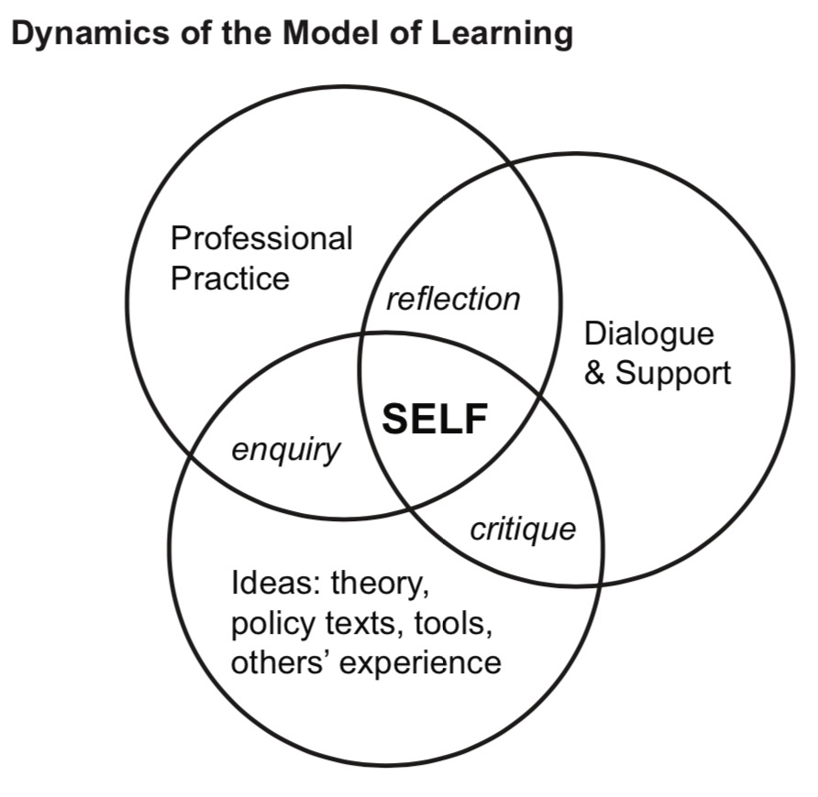

This seems especially relevant for the work of a starting principal where needs of the school overwhelmingly come in the first place.

Developing a coherent strategy to build leadership capacity in Scottish education
Forde is also co-author of ‘Developing a coherent strategy to build leadership capacity in Scottish education’ (2018) where Gillian Hamilton is the first author. Hamilton is the just appointed Strategic Director of the Scottish College for Educational Leadership (before SCEL becoming part of Education Scotland she was Chief Executive of SCEL).

Not surprisingly the authors focus on ‘a transition is necessary from a construct of leadership based on the separation of teaching and management to ‘the emerging concept of teacher leadership’ (p. 72). And: To build a national strategy for Scotland there is a need to balance the system need for leadership capacity with scope for individual practitioners to shape their own professional learning pathways that reflect their role, career patterns and aspirations.

This is more about how to attract enough teachers for middle leadership that might result in principal leadership than about the first phase of being a principal.

However the article is fascinating reading for someone who is interested in designing and building a Scottish NCSL without stepping into the pitfalls that made NCSL crumble and disappear. One of those pitfalls being a loss of support for the NCSL under principals and other providers because of focusing on coherence and central management of the (development of) support for principals.

It is the more fascinating when knowing about the plans of that time of the Ministry to create a new body responsible for Leadership Development (amongst other things): ‘Education Scotland’. (In the mean time established).

For a description of this plan and other intentions regarding headteachers see ‘Education Governance: Next steps. Empowering our teachers, parents and communities to deliver excellence and equity for our children’ (2017).
The report argues why the Scottish educational system has to change towards ‘A school and teacher-led system - Empowering teachers, parents and communities’. It sketches the ‘Educational improvement services to support a school and teacher-led system’ and the steps to ‘Delivering an empowered system.

One of the main instruments to deliver will be the creation of ‘Regional improvement collaboratives’ with as a first task to ‘provide excellent educational improvement support for headteachers, teachers and practitioners through dedicated teams of professionals. These teams will draw on Education Scotland staff, local authority staff and others’.

About new headteachers just is said ‘We will ensure there is an enhanced leadership support package to develop aspiring leaders, new headteachers and experienced leaders. (p. 10). For more see e.g.: http://www.columba1400.com/component/content/article/213-columba-1400-head-teachers-leadership-academies%20-%20covers%20topic%20/

The new Scottish College for Educational Leadership
The website of SCEL shows the progress made on the intentions of the Ministry. http://www.scelscotland.org.uk/ . Education Scotland is the overarching body for SCEL and several other organisations. The site shows an overview of what SCEL is offering as support, apart from their task on endorsement and research (promoting practitioner research and presenting online access for all teachers to educational journals and other resources).
The site also links to the Framework for Educational Leadership (https://www.scelframework.com/)
The site of the Framework offers entrance to online learning activities and one can browse an overall overview of Educational leadership development programmes of other providers.
It is not yet a communication forum between headteachers and others, but SCEL clearly steps in the footsteps of the former NCSL.

SCEL: In Headship
For support for beginning principals one has to look at ‘In Headship’. In Headship is a postgraduate programme for new head teachers which supports them to develop and continue to build the necessary knowledge, skills and understandings required of head teachers. In Headship is the third and final component of Specialist Qualification for Headship and participants will normally enter the programme within 2 years of taking up post as a head teacher. http://www.scelscotland.org.uk/what-we-offer/school-leadership/in-headship/

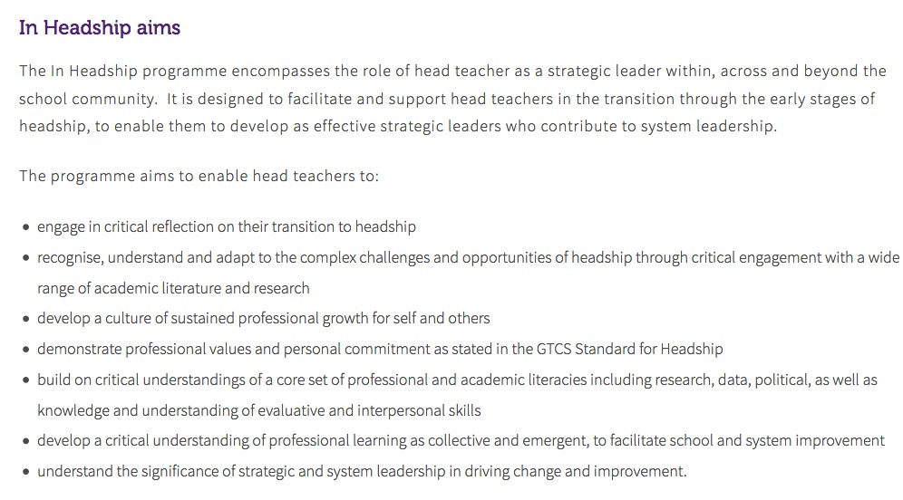
On induction and mentoring: ‘Participants will be expected to identify an experienced head teacher who can act as a critical colleague to support them in their professional learning throughout the programme.

Support by one of the organisations of school leaders (SLS)
Above is mainly about sweeping system-level changes. As a contrast it is good to know that school leaders also organize their own support in a more practical way. For secondary education School Leaders Scotland (head teachers secondary education) delivers services for £ 10 till 17.50 a month.

Services such as:
- Day-to-day practical support through telephone, email & website
- One-on-one support from a dedicated field officer
- Expert legal advice
- Access to a national network of colleagues
- Mentoring Service and Induction Programme
- Leadership development for all phases of education
- Career guidance and support
- Bespoke consultancy and programmes
- A comprehensive programme of conferences
- Regular mailings and advice on current issues
- Up-to-date, wide-ranging authoritative, practical guides and advice
- Coaching & mentoring (of new HTs and DHTs)
- Advice on management restructuring
- Pre/post HMIe Inspection support
- Support and advice on self evaluation
- Post formal procedures support
- Support on the full range of school management issues
- Timetabling support and advice
- Support and advice on school mergers
- Support and advice on child protection issues
- Support and advice on moving to a new school
- Advice and support on Leadership issue
http://www.sls-scotland.org.uk/services/

The Standards for Leadership and Management 2012
The General Teaching Council for Scotland published in 2012 ‘The Standards for Leadership and Management: supporting leadership and management development’
It is not quite clear what the current status is of this document after the latest restructuring resulting in the establishment of ‘Education Scotland’.
It includes chapters about
- Professional Values and Personal Commitment and
- Strategic Vision, Professional Knowledge and Understanding and Interpersonal Skills and Abilities
- The Professional Actions of Middle Leaders
- The Professional Actions of Head Teachers

There is no reference to starting headteachers.

7.0 Finland
Finland is chosen as country to describe because worldwide the educational system distinguishes itself as really different and in international comparisons results of education in Finland are high.

Pasi Sahlberg defines the mainstream of characteristics in educational systems as GERM (Global Educational Reform Movement): Competition, Standardisation, Test-based accountability, Education as an Industry and School choice.
In contrast the characteristics of the Finnish Way are: Collaboration, Individualisation, Trust-based professionalism, Education as a human right and Equity in education. (Sahlberg 2015)

Sahlberg description is recognized worldwide and many countries have tried to copy some of the Finnish characteristics in their educational systems. Sahlberg himself warns not to do that in a simplistic way.

This chapter starts with features of the Finnish Educational System as currently seen by the Ministry of Education and Culture. Given the success of those features the Ministry sees possibilities to sell education in Finland as a ‘brand’. See the action plan for that (Doyle 2017).
The success was not really dependant on the role of principals (or support to them) as might be concluded from a publication of the Finnish National Board of Education (2012). It presents a study of induction in several countries and it is interesting to see what conclusions might be drawn from the survey. The concluding part of the study formulates future prospects for Finland, the focus of this chapter.
The last report presented in this overview is a status review on research on school management (2012).

Special features of the Finnish Educational System as currently seen by the Ministry of Education and Culture
A selection:
- Finnish teachers are highly educated and strongly committed to their work.
Teacher education is highly respected and very popular in Finland. Teachers are required to have a Master's degree, and their initial training includes teaching practice.
The Finnish education system is based on trust in teachers and teacher education. Because of the consistent quality of their training, teachers can be given extensive freedom in developing their own work. Teachers have the power to decide which teaching methods and learning materials they want to use. In Finland, no national evaluation or registration of teachers takes place.
- Only the core curricula are designed for nationwide application.
They leave freedom for local education authorities to arrange teaching in the best way suited to local circumstances. This decentralised system is based on the locally designed and implemented curricula, in which pupils' individual needs are taken into consideration. The local curriculum design at school level commits the local teaching staff to the development of the education system and gives them wide pedagogic responsibility in the teaching work.
- In Finnish schools, a great deal of attention is paid to individual support for pupils’ learning and wellbeing, and the relevant guidelines concerning this support are recorded in the national core curriculum.
School work and teaching arrangements are based on a conception of learning that emphasises the importance of pupils' own activity and their interaction with their teacher, other pupils and the learning environment. High-quality special needs education and the principle of early diagnosing guarantee that no one is left behind.
- The nature of the evaluation of learning outcomes at schools is encouraging and supportive.
There is no national testing, no school ranking lists and no inspection systems.

For the complete list see: https://minedu.fi/en/koulutusjarjestelman-erityispiirteet
See also ‘10 reasons why Finland’s education system is the best in the world’. (2018). World Education Forum

Action Plan Report for Global Education Brand Finland (2017)
In 2017 William Doyle presented this report made on request of the Ministry of Education and culture. A unique report.
Objectives of the report are to:
• Present recommendations for Finnish exports and partnerships to benefit from potential leverage and entry points in the global education market.
• Develop recommendations for improving the impact of marketing, messaging, packaging and positioning of Finland as a global education brand.
• Explore the feasibility of Finland spearheading a public/private global education investment fund; a global educational leadership and futures institute; and a global teacher-training academy.
• Initiate a preliminary top-line evaluation of the United States as a potential market for export and exchange.

Some quotes of the report that deal with school principals:
- Ideally, the world’s education systems should be inspired en masse by Finnish-style practices, and international teachers, principals, system administrators and ministers, NGOs, foundations and investors should be flocking in greater numbers to enter large-scale, long- term, collaborative and contractual relationships with Finnish partners. But Finnish “education export” has a long way to go. (p. 8)
- Action Step #3:
Launch an Education Futures Institute – for Collaboration, Exchange, Research, Innovation, School Operations, Leadership and 21st Century Skills.
- Finland should be the CERN of global education.
- The non-profit research and development arm would gather, “curate” and circulate the world’s best research on those subjects, plus high-interest topics that, in this author’s estimation, Finland either has special expertise on, or great interest in, including:
2. Professional development of existing teachers and principals
- Action Step #7
There is a major new opportunity for Finland to add value and generate revenue from the enormous U.S. education market – by entering the $20 billion market for professional development [PD] of existing teachers and principals.
- Finland can host groups of American, Canadian, Australian, New Zealand, Asian and global teachers, principals and education officials for tailored, high-end “boutique” short-or- medium-term professional development experiences, both in-person and ongoing over the web.

If so, it could be done of course with principals from Africa also. But it should focus then on the real needs of African principals.
Do we already have some indications what could or should be offered?

School Leadership Training for Accountable Quality Education in Finland: Preliminary Viewpoints (2005)
‘The first official statute regarding principal qualifications was set in 1992. The law of 1992 stated that a special certificate in educational administration was a prerequisite for an appointment as principal. The certificate focused only on administrative issues, the legislature, norms and finances of the school. (Värri et al. 2005.)

The new legislation of 1999 brought together earlier dispersed educational legislation. At the same time it clarified the role of the principal – he/she is a leader fully responsible for the results of the school (Nikki 2001, Tiihonen 1999, 21). The legislation of 1999 also included the statutes concerning principal qualifications. According to the statute (Teaching Qualifications Act) an appointed principal shall have (i) a master’s degree, (ii) qualifications for teaching at that particular school, (iii) adequate teaching experience, and (iv) certificate in educational administration (12 cr), at least 25 credits long principal preparation program at university, or knowledge in educational administration gained in some other way.

Those criteria are common to all school principals, whether they are working in basic education (comprehensive school), upper secondary (general upper secondary schools and vocational schools) or liberal adult education (adult education centres, folk high schools, etc.). Although there still is an option to get a principal appointment without any studies in educational leadership or administration (“knowledge in educational administration gained in some other way”), it is mainly applied only in small lower comprehensive schools. Thus, the statute as such legitimises educational leadership training. But it is only one aspect of the training, a training giving formal qualifications to be appointed principal. It pays no attention to other school leadership training, e.g. updating career training.

Changes in national school policy in last fifteen years have shifted the developmental focus to the local level, to the level of schools and municipalities. The change can be seen both in curriculum development, the organising of education and school finances. Principals have adapted the professional-managerialist framework instead of the professional-bureaucratic framework. Principals have become actors in local school policy. While the field of schoolleadership is becoming more complex, principal’s strategic leadership roles are increasing and the principal’s own role as an educator has decreased. I.e. there is a growing demand and need for school leadership training (Tiihonen 1999, 36).’ (p.4)

‘School leadership programs in Finland can be divided into five different categories: (i) qualification programs, (ii) Specialist Qualification in Management programs, (iii) Professional Development (PD) programs, (iv) advanced studies at universities, and (v) other courses and studies. There are two kinds of qualification programs for principals in Finland. National Board of Education has its certificate in educational administration (12 credits) and some universities have 25 credits long principal preparation training programs. Besides that there are other studies and programs that can be found substitutive or beneficial to the appointment.’ (p. 5)

‘There is a large diversity of other courses and studies in the field of educational leadership programs. They are run by different institutes, firms and also local authorities. They can be short, one-day courses on certain limited, often actual and technical topics or longer programs that can have both preparatory and adult continuing educational purposes (updating career training). Then there are many informal forms of training as well, e.g. peer-assisted methods are used both formally and informally (Taipale 2000). There is a huge variety of programs and also organisers, but maybe three aspects need to be mentioned.
First, special programs for new principals (usually 6-10 cr) have become popular. They are used as a guided help for new principals and also vice principals. The basic training of principal training (9 cr) (at the National Centre for Professional Development in Education) is free, because it is subsidised by the National Board of Education. Larger employers (usually cities) can also have their own school administration training programs. School leadership programs have usually been targeted at individual principals only, but during the last few years there has also been a trend to create common programs for the whole leading group of the school. E.g. a program “Leading team – a support in developing the school as a community” (8 cr) has been very popular.’ (p. 8)

Finnish National Board of Education (Taipele 2012)
The Finnish National Board of Education (FNBE) decided in 2011 to commission a survey to investigate qualifications requirements and continuing education systems for school principals/leaders in the following target countries and districts: Finland, Sweden, Norway, Denmark, Germany (Baden-Württemberg, Hessen), the Netherlands, France (Paris), Scotland, Russia (St. Petersburg), Canada (Ontario), the United States (New York City, Los Angeles), China (Shanghai), South Korea, Australia (Victoria) and New Zealand. The aim was to collect information about practices in other countries, compare and mirror the information obtained against current Finnish practices and use these as a basis to brainstorm new innovative models for continuing education for school leaders and management teams

The resulting ‘International Survey on Educational Leadership’ (2012) deals with school leadership systems, allocation of resources to leadership, qualifications requirements for leaders and selection procedures for leadership positions. The focus is on pre-service programmes for those applying for leadership positions and induction programmes for new principals. Further areas of interest include the practices and contents of in-service training for serving principals and comparisons between them. The survey also highlights interesting good practices in different countries.

Paragraph 7.2 deals with ‘Induction training programmes and other forms of
induction of new principals’ (see also Appendix II).

From the overviews it is evident that there was a great variety in induction. Apart from training programmes (universities or other providers, practice-oriented and/or theory oriented, compulsory or not, centralized curriculum or local (parts) accredited, supervised or not, short and long, national or local, own payment or government funding) other induction elements were: mentors (in the school, outside the school, business executives), tutoring, informal clubs, visiting other schools, online communities, telephone support and (self-)assessments.

In many countries, the qualification process includes two phases: candidates first acquire sufficient basic knowledge to take up a principal’s position and are then required to obtain a professional credential or certificate during their first years in the position to gain permanent qualifications. In those cases, pre-service and induction training make up a whole that provides the qualifications.

Regarding the process of surveying the practices in other countries the document states:
‘It was not possible to focus on comparing evaluation data on school leadership training in sufficient depth in this survey due to the poor availability of data. There is some feedback data available on individual training programmes and, in some cases, on their effectiveness. Evaluation and comparison of the effectiveness of different school leadership training systems is practically impossible due to the complexity of the phenomena involved.’ (p. 43). That situation has not changed much since 2012.

There are also no conclusions about the (dis)advantages of the different solutions chosen in the countries included in the study or conclusions about trends.

For Finland the report advises:
‘In Finland, schools’ leadership resources are scarce. In addition, the current model of schools’ maintaining organisations requires reform, because instead of offering support services, resource-strapped local authorities need principals to uphold administration outside their schools.
Development of adequate principal training provided at different stages of the career path should be continued. At present, training provision is good and national solutions should be sought for the future in order to provide adequate and continuing extensive in-service training for everyone. Development of various professional development qualifications should be continued while also creating new opportunities for scientific postgraduate studies in the field in order to strengthen research and ensure a reserve of trainers.’

Changing School Management 2012
This status review (Jukka Alava et al.) is from the same year as the former report.
The status review is mainly based on doctoral theses. It is very informative about school management in Finland.
Not surprisingly after elaborating on ‘new pedagogical leadership’ the focus is mainly on future research more than delving into current or new needs for training or other support. (p. 46).

But it is mentioned in some places:
Paragraph formulates 6 conclusions about principals (4 cited below).
- ‘It is increasingly clear that the principal’s occupation is a specific profession in its own right, which should be supported through solid university-level initial training and extensive and integrated further and continuing training (Part of conclusion 3)
- Principals need to internalise the major changes that are currently taking place in the teacher’s role and its essence. An essential part of this development is the change of leadership towards distributed leadership and broad pedagogical leadership (conclusion 4)
- It is imperative to be able to meet the expectations, emerging from research as ever stronger conflicting pressures, on principals to function both as pedagogical leaders of their schools and as managers responsible for dealing with increasing administrative workloads. (conclusion 5)
- Sixth, it is necessary to place a stronger emphasis on the future-oriented nature of principals’ work. This necessity is manifested in two different ways. Firstly, there will be significant structural changes at a municipal level in the near future (see e.g. Kanervio & Risku 2009), which require consideration of the objectives and views of and competent involvement from municipal educational administration. Secondly, meeting the challenges of the quantum world of the future requires new types of knowledge and learning from our society and its members. Schools must be capable of enabling this new knowledge and learning. Teachers’ and principals’ work should place emphasis on building the future through the learning of children, young people and adults as well as through schools’ participation in society as a whole.’ (p. 35)

‘About the responsibility for professional development of principals the report formulates:
At the core of an education director’s pedagogical leadership, in turn, lies attending to knowledge and learning within the municipality’s educational administration as a whole. Principals’ pedagogical leadership focuses, first and foremost, on supporting teachers’ knowledge and learning. An education director’s pedagogical leadership, in turn, focuses on supporting principals’ knowledge and learning in particular. Just like a principal, an education director is not only responsible for functioning as the immediate administrative superior but also for being the pedagogical leader of their subordinates’ knowledge and learning. A principal’s remit covers the school and an education director’s remit covers the municipality’s educational administration as a whole.’ (p. 41)

Such a formulation might suggest that in Finland further professional development of principals is not a real issue for the officials responsible for that development.
That would not be a surprise since in-service training of teachers also in not a real issue given the strong pre-service education and the personal responsibility teachers have for their professional development.

The diverse offer of a range of different options for CPD for principals could be seen as sufficient for the different needs of principals who also have a personal responsibility for their development. Diversity might be an advantage in contrast with a focus on convergence and national accreditation.

Finnish principals through their basic education already have a broad background in management and education, their further education is focusing on wider and extensive items in developing quality in leadership. (Alava 2012) cited in Saarukka (p. 59).

Further analysis of current needs of principals and support to them is needed. Unfortunately current reports are available only in the Finnish language.
Contacts could be established with the current (Mika Risku) and former director (Jukka Alava) of the Institute of Educational Leadership (University of Jyväskylä)
8.0 Mapping and analysing the induction approaches and frameworks
Mapping and analysing here is understood as:
1. identifying what in the different countries is (or has been) seen as main design issues in establishing a system for CPD and especially for induction and mentoring of principals (IMP)
2. which of those issues are issues also in South Africa and
3. which of the solutions chosen might have relevance for South Africa.

It is about establishing new organisations or changing existing ones. It is about funding at the right moments in the right size or magnitude, it is about regulation putting demands and it is about stimulating.

None of the four EU countries currently has a fully developed INMP system. England in the past had, currently Flanders might be heading the pack while there still exist major wishes for further developments. Scotland is on the way to build a fully fletched central organisation also covering IMNP. The Netherlands has left development to market forces, the ministry granting subsidies for experimenting with promising initiatives. In Finland IMNP seems to be not a major issue.

What really seems to be relevant for South Africa has to be discussed with the stakeholders in South Africa.

Annex

List of references

10 reasons why Finland ’ s education system is the best in the world. (2018). World Education Forum.
Alava, J., Halttunen, L., & Risku, M. (2012). Changing School Management. Finnish National Board of Education.
Algemene regeling met betrekking tot de opleiding voor de ambten van directeur en adjunct-directeur in een instelling van het GO! onderwijs van de Vlaamse Gemeenschap. (2016). Huis van het GO!
Anderson, L. M., & Turnbull, B. J. (2016). Evaluating and Supporting Principals. Policy Studies Associates, Inc.
Augustine-Shaw, D., & Hachiya, R. (2017). Strengthening Decision-Making Skills of New School Leaders through Mentoring and Service. Servant Leadership: Theory & Practice, 4(1), 32–52.
Augustine-Shaw, D., & Liang, J. (2016). Embracing New Realities: Professional Growth for New Principals and Mentors. Educational Considerations, 43(3), 10–17.
Bal, J., & Jong, J. De. (2007). Improving School Leadership - OECD Review. Background Report for the Netherlands. OECD.
Barber, M., Whelan, F., & Clark, M. (2010). Capturing the leadership premium. How the world’s top school systems are building leadership capacity for the future. McKinsey&Company.
Barbour, J. D. (2005). Non-university-based Principal Preparation Programs: Analysis and Discussion of Findings. Leadership. Texas Woman’s University.
Barnett, B., Shoho, A., & Okilwa, N. (2017). Assistant principals’ perceptions of meaningful mentoring and professional development opportunities. International Journal of Mentoring and Coaching in Education, 6(4), 285–301.
Bayar, A. (2016). Challenges Facing Principals in the First Year at Their Schools. Universal Journal of Educational Research, 4(1), 192–199.
Best Practices in Teacher and Administrator Induction. (2016). CCSESA.
Binon, K. (2018). ProfS: Educational concept. VSKO.
Bolam R.(2004) Reflections on the NCSL from a Historical Perspective. Educational Management Administration & Leadership, 32 (3) 251-267
Breakspear, S., Peterson, A., Alfadala, A., & Khair, M. S. B. . (2017). Developing Agile Leaders of Learning : School leadership policy for dynamic times. WISE.
Burgmans, H. (2014). Inwerken van een beginnend schoolleider. In positie komen, in positie blijven. VO Academie.
Bush, T. (2018). Preparation and induction for school principals: Global perspectives. Management in Education, 32(2), 66–71.
Bush, T., & Glover, D. (2005). Leadership development for early headship: The New Visions experience. School Leadership and Management, 25(3), 217–239.
Bush, T., & Glover, D. (2016). School leadership and management in South Africa: Findings from a Systematic Literature Review. International Journal of Educational Management, 30(2), 211–231.
Bush, T., & Oduro, G. K. T. (2006). New principals in Africa: Preparation, induction and practice. Journal of Educational Administration, 44(4), 359–375.
Bush, T., Briggs, A. R. J., & Middlewood, D. (2006). The impact of school leadership development: Evidence from the ‘new visions’ programme for early headship. Journal of In-Service Education, 32(2), 185–200.
Bush, T., Dewes, I., Robinson, S., Smith, C., & Warren, A. (2017). The future of leadership preparation and development in English schools. BELMAS.
Chikoko, V., Naicker, I., & Mthiyane, S. (2015). School leadership practices that work in areas of multiple deprivation in South Africa. Educational Management Administration and Leadership, 43(3), 452–467.
Continuity and transitions in learner development. (2018). EC ET2020.
Darling-Hammond, L., LaPointe, M., Meyerson, D., Terry Orr, M., & Cohen, C. (2007). Preparing School Leaders for a Changing World: Lessons from Exemplary Leadership Development Programs. Stanford Educational Leadership Institute. http://doi.org/10.1017/CBO9781107415324.004
De Staat van de Schoolleider 2017. (2017). Algemene Vereniging Schoolleiders.
Department of Basic Education. (2011). Professional Learning Communities - A guideline for South African schools.
Devos, G., & Tuytens, M. (2006). Improving School Leadership - OECD Review. Education And Training.
Devos, G., Tuytens, M., & Valckx, J. (2014). Functioneren en welbevinden directeurs ProfSopleiding.
Devos, G., Vanblaere, B., & Bellemans, L. (2018). Stress en welbevinden bij schoolleiders. Steunpunt Onderwijsonderzoek, UGent.
Digwamaje, O. B., & Assan, T. (Tom) B. (2012). Nature and Characteristics of the Induction Programme for Primary School Principals in the North West Province, South Africa. The Anthropologist, 14(4), 269–277.
Donaldson, G. (2011). Teaching Scotland’s Future. Report of a review of teacher education in Scotland. Scottish Government.
Doyle, W. (2017). Action Plan Report for Global Education Brand Finland. Ministry of Education and Culture Finland.
Eacott, S., & Asuga, G. N. (2014). School leadership preparation and development in Africa: A critical insight. Educational Management Administration and Leadership, 42(6), 919–934.
Education Governance: Next Steps Empowering Our Teachers, Parents and Communities To Deliver Excellence and Equity for Our Children. (2017). Scottish Government.
Education Policy Outlook Netherlands. (2014). OECD.
El acompañamiento a los directores novatos: Prácticas y desafíos de los formadores de programas de inducción. (2018). Centro de Desarollo de Liderazgo Educativo.
Empowering school heads. (2018). Onderwijsraad.
EPNoSL at a glance. (2012). European Policy Network On School Leadership.
European ideas for better learning: the governance of school education systems. (2018). EC ET2020.
Forde, C., McMahon, M., & Dickson, B. (2011). Leadership development in Scotland: After Donaldson. Scottish Educational Review, 43(2), 55–69.
Gillet, A. (2015). Boarding Boarding @ Lucasonderwijs Lucasonderwijs.
Gray, C., Fry, B., Bottoms, G., & O’Neill, K. (2007). Good Principals Aren’t Born — They’re Mentored: Are We Investing Enough to Get the School Leaders We Need? SREB.
Grootscholte, M., Hoogeveen, Y., & Jettinghoff, K. (2011). Coaching voor en door schoolleiders Een onderzoek naar de effecten en succesfactoren van coaching in het primair onderwijs. Sectorbestuur Onderwijsarbeidsmarkt.
GTC Scotland Professional Standards: Bibliography. (2012). GTC Scotland.
Hallinger, P. (2017). Surfacing a hidden literature: A systematic review of research on educational leadership and management in Africa. Educational Management Administration & Leadership.
Hamilton, G., Forde, C., & McMahon, M. (2018). Developing a coherent strategy to build leadership capacity in Scottish education. Management in Education, 32(2), 72–78.
Held, L., Pethel, G., Stranahan, V., & Perkins, T. (n.d.). Mentors Support Novice Principals on the Job. Wallace Foundation.
Hicks, E. L. (n.d.). Design of Novice Principal Induction for a Central North Carolina School District. 2017. Department of Educational Leadership East Carolina University.
Hitt, D. H., Tucker, P. D., & Young, M. D. (2012). The Professional Pipeline for Educational Leadership. University Council for Educational Administration.
Hobson, A. (2003). Mentoring and Coaching for New Leaders. Educational Research. National College for School Leadership.
Hobson, A., Brown, E., Ashby, P., Keys, W., Sharp, C., & Benefield, P. (2003). Issues for Early Headship – Problems and Support Strategies. Strategies. National College for School Leadership.
Ingham, A. (2014). Recent Developments in the Leadership of Schools in England. Itaú Social Foundation (Brazil).
Into Headship Programme: Head teacher mentor specification. (2017). Scottish College for Educational Leadership.
Introducing the Framework for Educational Leadership. (n.d.). Scottish College for Educational Leadership.
Jones, M. (2009). Supporting the supporters of novice teachers: An analysis of mentors’ needs from twelve European countries presented from an English perspective. Research in Comparative and International Education, 4(1), 4–21.
Kearney, K. (2010). Effective Principals for California Schools: Building a Coherent Leadership Development System. Development. WestEd
King, C. (2018). Quality MeasuresTM Principal Preparation Program Self-Assessment Toolkit: for use in developing, assessing, and improving principal preparation programs. EDC.
Krüger, M. L., & Andersen, I. (2018). Effecten van professionalisering. SchoolManagement, 14–16.
Leadership matters: What the Research Says About the Importance of Principal Leadership. (2013). NASSP, NAESP
Leading for impact Australian guidelines for school leadership development. (2017). AITSL.
Levine, A. (2005). Educating leaders. The Education Schools Project.
Lochmiller, C. R. (2014). Leadership Coaching in an Induction Program for Novice Principals. Journal of Research on Leadership Education, 9(1), 59–84
Lockhorst, D., Jong, A. De, & Schenke, W. (2016). Monitor Professionele ontwikkeling schoolleiders VO 2016. VO Academie.
Lumby, J., & Macruairc, G. (2015). EPNoSL Final Evaluation Report External Evaluation Effectiveness.
Maphoto, M. H. (2016). The state’s capacitation of school principals: A positivist reflection on the effectiveness of development programmes in Soshanguve secondary schools, Gauteng Province. University of South Africa.
Martin, E. A. (2016). Kansas Public School Principal Induction Practices and New Elementary Principals’ Perceptions of Satisfaction and Preparation. School of Education of Baker University.
Melero P, D. (2017). Mentroría para Directores Novatos en Sistemas Escolares del Mundo. Centro de Desarollo de Liderazgo Educativo.
Mentink, R. (2016). Onboarding : hoe komen beginnende schoolleiders goed aan boord? Basisschool Management, 29–31.
Mestry, R. (2017). Empowering principals to lead and manage public schools effectively in the 21st century. South African Journal of Education, 37(1), 1–11.
Mitgang, L. D. (2008). Becoming a Leader: Preparing School Principals for Today’s Schools. Wallace Foundation.
Moorosi, P., & Grant, Ca. (2013). Preparing and developing school leaders: the African perspective. BELMAS.
Mourshed, M., Chijoke, C. and Barber, M. (2010) How the world’s most improved school systems keep getting better. McKinsey.
Msila, V. (2012). Mentoring and School Leadership : Experiences from South Africa. Journal of Social Sciences, 32(1), 47–57.
National model of professional learning. (n.d.). Scottish College for Educational Leadership.
National standards for headteachers. (2004) Department for Education and Skills.
Networks for learning and development across school education. (2018). EC ET2020.
Ng, S. W., & Szeto, S. E. (2015). Preparing school leaders: The professional development needs of newly appointed principals. Educational Management Administration and Leadership, 44(4), 540–557.
Nieuwe inhouden, nieuwe netwerken, nieuwe perspectieven - Inwerkprogramma’s voor beginnend schoolleiders. (n.d.). VO Academie.
Nusche, D., Braun, H., Halász, G., & Santiago, P. (2014). OECD Reviews of evaluation and assessment in education - Netherlands. OECD.
Opleiding schoolleider Basisbekwaam/vakbekwaam. (2018). NSO-CNA.
Opstart Traject Leidinggeven in onderwijs. (2017). Onderwijskoepel van Steden en Gemeenten.
Outhwaite, D., Close, P., & Kendrick, A. (2018). Special Issue on Leadership, Preparation and Development. Management in Education, 32(2), 63–65.
Parylo, O., Zepeda, S. J., & Bengtson, E. (2012). The different faces of principal mentorship. International Journal of Mentoring and Coaching in Education, 1(2), 120–135.
Plan anual de trabajo de las redes educativas para la mejora de los aprendizajes. (n.d.). USAID Peru.
Policy on the South African Standard for Principalship. (2015). Department Basic Education RSA.
Pont, B., Nusche, D., & Hopkins, D. (2008). Improving School Leadership Volume 2: Case Studies on System Leadership. OECD.
Pont, B., Nusche, D., & Moorman, H. (2008). Improving School Leadership Volume 1: Policy and Practice (Vol. 1). OECD.
Principal Preparation Program Self-Study Toolkit. (2018). Wallace Foundation, Education Development Center.
Principals and Administrators Induction Program Evaluation Rubric. (n.d.). Department of Education Colorado.
Prioritizing Leadership: An Analysis of State ESSA Plans. (2018) (Vol. 2101). New Leaders.
ProfS : doelenbevraging. (n.d.). ProfS.
Quality Assurance for School Development. (2016). EC ET2020.
Redesign of NPQH: Advice to the Secretary of State. (2007). National College for School Leadership.
Reviews of National Policies for Education: The Netherlands, Foundations for the Future. (2016). OECD.
Riley, D. L., & Meredith, J. (2017). State efforts to strengthen school leadership: Insights from CCSSO action groups. Policy Studies Associates.
Rodger, G. (2013). Developing our Leaders. Department of Education and Lifelong Learning Scotland.
Saarukka, S. (2017). Understanding School Principals´ Leadership. Åbo Akademi University.
Sahlberg, P. (2015). Finnish Lessons for Chile ! Sociedad Chilena de Políticas Públicas.
Schechter, C., & Firuz, F. (2015). How mentor principals interpret the mentoring process using metaphors. School Leadership and Management, 35(4), 365–387.
Schenke, W., Heemskerk, I., Lockhorst, D., & Bomhof, M. (2017). Monitor Professionele ontwikkeling schoolleiders en bestuurders VO 2016-2017. Kohnstamm Instituut.
Schleicher, A. (2012). Preparing Teachers and Developing School Leaders for the 21st Century (Vol. 17). OECD.
School Leadership Development Framework for the Gauteng Department of Education. (2013). Pat Sullivan and Associates.
Schratz, M., Aigner, H., & Krenn, S. (2014). Toolset on Educating school leaders as change agents. EPNoSL.
Sciarappa, K., & Y. Mason, C. (2014). National principal mentoring: does it achieve its purpose? International Journal of Mentoring and Coaching in Education, 3(1), 51–71.
Seashore Louis, K., & Murphy, J. F. (2018). The Potential of Positive Leadership for School Improvement: A Cross-Disciplinary Synthesis 1,.
Skillestad Bangert, K. M. (2012). Investigating the Effectiveness of a Formal Principals’ Mentoring Program. Montana State University.
Slater, C. L., Garcia Garduno, J. M., & Mentz, K. (2018). Frameworks for principal preparation and leadership development: Contributions of the International Study of Principal Preparation (ISPP). Management in Education, 32(3), 126–134.
Smylie, M. A., & Murphy, J. F. (2018). School Leader Standards From ISLLC to PSEL: Notes on Their Development and the Work Ahead. UCEA Review, 59(3), 24–28.
Southworth, G. (2004). A Response from the National College for School Leadership. Educational Management Administration & Leadership, 32(3), 339–354. http://doi.org/10.1177/1741143204044421
Spiro, J., Mattis, M., & Mitgang, L. (2007). Getting Principal Mentoring Right: Lessons From The Field. Perspective. Wallace Foundation.
Stewart, T. (2016). Hit the Floor Running : Assistant Principal Mentoring and Perceptions of Impact for Mentors and Proteges. Gardner-Webb University.
Stoll, L., & Temperley, J. (2009). Improving School Leadership: The Toolkit (Vol. 41). OECD.
Strategy to improve school management and governance in schools. (n.d.). Department Basic Educaton RSA.
Taipale, A. (2012). International Survey on Educational Leadership, A Survey on School Leader’s Work and Continuing Education. Finnish National Board of Education.
The Professional Development of Teachers. (2009). OECD.
The Professional Standards for Educational Leaders (PSEL) 2015 and the Interstate Leaders Licensure Consortium (ISLLC) Standards 2008: A Crosswalk. (2016). Center on Great Teachers & Leaders.
The SCEL Framework for Educational Leadership. (n.d.). Scottish College for Educational Leadership.
The School Leadership Association: Six building blocks to maximizing impact. (2015). Ontarion Principals’ Council.
Towards a National Teacher Induction Programme in South Africa. (2018). JET Education Services.
Värri, K., & Alava, J. (2005). School Leadership Training for Accountable Quality Education in Finland : Preliminary Viewpoints. Institute of Educational Leadership, University of Jyväskylä.
Verbiest, E. (2014). Leren leiden op niveau: Onderzoek in opdracht van de Vlaamse Overheid naar competenties en professionalisering van leidinggevenden in het basis en secundair onderwijs. Samen Wijs.
Wallace Foundation- Principal Pipeline : Recipe for Quality – Thoughtful Standards Changing K-12 and Higher Education. (2016). American Association of Colleges on Teacher Education.
Waslander, S., Dückers, M., & Dijk, G. Van. (2012). Professionalisering van schoolleiders in het voortgezet onderwijs Een gedeeld referentiekader voor dialoog en verbetering. Leadership Development Centre TiasNimbas Business School.
Weindling, D. (2004). Innovation in Headteacher Induction. National College For School Leadership (Vol. Spring). National College for School Leadership.
Wieczorek, D., & Manard, C. (2018). Instructional Leadership Challenges and Practices of Novice Principals in Rural Schools, 34(2), 1–21.
Wiehahn, J., & du Plessis, P. (2017). Professional development of newly-appointed principals at public high schools in Gauteng. Is social justice served? KOERS, 82(3), 1–11.
Williams, D. S. (2013). Mentoring School Leaders : Perspectives and Practices of Mentors and Their Protégés. University of Denver.
Wills, G. (2016). Principal leadership changes in South Africa : Investigating their consequences for school performance. Department of Economics, University of Stellenbosch. 05
Witten, A. (2014). Shifting Paradigms, Changing Practice: Values-based instructional leadership in schools. In The Design Charrette. SASOL.
Witten, A. (n.d.). Developing knowledge resources to build school leadership capacity in South Africa - Systems Framework for School Improvement. Sasol Inzalo foundation.
Young, M. D. (2018). Building Capacity for Program Excellence. UCEA Review, 59(3), 13–19.
Young, M. D. (2018). National Educational Leadership Preparation (NELP) Program Recognition Standards - Building Level, 1–106.
Young, R. A. (2017). Novice Principal Mentoring: An Examination of How Mentoring Relationships Influence Professional Development. University of Illinois at Urbana-Champaign.

E.g. Mentor school managers & manage mentoring programmes in schools (Advanced Certificate: Education (School Management and Leadership), Department of Education RSA (2008)
Towards a South African Teacher Induction Framework
http://www.norrag.org/evidence-before-marketing-recalling-the-known-independently-verified-facts-about-bridge-international-academies-by-113-signatories-as-collective-authors/
Recently C. Slater et al. reported about results of ISPP: Frameworks for principal preparation and leadership development: Contributions of the International Study of Principal Preparation (2018)
AERA – American Educational Research Association; CCEAM – Commonwealth Council for Educational Administration and Management; UCEA –University Council for Educational Administration; ICP - International Confederation of Principals; AITSL -Australian Institute for Teaching and School Leadership; ENIRDELM - European Network for Improving Research and Development in Educational Leadership and Management
For the next years I expect a major influence from two publications • Collaborative Professionalism (Andy Hargreaves - 2018) • Positive Leadership (Joseph Murphy, Karen Seashore Louis – 2018)
From: National Educational Leadership Preparation Standards: What They Are, How They Were Developed and What Purpose They Serve http://3fl71l2qoj4l3y6ep2tqpwra.wpengine.netdna-cdn.com/wp-content/uploads/2016/04/NELP-Standards-Introduction.docx
https://www.ovsg.be/
www.g-o.be/
https://www.katholiekonderwijs.vlaanderen/
APS: General Pedagogical Study centre, KPC: Catholic Pedagogical Centre, CPS: Christian Pedagogical Study centre
Bolam R.(2004) Reflections on the NCSL from a Historical Perspective Educational Management Administration & Leadership, 32 (3) 251-267
Levine, A. (2005). Educating leaders. The Education Schools Project.
Both articles in Educational Management Administration & Leadership (2004) 32 (3)
PricewaterhouseCoopers (PWC). Independent Study into School Leadership: Main Report (2007) DfES
This description is clearly from that period. Nowadays it would be normal to talk about ‘competences’ (however the current Minister of Education Damian Hinds has a fierce discussion with Andreas Schleicher OECD about not wanting to use that concept).Also lately one talks about ‘practices’(e.g. NSO-CNA in the Netherlands).
https://www.gov.uk/government/collections/david-h-hargreaves-thinkpieces-on-the-self-improving-school-system https://assets.publishing.service.gov.uk/government/uploads/system/uploads/attachment_data/file/406279/Three_greats_for_a_self_improving_system_pedagogy_professional_development_and_leadership_executive_summary.pdf

