**SCEMS Directors Meeting**

Minutes

July 18, 2019



Meeting called to order @1130. Began with Prayer lead by Bill. Please see document for attendance.

Minutes from May meeting motion by Reuter, changes to Marshall county as Start of Life, starting at 1100 and deletion of last time was update made by with second by Cox.

Motion passed unanimously.

*Minutes not necessarily recorded in order of discussions.

Guest/Presentation:

Introduction of Candace Wilkes who is the RHC for the region. Giles EMS asked to purchase 12 Maslow 57 RAD monitors spo2 monitors and each director will be able to put in county services for the director’s association.

* Josh Young from Giles county EMA was seeking these for his county and when approved it was decided to purchase one for each county
* DVD will be provided and you can also find a you tube for exposure
* Appreciation to Josh for his leadership in getting these for the region
* Any requests need to go through the Michael Bonner, who serves as representative to the HCC. Please send him any ideas or wishes to him. Goal is to ensure that the region is supported, and trying to find support for the region with whatever requests are placed
  + This year’s emphasis is Pediatrics
* Next HCC august 13th @ Hickman county EMA
* Maury has a protocol and has begun to collect this data, Lincoln has also been doing CO Firefighter surveillance

President Report:

Welcome to Allan Livingood, New Hickman county Director, [allen.livengood@hickmanco.com](mailto:allen.livengood@hickmanco.com) (615)969-1983

Financial Report: Shared by Brett who sends his regrets for today’s meeting. He had a personal commitment

Ted shared on behalf of Brett:

No invoice from accountant

Membership dues have been sent and if you didn’t get them

Seeking Credit Card



Motion to approve Cox, second Wright

LeeAnne Highlights:



*LeeAnne shared the following update:*

* Documents shared and please ensure that your RMCC information is updated.
* New inspection sheet was also shared, Point system. 30 points is the threshold where a unit may fail; however, goal is to work with you to support your efforts. Cleanliness can also be deducted with up to 30 points
* Working to streamline inspections and data collection with new leadership and make things more efficient
* September 25th and 26th are upcoming Board meeting
* EMITS is working to bringing vendors on line
* Strike team training, please see Jason Deal email in update and advise him of those interested
* Camp Hope this week in Maury. Danny Fleming is the contact if you would like to send a unit over to support. Any help appreciated e
* TECC Class Oct 17th and 18th intend to request support from HCC, currently have 10 participants have already registered and plan to cap at 17
* August 5th is Narcan training for non-healthcare providers
* Trauma conference August 8th and 9th

Monthly reports:

* District 6 No Report
* NAEMT No report
* TASA Ted reported

August 12th and 13th early registration

Q3 and Q4 payments should be coming soon. Please contact Brett Elder for any questions

August 14th having a legislative summit and if you can’t attend please share information with Ted

Keith reported working with Government to increase rates, hope that it would be Medicare rate

* RMCC: Microwave project is ending very soon, please anticipate phone call soon if you haven’t gotten one yet
* Jennifer Murks will be retiring after this meeting, 32 years of EMS, 21 Maury county EMS
* Ambu Bus: No report
* Ambulance Service Committee: No report

**Education**

* Conference Education subcommittee: shared by Eric
* 120 students will be able to accommodate with two cadavers and adult simulation. Great work to get this accomplished
* Intend to have registration live in August. Please ensure that you get registered as once the slots are done increases cannot be accommodated to increase
* Shirts will be available for purchase, and working to streamline information collection, follow up from May discussion.
* Motlow

Still need four paramedics for testing

Paramedic program is moving to Middle TN Educator C, Shelbyville adjunct instructors

Sept 2 AEMT refresher courser

Canceled AEMT in Fayetteville

* TEMSA conference is next week starting on Wednesday

Go to TEMSA FB for clinical challenge, must be ALS

* Columbia State NO official report, LeeAnne shared that two pilot courses are ending. May shorten timeframe. Mtg with EMS at TEMSA so hope to provide more information
* Community Integrated Paramedic
* Vanderbilt COE Shared by Clauss

August 15th and 17th

* Tristar No updates
* STT/ AEL
  + August 10th Sports Medicine at Nissan stadium
  + CC applications are posted, September 15th
* Bill Petty Scholarship No updates
* Needs Assessment No updates
* Randal Young Benevolent Fund No changes

Old Business:

* Discussion on if $500 was sent to Camp Hope, and during the meeting it was determined that this has not been shared with Brett. Check will happen this month
* TEMSA representative, was previously Drew Hooker, however,

Ashely volunteered for this role, and decision was made for her to serve in this role due to her willingness

* Discussion on meeting change:

Overview of possibly meet earlier or later due to current timing of the meeting.

Consensus was the 10am might be good due to having conference meeting prior 2/3 of the year. Additional discussion on possibly moving back to once per month meeting.

Motion: Meet once per month at 10 made by Roy, second by Brian. No further discussion

* Website: Shared by Kevin Nooner
  + Three-year domain and was reregistered with one or three-year cost of Approx. $350. Motion for 3-year contract by Larry, second Bill and unanimously passes
  + Site has been rebuilt
  + Please share high resolution graphic if you don’t like yours please share with Kevin
  + If you have changes you want to see on the site please let Kevin know
  + Members only section intend to place minutes, bylaws here.

New Business:

* Drew Hooker extended invitation to have this meeting in September 19th mtg and lunch will be provided.
* Brian shared that he had an EMT exposed to powder fentanyl. Followed decontamination and very little was found on how to decon the EMS uni. Please provide him any information that you on decontamination of unit. Bill shared that they had first batch of carfentanil. Discussion on sharing this information collectively due to the boarding counties and possible impact that might cross counties

Discussion on Narcan distribution, contact information shared

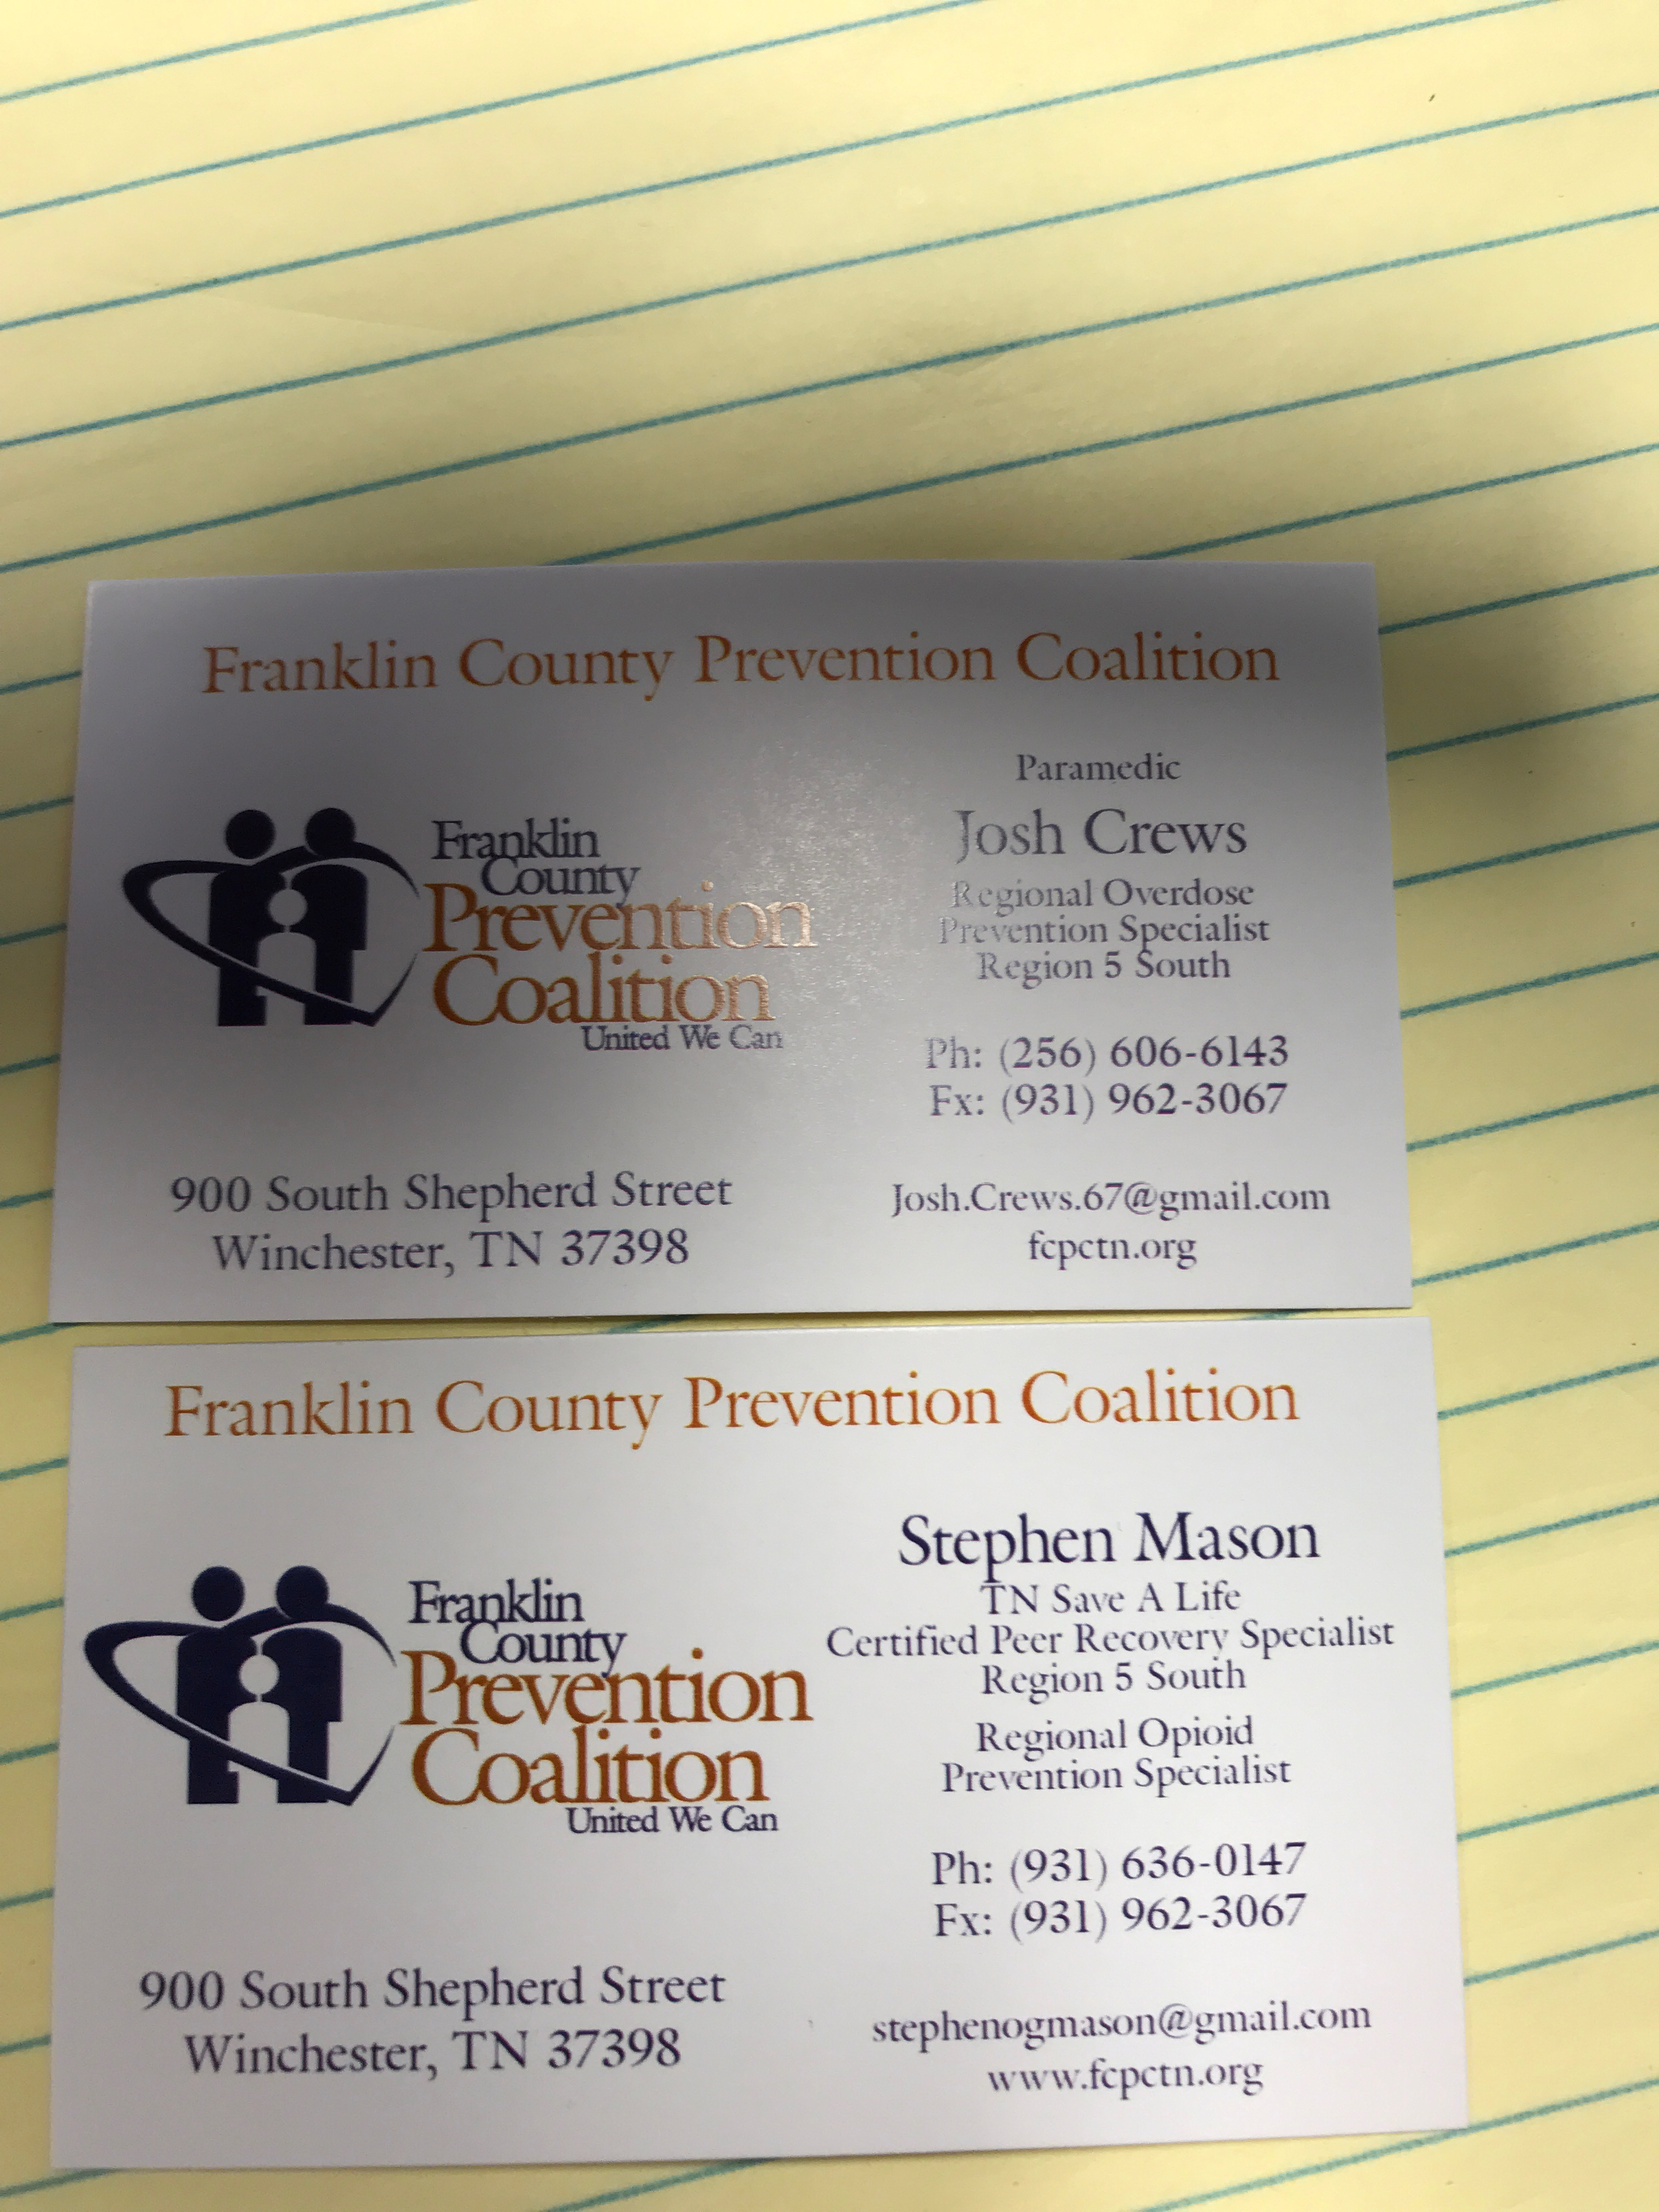

* August 23 and 24th Lynchburg music festival
* Discussion on August meeting and this coincides with the Iserve meeting. Offer was made to host this association and provide lunch after the
* Please remember Henry County who lost an EMT. She was leaving work this week and hydroplaned
* Please remember Bob Moore, who lost a family member this week
* Trailer update and it has had some cooling issues, may be ready by September

1st

* July meeting president elect representative. Nominations accept

Brian Hupp volunteered for this role, as it is a four-year commitment. Motion to cease nomination by Cox, second Bonner

* Thank you to HCC for simulator shared by LeeAnne

Introduction of Chris Cox, who is new training coordinator for Bedford county

Adjourned @1257

Minutes submitted by: Jeanne Yeatman

*Minutes not necessary recorded in order of discussion