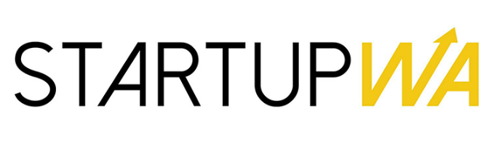
Media Release - Embargoed to Thurs 23 April 9am

“NOT JUST A FOUNDER ISSUE”: SHOCKING NEW DATA REVEALS HIGH LEVELS OF STARTUP STRESS IN WA

PERTH, WA , 23rd April 9am - A landmark report released today by StartupWA, the peak body for the Western Australian startup sector, has thrown the light on the local startup stress crisis.
StartupWA’s ‘Mental Health & Wellbeing Roundtable Report’ reveals that the psychological safety of founders has been neglected for too long, prompting a collective call to action across the innovation ecosystem.
An anonymous survey of 129 WA startup founders conducted in early 2026 found that the vast majority are struggling with significant stress-related issues.
Among the most alarming findings are that local startup founders have experienced (or are continuing to experience):
- financial stress (77%)
- lack of sleep (71%) and anxiety (72%)
- relationship stress (57%) and burnout (70%)
- panic attacks (31%) and depression (38%)
46% of the startups surveyed had made no income, further compounding these pressures.
More worryingly, the report found that most founders do not know where to turn for help within their own innovation community.
While 34% have seen a GP and 27% have received a formal diagnosis, there is a clear disconnect between the needs of founders and the support currently available in the ecosystem.
"This is not just a founder issue, or even a startup issue. It is an ecosystem issue," said StartupWA Chair Charlie Gunningham.

“Instinctively and anecdotally, we understand how hard ‘startup life’ can be in Western Australia. Many of us have experienced this personally.
“So we decided to dig into this more deeply - and we’ve been shocked by the results.”
The findings indicate that founders in this state are unable to perform at their best for their teams or investors.
In response to these findings, StartupWA has proposed nine key recommendations to shift the burden of mental health from the individual founder to the broader community:
- This is the ecosystem’s collective responsibility
- Have to start awareness early
- Investors must be empathetic to the pressures (and not add to them)
- Founder “buddy” system
- Directory of support services
- Teach existing programs how to cover this area
- Awareness campaigns and checkins
- Resilience and financial counselling programs
- Pay particular attention to vulnerable groups

Meshpoints Launches $150,000 Resilience and Wellbeing Challenge
To catalyse immediate action, Meshpoints - a Spacecubed program and partner in the report - has today opened applications for its first ever ‘Resilience and Wellbeing Challenge’.
The $150,000 initiative is designed to fund programs that directly address the startup mental health and wellbeing issues identified in the StartupWA report.
Key details of the Challenge include:
- Total Funding Pool: $150,000.
- Grant Amount: Applicants can be awarded up to $20,000 each for a relevant program or initiative.
- Purpose: To develop ecosystem-wide responses to founder burnout, anxiety, and psychological safety, and build resilience within the local innovation sector.
- Application Deadline: June 11, 2026.

“A sustainable, innovative society requires a proactive approach to all aspects of a founder’s life," said Spacecubed Founder Brodie McCulloch, in reaction to the Startup WA report.
“That’s why it is good to see the Meshpoints program responding, with some significant funding for ecosystem initiatives that can alleviate the situation.”

~~ ENDS

The full StartupWA Report is available for download at www.startupwa.org/reports, and details on the Meshpoints Challenge can be found at https://www.meshpoints.com/funding.

#Media Contact: Charlie Gunningham
StartupWA Chair
0411 092 669
charlie@startupwa.org
www.startupwa.org

