
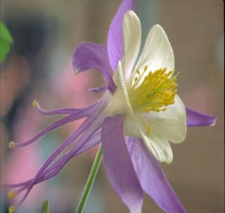
Reading at the Rock Summer Reading Program

June 1-through July30, 2026
COLORADO 1876-2026 150 years of statehood

Child’s Name: _____________________________ last name first name
Parent’s Name: ____________________________

Email address: ____________________________

Library Card Number: ____________
Grade entering in August (please circle)
Pre-K 1st 2nd 3rd 4th 5th 6th 7th 8th 9th 10th 11th 12th
Please add any special interests you’d like us to include_________
_________________________________________________

more on back

Reading at the Rock Summer Reading Program
Photo Waiver
Reading at the Rock Library has my permission to use my child’s name and photograph to announce any awards or special prizes that they might win during the 2026 summer reading program. Reading at the Rock has my permission to use my child’s photograph (without name) publicly to promote the library. I understand that the images may be used in print publications, online publications, presentations, websites, and social media. I also understand that no royalty fee or other compensation shall become payable to me by reason of such use.

Parent’s Signature Date
__________________________ ________

