I am a Christian. I participate in the very life of Christ, who is God. I share not only in the virtues of Christ, but in his very person. I participate in Christ by the indwelling of the Holy Spirit. I acknowledge God as the uncreated Creator; my own attributes of being, awareness, intellect, necessarily existed first in the Principle of my creation…God. God is aware, intelligent and good. God is a divine person, not a force of nature.
God does not create evil. Evil is virtue turned vice; it is patience mediated into anger, trust turned despair, reverence corrupted into indifference and disrespect. Because God cannot gain in virtue or suffer corruption, all of our actions, good or evil affect creation. I acknowledge the unseen spiritual framework of our world and of my own being. Words, thoughts, virtue, and vice are real with real effect.
My soul is my own immaterial being; will, intellect, memory, and virtue are all properties of my soul. For Christ to share in me, I must share in his virtue. I will take my place in the body of Christ according to the quality of virtue that I have acquired, not accidental form but fundamental virtue, not title but act. I will make real and practical effort in deepening my participation in Christ. I will make repeated acts of patience in the face of anger, acts of hope in reformation of despair, acts of modesty and chastity in our promiscuous culture, and acts of moderation instead of excess. Imperfections are developed as habits, and will be corrected by the acquisition of better habit.
My stewardship of creation requires that I pass on created virtues undistorted by sin. I share not only in the fruits of Christ, but in the ongoing redemptive mediation of Christ. My acts of prayer, virtue, and faith have an unseen, but real reformative effect in our world. As persons and nations are bettered, the disorder is not effected as war, disease, and poverty. Individuals too share in this restoration; with correct judgment and values they may now see clearly to elect salvation within Christ.

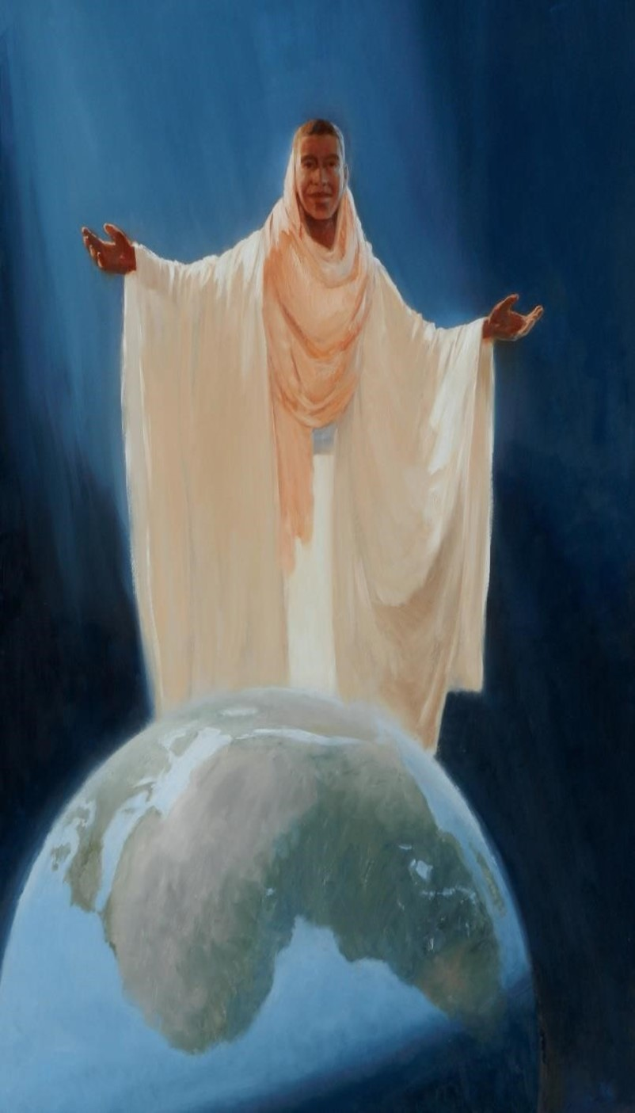
Our Lord
O f Africa

I seek to correct my faults, but also to master my legitimate self will. To the degree that I am self, I am not Christ as the body of Christ. With joy I forego the trinkets and luxuries that promote self instead of Christ. Anyone can cultivate a taste for violence, intoxication, pornography, or irreverence; it is my moral reasoning, not emotions that determine my actions. I desire nothing less than the fullest sharing in the life of God.
Prayer is my life breath. I make my prayer all those actions that raise my heart and mind to God. Physical, vocal, meditative, and contemplative. My contemporaneous sharing in the life of God progresses as I free each faculty of my soul of self will, allowing a deeper participation in the life of God.
My character is the common element in all that I do. I make the effort to increasingly share in the character and person of Christ. My work is done with skill and diligence; my example is not one of frivolity or indifference, but of purpose and optimism. My entertainment does not glorify violence or promiscuity.
Those under my care will receive proper care of soul, and cultivation of correct character. If in the end they attain salvation by my prayers, I have succeeded. I am a pilgrim in this world, striding towards my true homeland. On my journey I need little, and have no use for worry or hoarding.
The living body of Christ continues his redemptive sacrifice, and when hardship comes, perspective, peace and hope is my constructive response. There is no higher calling than that of sharing in the life of God.
God offers me an opportunity unmatched in our world. In its attainment a college degree is of no importance, a routine job is one less distraction, and personal faults are the material made into eternal gold. Every day is a record that is filled out for eternity, and I will let no day pass uncultivated.
www.CatholicBooklets.net

