INVESTMENTS IN THE COUNTRY'S INNER CITIES

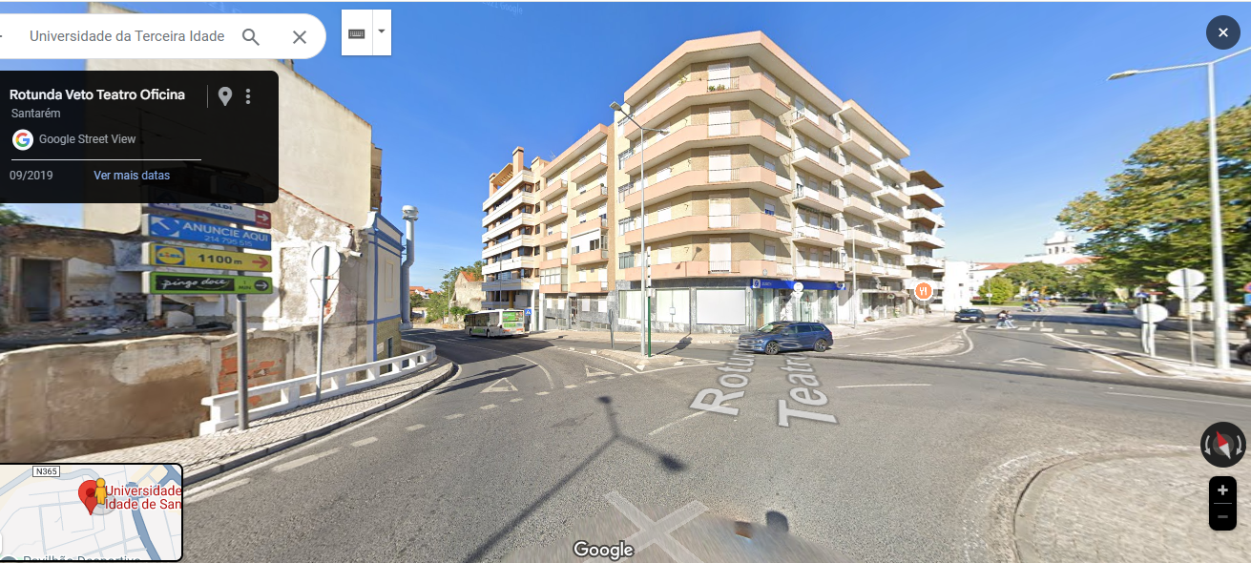IN YOUTH HOUSING WITH GOVERNMENT SUPPORT

### ****Sales Display: Prime Hotel Investment Opportunity in Portugal****

#### ****Unlock Exceptional Returns with a Guaranteed Investment Plan****

This investment is **real**, backed by a reliable construction team in Portugal, and offers outstanding profitability for small investors aiming to earn **over 65% profit** within 2-3 years. With turnkey solutions and market-ready approvals, this is a rare opportunity to maximize your investment potential.

### ****Investment Details****

**Total Cost Breakdown:**

* **Purchase of plots ready for construction:** €4,400,000
* **Turnkey construction (22 modules at €880,000 each):** €19,360,000
* **Promotion and marketing:** €2,800,000
* **Total Costs:** €26,560,000

**Sales Potential:**

* **Sales of 176 units at €250,000 average/unit:** €44,000,000

**Profit Analysis:**

* **Gross Profit Before Tax:** €17,440,000
* **Profit Margin (Over 65%):** Exceptional return compared to initial costs.

### ****Why Choose This Investment?****

**Guaranteed Profitability:**

* The structured plan ensures a significant profit margin within a short time frame.
* Verified by a reputable construction team in Portugal.

**Strategic Market Advantage:**

* High demand for quality accommodations in this region guarantees strong sales potential.
* The property is designed to appeal to both local and international buyers.

**Turnkey Execution:**

* Streamlined construction process ensures efficiency and adherence to budgets and timelines.

**Ideal for Small Investors:**

* A low-risk venture with substantial rewards within just 2-3 years.
* Perfect for those looking to diversify their investment portfolio.

### ****The Opportunity:****

* **Invest Now:** Leverage this opportunity to secure a property in a growing market.
* **Achieve High ROI:** Earn more than 60% profit, making this one of the best investments in the region.
* **Secure Your Future:** Join a trusted network of developers and marketers for a seamless investment experience.

#### ****Next Steps****

Contact us now to:

* Receive detailed project plans and financial breakdowns.
* Discuss customization options with the construction and development team.
* Begin your journey to profitability with this premium investment.

**Don’t miss this chance to secure your stake in Portugal’s booming real estate market.**