“We Will Rock You”

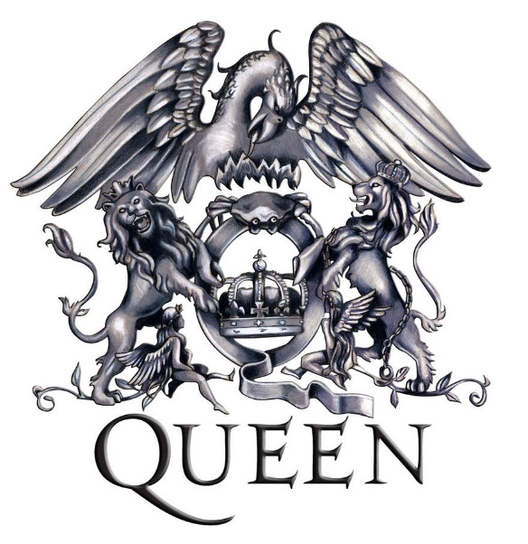***1*** Buddy you’re a boy, make a big noise  
***2*** Playing in the street, gonna* be a big man, someday  
3 You got mud on your face, you big disgrace  
4 Kicking your can all over the place

5 Singing, we will, we will rock you  
6 We will, we will rock you  
  
***7*** Buddy you’re a young man, hard man  
***8*** Shouting in the street, gonna* take on the world, someday  
9 You got blood on your face, you big disgrace  
10 Waving your banner all over the place  
  
11 We will, we will rock you

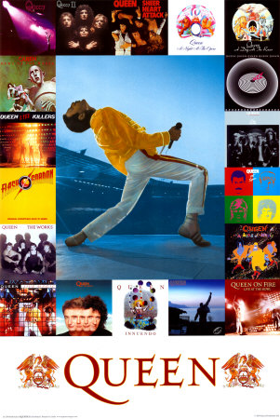12 Singing (ah), we will, we will rock you  
  
***13*** Buddy you’re an old man, poor man  
***14*** Pleading with your eyes gonna* make you some peace someday  
15 You got mud on your face, big disgrace  
16 Somebody better put you back in your place  
  
17 We will, we will rock you, singing

18 We will, we will rock you

19 Everybody, we will, we will rock you

20 We will, we will rock you

(Guitar Break/Solo)

*(gonna=going to)

*Created by Mr. Clark*

“We Will Rock You”

by Queen

***1*** Buddy you’re a boy, make a big noise  
***2*** Playing in the street, gonna* be a big man, someday  
3 You got mud on your face, you big disgrace  
4 ______ your can all over the place

5 Singing, we will, we will rock you  
6 We will, we will rock you  
  
***7*** Buddy you’re a young man, hard man  
***8*** Shouting in the street, gonna* take on the world, someday  
9 You got ______ on your face, you big disgrace  
10 Waving your banner all over the place  
  
11 We will, we will rock you

A. will

B. everybody

C. we

D. kicking

E. you

F. rock

G. blood

H. singing

I. face

12 ______ (ah), we will, we will rock you  
  
***13*** Buddy you’re an old man, poor man  
***14*** Pleading with your eyes gonna* make you some peace someday  
15 You got mud on your ______, big disgrace  
16 Somebody better put you back in your place  
  
17 We will, we will rock you, singing

18 We will, we will rock you

19 ______, we will, we will rock you

20 We will, ______ ______ ______ ______

(Guitar Break/Solo)

*(gonna=going to)

*Created by Mr. Clark*

“We Will Rock You”

by Queen

***1*** Buddy you’re a boy, make a big noise  
***2*** Playing in the street, gonna* be a big man, someday  
3 You got mud on your face, you big disgrace  
4 ___D___ your can all over the place

A. will

B. everybody

C. we

D. kicking

E. you

F. rock

G. blood

H. singing

I. face

5 Singing, we will, we will rock you  
6 We will, we will rock you  
  
***7*** Buddy you’re a young man, hard man  
***8*** Shouting in the street, gonna* take on the world, someday  
9 You got ___G___ on your face, you big disgrace  
10 Waving your banner all over the place  
  
11 We will, we will rock you

12 ___H___ (ah), we will, we will rock you  
  
***13*** Buddy you’re an old man, poor man  
***14*** Pleading with your eyes gonna* make you some peace someday  
15 You got mud on your ___I___, big disgrace  
16 Somebody better put you back in your place  
  
17 We will, we will rock you, singing

18 We will, we will rock you

19 ___B___, we will, we will rock you

20 We will, ___C___ ___A___ ___F___ ___E___

(Guitar Break/Solo)

*(gonna=going to)

*Created by Mr. Clark*