**2025 Goals Template**

Before you start building your new year goals, reflect and review the previous year.

Identify the goals that didn’t go according to plan and why you might have failed at them.

Identify people or things that need to be cut or sacrificed (I don’t mean the harmful kind of sacrifice o lol).

Also, ask yourself if your 2024 goals are still relevant in 2025 or if you want to pursue new goals instead.

Key Notes For Goal Planning:

* Identify a “**Key Theme**” to guide all your goals throughout the year.
* Provide the **What**, **Why** and **How** for each main goal (the how should also include a monitoring plan - I showed an example of mine in the video below).
* Break down each “Main Goal” into monthly goals and quarterly goals to allow easy tracking.
* Find references (this could be images, screenshots, podcast episodes, a particular saying etc).
* Leverage AI tools in case you get stuck.
* Personal development goals are how you intend to improve yourself health wise, self development wise, business wise and career wise (if applicable).
* Make sure to include social goals as well. This is how you intend to improve the relationships wth your loved ones during the year. This could be family activities with a significant other, friends, siblings or parents.

*A lot of people ignore social goals but it’s as important as your other goals cause we are social creatures! There’s no point in improving yourself and not being able to share your progress with loved ones.*

**My Key Theme For 2025: Focus & Priority (create yours)**

**Health Goal Example - Live a more active lifestyle & lose 10kg.**

* 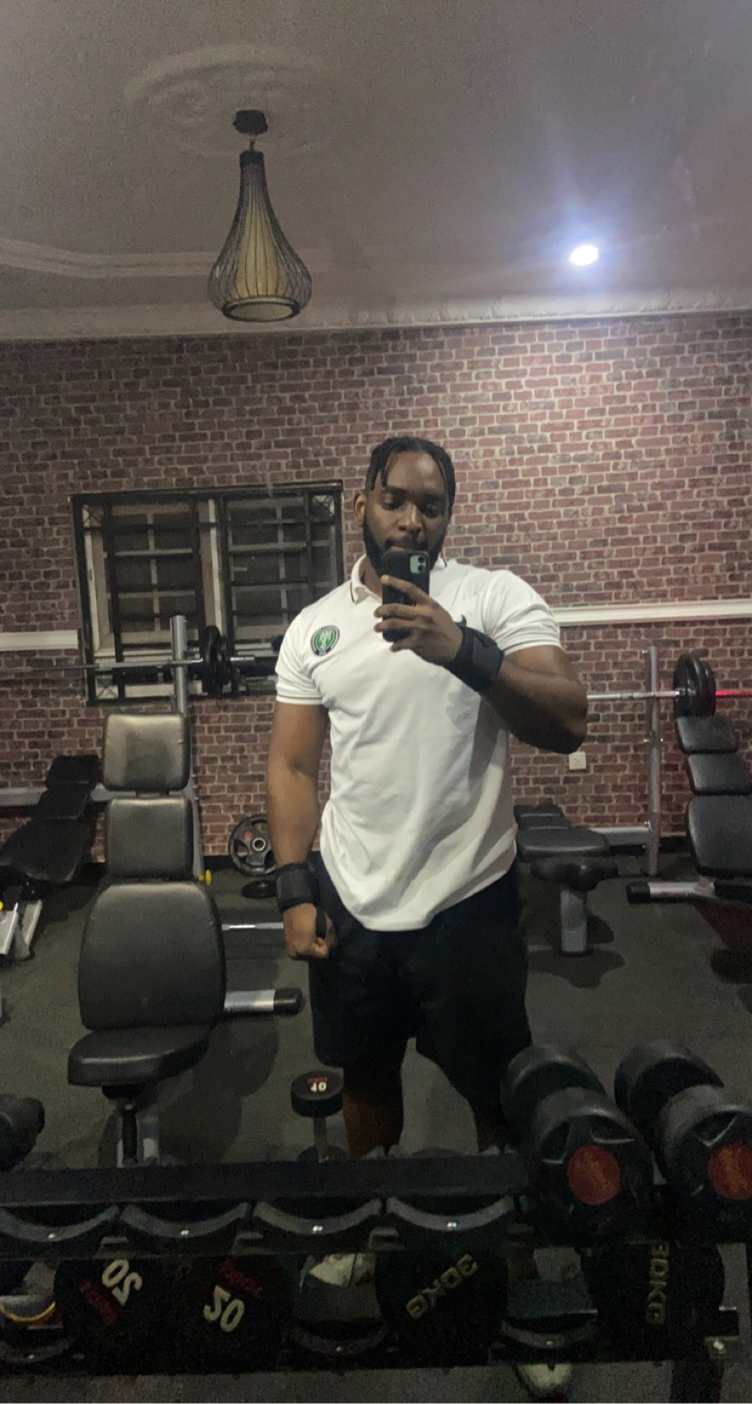*

*I weighed 96kg in this image and I’ll like to go back to this within the next few years so I’m using it as a reference (I currently weigh 122kg 🙈 #welistenandwedontjudge)*

**Why is this goal important to me:**

* Improve my health and fitness levels.
* Create more reasons to go out more often and find fun activities to engage in.
* Look better in clothes.

**How I will achieve this goal:**

* Only have takeout once a month.
* Find social activities for exercising (tennis, swimming, basketball, gym etc minimum of 3 times a week).
* Reducing my sugar intake heavily - less chocolate, biscuits, cross buns.
* Monitor what I consume & practice portions control
* More water and less milk (especially for coffee)
* Replace crave for sugar with fruits (banana, red apples, oranges, watermelon)
* Always eat at least 2 actual meals a day to reduce peckish desires or cravings.
* Take long walks if you miss social activities (you can listen to audible while doing this) - you can do this even though you still do different activities.
* Have more money in the bank and clean up credit score (this helps with my mental health)

**Monitoring plan to ensure success:**

* Recording my weight each month
* Create an actual meal plan that is consistent and sustainable (probably focus more on “air fryer” able meals.)
* Monitor water intake each day (buy one of those bottles with tracking)
* 1 Audible book a month (a must!)
* Always collect receipts and review (so you can see your sins when you fall off - hopefully you don’t)
* Buy them one of those smartwatches to monitor your steps (maybe a whoop 😉)

*Now use this example to create your own personal development goals for your health, self-development, business(es), social goals and/or career (if applicable).*

You can also see an example of one of my business goals for 2025 in this YouTube video below:

<https://damini.openinapp.co/2025goalsetting>