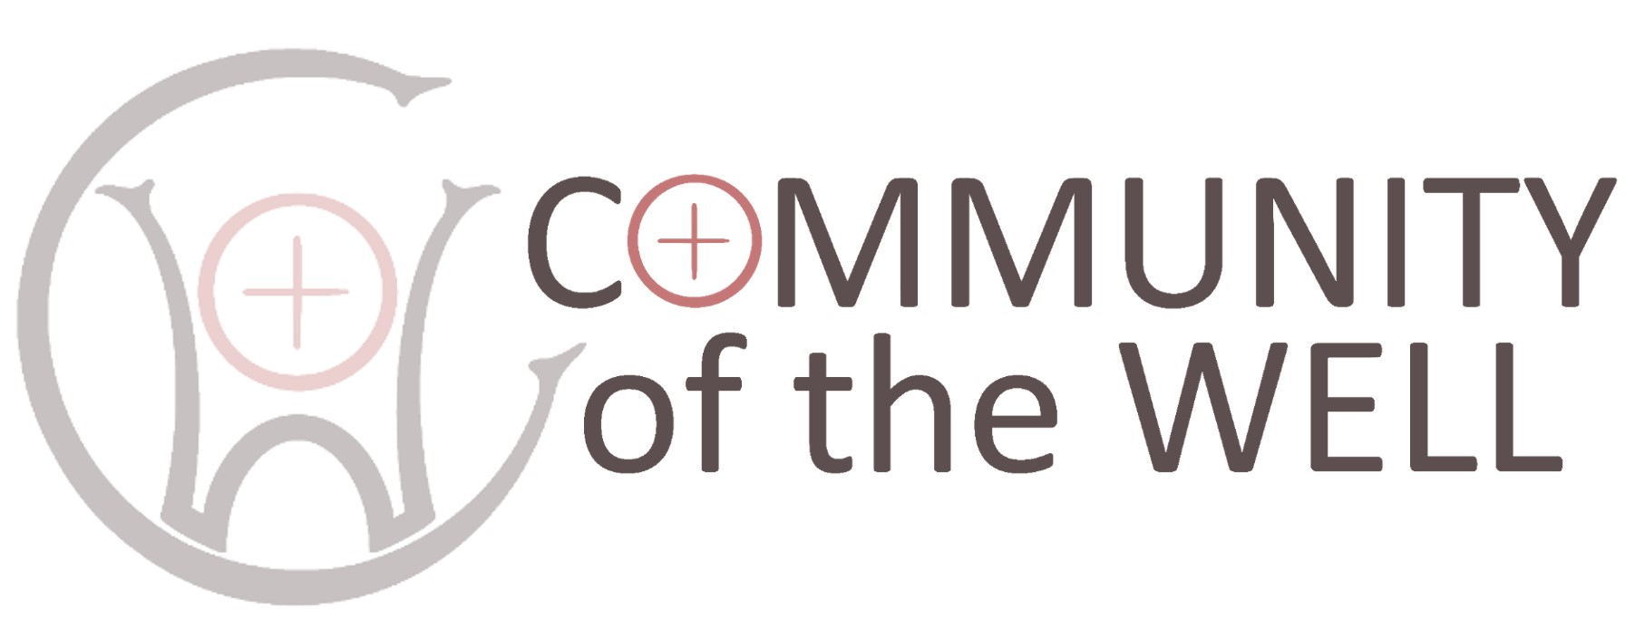
BOOKING FORM
QUIET DAY, Woman at the Well |  |  |  |  |  | Saturday August 2nd 2025
Name
Email
Preferred pronoun
Accessibility requirements
To help us plan catering quantities:
Are you planning to bring a packed lunch?
Are you planning to purchase refreshments?
Other comments

Return completed form to retreats@brancepethcastle.uk

Community of the Well Ltd is a non-profit making company
Company Number 13436930 Directors Rev Deborah Hodge and Rev Alison Hobbs

