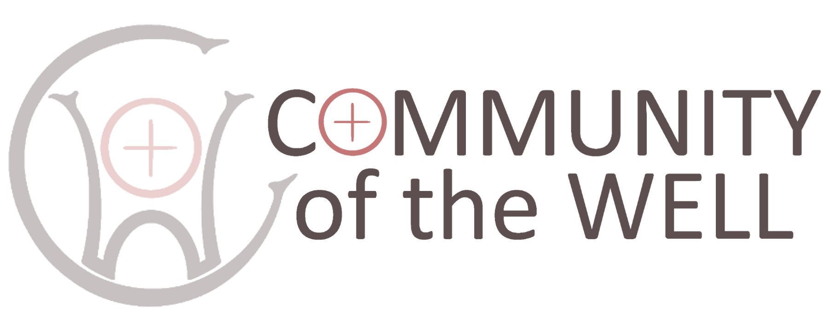
BOOKING FORM
RETREAT DATES | Sunday August 10th – Friday August 15th 2025
Name
Email
Home address

Emergency contact
Age (optional)
Preferred pronoun
Denomination, if any
Are you an ordained Minister?
Accessibility requirements
Dietary requirements
Have you been on a retreat before?
What are your hopes for this retreat?

Other comments

Return completed form to retreats@brancepethcastle.uk

Community of the Well Ltd is a non-profit making company
Company Number 13436930 Directors Rev Deborah Hodge and Rev Alison Hobbs

