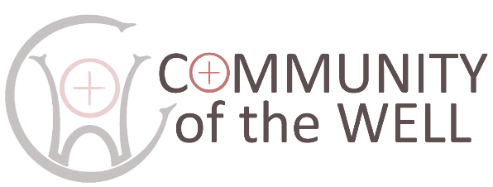
POLICY FOR RESPONDING
TO DOMESTIC ABUSE

Last reviewed: April 2026. Approved by Directors:

All forms of domestic abuse are wrong and should stop. We are committed to promoting and supporting environments which:

- Ensure that all people feel welcomed, respected and safe from abuse;
- Protect those vulnerable to domestic abuse from actual or potential harm;
- Recognise equality amongst people and within relationships;
- Enable and encourage concerns to be raised and responded to appropriately and consistently.

We recognise that:
- All forms of domestic abuse cause damage to the victim and express an imbalance of power in the relationship;
- All victims (regardless of age, disability, gender, racial heritage, religious belief, sexual orientation or identity) have the right to equal protection from all types of harm and abuse;
- Domestic abuse can occur in all communities;
- Domestic abuse may be a single incident, but is usually a systematic, repeated pattern which escalates in severity and frequency;
- Domestic abuse, if witnessed or overheard by a child, is a form of abuse by the perpetrator of the abusive behaviour;
- Working in partnership with children, adults and other agencies is essential in promoting the welfare of any child or adult suffering abuse.

We will endeavour to respond to domestic abuse by:
In all our activities valuing, listening to and respecting both victims and alleged or known perpetrators of domestic abuse;
In our publicity raising awareness about other agencies, support services, resources and expertise, through providing information in public and women-only areas of relevance to victims, children and alleged or known perpetrators of domestic abuse;
When concerns are raised:
- Ensuring that those who have experienced abuse can find safety and informed help;
- Working with the appropriate statutory bodies during an investigation into domestic abuse, including when allegations are made against a member of the church community;
In our care:
- Ensuring that informed and appropriate pastoral care is offered to any child or adult who has suffered or is suffering abuse;
- Identifying and outlining the appropriate relationship of those with pastoral care responsibilities with both victims and alleged or known perpetrators of domestic abuse.

If you have any concerns or need to talk to anyone please contact Deborah Hodge, 01388 745455 or 07791 241608, deborah.hodge@hotmail.com.

