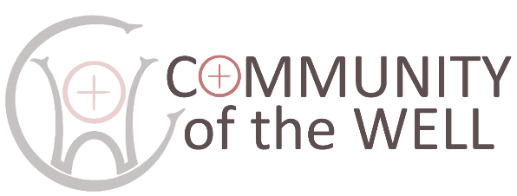
POLICY STATEMENT ON
SAFEGUARDING ADULTS

Last reviewed: April 2026. Approved by Directors:

This policy will be reviewed each year to monitor progress achieved.

- We recognize that everyone has different levels of vulnerability and that each of us may be regarded as vulnerable at some time in our lives. However, we follow the Durham Diocesan Safeguarding Policy (2023) where a vulnerable adult is defined as ‘a person aged 18 or over whose ability to protect himself or herself from violence, abuse, neglect or exploitation is significantly impaired through physical or mental disability or illness, emotional fragility or distress, or otherwise; and for that purpose, the reference to being impaired is to being temporarily or indefinitely impaired’.
- As members of the Community of the Well we commit ourselves to respectful pastoral care for all adults to whom we minister.
- We commit ourselves to the safeguarding of people who may be vulnerable, ensuring their well-being in the activities run by the Community of the Well
- We commit ourselves to promoting safe practice by those in positions of trust.
- The Community of the Well commits itself to promoting the inclusion and empowerment of people who may be vulnerable.
- It is the responsibility of each of us to prevent the physical, emotional, sexual, financial and spiritual abuse of vulnerable people, and to report any such abuse that we discover or suspect.
- We undertake to exercise proper care in the appointment and selection of those who will work with people who may be vulnerable.
- The Community of the Well is committed to supporting, resourcing, training and regularly reviewing those who undertake work amongst people who may be vulnerable.
- The Community of the Well adopts the guidelines of the Church of England and the Diocese.
- Each person who works with vulnerable people will agree to abide by these recommendations and the guidelines established by the Community of the Well.

The Community of the Well appoints Deborah Hodge and Judith Minto to represent the concerns and views of vulnerable people at our meetings and to outside bodies. Deborah can be contacted on 01388 745455 or 07791 241608, deborah.hodge@hotmail.com.
Judith can be contacted on 07905 645674

