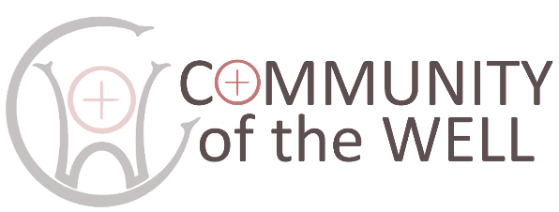
SAFEGUARDING POLICY:
CONTACTS

Last updated: April 2026. Approved by Directors:

The Community of the Well has in place a Safeguarding Policy for the protection of children and vulnerable adults which is displayed on noticeboards in the Castle, and on the Community of the Well page of the Castle website.
The following are available contact points should you have any concerns related to a safeguarding issue:

Community of the Well Safeguarding Officer:
Deborah Hodge
01388 745455 or 07791 241608
deborah.hodge@hotmail.com

Diocesan Safeguarding Advisor:
Beth Miller
07968 034075
Beth.miller@durham.anglican.org
https://durhamdiocese.org/safeguarding/report-abuse/

Local Authority direct line:
03000 267 979

Police:
101 or 999

