Support Veterans Mental Health by presenting this flyer to the Crestview Florida
Location on January 22nd and Texas Roadhouse will donate 10% of your total food purchases to Riding 22 in 22 VSA!
Riding 22 in 22 VSA 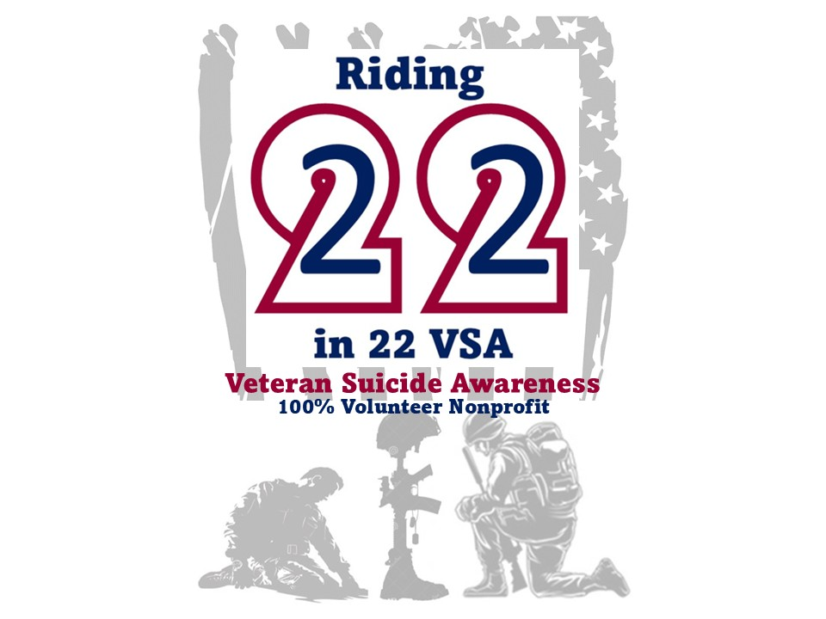
Thursday January 22nd
(850) 801-0493
245 Rasberry Rd, Crestview FL

