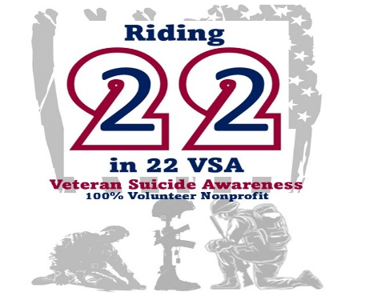
Riding 22 in 22 VSA
January 22, 2026
11am – 9pm
Support Riding 22 in 22 VSA by presenting this flyer to the Richmond Rd, Lexington Location and Texas Roadhouse will donate 10% of your total food purchases to Riding 22 in 22 VSA!

(859) 268-2507
3116 Richmond Road| Lexington, KY

