**CITY COUNCIL LAND USE TEAM - OPERATION ORDER**

**ACTIVITY:** Joint Council and QPS Search Warrant

**TIME:** 10:00am

**DATE:** Wednesday 15th December 2021

**ADDRESS** QLD

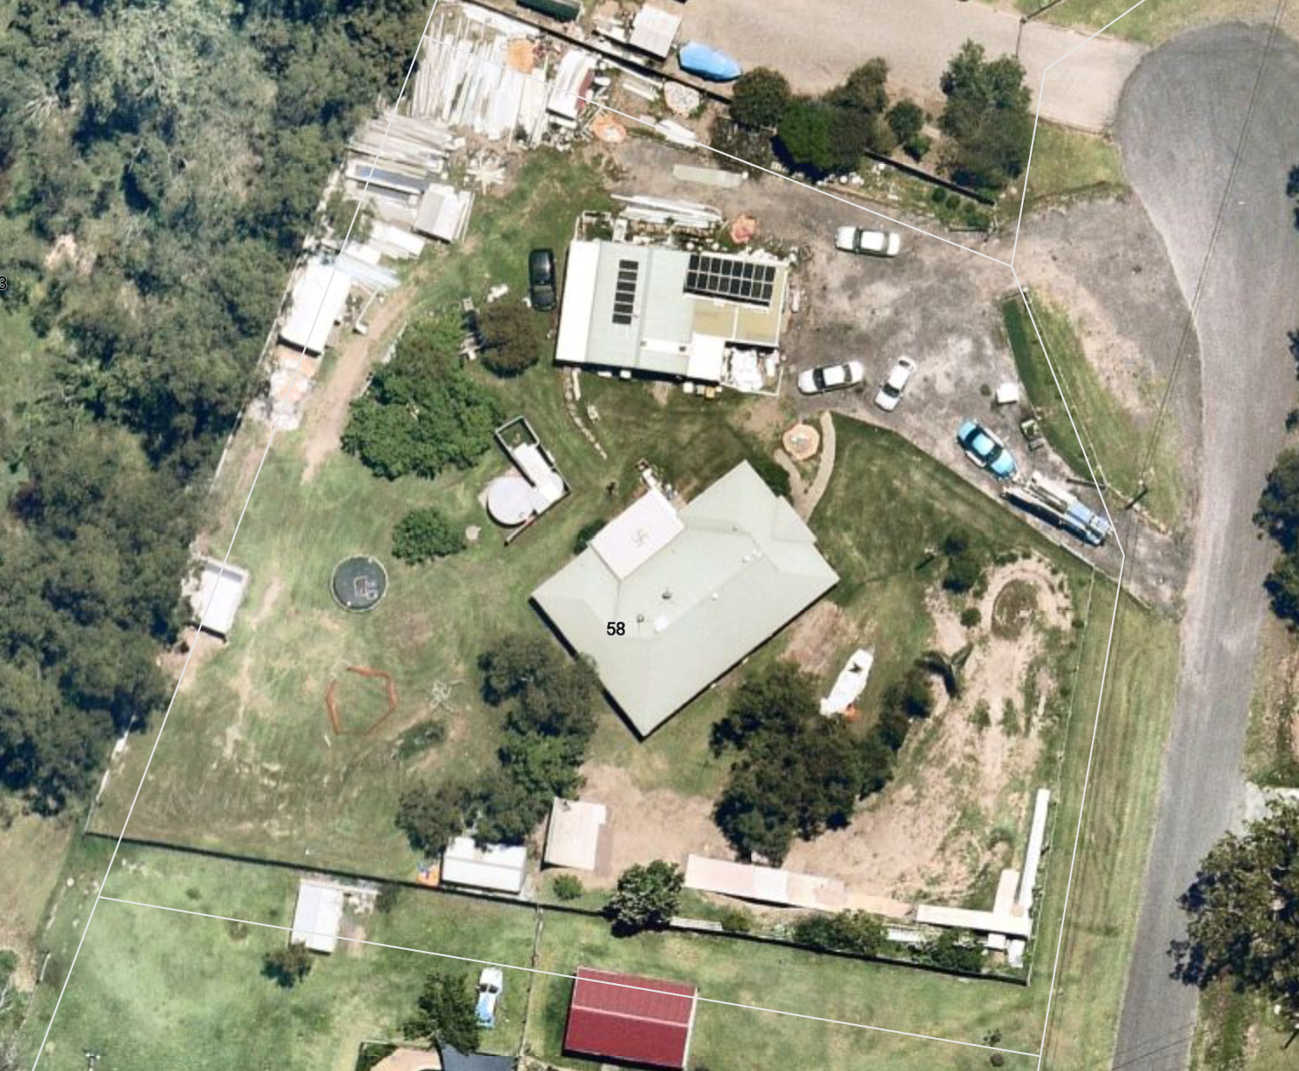**Latest NearMaps Image as of 14 November 2021**  
  
**OFFENCE(S):**

Section 163 – Carrying out assessable development without a permit (Planning Act 2016 Qld)

Section 165 – Unlawful use of premises (Planning Act 2016 Qld)

Section 115 Building Act 1975 – Compliance with relevant BCA and QDC provisions for occupation and use of building.

Section 70 Plumbing and Drainage Act 2018 - Owners obligation for operating and maintaining plumbing and drainage.

**BACKGROUND:**

The Land Use Team have been investigating the above premises from August 2021 to the current date for the following activities:

* Operating a warehouse and/or Low impact industry use of the property, namely the storage of roofing material on the property in association with the occupant’s business.
* Illegal building and plumbing works

**PERSON(S) OF INTEREST:**

|  |  |
| --- | --- |
| **Party** | **Alleged role** |
| Jody | Property Owners |
| Jason | Property Tenant/Occupier |

**GROUPING AND TASKS:**Operation Commander: Principal Investigator Supervisor: Senior Investigator   
Case Officer / Warrant Holder: Investigator   
Corroborator: Investigator   
Search Officer/s: Investigator  
 Investigator   
Drone Operator: Investigator   
 Senior Investigator   
Officer Safety: Officer   
 Officer   
QPS assisting Council: 2 x Uniformed General Duties Police   
2 x Detectives  **ACTIONS:   
  
Premises unoccupied:**

* Attempt to contact occupant via phone (0415 xxxx). If necessary contact locksmith to obtain entry and search premises.

**Occupant refuses Council entry:**

* Attempt communication to gain peaceful entry. Forced entry will be required on Warrant Holder’s directions.

**Person(s) attempt departure from premises:**

* It is desirable that no persons depart premises due to risk of destruction of evidential material that may be located at unknown premises.
* If persons attempt to leave then Council Officers do not have powers to detain them. However, advise Warrant Holder that persons intend to leave before warrant is completed.

**Code words during warrant action:**

* Officers requiring URGENT assistance within the premises will call: “HELP, HELP, HELP”.
* Tactical disengagement requiring all officers to depart the premises immediately will be at the call of “EVACUATE, EVACUATE, EVACUATE”.

**Discovery of explosives or suspected explosives:**

* Leave item in situ.
* Inform Warrant Holder immediately.
* Evacuate the premises immediately.

**Discovery of a Clan Lab or Chemicals:**

* Inform Warrant Holder immediately.
* Do not switch anything off on the premises or touch any of the equipment.
* Evacuate the premises immediately.
* Contact Queensland Police Illicit Laboratory Investigation Team (ILIT) on (07) 3346 6166.

**Use of Force:**

* Officers to provide immediate assistance to each other to safely and quickly regain control.
* Warrant Holder to be informed immediately of incident.
* Emergency services to be called immediately to report the incident.

**RESOURCES:**

Search Kits  
Digital hand held recorders   
Mobile phones  
Navigation equipment   
Digital Camera   
Video/Digital Camera Kit   
Notebooks   
Exhibit bags

**SAFETY AND SECURITY:**

Officers are instructed to observe standard WHS considerations as per Investigation Training   
Officers to wear appropriate clothing that also identifies them as Council Officers.  
Gloves to be worn at all times at the target premises.   
Investigators to display ID Authority cards at all times.   
Risk Assessment level is deemed to be **MEDIUM**

**Medical**  
  
First Aid Kits are located in Council vehicles.  
All emergency situations, should dial “000”.  
 **Hospital and Medical Centre**  
  
Beaudesert Hospital   
64 Tina Street  
Beaudesert Qld 4285  
(07) 5541 9111  
  
**Police**  
  
xxxxx Police Station   
  
  
**Justice of Peace**  
  
(Details of coordinator, if required)   
 **Locksmith**

**WEATHER** – To be included when available