Webcast: Simplify your Zero Trust strategy with the latest end-to-end security innovations
Duration: 58 minutes
Live broadcast on July 31, 2024
Format: Vasu Jakkal will share new Microsoft Security innovations that help maintain Zero Trust security principles. A demo of specific scenarios using the products follows, and then a panel discussion, with special guests from Virgin Money and Forrester Research, to discuss how customers can elevate their pursuit of a Zero Trust approach to security.
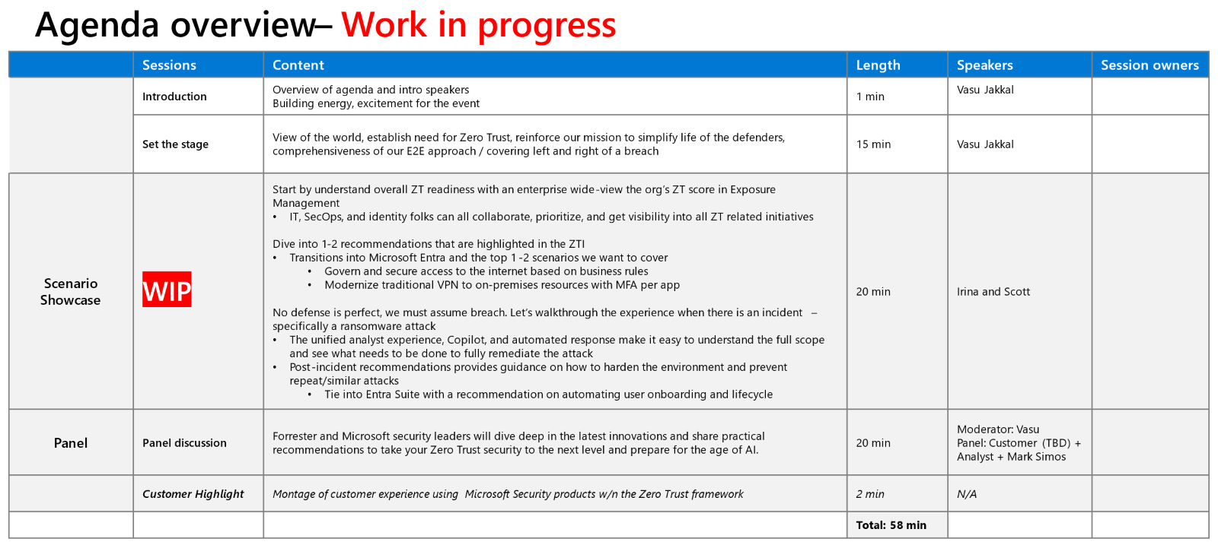
Presenters:
Vasu Jakkal
Irina Nechaeva
Scott Woodgate
Gary McClellan Head of Engineering Frameworks & Core Mobile Apps, Virgin Money
Carlos Rivera, Forrester Senior Analyst
Time | Key Sections | Topics & Talking Points
1 min |  | Webcast Introduction
15 min | Hello and Introduction  High-level introduction of Zero Trust as a focus  High-level acknowledgement of challenges/empathy toward audience and what they face  Optimistic note  Summary of what the webinar will be  High-level description of demo part 1  High-level description of demo part 2  High-level introduction of panel discussion and participants | Set the stage: Keynote  Thank you so much for joining us today. We have a lot we want to share with you.  I’m excited today to tell you about some new developments that should help organizations on their Zero Trust journey.  We know from working with customers and partners around the world just how difficult security is in the face of constant change and seemingly unending escalation of threats. But even as the age of AI dawns, the foundation of Zero Trust principles remains a critical grounding force for enterprise security  And that’s why I’m pleased to be able to share with you some real solutions to today’s challenges that can facilitate a Zero Trust approach to security: end-to-end solutions that will simplify and unify the tasks you perform every day. And we’re not just going to talk about them, we’re going to show you how it all works.  My colleague Scott Woodgate is going to walk you through a high severity attack by a known threat actor to show you how strong a Zero Trust strategy can thwart a breach attempt at machine speed with the world’s first unified Security Operations platform.  Then, my colleague Irina Nechaeva will demonstrate how the new Microsoft Entra Suite helps you protect every access point to any resource, from anywhere.  That sounds like a lot of absolutes, but we’re truly excited about the potential of these innovations in security.  After the demo, I’ll welcome Gary McClellan, from Virgin Money, and Forrester Research analyst Carlos Rivera to talk about practical ways to take your Zero Trust strategy to the next level.  We have so much to talk about, but I want to begin by sharing how we see Zero Trust today and what it means for the growing challenges we’re hearing about from organizations across every market.
 | Evolution of Zero Trust  COVID changed how we thought about Zero Trust  AI will change how we think about and practiced Zero Trust  AI bring challenges of even more attacks | Security is constantly evolving to keep pace with technology transformation. Zero Trust is a great example of this.  As you may know, the concept of Zero Trust was first introduced almost 30 years ago.  By 2015 Zero Trust was emerging as a philosophy for security.  But the global pandemic in 2020 created a critical inflection point. Entire organizations had to shift to remote work, almost overnight, and employees needed secure access to data resources, no matter where they were.  More than ever, the Zero Trust principles became an essential part of enterprise protection.  They became a critical way of thinking about how to secure valuable data and apps when an organization’s network perimeter was becoming significantly and permanently less defined.  Today we’re facing another major catalyst for change with the dawning of the age of AI.  AI is changing … almost everything. It will change the way we think about Zero Trust once again, and how we strive to implement those principles.  AI will help us achieve better security by letting us react to intrusions at machine speed and scale. It will help us spot anomalies in massive data sets that might elude the human eye. And it will help us streamline workflows and free security professionals for higher-level, strategic thinking.  AI integrated with the product innovations we’re here to talk about today will make it possible to truly think about Zero Trust as an end-to-end security model.  But for all of its promise, AI brings challenges, too.  Unfortunately, criminals see the potential for AI to drastically reduce the cost, time, and skillset required to probe for vulnerabilities.  The potential for harm is enormous.  Our research shows us that 93% of organizations have network vulnerabilities that could be exploited.
 | Identity will be one of the most attacked  Entra solves the identity issue  Ease of use is important for productivity  Complexity makes security hard to use  MSFT unified SecOps solves the complexity problem  These two developments allow end to end security  MSFT value prop  Benefits  Tee up demo | Identity is the front line of the cyber battleground.  In fact, two-thirds of all attack paths involve insecure identity credentials. Bad actors target identity, appropriating and manipulating it, or tainting it with malicious code. We have seen password attacks—identity attacks—increase from 579 per second in 2021 to over 11,000 attacks per second in 2024.  Identity also lies at the heart of Zero Trust concepts. “Verify explicitly” is the first tenet of Zero Trust philosophy.  That’s why today we are excited to introduce and demonstrate innovations in solution design that will enable you to strengthen your identity management and up-level your Zero Trust strategy.  This month Microsoft announced the general availability of the Microsoft Entra Suite, the industry’s most comprehensive secure access solution for the workforce, and the Microsoft unified security operations platform, which delivers unified threat protection and unified posture management.  Together, these two innovations simplify implementation of Zero Trust security principles and bring the power of AI to Zero Trust architecture, enabling a truly end-to-end approach to security.  The new Entra Suite helps you secure access to any resource, anywhere, from any device.  It converges network and access security in a single access policy engine.  It unifies policies with just-in-time and just-enough access to secure both data and productivity.  And it makes things easier for security teams—and all users—even while strengthening the organization’s security posture.  Ease of use is so important to securing identity without causing a drag on productivity. But companies reacting to pressing needs created by accelerating attacks may see growing complexity in their security operations  .  Our research indicates that organizations use as many as 80 individual point solutions in their security portfolio. Eighty!  Of course it doesn’t work. In fact, our research tells us that the higher the average number of platforms a company uses, the more cybersecurity incidents they have experienced.  What happens with all those different platforms is SOCs are buried under mountains of alerts, security signals, and initiatives. Analysts burn time sifting through low-level alerts, jumping between portals, and navigating complex workflows—instead of concentrating on what happened, how to resolve it, and how to prevent it from happening again  We’ve heard from our customers how they want more simplicity. Many of them are actively looking to consolidate solutions.  Because Microsoft is the only provider that has leading solutions across virtually every layer of the digital estate—identity and access, endpoints, infrastructure, apps, data, network, and more—we can unify more than any other vendor. We’ve been on a journey to do that and simplify security solutions over the past few years.  Which is why we are so excited to also show you how we combined the threat information aggregated by Sentinel, our SEIM product, and the XDR capability of Defender—along with exposure management, and enriched by Copilot for Security our generative AI solution for analysts—to create the world’s first unified Security Operations platform.  Bringing SIEM, XDR, exposure management, generative AI, and threat intelligence together means streamlined workflows for security teams.  It means bringing together security data stored in siloes across the organization, surfacing all that data, collecting and normalizing it, monitoring and adding analytics to it, enriching it with threat intelligence and acting on insights across the entire digital estate  It means one view of active incidents across all your security solutions—and threat intelligence right on the same screen.  And because “assume breach” is a key pillar of Zero Trust, we’re going to show you how critical end-to-end visibility and control is by demonstrating how our solutions help you prepare before, during and after a breach.  At Microsoft, we’re proud to help enable that. We are the only company in the world that combines four critical advantages:  - large-scale data and threat intelligence;  - the most complete end-to-end platform;  - industry leading, responsible AI;  - and the ability to design solutions and products to help you secure and govern AI.  Integrating controls across security pillars will enable organizations to apply unified policies and enforce them consistently.  Unifying strategy and security policy with Zero Trust breaks down siloes and enables better visibility and protection across the IT stack. That’s how we build end-to-end security.  That’s how we can help you maintain both a proactive and reactive posture. In just a moment I’m going to bring on my colleagues Scott and Irina and they’re going to show you more about that.  They’re going to show you how these two new security solutions help you on either side of a breach.  How we can help you proactively prevent a breach.  How you can reactively meet a breach at the speed of attack.  And how you can self-heal and help analysts understand exactly what happened so you can prevent another similar attack from happening in the future.
 | Conclusion | Today we are bringing to life solutions that will tip the scales in favor of the defenders.  We’re harnessing the power of AI to free the power of human potential.  Turning both proactive and reactive approaches to Zero Trust into practical solutions that give people freedom to imagine and create.  Since the development of the digital economy, we have made a lot of incremental progress in securing data and digital assets—including the embrace and evolution of Zero Trust principles.  In my life, I believe in trust. I truly do. I believe it enables all beautiful human imperatives like love, kindness, empathy and help.  But in cybersecurity, I believe we must embrace the idea of Zero Trust.  Zero Trust provides us freedom.  If I know I am where I am supposed to be, I don’t have to worry about making mistakes.  I don’t have to fear somebody taking advantage of my vulnerabilities.  I am free to experiment, to make whatever my imagination inspires.  And that is what we want for each of you, and everybody in your organization—security that allows you the freedom to do.  So I’d like to welcome now Scott Woodgate and Irina Nachaeva to show you these new capabilities.…
 |  | END

**6/26 Note: This document only contains the keynote for review and feedback purposes. We will further build out the full ZT narrative in this doc to cover all components of the webinar (i.e., scenario showcase, panel and customer highlight reel).

