£25m boost to foster care support and recruitment from 2026-28

Money designed to recruit 400 more foster families and improve peer support carers, as government seeks to counter decline in number of mainstream fostering households

by **[Mithran Samuel](https://www.communitycare.co.uk/author/f3206a8f44bd451f92cd7d9d9620297c/" \o "Posts by Mithran Samuel)** on April 8, 2025 in [**Children**](https://www.communitycare.co.uk/children/), [**Social work leaders**](https://www.communitycare.co.uk/social-work-leaders/)

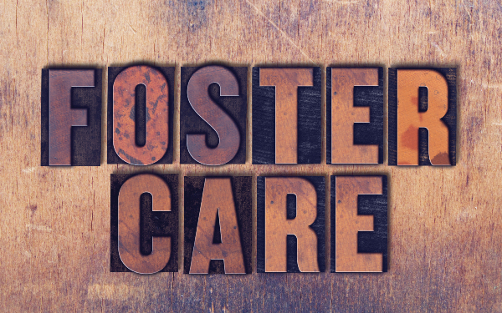

*Photo: enterlinedesign/Adobe Stock*

The government has committed £25m to boosting foster care recruitment and support in England from 2026-28.

The money was announced in the [government’s spring statement last month](https://assets.publishing.service.gov.uk/media/67e3ec2df356a2dc0e39b488/E03274109_HMT_Spring_Statement_Mar_25_Web_Accessible_.pdf), when the Treasury said it would be used to recruit a further 400 fostering households.

Further details were provided last week by children’s minister Janet Daby, in [response to a written parliamentary question from Liberal Democrat MP Tom Gordon.](https://questions-statements.parliament.uk/written-questions/detail/2025-03-26/41621)

Daby said the money would be available over two years – 2026-27 and 2027-28 – and was also designed to fund peer to peer support for foster carers, as well as bolster recruitment.

The funding builds on £36m allocated from 2023-25 by the previous government and £15m for 2025-26 provided by the current administration to tackle shortages in England’s fostering capacity. There was a [10% drop from 2021-24 in the number of mainstream foster carers – a category that excludes kinship carers approved to look after specific children](https://www.communitycare.co.uk/2024/11/13/number-of-mainstream-foster-care-households-down-by-10-over-past-three-years/).

**Investment in regional fostering schemes**

The investment to date has been designed to roll out[regional fostering recruitment and retention programmes, set up by clusters of local authorities. These comprise three elements:](https://www.mutualventures.co.uk/_files/ugd/661139_7fb419844cef4a148a6463f12705b7de.pdf)

1. A fostering recruitment support hub, providing an information and support service to help prospective carers from their initial enquiry to making an application.
2. A communications campaign to drive interest in fostering across the region and increase the number of enquiries received by the hub.
3. Expanding the ‘Mockingbird model’, developed by the Fostering Network in the UK, under which “constellations” of fostering households provide mutual support to one another, led by an experienced carer who provides a ‘hub home’ for the others. [A 2020 evaluation of the scheme for the DfE](https://assets.publishing.service.gov.uk/media/5fa412dfd3bf7f03a40fe598/Fostering_Network_Mockingbird.pdf) found that households who participated in Mockingbird were 82% less likely to deregister than households who did not.

In her answer to Gordon, Daby did not confirm whether the £25m for 2026-28 would provide further funding for these regional programmes or a different purpose.

**Foster carers ‘lack authority to take decisions’**

Alongside the increased investment, the DfE is also planning to enable foster carers to take more day-to-day decisions about children in their care.

Currently, a child’s placement plan must set out where authority to make decisions has been delegated from parents and councils, where they share parental responsibility, to carers, in relation to matters including healthcare, education, leisure, home life, faith and social media use.

[Statutory guidance](https://assets.publishing.service.gov.uk/media/60e6fb43d3bf7f56896127e5/The_Children_Act_1989_guidance_and_regulations_Volume_2_care_planning__placement_and_case_review.pdf) states that foster carers should have delegated authority in relation to day-to-day parenting decisions, but the Fostering Network has warned that this is not borne out in practice.

The charity worked with Green MP Ellie Chowns to table an amendment to the current Children’s Wellbeing and Schools Bill to give foster carers delegated authority over these decisions by default.