WizardShot

Tutorial: Audit Courses with A11y Audit Pro

Visit Wizardshot | Dashboard

Switch to A11y Audit Pro

Adding a new Course for Audit

Click on "New Course" in the top right corner of the application.
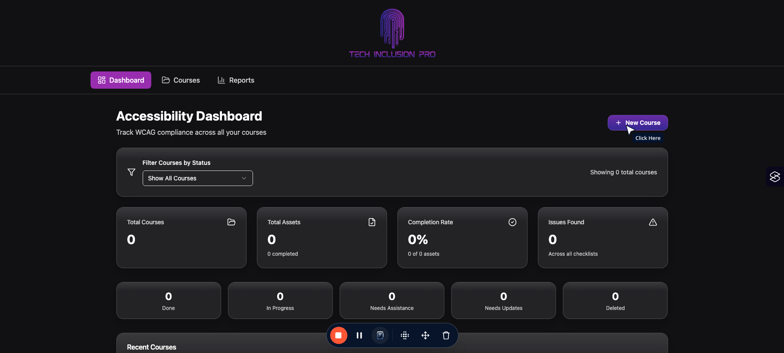

Click on "Create Your First Course" (or click on "+ New Coure" button if you already have created other courses)
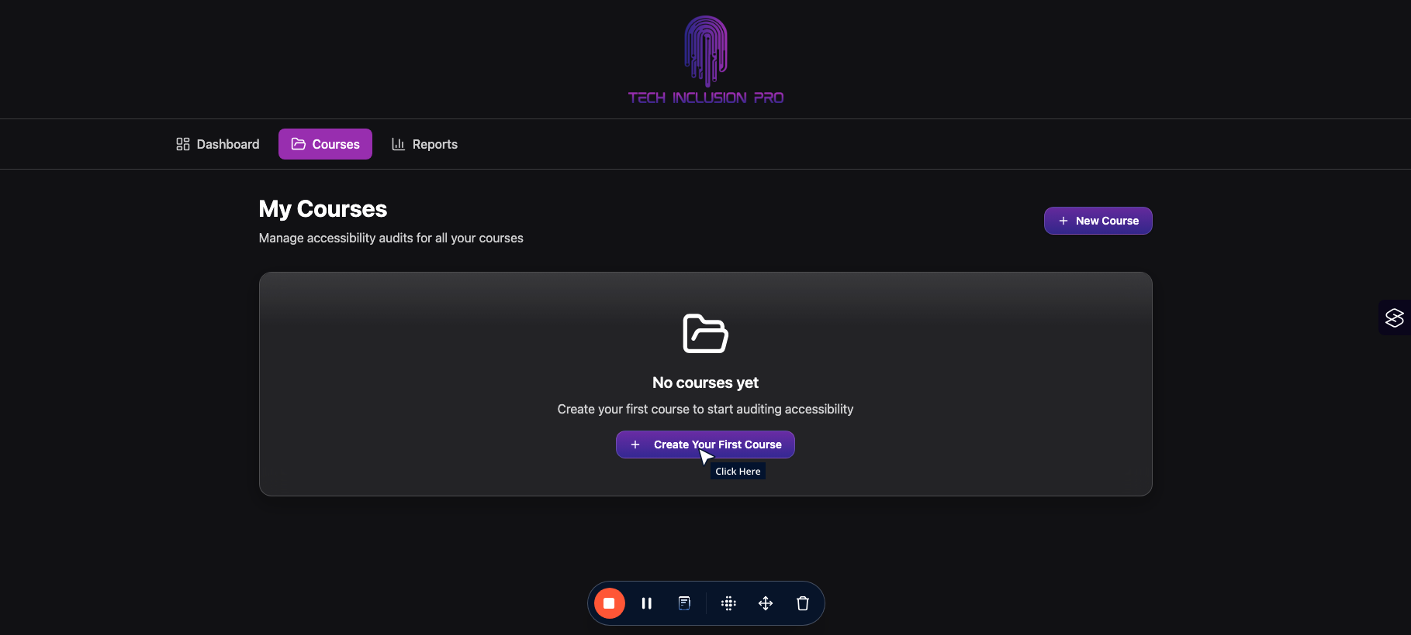

Fill in each text area to give your course details in your notes.
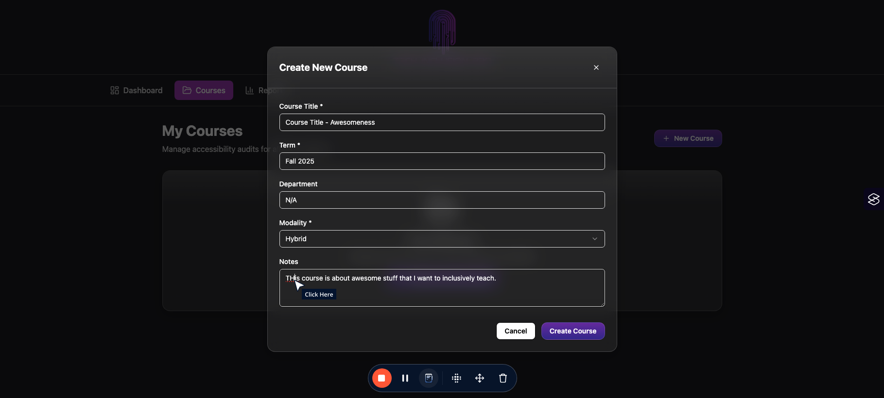

When all areas are filled in, click on "Create Course" in the bottom lefthand corner of the screen.
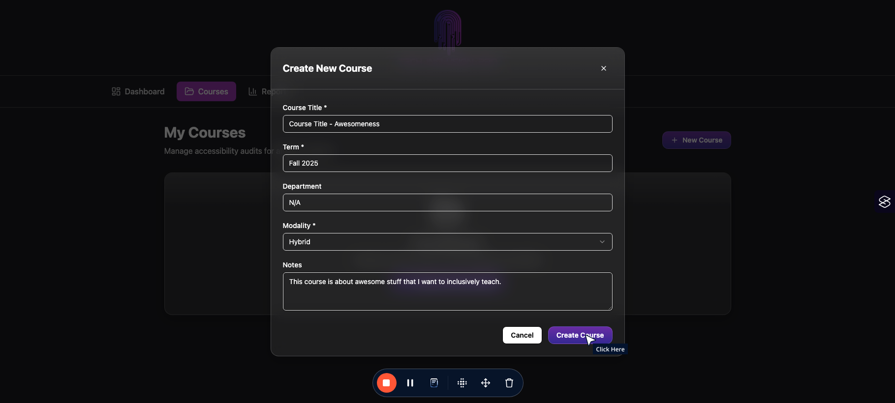

Adding Course Assets for Auditing

To add a course asset (syllabus, videos, assignments, etc.), click on "Add Your First Asset" (or the "+ Add Asset" button int he top right corner of the application)
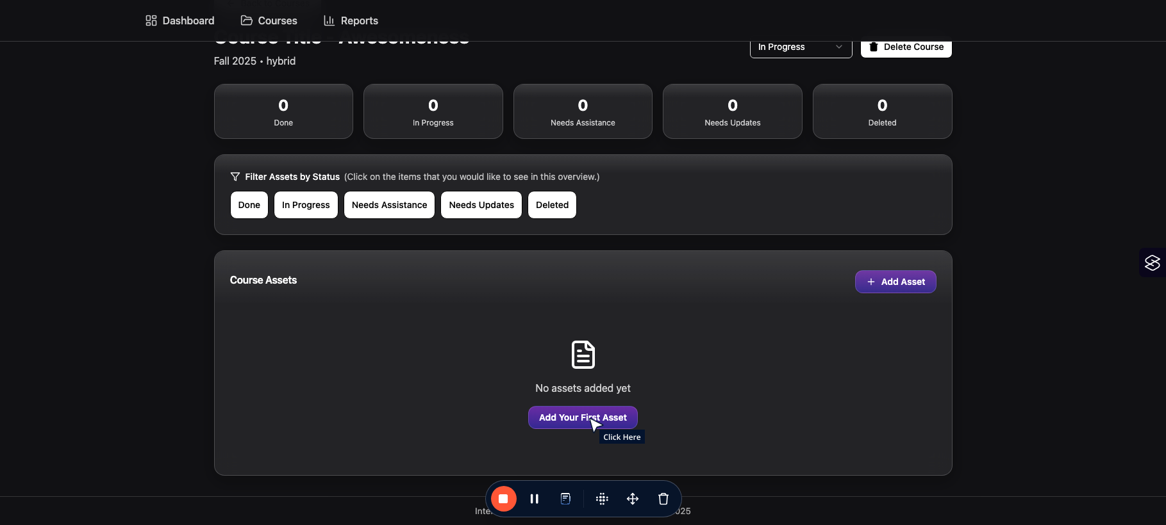

Fill in each text area with what you would like to have filled in.
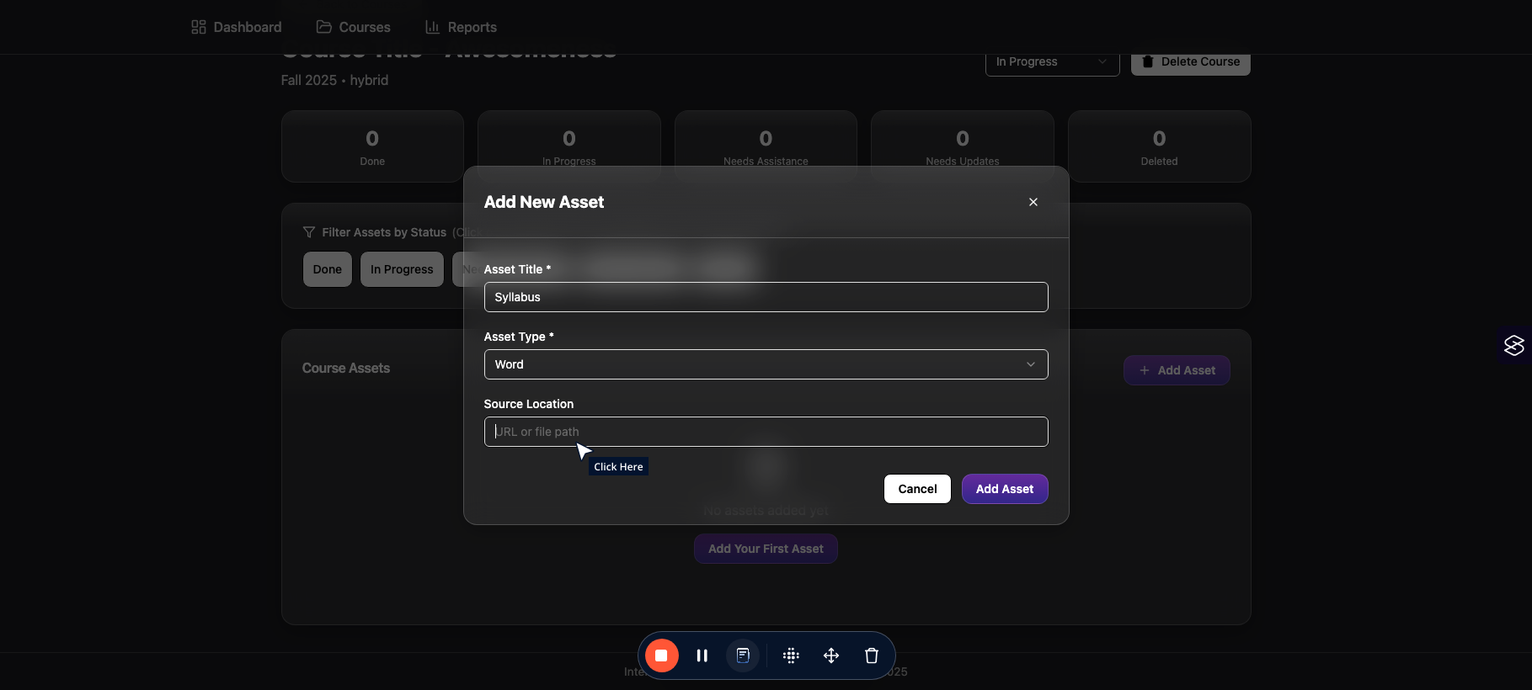

When complete, click on "Add Asset" button on the bottom right hand corner of the screen.
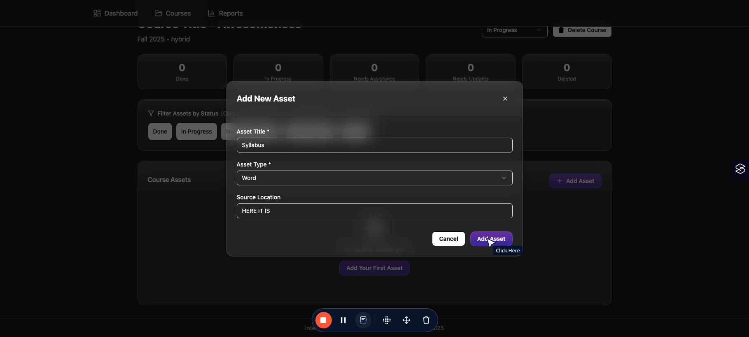

Auditing your Assets

To audit (e.g. view and fill the audit checklist), click on "Audit" button on that asset your want to target which can be found on the right side of the asset box.
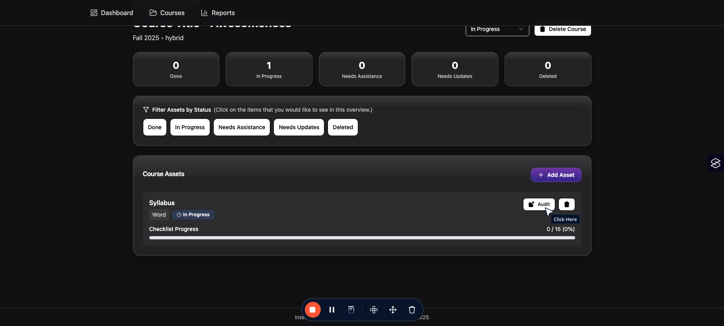

You will now see a variety of areas to fill for each of your course assets. This follows the WCAG 2.1 AA guidelines for Perceivable, Operable, Understandable, and Robust (POUR) aspects fo your course.
To help you with HOW to fix the items, click on the "how to check" and "Fix Hint" drop downs for ways to approach. Feel free to check out WCAg resources on line for further details.

After reading the criteria, if you think your asset fits, click on "Pass" to indicate it meets that criteria.
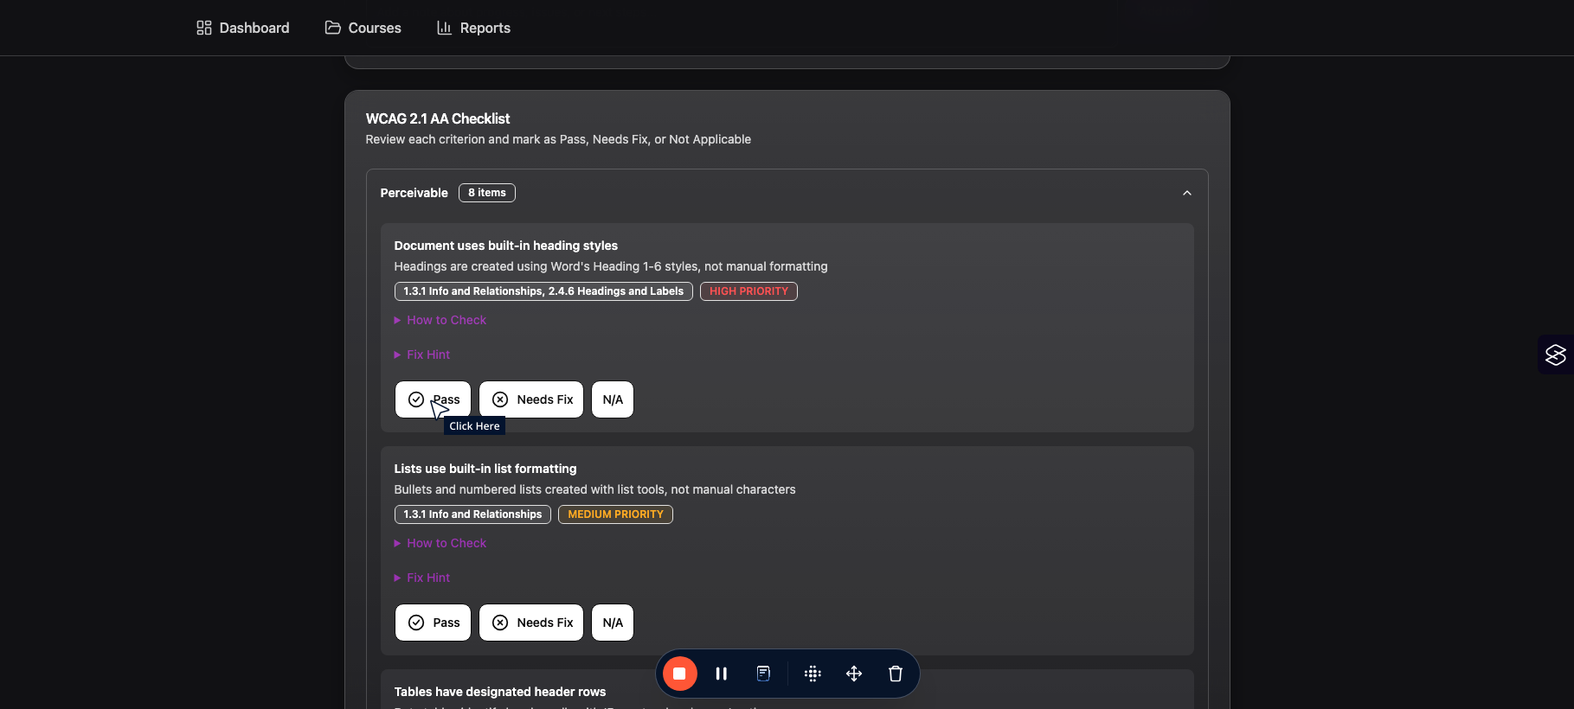

If it does not fit, click on "Needs Fix" to indicate that it does not fit the criteria.
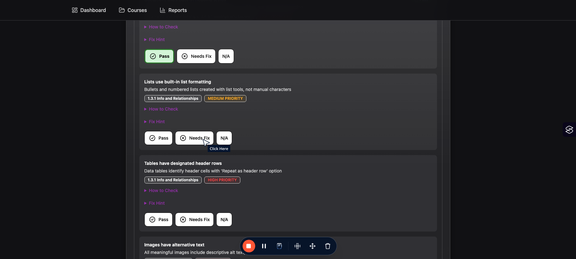

Fill in each of these areas to keep notes on why it is not fixed and what you plan to do to fix it.
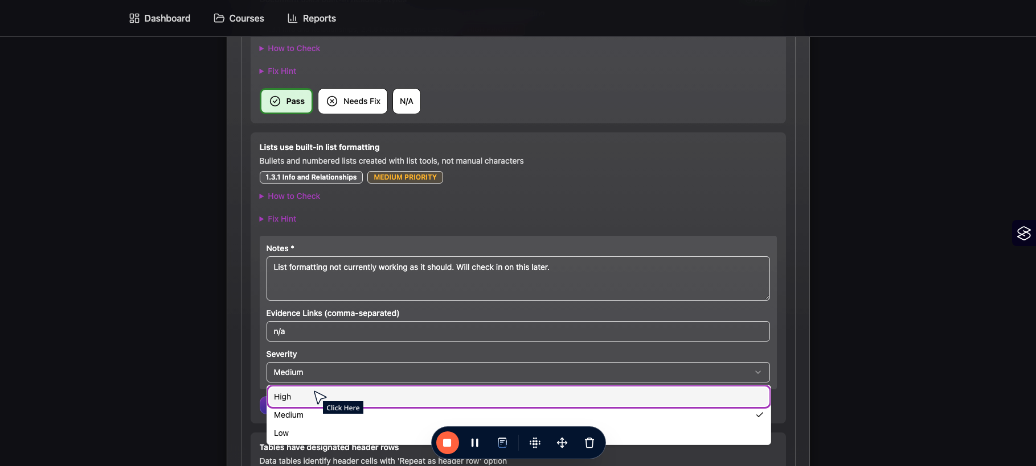

Once done, click on "Save Details" to save the notes you took for this course.
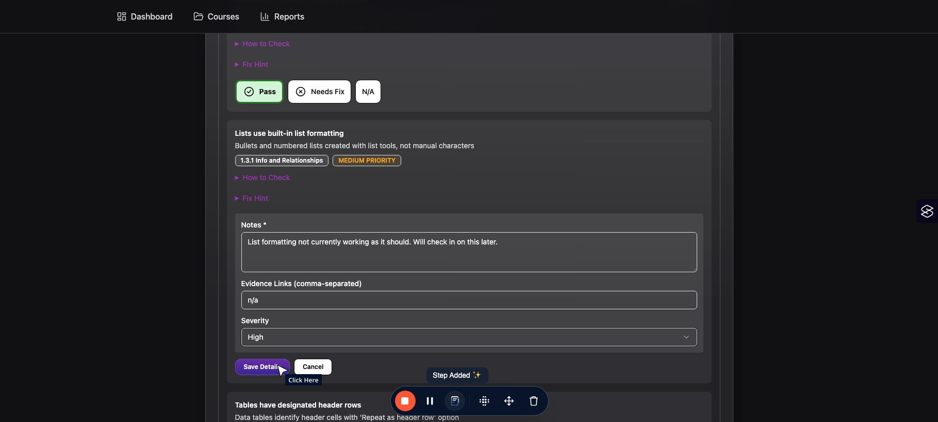

You can now do this for each of the POUR areas for your course asset.

Additionally, you can add general notes (which will be dates and time-stamped) by typing int he "Asset Notes" section and clicking on "Add Note" - this will create a running list of notes you may have about a particular asset audit.
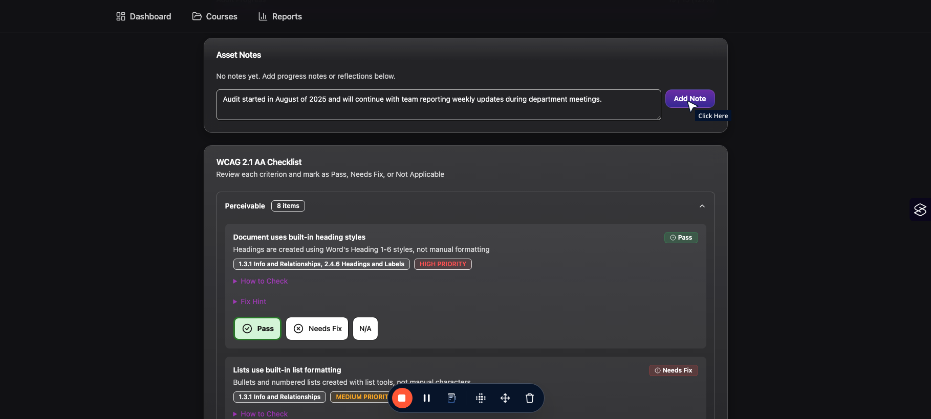

On your course page, you can now see the progress being made for EACH asset while also filtering from status types if you have several asset for a course (sometimes there are hundreds of files depending on how big your course is).
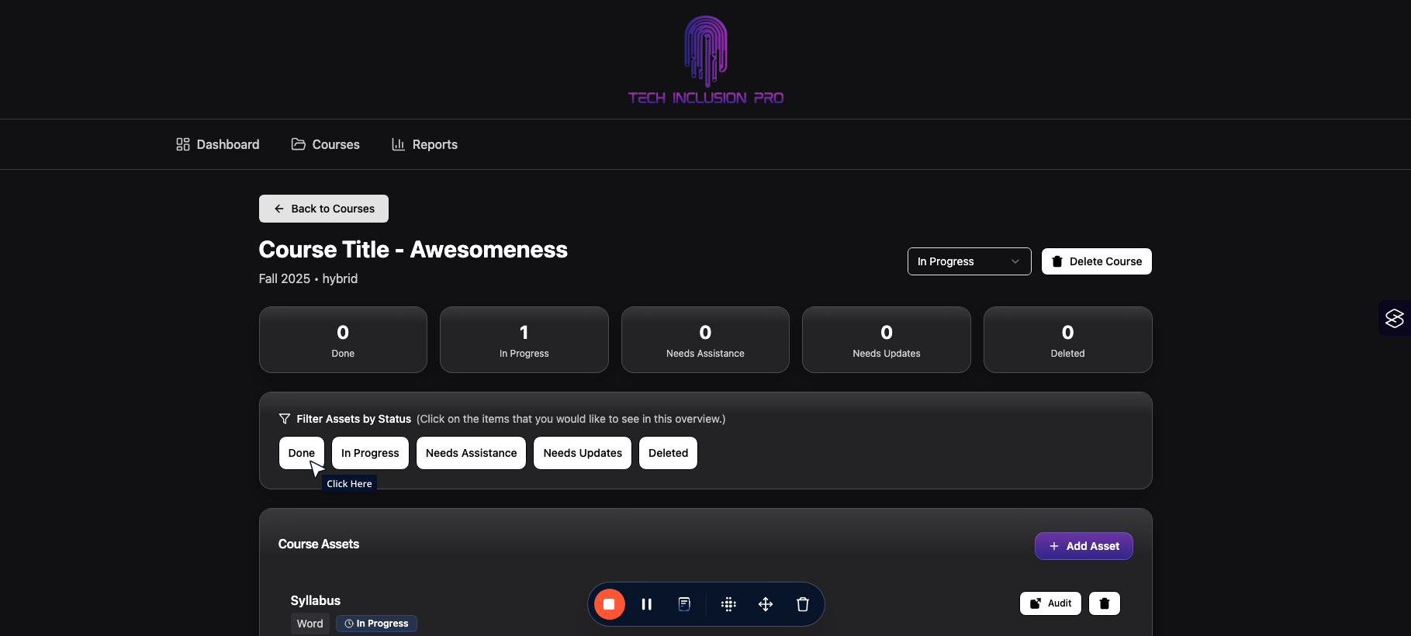

View and Create Reports

To view the overall report of progress, you can click on "Reports" in the top of the application.
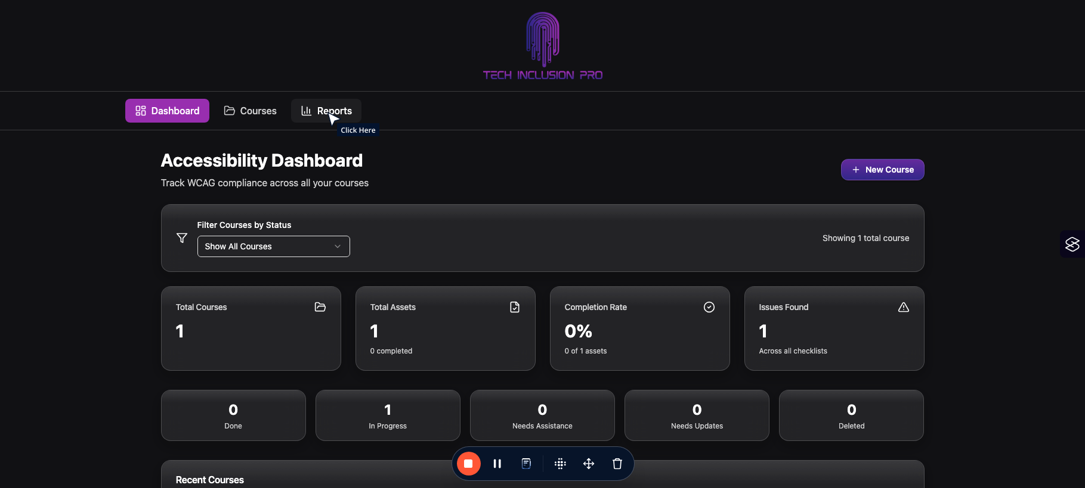

This step will show your progress across all your courses and assets. You can also chose to show only courses in progress as well depending on what you would like to do.

You can also download an overview of your report to share with your teams by click on the "Download CSV" or "Download JSON" files (as needed).
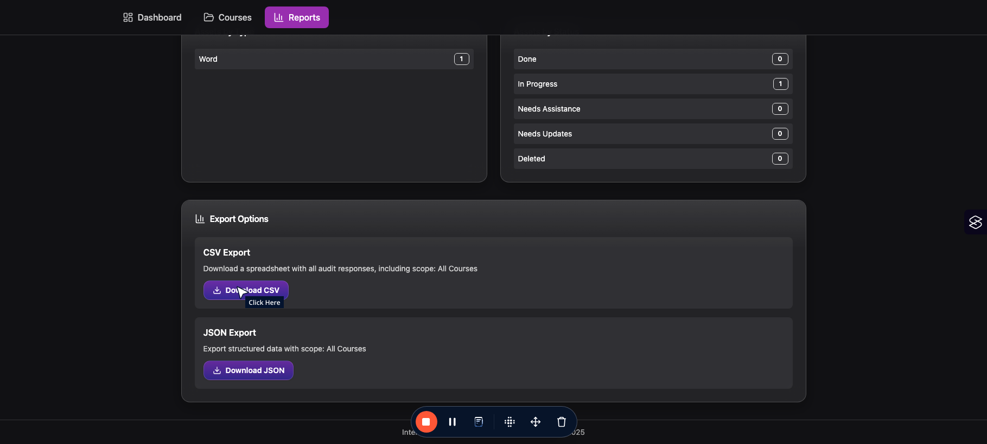

And that is that! Please check this out and email techinclusionpro@gmail.com us if you have any questions or fill our feedback survey by clicking this link here https://docs.google.com/forms/d/e/1FAIpQLScSH0KSWDXYGVykeWtipGRbnJ233FIi44JbV88SLAm1YO-Xxg/viewform?usp=dialog

