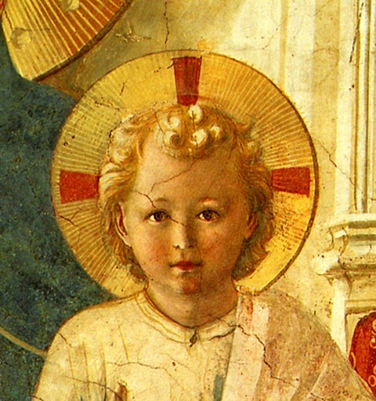

TERTIUS ORDO PENITENTIAE LETTER Nº 9
December 22, 2016
Feast of the Patronage of Our Lady over the Order of Preachers
Dear tertiaries and aspirants,
On this eight hundreth anniversary of the approbation of the Order by Honorius III on December 22, 1216 we send you the complete text of a famous sermon of Pope Saint Leo the Great on the feast of the Nativity. This is the sermon that contains, in its conclusion, the phrase you often hear alluded to : “Agnosce, O Christiane, dignitatem tuam: Acknowledge, O Christian, the dignity that is yours!” The whole sermon, however, is well worth reading and it is short enough to make that easy, as you will see. You will also see that the dignity he speaks of is not at all the “Dignitatis humanae” of which the Second Vatican Council makes so much, a dignity that comes from the mere fact of being human. On the contrary, this Christian dignity comes to men from the fact that they have been “rescued from the powers of darkness” and their “former vileness” and made “partakers of the divine nature” by having been made “partakers of the birth of Christ”. As is the case so often in the sermons of this truly great pope and doctor, every word is worth meditating and savouring.
You will find added as well, in a separate document, the translation of a commentary of the first two articles of the Rule of the Third Order by Father Lussiaa, O.P. A tertiary at St. Mary’s has begun this translation for use in the meetings of the tertiaries there, so I pass it on to all of you for your education and edification in your Dominican life. These first articles are very important since they give the definition and object of the Third Order. I have added a couple of explanations of some points that might not be clear : feel free to send me any further questions you might have.
On the occasion of this centenary, may Saint Dominic and all his children obtain for us a share in the grace that filled them for their own sanctification and for that of the whole Church. It is the grace we can ask the Divine Child to give us this Christmas, through the intercession of the Mother of Preachers.
In Sancto Patre Dominico
Father Albert
News
Thank you for your prayers for the trip to the U.S. in October. The Rosary mission went well and at St. Mary’s we were able to have a meeting of tertiaries and accept a new novice; Mr. Eric Kullavanijaya who took as a patron the Roman martyr, St. Sebastian, in honor of a Dominican of the same name who was martyred while preaching the Gospel in Thailand, the homeland of Eric’s father. The tertiaries of St. Mary’s plan now to start having regular meetings, the first one being hopefully sometime before Christmas.
At Chicago during the Fatima conference there, another postulant entered the novitiate : Mr. Kevin Westholder, who received the name of Michael. The talks given at this conference are available on the Fatima Center site.
Last time I recommended to your prayers the purchase of a property in France. As you should already know by the newsletter and flyer we sent out, our offer has been accepted and we are now in the midst of finalizing the purchase and above all seeking for donations to enable us to pay for it and do the necessary work that will need to be done. Please don’t hesitate to send us addresses or ask for extra copies of flyers : a postulant in Nevada has agreed to take care of mailing of the English version which we had printed there. If all goes well, we should be able to move in sometime after Easter.

Pope Saint Leo the Great

Sermon I On the Nativity of Our Lord Jesus Christ

I. Our Saviour, dearly Beloved, is born this day, let us rejoice. It is not fitting that sadness be where there is the birth of Life, Life which abolishes the fear of death and fills us with gladness of promised immortality. No one is excluded from sharing in this gaiety, there is one common reason of joy for all : Our Lord, the Destroyer of sin and death, just as He found no one free from guilt, so came to free all.
Let him who is sanctified exult, for he draws nigh to the palm of victory. Let the sinner rejoice, for he is invited to receive pardon. Let the Gentile be revived, for he is called to life. For the Son of God, in the fullness of time, decreed by the inscrutable depths of the divine counsel, has assumed the nature of the human race to reconcile it to its author, so that the devil, the inventor of death, might be vanquished by that very nature he had vanquished.
In this combat that He entered into for us, the contest was fought with a great and wonderful fairness : the omnipotent God took on this most cruel enemy, not in His majesty, but in our lowliness, presenting to him the same form and the same nature as ours, sharing in our mortality but free from all sin.
Far removed indeed from this nativity is what we read with regard to all men : “No one is free from sin, not even the infant whose life upon the earth is but a day” (Job 14 : 4). Nothing, therefore, of the concupiscence of the flesh passed into this unique nativity, nothing of the law of sin flowed into it. A royal virgin of the house of David is chosen as the bearer of the Sacred Fruit, who had conceived her divine and human Offspring in her soul, before she conceived Him in her body. And lest, ignoring the divine plan, she be fearful at such unheard of tidings, she learns from an angelic colloquy what was to be wrought in her by the Holy Ghost. Nor did she, who was about to become the Mother of God, believe that this betokened the loss of her virginity. Why should she doubt this new manner of nativity, she to whom the power of the Most High is promised ? The faith of she who believed is confirmed by the witness of a preceding miracle, and to Elizabeth is given surprising fruitfulness; that it might not be doubted, that He Who had given to the barren to conceive, would do likewise to a virgin.

II. The Word of God, therefore, God, the Son of God, Who in the beginning was with God, by Whom all things were made, and without Whom was made nothing that was made, became man, that He might free man from eternal death : so inclining Himself to take on our lowliness without lessening His majesty, that remaining what He was, and taking upon Himself what He was not, He might join the true form of a servant to that form in which He is equal to God the Father; and by such a bond so link both natures, that neither glorification consume the lower, nor assumption lessen the higher. What is proper to each substance being preserved, then, and coming together in One Person, lowliness is assumed by majesty; infirmity, by power; mortality, by immortality : and to pay the debt of our present state, an inviolable nature is united to our suffering one; and true God and true man are combined into the unity of One Lord, so that, as was needed for our healing, one and the same Mediator of God and men, might, by the one, suffer death, and by the other, rise again from the dead. Rightly then, did the birth of our salvation bring no taint of corruption to the Virginal integrity; for the birth of Truth, was the guardian of virginity.
Such a Birth, dearly Beloved, befitted Christ, the Power of God, and the Wisdom of God; whereby He would be both similar to us by His humanity and far above us by His divinity. For unless He were true God, He could bring us no remedy; and were He not true man, He could offer us no example. The exulting angels, therefore, sing at the birth of the Lord : “Glory to God in the Highest” and “peace on earth” is proclaimed “to men of good will”. For they see the heavenly Jerusalem being constructed from all the peoples of the earth. With what joy must not lowly mankind be glad in this unspeakable work of the divine compassion, when the sublimity of the angels rejoices so much ?

III. Let us, therefore, give thanks, dearly Beloved, to God the Father, through the Son, in the Holy Ghost; Who, because of the exceeding great love wherein He has loved us, has had compassion on us : and “even when we were dead in sins, hath quickened us together in Christ” [Eph. 2:5], that in Him we might be a new creature, and a new work. Let us put off therefore the old man with his deeds; for being made partakers of the birth of Christ, let us renounce the deeds of the flesh [Col. 3:9].
Acknowledge, O Christian, the dignity that is yours, and having been made a partaker of the divine nature, do not by a degenerate manner of living fall back into your former vileness. Remember of Whose Head, and of Whose Body, you are a member. Remind yourself that having been rescued from the powers of darkness, you have now been transferred into the light and the kingdom of God. By the sacrament of baptism you have become the temple of the Holy Ghost : do not, by evil deeds, drive out from you such a great Guest and submit yourself again to the slavery of the devil; for your price was the Blood of Christ; because in truth He shall judge you, He Who in mercy has redeemed you, Who with the Father and the Holy Ghost, livest and reignest, world without end. Amen.

- PL 54, 0190-0193.

