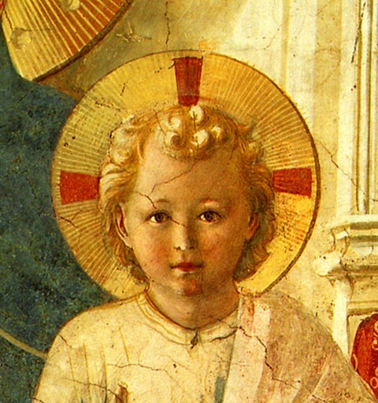

TERTIUS ORDO PENITENTIAE LETTER Nº 39
April 30, 2024
Saint Catherine of Siena

Dear Tertiaries and Aspirants,
It is reported that the English poet, Ezra Pound, on being asked for some comment by reporters on the day of the burial of his friend, T.S. Eliot, replied simply : "READ HIM !"
We say the same thing to you, dear tertiaries about the great saint we celebrate today, who is our special patron in the Third Order of Saint Dominic because she was a tertiary herself : "READ HER !"
It is not always an easy task, for she has written very much and many have written about her, and her style is often very elevated and prolix. To help you start, we send you here a translation of the first of her famous Orazioni, prayers pronounced while in ecstasy and written down by her disciples. This first prayer was made at the request of the Pope Gregory XI himself after she visited him in Avignon and told him that God wanted him to return to Rome, which he did shortly after (few people, even popes, even managed to refuse the famous Voglio : I want it so ! of Saint Catherine).
As you will see at the end of the prayer, it is a fitting continuation of the letter we sent you in February on the feast of the Chair of Saint Peter :
Open the eye of your vicar on earth so that he may not love you for his own sake,
nor himself for his own sake, but may love you for yourself and himself for your sake.
For when he loves either you or himself for his own sake we are all lost,
because he who should be our life is our death
to the extent that he is not careful to shelter us little sheep who are going astray.
But if he loves himself for your sake and you for yourself, we live,
because we receive our example for living from the good shepherd.
In Sancto Patre Dominico
Father Albert

NEWS

April 14th at Our Lady of Guadalupe monastery at Silver City, New Mexico Mr. Rigoberto Santiago entered the noviciate and received the name of Brother James (or Santiago in Spanish) after the great apostle, brother of Saint John the Apostle and Evangelist.

ORAZIONE PRIMA
LA MISSIONE DEL VERBO

Catherine of Siena made this prayer in Avignon when Pope Gregory XI first commanded her for the first time to implore the Lord for him in particular. It was recorded and written down by a certain Reverend Father Thomas Petra who was her abbreviator. And later he was secretary to Pope Urban VI.
Prayer of Catherine of Siena which she made on the vigil of the Assumption in the year of Our Lord 1376, being motionless, her eyes half-open, while lying completely immobile and in ecstasy, so contracted that her members could have been more easily broken than moved and whose whole body moved at the motion of any member.

Godhead ! Godhead ! Ineffable Godhead !
O supreme goodness that for love alone made us in your image and likeness !
For when you created humankind you did not say (as when you created the other creatures)
“Let it be made”.
No, you said – O unutterable love ! – “Let us make humankind in our image and likeness”
so that in this the whole Trinity might give assent together and in the powers of our soul
you fashioned us after the very Trinity, Godhead eternal.
To fashion us after yourself, eternal Father –
you who as Father hold and keep all things within yourself –
you gave us memory
to hold and keep what our understanding perceives and knows of you, infinite goodness.
And in knowing our understanding shares in the wisdom of your only-begotten Son.
You gave us our will, gentle mercy, Holy Ghost, which like a hand reaches up filled with our love to take whatever our understanding knows of your unutterable goodness
and then this will, this strong hand of love, fills our memory and affection with you.
Thanks, thanks be to you, high eternal Godhead, that you have shown us such great love
by fashioning us with these gracious powers in our soul :
understanding to know you,
memory to keep you in mind, to hold you within ourselves,
will and love to love you more than anything else.
It is only reasonable that I should love you, infinite goodness, once I know you.
And so powerful is this love
that neither demon nor anyone else can take it away from us unless we so will.
How ashamed they should be, then, who do not love you
though they see how much you have loved them !

O eternal Godhead, ineffable love, in you I see the love that compelled you to open the eye of your compassion upon us poor wretches.
For after we had, through our wretchedness and weakness, fallen into the filth of sin
when our first father disobeyed you,
you, high eternal Father, sent us the Word incarnate,
your only-begotten Son, veiled in our poor flesh and clothed in our mortality.
And you, Jesus Christ, our reconciler, our refashioner, our redeemer –
You, Word and love, were made our mediator.
You turned our great war with God into a great peace.
You took out on your own body the punishment for Adam’s disobedience and our sins
by being obedient even to the shameful death of the cross.
On the cross, Jesus gentle love, when you took on your very self the punishment for the offense committed against your Father, you dealt a blow that at the same time amends for the offense against your Father and atoned for our sins.

I have sinned against the Lord. Have mercy on me.
In whatever direction I turn I find unutterable love.
So we can never be excused for not loving you for it is you alone, God and man,
who loved me without my having loved you.
For I did not exist and you made me.
Whatever I want to love, whatever has being, I find in you –
but not sin, which is non-being and does not exist in you and so is not worthy of love.
If it is God I want to love, I have your ineffable Godhead, and if it is humanity I want to love,
you are a man in whom I can come to know you, priceless purity.
If it is a lord I want to love, you are Lord
and you paid the price of our blood when you rescued us from the slavery of sin.
You, eternal Godhead, in your boundless kindness and charity
are lord and father and brother to us.
This Word, your Son, knowing and accomplishing your will, was willing
to shed his precious blood for our wretchedness on the saving wood of the most holy cross.
You, Godhead, highest wisdom –
I am a foolish and wretched creature while you are supreme eternal goodness.
I am death and you are life.
I am darkness and you are light.
I am ignorance and you are wisdom.
You are infinite and I am finite.
I am sick and you are the doctor.
I am a weak sinner who has never loved you.
You are purest beauty and I am the filthiest of creatures.
You have drawn me to yourself in unutterable love and you draw all of us to yourself
not because you must but freely – if only we choose to let ourselves be drawn to you,
that is, if our will does not rebel against yours.

Woe is me ! I have sinned against the Lord. Have mercy on us !

Eternal goodness,
do not look at the wretched deeds we have committed of our very own selves,
cutting ourselves off from your boundless goodness
and cutting our souls off from their proper goal.
No, I beg you, in your infinite mercy
open the eye of your supreme clemency and compassion and look at your one bride.
Open the eye of your vicar on earth so that he may not love you for his own sake,
nor himself for his own sake, but may love you for yourself and himself for your sake.
For when he loves either you or himself for his own sake we are all lost,
because he who should be our life is our death
to the extent that he is not careful to shelter us little sheep who are going astray.
But if he loves himself for your sake and you for yourself, we live,
because we receive our example for living from the good shepherd.

O supreme and ineffable Godhead, I have sinned and am not worthy to pray to you,
but you can make me worthy.
Punish my sins, my Lord, and do not look at my wretched deeds.
I have one body and to you I offer and return it.
Here is my flesh, here is my blood ; let me be slain, reduced to nothing ; let my bones be split apart for those for whom I am praying, if such is your will.
Let my bones and marrow be ground up for your vicar on earth, your bride’s only spouse.
For him I beg you to deign to listen to me.
Let this vicar of yours be attentive to your will,
let him love it and do it so that we may not be lost.

Make him a new heart, that he may constantly grow in grace and be strong
in raising the standard of the most holy cross to make the unbelievers share as we do
in the fruit of the passion and blood of your only -begotten Son, the spotless Lamb,
high, eternal, ineffable Godhead.
I have sinned against the Lord. Have mercy on me !

- First prayer : The Mission of the Word. The Prayers of Catherine of Siena, edited by Susan Noffke, Paulist Press, 1983.

