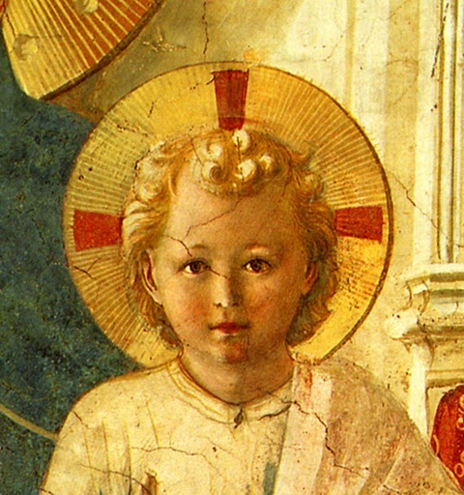

TERTIUS ORDO PENITENTIAE LETTER Nº 33
December 24, 2022
The Vigil of the Nativity of Our Lord Jesus Christ

Dear Tertiaries and Aspirants,
For the Nativity of Our Lord we send you the beginning of the First Sermon of Saint Bernard for this great feast. As always in these sermons for his monks, he draws the moral lessons from the liturgical feast and presents them to us. In this case it is first of all humility, because of the example of it given by the Son of God becoming incarnate. Then, secondly, he speaks of confidence in the mercy of God shown in such a spectacular manner in this mystery, as if to convince us that we no longer need to run and hide from God, like Adam after his fall, but rather must we embrace the helping hand He so graciously extends to us in the humanity His Son assumes for us. Far from coming to judge us, He has come to do battle against our enemies, Sin and Death, and defeat them forever.
May Our Lord grant you all many graces on the occasion of this wonderful feast in which He comes to save mankind.
In Sancto Patre Dominico
Father Albert

NEWS
Mr. Joseph Sandow and his wife Normajean were received into the novitiate on December 4th at Our Lady of Sorrows parish and received the names of Joseph and Marie. Better patrons for their religious life could hardly be chosen, especially during this season when they are the centre of attention for the whole Christian world.

Mr. Matthew Corrigan entered the noviciate on December 19th at St. Patrick's Oratory in Waterbury, Connecticut and received the name of Michael. May this great warrior of God help him to be a good pugilis fidei, the name given to the Dominicans by Honorius III and which means, literally "fighter for the faith".

Sister Jane of Aza from the tertiary chapter in Dallas gave birth to a daughter, Mary Rose Williams on December 6th. May Our Lady, along with Saint Rose, great model and patron of Dominican tertiaries, guide this soul through life to arrive one day to be with them in heaven.

On the Saviour as a Fount of Grace

1. The Festival of the Lord’s Nativity, brethren, is indeed a great solemnity : but a short day obliges us to abbreviate the sermon. Nor is it surprising if we shorten our word when God the Father also shortened His Word. Would you know how great He is, yet how little He made Himself to be? This Word says : I fill Heaven and earth (Jer. 23:24). Now made flesh He is laid in a narrow manger. From everlasting to everlasting, says the Prophet, Thou art God (Ps. xc. 99:22), and lo ! He has become an Infant of a day old. Now for what purpose was it, brethren, that He thus emptied Himself or what necessity was there that the Lord of Glory should so empty, so humble, so shorten Himself? Was it not so that you might do likewise ? He begins already to cry to you by His example what He would afterwards preach to you in His word, Learn of Me , for I am meek and lowly in heart (Mt 9:29). So that he who says that Jesus began both to do and to teach 1 (Acts 1:1) states only what is exactly true. And so I earnestly beg and intreat you, brethren, not to suffer an example so precious to be placed before your eyes in vain, but that you conform yourselves to it and be renewed in the spirit of your mind. Strive after humility, which is the foundation and the guardian of all the virtues ; follow it , which alone is able to save your souls. For what is more unworthy, more detestable and deserving of greater punishment, than that after seeing the God of Heaven humbling Himself to become a little child, man should still attempt to magnify himself and lift himself up above the earth? It is a proof of intolerable effrontery, for a miserable worm to be puffed up and swollen with pride when the majesty of God emptied Itself.

2. This then is the reason why He emptied Himself and took the form of a slave, He who was equal with the Father in the form of God ; but if He emptied Himself, it was of His power and His glory, not of His goodness and mercy. For what says the Apostle ? The goodness and mercy of God our Saviour towards man has appeared (Titus 3:4). His power had previously appeared in the creation of the world, His wisdom appeared in its government : but the goodness of His mercy now appeared most clearly of all, in His Humanity. His power had been made known to the Jews in signs and wonders ; wherefore you will find frequently occurring in the Law the words : I am the Lord, I am the Lord. His glory had made Itself evident to philosophic minds also by abundant proofs ; according to the words of the Apostle, that what is known of God , has been manifested to them (Rom 1:19). But on the one hand the Jews were weighed down by the thought of His power, and the philosophers were oppressed in their meditations upon God, by the thought of His glory. Power demands submission: and glory admiration; but neither commands imitation. Let Thy goodness, O Lord, appear, so that man, who was created in Thy image, may be conformed unto it : for we are not able to imitate, and ought not to emulate, Thy majesty, Thy power and Thy wisdom. How long is Thy mercy straitened in the case of the Angels ; and does Thy justice engross the remainder of it equally with the whole human race ? Thy mercy, O Lord, is in the heavens and Thy truth reacheth into the clouds (Ps 36:5) condemning both the whole earth, and the powers of the air. Let Thy mercy enlarge its boundaries, extend its limits, expand its folds, and stretch with power from one end of the world to the other, ordering all things with gentleness. Unbind, O Lord, Thy bosom, closed to us by justice, and come to our help abounding with pity and overflowing with charity.

3. Why do you fear, O man, why do you tremble at the thought of the presence of the Lord who comes ? He comes, not to judge the world, but to save it. Once you were persuaded by some unfaithful servant to furtively take the king's crown and put it on your head. Having been caught in your theft, why wouldn't you fear ? Why wouldn't you fly from before His face ? For perhaps He was already swinging the flaming sword. Now, dwelling in exile, you eat your bread in the sweat of your brow ; and lo, a voice is heard in the earth, that its Ruler approaches. Whither will you go from His Spirit? and whither will you fly from His Presence ? But do not fear nor fly. He does not come with the armed hand; nor does He call for you to punish, but to save. And lest you say again now : I heard Thy voice, and I hid myself (Gen 3:10), behold, He comes as a little child and has no voice. For the voice of a wailing child is more to be pitied, than feared : or if it is terrible to any, it is not so to you. He has become a little Child : His Virgin Mother binds His tender limbs with swathes : and do you still tremble with fear ? Learn at least from this that He comes not to destroy you, but to save : not to enslave you, but to deliver you. Already He contends against your enemies ; already He who is nothing less than the Power and Wisdom of God, sets His foot upon the necks of those proud and lofty ones.

4. You have two enemies, Sin and Death : that is, the death of the body and that of the soul. He has come to make war on both, and to save you from both ; fear not. Already in His own person He has conquered sin, in assuming human nature without any stain of it. Great is the blow given to sin, and striking the defeat it has experienced, when human nature, which it boasted itself to have entirely occupied and overcome, is found in Christ entirely free from sin. From that moment He follows after these your enemies, and overtakes them ; nor will He turn back until he has destroyed them. Warring against sin in His life, so He opposes it equally by word and example, but in His Passion He binds it, He binds completely the strong man and ravages his possessions. Then, continuing His victory, He triumphs over death also; first in His own Person when He rises again, the first-fruits of them who sleep, the first-born from the dead ; and afterwards He shall subdue it equally in all of us, when He shall raise up our mortal bodies, and death itself, the last enemy, shall be destroyed. For that is why He is clad with glory in His Resurrection, not wrapped in swathing bands as at His birth. Therefore He who at first gave forth freely of the affluence of His mercy, and judged no man : when He has risen again, draws tight, as it were, the girdle of His justice, and gathers in the flowing folds of His mercy ; since then He is prepared for the judgment, which shall take place at our resurrection. Also for this He came before as a little child, so that He might first ask for mercy and, running before the future judgment which will take place at the end, temper it by mercy. (...)

– Sermon I. On the Nativity of our Lord (PL 183, 0115- 0117)

