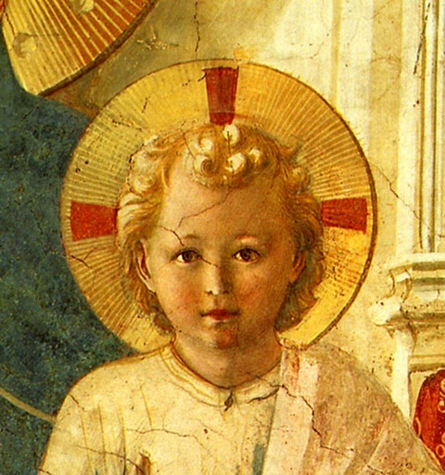
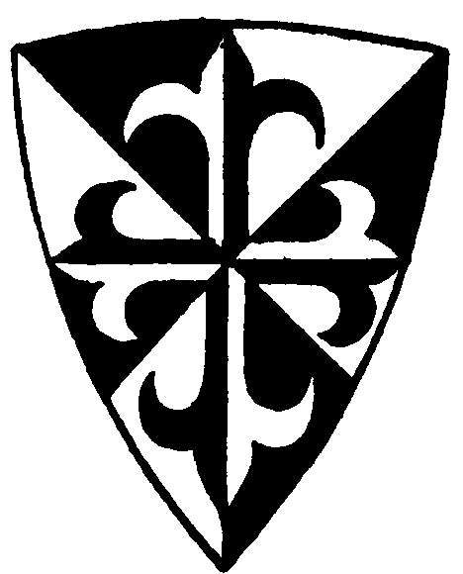

TERTIUS ORDO PENITENTIAE LETTER Nº 21
December 8, 2019
The Immaculate Conception of Our Lady
Dear Tertiaries and Aspirants,
For this great feast of the Immaculate Conception of Our Lady, we are sending you a text of Father Maximilian Kolbe, the Franciscan priest who died at Auschwitz in the place of a fellow prisoner in 1941. Already as a seminarian in Rome, his favourite name for Our Lady was “The Immaculata,” not only because of the traditional devotion of the Franciscan Order to this mystery, but because of Our Lady Herself, as he writes his brother from Rome :
She willed to call Herself at Lourdes : “Immaculate Conception” ; therefore we invoke her often by this name .
Twenty years later in a conference to his brothers he explains :
The name Immaculate Conception is very important and proves that the Immaculata is all beautiful, without any sin. This is Her very first privilege, and that which is first is most dear .
He spent his whole life meditating on this mystery and the very last text we have from him, dictated on the morning of his arrest, is a very profound meditation that sums up the fruit of the many years of his contemplation on it. We send a résumé of this text to you, then, to help you celebrate this wonderful mystery that is at the origin of the salvation of the human race.

In Sancto Patre Dominico
Father Albert

P.S. We are sending as well another four articles of the commentary of Fr. Lussiaa on the Rule.

The Testament of Father Maximilian Kolbe

The text can be divided into three parts :
1) the first part shows why Our Lady at Lourdes could say “I am the Immaculate Conception” ;
2) the second part shows how this same name can be applied to the Third Person of the Holy Trinity ;
3) the third part explains more deeply this intimate union between Our Lady and the Holy Ghost that makes them share the same name.

1) Our Lady is the Immaculate Conception
Our Lady at Lourdes said : “I am the Immaculate Conception.” How is this possible ?

These words, he says, came out of the mouth of the Immaculata herself. They must indicate, then, with the greatest precision and in the most essential manner, who she is.

And he goes on to explain how this name applies uniquely to Our Lady, and contains her essence in the strict scholastic sense of the term since it gives her genus and species :

Who are you, O Immaculate Conception ?
Not God, for he has no beginning, not an angel created without any intermediary from nothing ; not Adam formed out of the dust of the earth, not Eve taken out of Adam, neither the Word incarnate, who existed from eternity already and thus is conceived rather than a conception. The children of Eve did not exist before their conception, thus they can be called conceptions, but you are distinguished from them all, because they are conceptions stained with original sin, but you are the one, unique Immaculate Conception.

2) The Holy Ghost is also an Immaculate Conception
In the second part of this text he explains how the name Immaculate Conception can be applied as well, nonetheless, in a certain way, to the Third Person of the Most Holy Trinity, the Holy Ghost. He begins by posing a principle, namely, that everything that exists outside of God has imprinted in it a certain resemblance to its Creator, since everything in it comes from Him. But this Creator, this God that all creatures resemble, is, as our faith teaches us, the Most Holy Trinity. Thus he writes :

All the perfections found in creatures… are nothing but a multi-natured echo, a hymn of praise in multi-colored tones of the first and the most beautiful mystery, the mystery of the Most Holy Trinity.
But if this is true, if all creatures must necessarily resemble their Creator, the Most Holy Trinity, then this must be true as well of the created reality that we call “conception,” for, as Fr Maximilian writes :

Here, there are no exceptions at all.

So the conceptions of life that we see in the universe — and we must remember that life itself is the highest thing in creation, and that its conception is the most wonderful thing there is about life — these conceptions must be a reflection of the mystery of the Most Holy Trinity. But of what are they a reflection exactly ? Of the procession of the Third Person of the Most Holy Trinity, answers Fr. Kolbe, the procession of the Holy Ghost. He explains :

Who is the Holy Ghost ? (He is) the fruit of the love of the Father and the Son. The fruit of created love is a created conception. The fruit, then, of that love that is the prototype of this created love is also nothing else than a Conception. The Holy Ghost, therefore, is an uncreated, eternal conception, and the prototype of all conceptions of life in the universe…The Holy Ghost is a most holy conception, infinitely holy, Immaculate.

The Holy Ghost, then, can also be called Immaculate Conception, this name which, as we saw previously, distinguishes Our Lady from everything else in the universe — everything else but, as we see now, the Holy Ghost. In the final and third part of his meditation Fr. Kolbe explains the intimate union between Our Lady and the Holy Ghost that makes them share this name.

3) The union between the Holy Ghost and the Immaculata
Again he starts by stating a principle:

In the universe, he says, we find everywhere an action and a reaction equal to that action but contrary to it, a going out and a coming back, a distancing and a drawing close, a division and a unification. But the division is always for the unification, which is creative. This is nothing but an image of the Most Holy Trinity in the activity of creatures. Unification is love, creative love.

This physical law of action and reaction, then, is just another reflection of the mystery of the Most Holy Trinity. Although he doesn't spell it out, it seems evident that what Fr. Kolbe means to say here is that action reflects the procession of the Son from the Father and reaction the procession of the Holy Ghost that follows this action but in the opposite direction. By the procession of the Son, God, as it were, goes out from Himself and then by the procession of the Holy Ghost, He comes back to Himself by the love that unites the Father and the Son.
He then goes on to say that in a similar way, when God creates the universe there is a sort of action by which He goes out of Himself which is followed by a reaction by which the creatures He has made return to God by trying to perfect themselves and thus become similar to Him .

And it is not otherwise that proceeds the activity of God outside of Himself. God creates the world — this is like a separation. The creatures, then, by the natural law given them by God, perfect themselves, they become similar to God, they return to Him, and the rational creatures consciously love and by this love unite themselves more and more to Him, they return to Him.

At the head of this movement of return to God, however, is the most perfect of creatures, the Immaculate Conception, the creature who most resembles God and comes back to Him in the most perfect fashion and leads all the rest of creation back to Him.

But the creature, he says, completely full of this love, of the divinity — is the Immaculata, without even the slightest stain of sin, she who never deviated in anything from the will of God, united in an ineffable manner to the Holy Ghost as His Spouse, although in a sense incomparably more perfect than what that word expresses among creatures.

The Immaculate Conception is an image, then, of the Holy Ghost, she does in creation what He does in the bosom of the Trinity. The Holy Ghost, the love uniting the Father and the Son, is the reaction in the Most Holy Trinity that responds to the action that is the procession of the Son : Our Lady, the Immaculate Conception, is the reaction of creation, returning by love to its principle by perfecting itself, which corresponds to the action of God by which it was originally created.
Thus Fr. Kolbe writes :

In the union of the Holy Ghost with [the Immaculata], not only does love unite these two beings, but one of them is all the love of the Most Holy Trinity and the other is all the love of creation, and thus in their union heaven is united to the earth, all of heaven with all the earth, all Eternal Love with all created love. It is the summit of love.

This union, he explains, is eminently interior: it is the life of love of the Holy Ghost in the soul of the Blessed Virgin.

What is this union like? It is above all interior, it is the union of her being with the being of the Holy Ghost. The Holy Ghost dwells in her, lives in her and does this from the first moment of her existence, always and forever.
In what does this life of His in her consist ? He Himself in her is love, the love of the Father and the Son, the love by which God Himself loves Himself, the love of the Whole Blessed Trinity, a fertile love, a conception. …The Holy Ghost lives in the soul of the Immaculata, in her being, and fecundates it and this from the first moment of her existence throughout her whole existence, that is, eternally. The Eternal Immaculate Conception Immaculately conceives in the soul of her who is His Immaculate Conception divine life.

And thus he concludes, saying that all this explains why Our Lady, Spouse of the Holy Ghost, is called “Immaculate Conception.”

If in creatures the spouse receives the name of her spouse because she belongs to him, is united to him, becomes similar to him and, in union with him becomes a creative agent of life, how much more the name of the Holy Ghost, Immaculate Conception is the name of her in whom He lives by a love that is fertile in the entire supernatural order.

– SK 21, after 26/9/1918.
– K 92, 10/8/1937.
— Scritti Kolbiani, the critical edition in Italian of the writings of Fr. Kolbe SK 1318.
— "Exivi a Patre" as Our Lord says : “I came out, I exited from the Father” (Jn 16:28). St. Thomas, in his commentary on this text, refers it to the eternal procession of the Son from the Father.
— In some notes, written a few years earlier, he says : “God said: ‘Fiat’ and creation existed. A creature, Mary, said : ‘Fiat mihi’ and God became present in her. Also the creatures repeat: ‘Fiat.’ They accord their will with the will of the Immaculata. Action and reaction of love.” (SK 1283 before the end of 1937)

