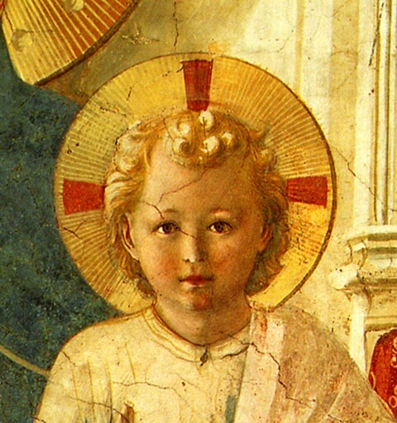


TERTIUS ORDO PENITENTIAE LETTER Nº 19
June 8, 2019
Vigil of Pentecost
Dear Tertiaries and Aspirants,
For this eminently Dominican feast of Pentecost, we send the opening section of the homily of Pope Saint Gregory the Great delivered on this solemnity in Rome and included in his famous Homilies. These homilies, of which there are forty altogether, are classics which the Church often includes in the breviary readings for the various feasts. This one on the Feast of Pentecost is particularly well known and you will perhaps recognize certain phrases in it that you have heard quoted elsewhere, as for example : Ipse Spiritus Sanctus amor est (the Holy Ghost Himself is love) or again Probatio dilectionis est exhibitio operis (the proof of love is the exhibition of works).
The holy pope begins by saying that his commentary on the Gospel will be brief in order to allow more time after to contemplate the mystery celebrated by the feast. We are sending you here just this commentary, but the rest of the sermon is well worth reading too. You can find it in the collection of his forty homilies on the Gospels (Homily XXX).
We include as well another installment of Fr. Lussuia’s commentary on the Rule in which he discusses the articles which speak of reception into the novitiate and the blessing of the scapular. Note in particular the importance given to this taking of the habit of the Order that carries with it a participation in all the spiritual goods of the Order. Even if a novice dies before profession he receives this participation, just as those who are professed. Indeed, the adage is not in vain that says : “Blessed is he who dies a Dominican !”

In Sancto Patre Dominico
Father Albert

NEWS

On May 25th, Mrs. Kristena Zaraza received the scapular and entered the novitiate of the Third Order at Winona, Minnesota. She will be called in the Order Sister Mary Catherine.
The ceremony took place very fittingly at the Holy Angels Novitiate of the Brothers of the Society of Saint Pius X during a weekend celebration honouring the 70th anniversary of the Dominican noviciate of the Province of Saint Albert which opened there in 1949. May all the holy Dominicans for whom Winona was home intercede for our new novice that she may persevere in the Order usque ad mortem !

POPE SAINT GREGORY THE GREAT
HOMILY XXX
FOR THE FEAST OF PENTECOST
I. I would like, dear brethren, to briefly go through the text of the reading of the Gospel, so that afterwards we might spend more time in lingering in the contemplation of such a great feast. For today the Holy Ghost, with a sudden sound, came upon the disciples and transformed the souls of carnal men with a love of Himself, and inflamed their hearts interiorly by the tongues of fire which appeared exteriorly, because when they received God in a vision of fire they sweetly burned with love. For the Holy Ghost Himself is love. Thus also John says : God is love (I Jn IV, 8, 16). Therefore he who desires God with his whole soul, really already possesses Him whom he loves. For no one can love God if He does not have Him whom he loves. No doubt if any one of you was asked if he loved God he would say, with complete confidence and a sure conscience : “I do.” But you heard what the Truth said at the beginning of the reading : If anyone love me, he will keep my word. The proof of love, therefore, is the exhibition of works. Thus in his epistle the same John says : He who says he loves God and does not keep His commandments is a liar (Ibid., 20). Indeed, we truly love God if we restrain ourselves from our desires in order to keep His commandments. For he who is corrupted by unlawful desires obviously does not love God, because He contradicts Him by his will.
2. And My Father will love Him, and We will come and make our abode with him. Weigh well, dear brethren, how great is this feast, to have God come as a guest in our heart ! Certainly if some rich and powerful friend were to come to your house, you would in all haste clean it entirely, lest something be found displeasing to his eyes when he enters. He, therefore, who prepares for God the dwelling of his soul, takes care to remove the stains of his sins. But listen to what the Truth says : We will come and make Our abode with him. For He comes into the hearts of some and does not make His abode there, because although they were touched by the thought of God by compunction, in the time of temptation they forgot their compunction and returned to the sins they had committed as if they had never been sorry for them at all. Therefore, he who truly loves God, keeps His commandments, and the Lord comes into his heart and makes His abode there, because the love of God so penetrates him, that he does not recede from this love in the time of temptation. Therefore he truly loves, whose soul is not overcome by the consent to depraved pleasure. For the more someone delights in inferior things, the more is he distanced from the love of higher things. Thus He adds : If someone does not love Me, he does not keep My words. Enter into yourselves, therefore, dear brethren ; examine yourselves to see if you truly love God ; but may no one believe what his soul responds if it does not have the attestation of works. For the love of our Creator, our tongue, our mind and our life are all required. The love of God is never idle. If it is present, it works great things ; if it refuses to work, it isn’t love. And the word that you have heard is not Mine, but of the Father who sent Me. You know, dear brethren, that He who speaks is the only begotten Son, the Word of the Father, and thus the word that the Son speaks is not of the Son, but of the Father, for the Son is Himself the Word of the Father. These things I have said to you while I remained with you. When will He not remain with us, He who, about to ascend to heaven, promised : Behold, I am with you all days until the end of the world ? But the incarnate Word both remains and departs : He departs in His body, He remains in His divinity. He says He will remain with them , therefore, because He who was departing in His visible body, was always present by His invisible power.
3. But the Paraclete, the Holy Ghost whom the Father will send in My name, He will teach you all things, and bring all things to your mind, whatsoever I shall have said to you. Many of you know, brethren, that the Greek expression Paraclete in Latin is Advocate or Consoler. He is called the Advocate because He intervenes before the justice of the Father for the faults of those who sin. He who is one substance with the Father and the Son is said to pray for those who have sinned because He fills those whom He inspires to pray. Thus Paul says : The Spirit Himself asketh for us with unspeakable groanings (Rom. VIII, 26). However, he who asks is less than he who is asked ; how then is the Spirit, who is not less, said to ask ? The Spirit Himself asks, because He inflames those whom He fills so that they ask. The same Spirit is also called the Consoler because when He gives the hope of pardon to those who are sad because of the sins they have committed, He cheers their afflicted souls. About Him it is rightly promised : He will teach you all things. For if this same Spirit be not in the heart of him who hears, the word of the teacher will be useless. Therefore, let no one attribute to the man who teaches that which he understands from the mouth of this teacher, because unless there be within him someone who teaches, the tongue of the teacher works exteriorly in vain. Look : you all hear in the same way the same voice of someone speaking and yet you do not all perceive in the same way the meaning of what the voice you heard said. Why, therefore, if the voice was not different, is what you understood in your minds not the same, unless there be an interior teacher who teaches some in a special way the meaning of what the voice that spoke announced to everyone ? With regard to this unction of the Spirit, by John again it is said : As His unction teacheth you of all things (I Jn II, 27). Therefore, one is not instructed by the voice when the mind is not anointed by the Spirit. But why do we say these things about the teaching of men, when even the Creator Himself does not speak in such a way to teach a man, if He doesn’t speak to Him by the unction of the Spirit ? Cain certainly heard, before he perpetrated his fratricide : You have sinned. Stop (Gen IV, 7 according to the Septuagint version). But because, due to his sins, he was warned by the voice, but not by the unction of the Spirit, he was able to hear the words of God, but He contemptuously refused to obey them.

– Patrologia Latina 76, 1220-1222.

