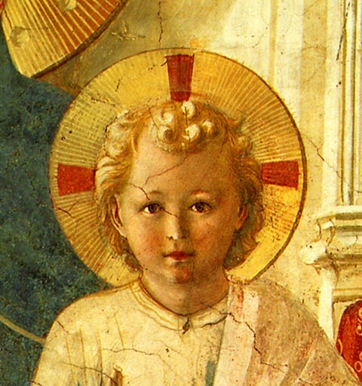


TERTIUS ORDO PENITENTIAE LETTER Nº 17
December 24, 2018
Vigil of Christmas

Dear Tertiaries and Aspirants,
For this Vigil of Christmas we are sending you a sermon of Pope Saint Gregory the Great who meditates on the Gospel of Saint Luke on the Nativity of Our Lord at Bethlehem which is read at Midnight Mass. As he says at the beginning, he cannot speak too long because there are three masses to be said, and he keeps his word, for his sermon is as little as the Divine Babe it honours. However, as you will see, its very conciseness seems to force him to pack into this little sermon a very concentrated amount of rich matter for meditation.
Among other things one can remark in particular Saint Gregory’s remarks on the dignity conferred to human nature by the Incarnation of the Son of God. Post Vatican II popes also speak of this, in particular John Paul II, but in a very different way. For them the Incarnation seems to have had as a motive the greatness of human nature itself, and at the same time to confer on it an inalienable dignity. Pope Saint Gregory, on the contrary, insists on the unworthiness of human nature before the Incarnation, on account of its sinfulness which excluded it from communion with God and His angels. It is only by the mercy of God, taking on human nature to Himself, that confers it its dignity, a dignity which, far from being considered as inalienable, is said to impose on us the strict obligation to refrain from all actions that might defile it.
May this text serve as an introduction for you into the contemplation of this great mystery of the coming of the Son of God to save mankind and a provocation to give Him the thanksgiving and love which He so richly deserves, but He so rarely receives from these same ungrateful men.

In Sancto Patre Dominico
Father Albert

NEWS

December 7th, on the Vigil of the Immaculate Conception of Our Lady, a meeting of tertiaries was held at St. Mary’s, Kansas during which Br. Sebastian (Eric Kullavanijaya) made final profession and three postulants entered the noviciate : Daniel Gillman, who received the name of Br. Ambrose (after Blessed Ambrose of Sansedoni, a renowned Dominican preacher of the thirteenth century), Jane Carver, who received the name of Sr. Generosa, and Regina Klinges, who received the name of Sr. Mary Thomas. Our little group at St. Mary’s is now not so little : may they continue to grow especially in virtue and sanctity and not just in number !

December 19th, here at the monastery of Our Lady of Guadalupe in New Mexico, Alan Aversa from Phoenix, Arizona, entered the novitiate and received the name of Catherine Thomas in honour of the second and third persons of the “Dominican Trinity”. May these two great saints help him along the way to heavenly glory.

Habita ad populum in basilica beatae Mariae Virginis, in die Natalis Domini.

POPE SAINT GREGORY THE GREAT
HOMILY VIII : PREACHED IN THE BASILICA OF THE BLESSED VIRGIN MARY
ON THE DAY OF THE NATIVITY OF THE LORD
Since, by God’s goodness, we will celebrate Holy Mass three times today, we cannot speak at length about the Gospel reading. However the very Nativity of Our Redeemer compels us to say, at least briefly, something. Why is it that as the Lord is about to be born that there is a census of the whole world, if it is not because He was coming in the flesh Who was to enroll His elect into eternity ? On the contrary the Prophet says of the reprobates : Let them be erased from the book of the living, et let them not be written together with the just (Ps 68 :29). Who also is fittingly born in Bethlehem : Bethlehem, in fact, is interpreted “House of bread”. For He is the one who says : I am the living bread that has come down from heaven. Therefore the place where the Lord is born, was previously called the house of bread, because in all truth He was to appear there by the matter of His flesh who would replenish the minds of the elect by an interior fullness. He is not born in the house of His parents but on a trip, so that He clearly show that by the humanity that He had assumed He was being born, as it were, in a foreign country. Foreign, that is, not according to His power, but according to His nature. For of His power it is written : He came unto His own (Jn 1 :11). For He was born in His own nature before time and came in ours in time. To Him, therefore, Who, remaining eternal appears in time, there where He descends is a foreign land. And since by the prophet it is said : All flesh is straw (Is 40 :6), having become man, He has turned our straw into wheat, He Who said of Himself : Unless the grain of wheat fall into the ground and die, it remaineth alone (Jn 12 :24). Thus also having been born, He is laid in a manger, so that He might feed all the faithful, that is, the holy animals, with the wheat of His flesh, let they remain famished of the food of eternal understanding. What does it mean that the angel appears to watching shepherds and that the brightness of God surrounds them, if it is not that they merit before others to see sublime things who are solicitous in their charge of ruling the flocks of the faithful ? While they piously watch over their flock, divine grace shines out abundantly upon them.
2. The angel announces the King Who has been born, and the choirs of angels join their voices to his, rejoicing together and crying out : Glory to God in the highest and on earth peace to men of good will. Before our Redeemer was born in the flesh, we were in discord with the angels, from whose brightness and purity we remained far distant by the guilt of our first fault and by our daily crimes. For since we were estranged from God, the angels, citizens of God, considered us as estranged from their company. But since we have recognized our King, the angels have acknowledged us as their co-citizens. For since the King of heaven assumed the earth of our flesh, no longer does that angelic celestial nature look down on our infirmity. The angels make peace with us again, they leave behind the former discord ; and those whom they had looked down upon as weak and abject, they now venerate as companions. For thus it is that Lot (Gn 19 : 1) and Joshua (Jos 5 : 15) adore angels and are not prohibited from adoring them, but John in the Apocalypse wanted to adore an angel who stopped him from doing so saying : Don’t do that, for I am your co-servant and one of your brothers ( Ap 22 : 9). Why is that angels are adored by men before the coming of the Redeemer and they remain silent, while after it they refuse to be adored, unless it is because our nature, which they looked down upon before, after, seeing assumed above them, tremble to see it put under them ? No longer do they dare to despise under them as weak that which they venerate above themselves in the King of heaven. Neither do they disdain to have man as their companion, those who adore above them the man God.
Let us careful, therefore, dear brethren, lest some impurity pollute us, we who in the eternal foreknowledge are citizens of God and equals of His angels. Let us vindicate by our morals our dignity, may no licentiousness defile us, may no shameful thought accuse us, may no maliciousness wound our mind, may no rust of envy eat away at it, may no elation inflate it, may not ambition rend it by earthly desires, may no anger inflame it. For men have been called gods. Defend against vice, therefore, O man, the honour of God, because for your sake God has been made man, He who lives and reigns forever and ever. Amen.

– PL 76, 103-1105

