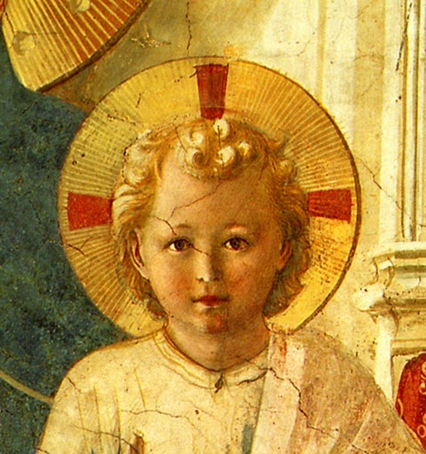
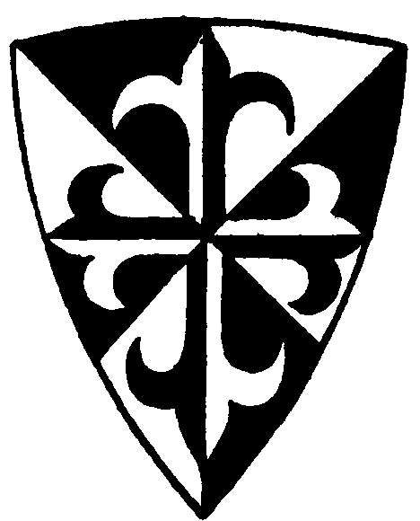

Feast of the Immaculate Conception of the Blessed Virgin Mary
December 8, 2014
Dear tertiaires and aspirants,
This letter is sent to you in answer to the response you have given to the letter I sent out some weeks ago with regard to our new Third Order. As I explained, our new foundation here in Belgium has accepted to begin this Third Order, in spite of the fact that we are obviously very occupied with our new foundation, in order to respond to the request of a number of you who had become tertiaries with the Dominicans of Avrillé but no longer want to be affiliated to them because of their new position in opposition to the Society of St. Pius X. For the present, I will simply continue to do as I did for several years when I was Director of the English speaking tertiaries of Avrillé, that is, I will send out a quarterly letter with some text to help you in your spiritual life as Dominicans. I don’t consider it necessary to go into the questions that have caused this split, since if you have written to me to ask to join our new Third Order it is because you have already decided which side to choose. However if any of you wish to discuss this subject, feel free to write me about it. It is simply an aspect of the ever-deepening crisis in the world and in the Church which requires of us a similar deepening in our union with God, through Our Lady and Saint Dominic, lest we be blown off-course in this tempest that rages more and more. Let us keep our eyes humbly fixed on the Star of the Sea and she will certainly bring us safely to port.
The text I am sending this time comes from the Benedictine Abbot, Dom Vonier, an excellent author whose books I strongly recommend. In the passage we have selected, he explains that Our Lady’s maternity is at one and the same time truly divine, because she is truly the Mother of God Himself, and truly human, because it is a natural maternity, not miraculous. For the conception of Jesus was miraculous in so far as paternity was concerned, but it was perfectly natural with regard to maternity, for Our Lady contributed to it everything that all mothers do. He also shows how the Church evokes in her liturgy the saving power of this wonderful human Nativity of the Son of God so that we might receive its effects in our souls.
May this passage of his book on the Divine Maternity of Our Lady help you to receive more abundantly these graces contained in the Christmas liturgy.
In Sancto Patre Dominico
Father Albert

THE TWOFOLD BIRTH OF THE SON OF GOD

All created perfection is a ray from God’s own light; it is a resemblance of God. No higher metaphysical explanation can be given of the meaning of the universe than to say it is a resemblance of God, that its ultimate destiny is to represent Deity in a finite way. The generation of the Word, the birth of the Son from the Father would seem to belong too exclusive1y to God's Inner life to be communicable to the created universe, to have any resemblance in the realm of nature and grace. Mary is God's resemblance in this adorable thing, the birth of the Son, the second Person of the Trinity.
When we meditate on the Incarnation there is a mental danger against which we have to be on our guard: too easily we might suppose that there is no life-sequel in the Incarnation, that it is all a series of miracles, and that therefore no biological conclusions could be deduced from it with any certainty. So we might exaggerate the miraculous side of Christ's birth from Mary, and thus unconsciously deprive Mary of the true glories of motherhood, making the blessed maternity into a mere instrument of God's omnipotence. But if Catholic theology insists on anything, it insists on this point, that Mary is not the miraculous Mother to the Son of God, but a natural Mother. "From the Mother's side Christ’s birth was a natural birth, but from the side of the Holy Ghost's working it was a miraculous birth: therefore the Blessed Virgin is a true and natural Mother to Christ” (Summa III, q.35, a. 3). I thought it worth quoting the text of St. Thomas in the enunciation of this most important truth that Mary's motherhood is not a miraculous motherhood, but a natural one; it is miraculous only from the side of the active principle, the Holy Ghost; but Mary's own motherhood, though started miraculously, developed naturally. The initial miracle, great as it was, did in no wise curtail the life-functions which naturally belong to a mother.
It ought not to be difficult then to see how birth of one and the Same Person, the Son, brings Mary near unto God, makes her the most perfect resemblance of God's internal !ife. The Son, the second Person of the Trinity, came forth naturally, through birth, from the Father. The birth of God takes Mary out of the ordinary plane of sanctity and gives her a place no other creature can share. It is as true to say that God is born of the Virgin as to say that God is born of God.
We do say, of course, that Mary is Mother to the Son of God not through the divine portion of that Person, but through the human nature in that Person; divinity was not formed from Mary's most pure blood, but only humanity. This distinction, however, in no wise does away with the greater truth that Mary is truly a God-bearer, not a man-bearer. Theologians give an easy simile to enable us to understand this. In each human being the soul comes directly from God, whilst the body owes its origin to the factors of parental generation; but who will ever say that a mother is a mother, not to her boy, but merely to the body of the boy! To the whole person she is mother. So likewise in the Incarnation. Of Mary a Child was born Who is the Son of God, born of God in all eternity.
Moreover, the human nature which owes its nature to Mary's most pure blood is not a simple human nature: it a deified human nature, united hypostatically with the Eternal Word, just as the ordinary human body that is built up in a mother's womb is not an organism merely, but an organism penetrated through and through by the presence of an immortal spirit, the rational soul.
As we saw in a previous chapter, Mary was giving of her life to an Organism in Which there was the clear vision of God, in virtue of the very laws of life belonging intrinsically to that adorable Organism, because It lived and existed through divine existence, the existence of the Word. When shall we grasp the great truth that Christ's human portion was raised up to the plane of the Infinite through Hypostatic Union? If we were to confine our attention exclusively to the human nature of Christ in Mary's Childbirth we should still be in presence of a Mother who bore an Infinitely Holy Thing. But Mary is the Mother of the whole Person of Christ, and from the highest summits of Heaven to the farthest ends of the universe the mystery of God’s birth is found to exist only in two forms, in the Eternal Father and in Mary. (…)
Unless we give to Christ's second birth an infinite spiritual significance we shall never be able to understand the language of the Church in her Christmas Liturgy. If the first birth, the eternal birth, is the source of all life, so is the second birth, the birth from Mary. (Thus at Matins on Christmas the Church has us sing:)
Hodie nobis de coelo pax vera déscendit; hodie per totum mundum melliflui facti sunt coeli; hodie illuxit nobis dies redemptionis novae, reparationis antiquae, felicitatis aeternae: ''To-day true peace came down to us from heaven; to-day all over the world the heavens shed honey; to-day there shone for us the day of the new redemption, of the long-expected restoration, the eternal happiness."
Such words as these make up the Christmas Liturgy of the Catholic Church, and show very clearly how Christ's second birth is, in the mind the Church, an event of infinite splendour, of endless vitality; very often the words applicable to the first birth are applied by the Liturgy to the second birth, as the two births, though such distinct acts, have a common characteristic of spiritual immensity. But the centre of all this glory is the Virgin Mother whose womb brought forth Him to Whom the Eternal Father says: "From the womb before the day-star I begot thee" (Psalm 109, 3).
We may fitly conclude this chapter with the collect of Christmas Day with its clear enunciation as to the spiritual power contained in Christ's second birth, the birth from Mary:
“Grant, we beseech Thee, omnipotent God, that the new birth of Thy Son in the flesh, might free those whom ancient slavery holds under the yoke of sin.”

– Dom Anscar Vonier, The Divine Motherhood, Herder, 1921, p. 60-66;

