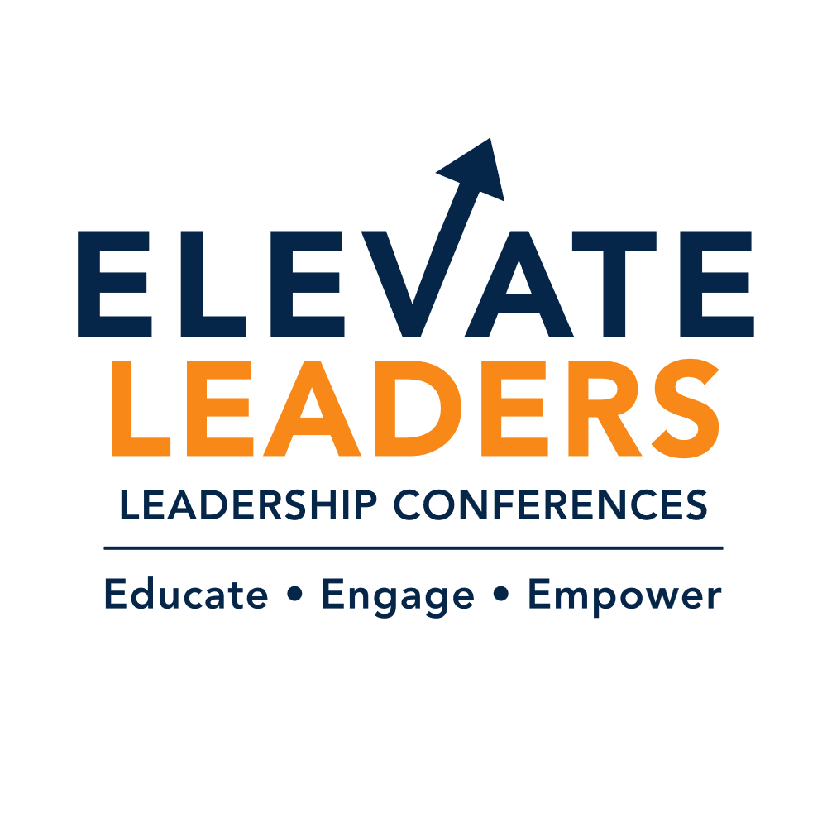
ELEVATE: A Maui Leadership Experience
Designing What Works Now - Practical Strategies for Sustainable Systems, Workforce Stability, and Better Outcomes
Elevate brings together leaders across healthcare, higher education, operations, and workforce development to address the reality organizations are navigating today - rising demand, workforce strain, financial pressure, and rapidly changing expectations.
This conference is designed to move beyond discussion into practical strategies, tools, and approaches organizations are actively using to improve outcomes.
Tracks include:
• Healthcare & Nursing Leadership
• Higher Education & College Health
• Administrative Support Professionals
• Clinical Educators & Faculty
Participants will engage in shared sessions, track-specific breakouts, and structured engagement experiences that reinforce learning and support implementation after the conference.

DAY 1 - The Reality Shift: Designing What Works Now
8:00 – 9:00am | Breakfast & Networking
Guided arrival experience focused on reflection, presence, and intentional transition into leadership learning.
9:00 – 10:15am | The Reality Shift - Why Old Models No Longer Work (All Tracks)
This session examines the structural changes reshaping organizations and why current service models are creating strain today.
Learn how demand growth, workforce constraints, and expanding expectations are influencing design decisions.
Participants will leave with:
• A demand vs capacity diagnostic framework
• Service inventory approach
• Redesign metrics used by organizations

10:15 – 10:30am | Break

10:30 – 11:45am | Track Breakout: Redesigning Core Services
Track sessions focus on redesign approaches across care delivery, student support, operational workflow, and practice readiness.
Explore real examples, tradeoffs, and implementation considerations.
Participants receive:
• Track-specific redesign templates
• Decision checklists
• Case studies and examples
- Healthcare & Nursing Leadership - Redesigning Care Delivery for Demand That Doesn’t Slow Down
- Higher Education & College Health - Reimagining Student Support Models for Complexity and Access
- Administrative Support Professionals - Operational Workflow Redesign: Reducing Friction Across Teams
- Clinical Educators & Faculty - Practice Readiness by Design: Aligning Curriculum With Real Work

11:45 – 12:45 | Lunch
12:45 – 2:00 | From Pressure to Design - Making Operational Decisions (All Tracks)
This session introduces prioritization frameworks leaders use when deciding what to continue, redesign, or stop.
Participants will leave with:
• Service prioritization matrix
• Stop / Continue / Redesign framework
• Outcome measurement examples
2:00 – 2:15pm | Break
2:15 – 3:30pm | Track Breakouts: Staffing, Data, Communication & Partnerships
Track sessions focus on applied strategies that improve stability and clarity.
Participants receive:
• Staffing scenario tools
• Outcome dashboard examples
• Communication protocols
• Partnership structures
- Healthcare & Nursing Leadership - Staffing Models That Protect Capacity and Patient Safety
- Higher Education & College Health - Using Data to Identify Risk Earlier and Intervene Smarter
- Administrative Support Professionals - Communication Structures That Reduce Confusion and Rework
- Clinical Educators & Faculty - Strengthening Academic-Practice Partnerships That Actually Work
3:30 – 4:00pm | Myth vs Reality: Leadership Edition
An interactive session that challenges common leadership assumptions and surfaces the gap between strategy and operational reality.
DAY 2 - Innovation to Implementation: Making Change Work to Improve Outcomes
8:00 – 9:00am | Breakfast
9:00 – 10:15am | Innovation Without Chaos (All Tracks)
How organizations pilot change safely while maintaining stability.
Participants receive:
• Pilot framework
• Experiment tracking template
• Innovation metrics library
10:15 – 10:30 | Break
10:30 – 11:45am | Track Breakouts: Applying Innovation
Explore using and integrating AI, digital service delivery, automation, and curriculum innovation.
Participants receive:
• Evaluation checklists
• Implementation examples
• Governance models
- Healthcare & Nursing Leadership - Digital Care, AI & Workflow Automation in Clinical Settings
- Higher Education & College Health - Expanding Access Through Digital Student Services
- Administrative Support Professionals - Automation That Improves Throughput Without Losing Human Connection
- Clinical Educators & Faculty - Curriculum Innovation for Workforce Readiness
11:45 – 12:45pm | Lunch
12:45 – 2:00pm | The Readiness Illusion: Why Competence Doesn’t Always Translate to Practice (All Tracks)
This session focuses on naming the gap between education to onboarding to operational performance. You will learn the difference between competence and operational readiness, the 5 domains of readiness, signals organizations already collect, where measurement currently fails, and how readiness connects to workforce stability.
Participants receive:
- A practice readiness framework
- A readiness signal map
- A measurement starter set
- A readiness conversation guide
- A scaling decision framework
- Cross-industry application examples
- A 90-day readiness action template
2:00 – 2:15pm | Break
2:15 – 3:30pm | Track Breakout: Designing Operational Readiness
The sessions focus on how readiness is built not assumed. Participants explore how organizations translate strategy into practice through onboarding design, workflow clarity, decision ownership, communication structures, and faculty-practice alignment. Each track will share tools, metrics, and real implementation examples you can take back to your team right away.
- Healthcare & Nursing Leadership – From Orientation to Operational Readiness
- Higher Education & College Health – Designing Student Support Systems That Scale
- Administrative Support Professionals – From Task Support to Operational Leadership
- Clinical Educators & Faculty – Teaching for Practice – Not Just a Test
• 3:30 – 4:00pm | The Assumption Crash Test: Experiencing Readiness Gaps in Real Time
Participants engage in a fast paced simulation that reveals how organizations unintentionally assume readiness across roles, workflows, and partnerships. Through real world scenarios, leaders experience where decision ownership, communication pathways, and expectations break down and how to recognize these gaps earlier.

DAY 3 - Partnerships, Systems & Cross-Functional Work
8:00 – 9:00 | Breakfast
9:00 – 10:15am | Why Partnerships Fail - and How to Fix Them (All Tracks)
Explore ownership, alignment, and coordination across departments and organizations.
Participants receive:
• Partnership alignment checklist
• Shared metric examples
• Governance approaches
10:15 – 10:30am | Break
10:30 – 11:45am | Track Breakouts: Strengthening Partnerships
- Healthcare & Nursing Leadership - Care Coordination Across Systems: Designing Continuity
- Higher Education & College Health - Integrating Health, Counseling, Advising & Basic Needs
- Administrative Support Professionals - Cross-Functional Collaboration That Speeds Decisions
- Clinical Educators & Faculty - Faculty-Practice Integration Models That Improve Outcomes
11:45 – 12:45pm | Lunch
12:45 – 2:00pm | Governance & Decision Structures That Work (All Tracks)
How organizations clarify authority and accelerate decisions.
Participants receive:
• Decision pathway templates
• Committee redesign checklist
• Escalation frameworks
2:00 – 2:15pm | Break
2:15 – 3:30pm | Track Breakout: Funding, Coordination & Workforce Alignment
- Healthcare & Nursing Leadership - Workforce Pipeline Design: From Recruitment to Retention
- Higher Education & College Health - Funding Student Well-Being as Institutional Strategy
- Administrative Support Professionals - Resource Allocation Models That Support Long-Term Stability
- Clinical Educators & Faculty - Designing Clinical Placement Models That Scale
3:30 – 4:00pm | The Coordination Challenge: Systems Jeopardy
Participants apply concepts from the day through an interactive team-based strategy game that tests decision-making across partnerships, governance, workforce alignment, and resource coordination.

DAY 4 - Implementation, Sustainability & Leadership
8:00 – 9:00am | Breakfast
9:00 – 10:15am | Turning Strategy Into Execution
How organizations move from planning to sustained change.
Participants receive:
• Implementation roadmap
• Adoption metrics
• Resistance mapping tools
10:15 – 10:30am | Break
10:30 – 11:45am | Track Breakouts: Sustaining Capacity
- Healthcare & Nursing Leadership - Retention as Infrastructure: Supporting Nurse Leaders and Teams
- Higher Education & College Health - Sustaining Student Support Without Expanding Staff
- Administrative Support Professionals - Operational Stability in High-Demand Environments
- Clinical Educators & Faculty - Faculty Sustainability and Preventing Educational Burnout
11:45 – 12:45pm| Lunch
12:45 – 2:00pm | Maintaining Momentum After the Conference
Focus on 90-day implementation planning and accountability.
Participants receive:
• Action plan template
• Accountability structure
• Leadership communication examples
2:00 – 2:15pm | Break
2:15 – 3:00pm | Track Breakouts: Leading Long-Term Change
- Healthcare & Nursing Leadership - Leading Improvement When Change Fatigue Is Real
- Higher Education & College Health - Building Improvement Cultures Across Campus Systems
- Administrative Support Professionals - Scaling Initiatives Without Creating Initiative Overload
- Clinical Educators & Faculty - Designing Talent Pipelines for the Future Workforce
3:30 – 4:00pm | From Insight to Movement
Participants identify one system shift that will create the greatest impact in their organization and stress-test it through peer challenge, cross-industry perspective, and implementation planning. Move beyond action lists to clarify decision ownership, early signals of success, and the structure required to sustain momentum after the conference.

